CSS Cascading Style Sheets 6

Why Use CSS? 6

CSS Syntax 7

Add CSS in html 8

External CSS 8

Internal CSS 9

Inline CSS 10

Multiple Style Sheets 10

Selectors 11

Element Selector 12

id Selector 12

class Selector 13

Universal Selector 15

Grouping Selector 15

CSS Comments 16

Colors 16

border color 16

Color Values 17

RGB Colors 18

RGBA Value (RED GREEN BLUE ALPHA) 19

HEX Colors (hexadecimal) 19

3 Digit HEX Value 20

HSL Colors (hue, saturation, lightness) 21

Backgrounds COLOR 22

Opacity / Transparency 22

Transparency using RGBA 23

background-image 23

background-repeat 24

background-repeat: no-repeat 25

background-position 25

background-attachment 26

background - Shorthand property 27

Borders 28

Border Width 29

Specific Side Widths 29

Border Color 30

Specific Side Colors 30

Border - Individual Sides 31

Border - Shorthand Property 32

Rounded Borders 33

Margins 34

Margin - Individual Sides 34

Margin - Shorthand Property 35

The auto MARGIN 36

The inherit Value 37

Margin Collapse 38

Padding 39

Padding - Shorthand Property 40

Padding and Element Width 41

Height, Width and Max-width 43

Box Model 45

Outline 47

Text 51

TEXT COLOR 51

Text Alignment and Text Direction 51

Text Alignment 52

Text Align Last 53

Text Direction 53

Vertical Alignment 54

Text Decoration 54

Decoration Line to Text 55

Specify a Color for the Decoration Line 56

Specify a Style for the Decoration Line 56

Specify the Thickness for the Decoration Line 57

The Shorthand Property 57

A Small Tip 58

Text Transformation 59

Text Spacing 59

Text Indentation, Letter Spacing, Line Height, Word Spacing, and White Space 59

Text Indentation 60

Letter Spacing 60

Line Height 61

Word Spacing 61

White Space 62

Text Shadow 62

Fonts 63

Web Safe Fonts 65

What are Web Safe Fonts? 65

Fallback Fonts 65

Best Web Safe Fonts for HTML and CSS 65

Font Style 66

Font Weight 67

Font Variant 67

Font Size 68

Google Fonts 70

CSS Links 70

CURSOR 73

List 74

list-style-type 75

list-style-image 75

list-style-position 76

Remove Default Settings 77

Styling List With Colors 77

Tables 78

Table Borders 78

TABEL WIDTH 79

Collapse Table Borders 79

Table 80

Table Alignment 81

Horizontal Alignment 81

Vertical Alignment 82

Table Style 83

Table Padding 83

Horizontal Dividers 83

Hoverable Table 84

Striped Tables 84

Responsive Table 85

DISPLAY 86

The display Property 86

Block-level Elements 86

Inline Elements 86

Display: none; 87

Override The Default Display Value 87

Hide an Element - display:none or visibility:hidden? 89

Layout - width and max-width 90

Using width, max-width and margin: auto; 90

POSITION 92

position: static; 93

position: relative; 94

position: fixed; 95

position: absolute; 96

position: sticky; 97

Z-INDEX 98

OVERFLOW 99

overflow: visible 99

overflow: scroll 100

overflow: auto 100

overflow-x and overflow-y 101

FLOAT AND CLEAR 102

The float Property 102

The clear Property 104

The clearfix Hack 105

INLINE-BLOCK 106

Using inline-block to Create Navigation Links 107

# CSS Cascading Style Sheets

* CSS stands for Cascading Style Sheets
* CSS describes how HTML elements are to be displayed on screen, paper, or in other media
* CSS saves a lot of work. It can control the layout of multiple web pages all at once
* External stylesheets are stored in CSS files

# Why Use CSS?

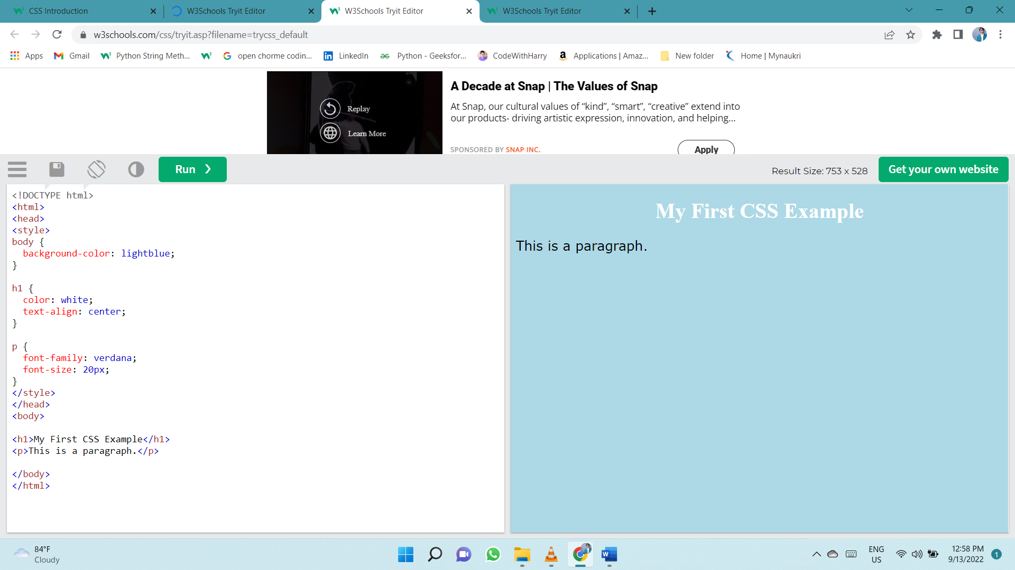CSS is used to define styles for your web pages, including the design, layout and variations in display for different devices and screen sizes.

# CSS Syntax

A CSS rule consists of a selector and a declaration block.

CSS Syntax

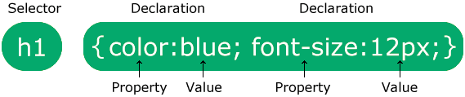

The selector points to the HTML element you want to style.

The declaration block contains one or more declarations separated by semicolons.

Each declaration includes a CSS property name and a value, separated by a colon.

Multiple CSS declarations are separated with semicolons, and declaration blocks are surrounded by curly braces.

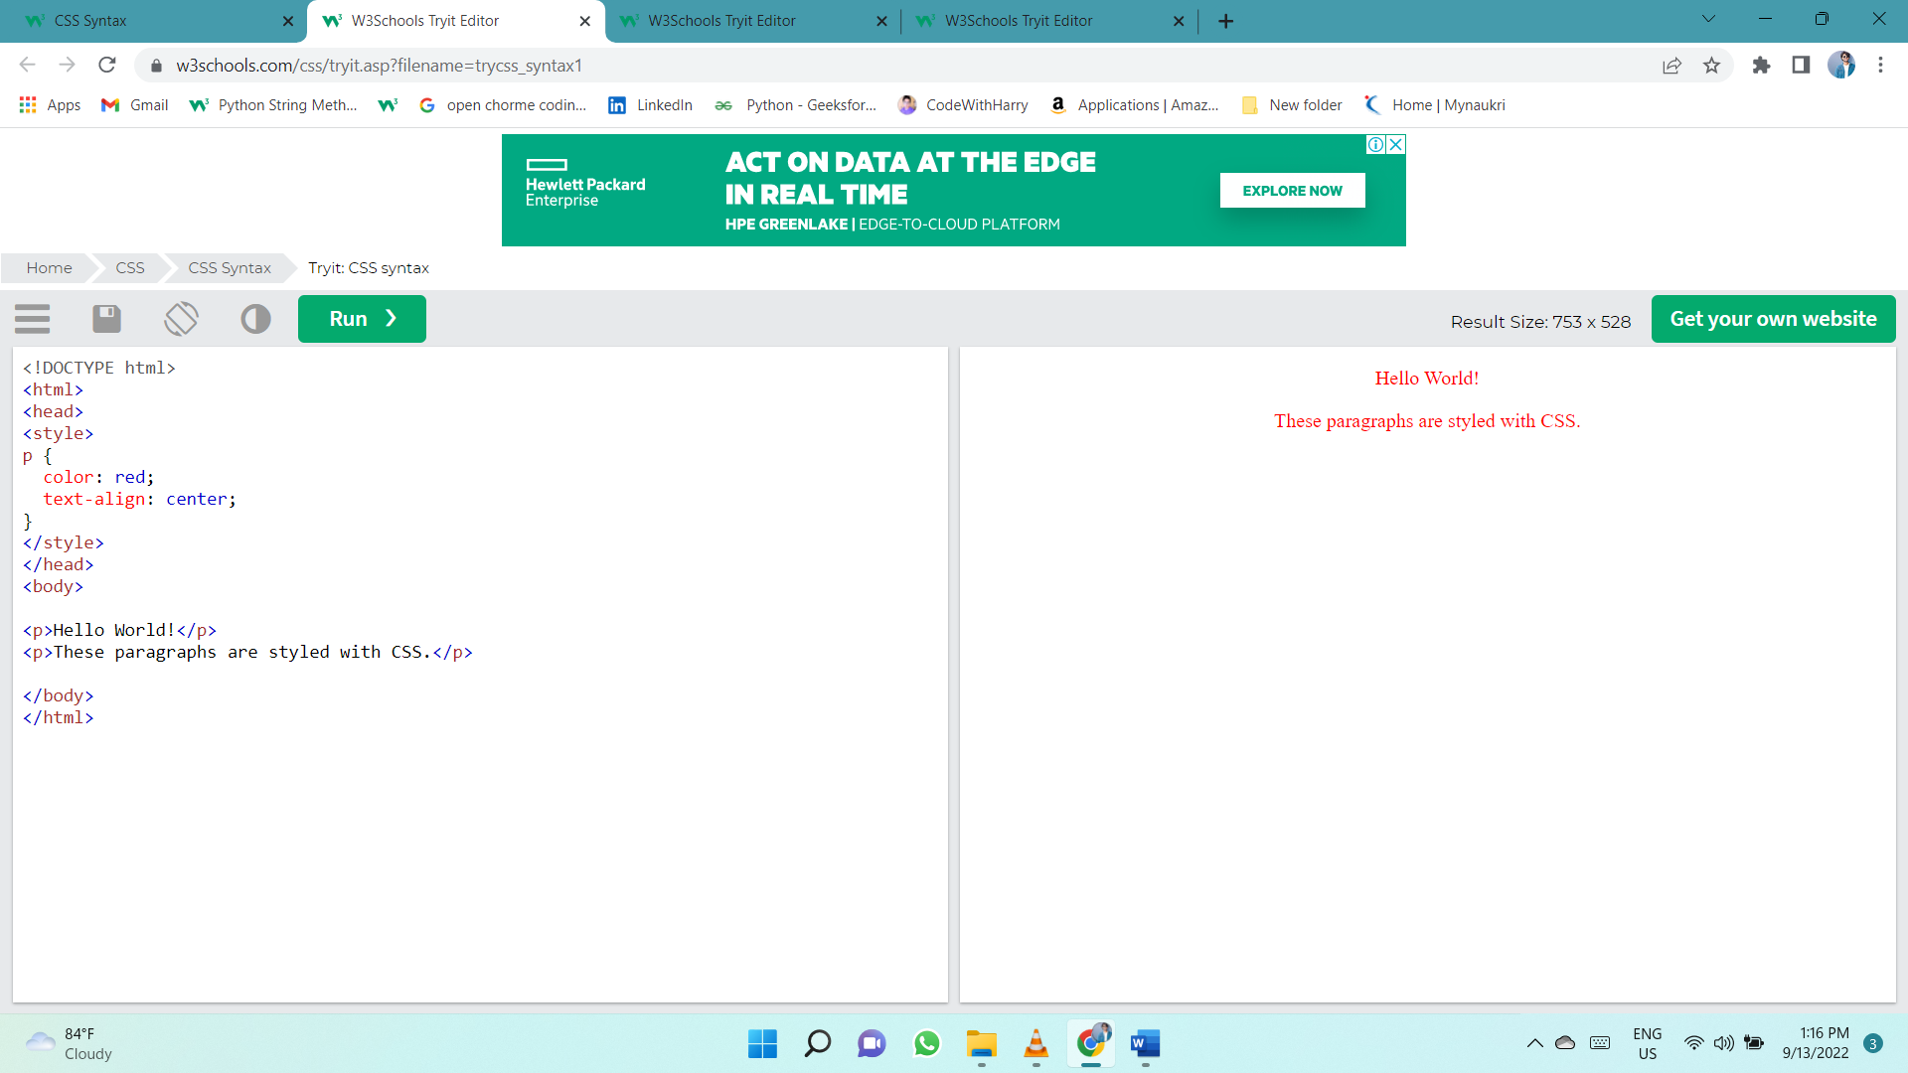

# Add CSS in html

There are three ways of inserting a style sheet:

* External CSS
* Internal CSS
* Inline CSS

## External CSS

With an external style sheet, you can change the look of an entire website by changing just one file!

Each HTML page must include a reference to the external style sheet file inside the <link> element, inside the head section.

External styles are defined within the <link> element, inside the <head> section of an HTML page:

<!DOCTYPE html>  
<html>  
<head>  
<link rel="stylesheet" href="mystyle.css">  
</head>  
<body>  
  
<h1>This is a heading</h1>  
<p>This is a paragraph.</p>  
  
</body>  
</html>

An external style sheet can be written in any text editor, and must be saved with a .css extension.

The external .css file should not contain any HTML tags.

Here is how the "mystyle.css" file looks:

"mystyle.css"

body {  
  background-color: lightblue;  
}  
  
h1 {  
  color: navy;  
  margin-left: 20px;  
}

## Internal CSS

An internal style sheet may be used if one single HTML page has a unique style.

The internal style is defined inside the <style> element, inside the head section.

Internal styles are defined within the <style> element, inside the <head> section of an HTML page:

<!DOCTYPE html>  
<html>  
<head>  
<style>  
body {  
  background-color: linen;  
}  
  
h1 {  
  color: maroon;  
  margin-left: 40px;  
}  
</style>  
</head>  
<body>  
  
<h1>This is a heading</h1>  
<p>This is a paragraph.</p>  
  
</body>  
</html>

## Inline CSS

An inline style may be used to apply a unique style for a single element.

To use inline styles, add the style attribute to the relevant element. The style attribute can contain any CSS property.

Inline styles are defined within the "style" attribute of the relevant element:

<!DOCTYPE html>  
<html>  
<body>  
  
<h1 style="color:blue;text-align:center;">This is a heading</h1>  
<p style="color:red;">This is a paragraph.</p>  
  
</body>  
</html>

## Multiple Style Sheets

If some properties have been defined for the same selector (element) in different style sheets, the value from the last read style sheet will be used.

Assume that an **external style sheet** has the following style for the <h1> element:

h1 {  
  color: navy;  
}

Then, assume that an **internal style sheet** also has the following style for the <h1> element:

h1 {  
  color: orange;     
}

If the internal style is defined **after** the link to the external style sheet, the <h1> elements will be "orange":

<head>  
<link rel="stylesheet" type="text/css" href="mystyle.css">  
<style>  
h1 {  
  color: orange;  
}  
</style>  
</head>

However, if the internal style is defined **before** the link to the external style sheet, the <h1> elements will be "navy":

<head>  
<style>  
h1 {  
  color: orange;  
}  
</style>  
<link rel="stylesheet" type="text/css" href="mystyle.css">  
</head>

# Selectors

CSS selectors are used to "find" (or select) the HTML elements you want to style.

We can divide CSS selectors into five categories:

* Simple selectors (select elements based on name, id, class)
* [Combinator selectors](https://www.w3schools.com/css/css_combinators.asp) (select elements based on a specific relationship between them)
* [Pseudo-class selectors](https://www.w3schools.com/css/css_pseudo_classes.asp) (select elements based on a certain state)
* [Pseudo-elements selectors](https://www.w3schools.com/css/css_pseudo_elements.asp) (select and style a part of an element)
* [Attribute selectors](https://www.w3schools.com/css/css_attribute_selectors.asp) (select elements based on an attribute or attribute value)

## Element Selector

The element selector selects HTML elements based on the element name.

Here, all <p> elements on the page will be center-aligned, with a red text color:

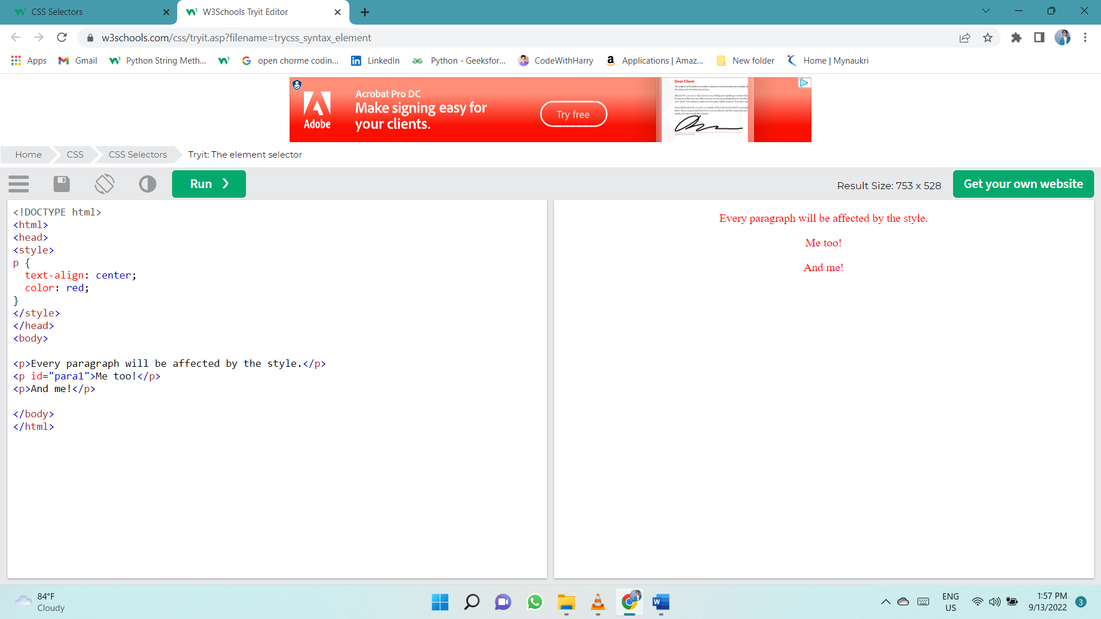p {  
  text-align: center;  
  color: red;  
}

## id Selector

The id selector uses the id attribute of an HTML element to select a specific element.

The id of an element is unique within a page, so the id selector is used to select one unique element!

To select an element with a specific id, write a hash (#) character, followed by the id of the element.

The CSS rule below will be applied to the HTML element with id="para1":

#para1 {  
  text-align: center;  
  color: red;  
}

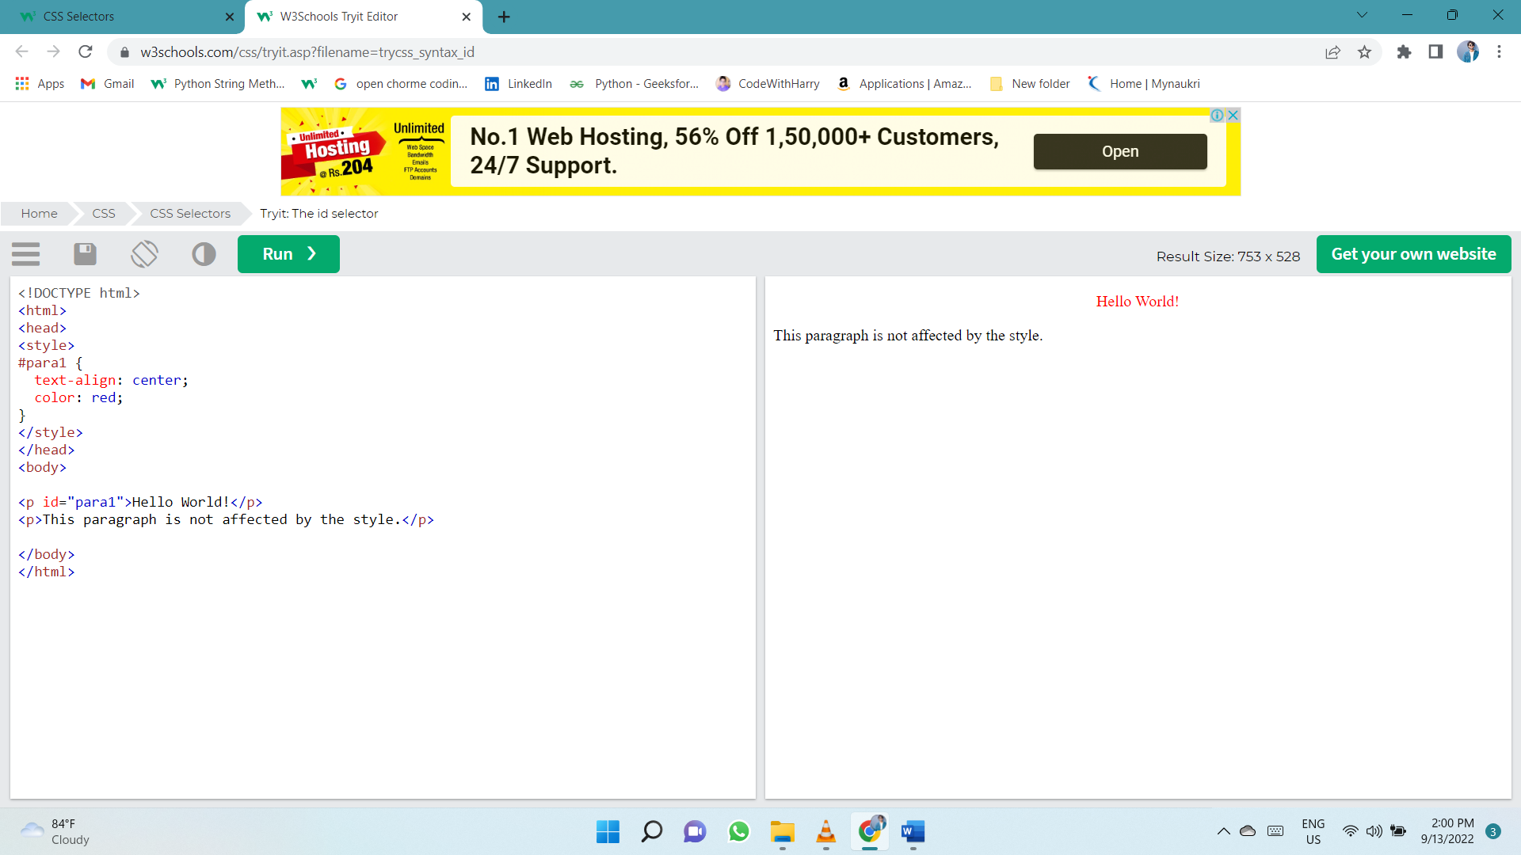

## class Selector

The class selector selects HTML elements with a specific class attribute.

To select elements with a specific class, write a period (.) character, followed by the class name.

In this example all HTML elements with class="center" will be red and center-aligned:

.center {  
  text-align: center;  
  color: red;  
}

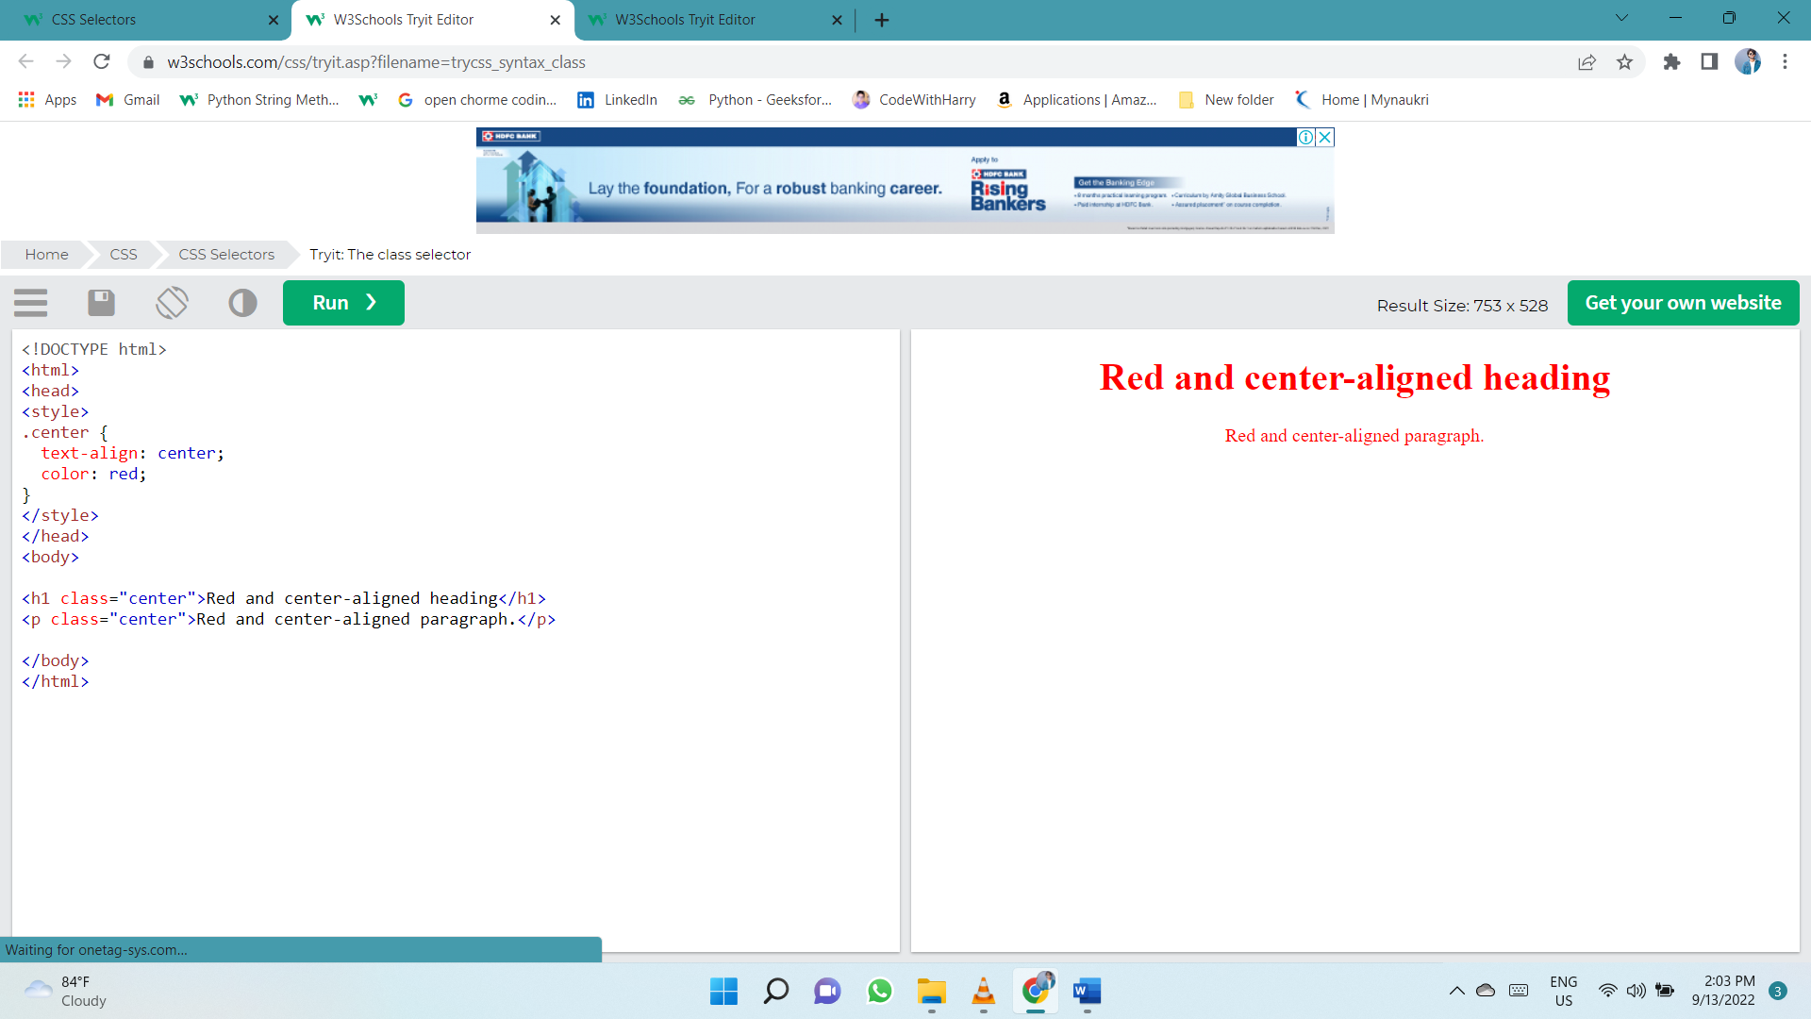

You can also specify that only specific HTML elements should be affected by a class.

In this example only <p> elements with class="center" will be red and center-aligned:

p.center {  
  text-align: center;  
  color: red;  
}

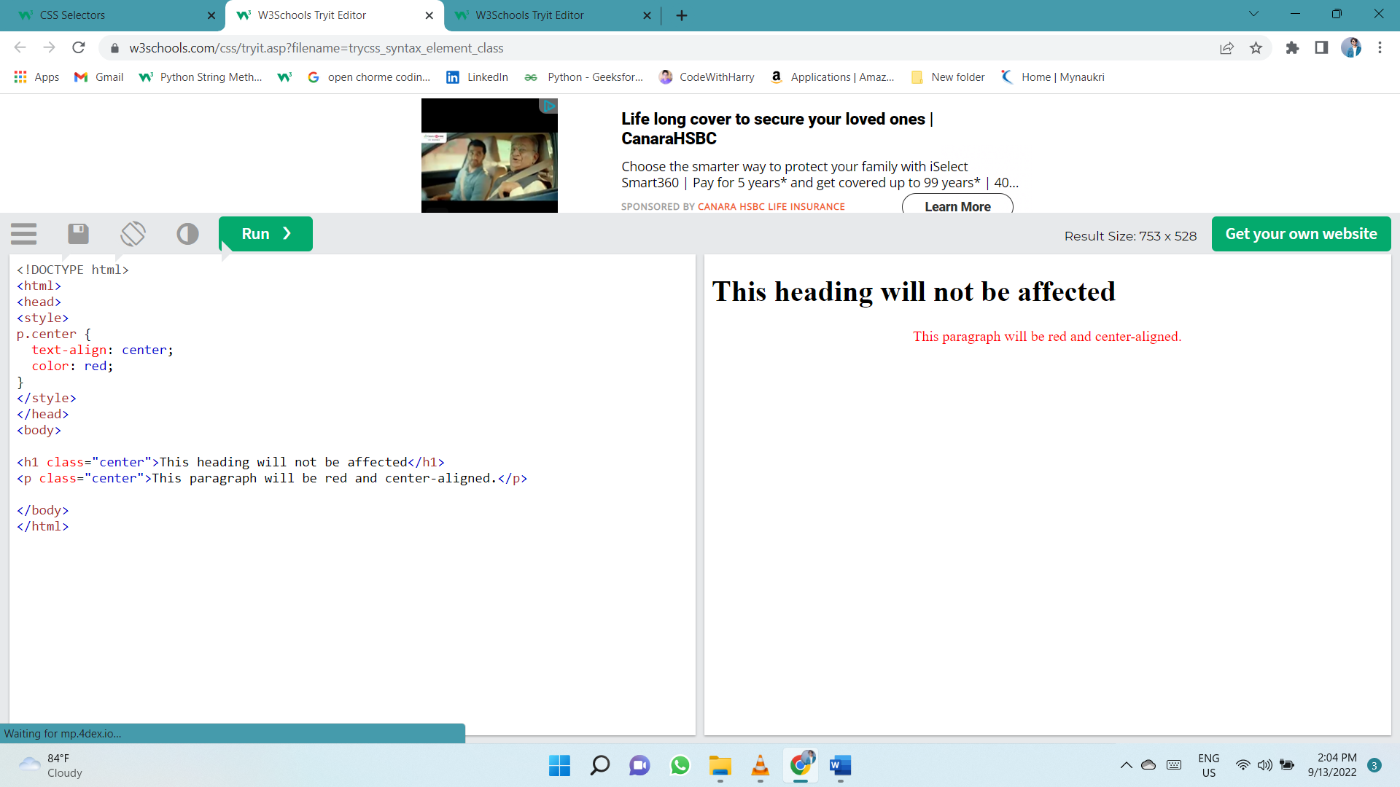

HTML elements can also refer to more than one class.

In this example the <p> element will be styled according to class="center" and to class="large":

<p class="center large">This paragraph refers to two classes.</p>

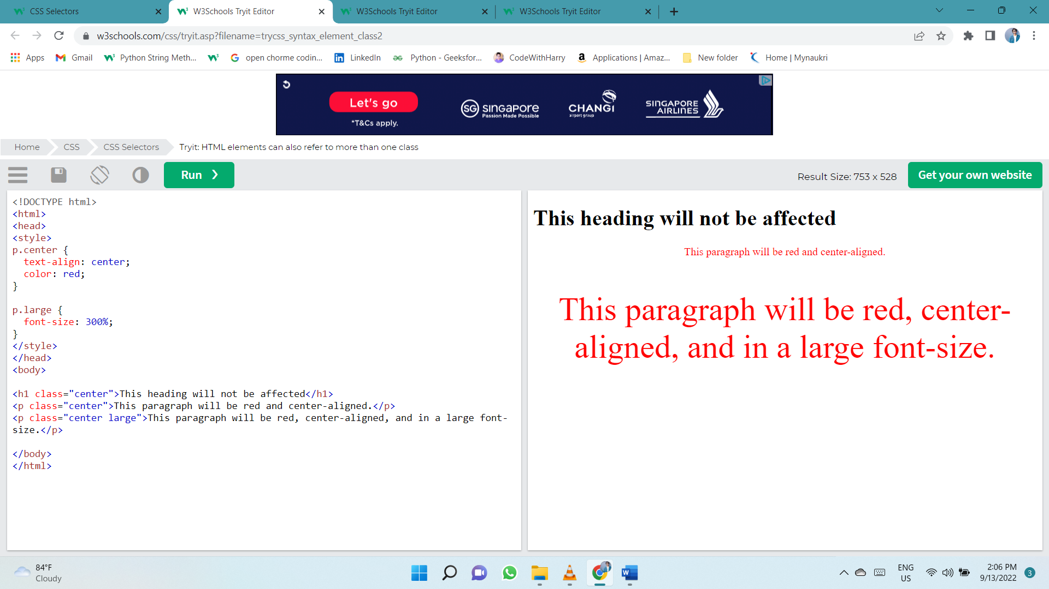

## Universal Selector

The universal selector (*) selects all HTML elements on the page.

The CSS rule below will affect every HTML element on the page:

* {  
  text-align: center;  
  color: blue;  
}

## Grouping Selector

The grouping selector selects all the HTML elements with the same style definitions.

Look at the following CSS code (the h1, h2, and p elements have the same style definitions):

h1 {  
  text-align: center;  
  color: red;  
}  
  
h2 {  
  text-align: center;  
  color: red;  
}  
  
p {  
  text-align: center;  
  color: red;  
}

It will be better to group the selectors, to minimize the code.

To group selectors, separate each selector with a comma.

In this example we have grouped the selectors from the code above:

h1, h2, p {  
  text-align: center;  
  color: red;  
}

# CSS Comments

/* This is a single-line comment */

# Colors

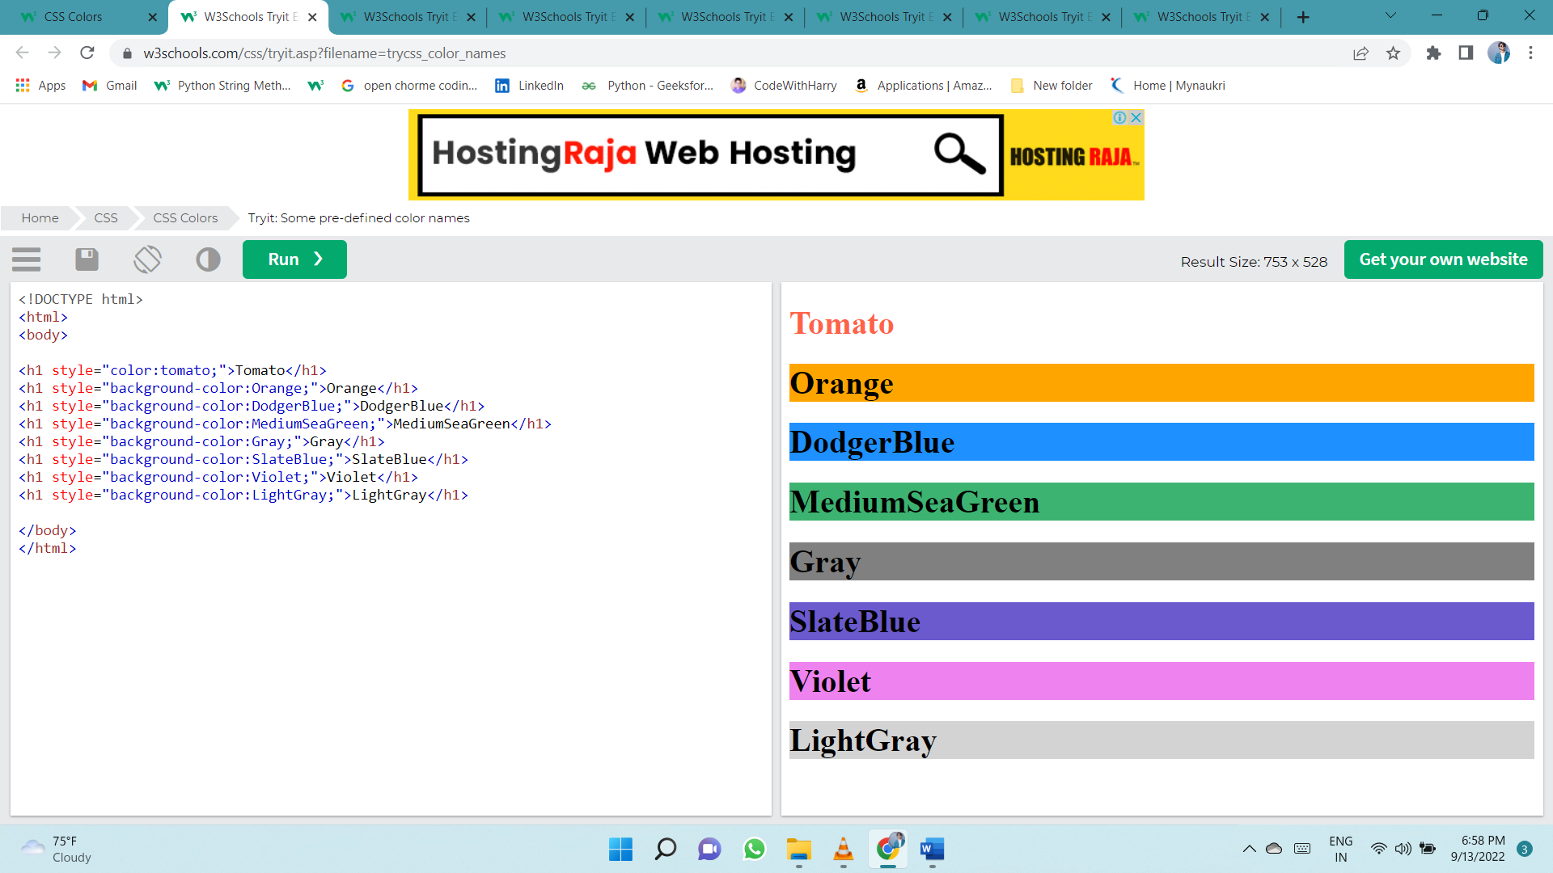Colors are specified using predefined color names, or RGB, HEX, HSL, RGBA, HSLA values.

## border color

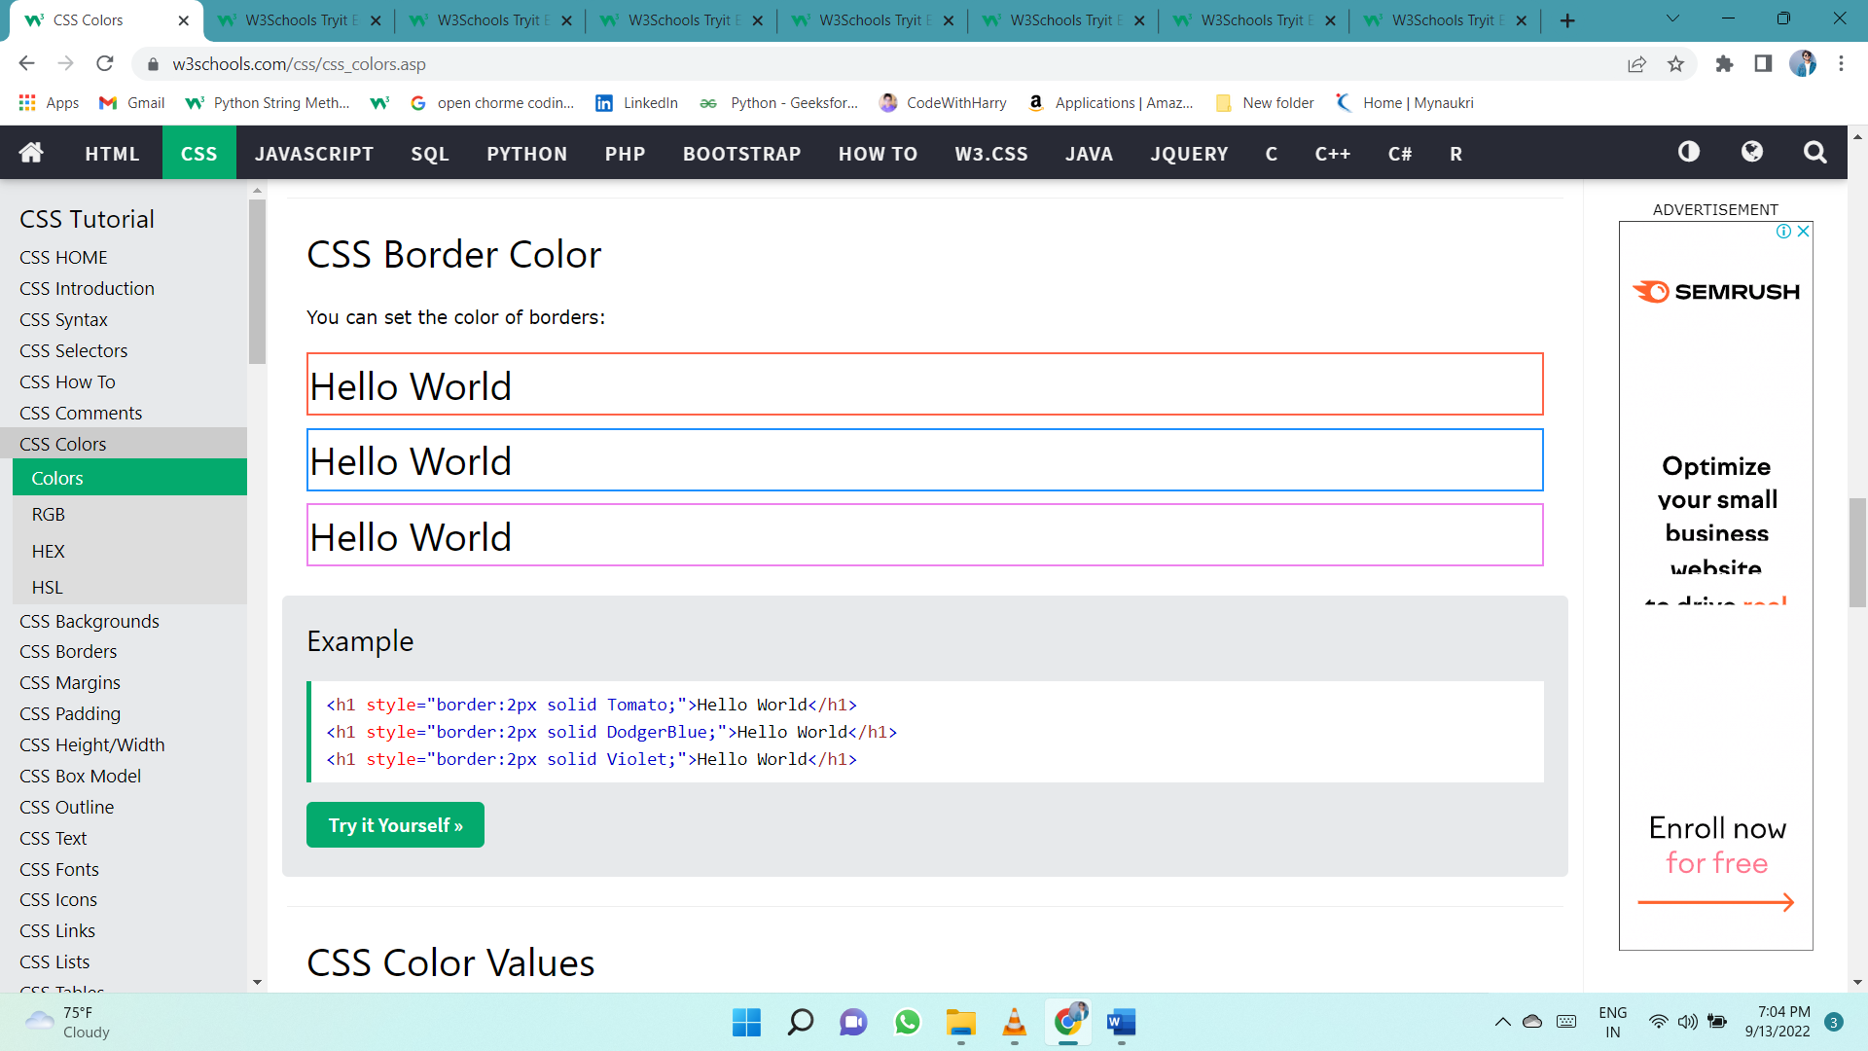

## Color Values

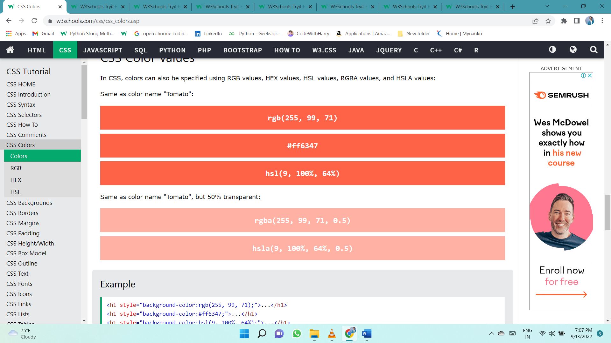In CSS, colors can also be specified using RGB values, HEX values, HSL values, RGBA values, and HSLA values:

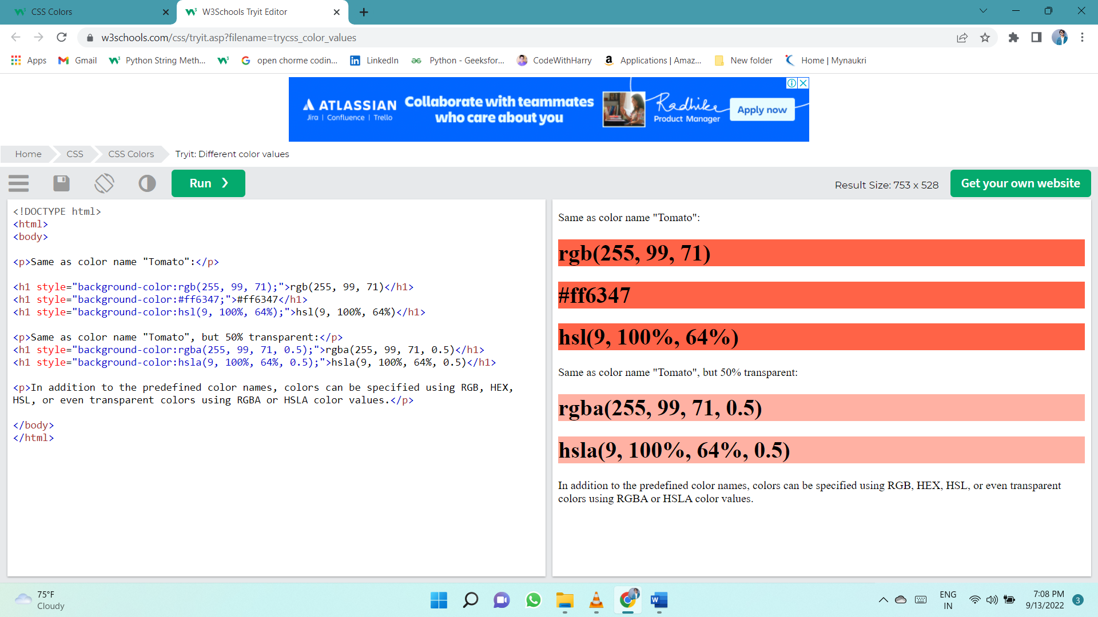

## RGB Colors

In CSS, a color can be specified as an RGB value, using this formula:

**rgb(*red,* *green*, *blue*)**

Each parameter (red, green, and blue) defines the intensity of the color between 0 and 255.

For example, rgb(255, 0, 0) is displayed as red, because red is set to its highest value (255) and the others are set to 0.

To display black, set all color parameters to 0, like this: rgb(0, 0, 0).

To display white, set all color parameters to 255, like this: rgb(255, 255, 255).

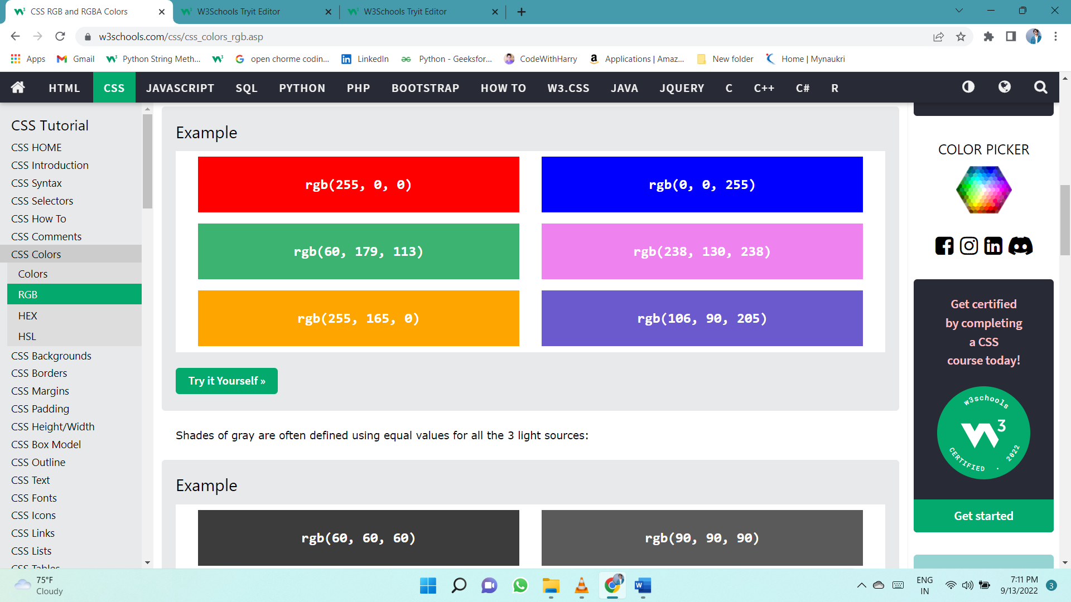

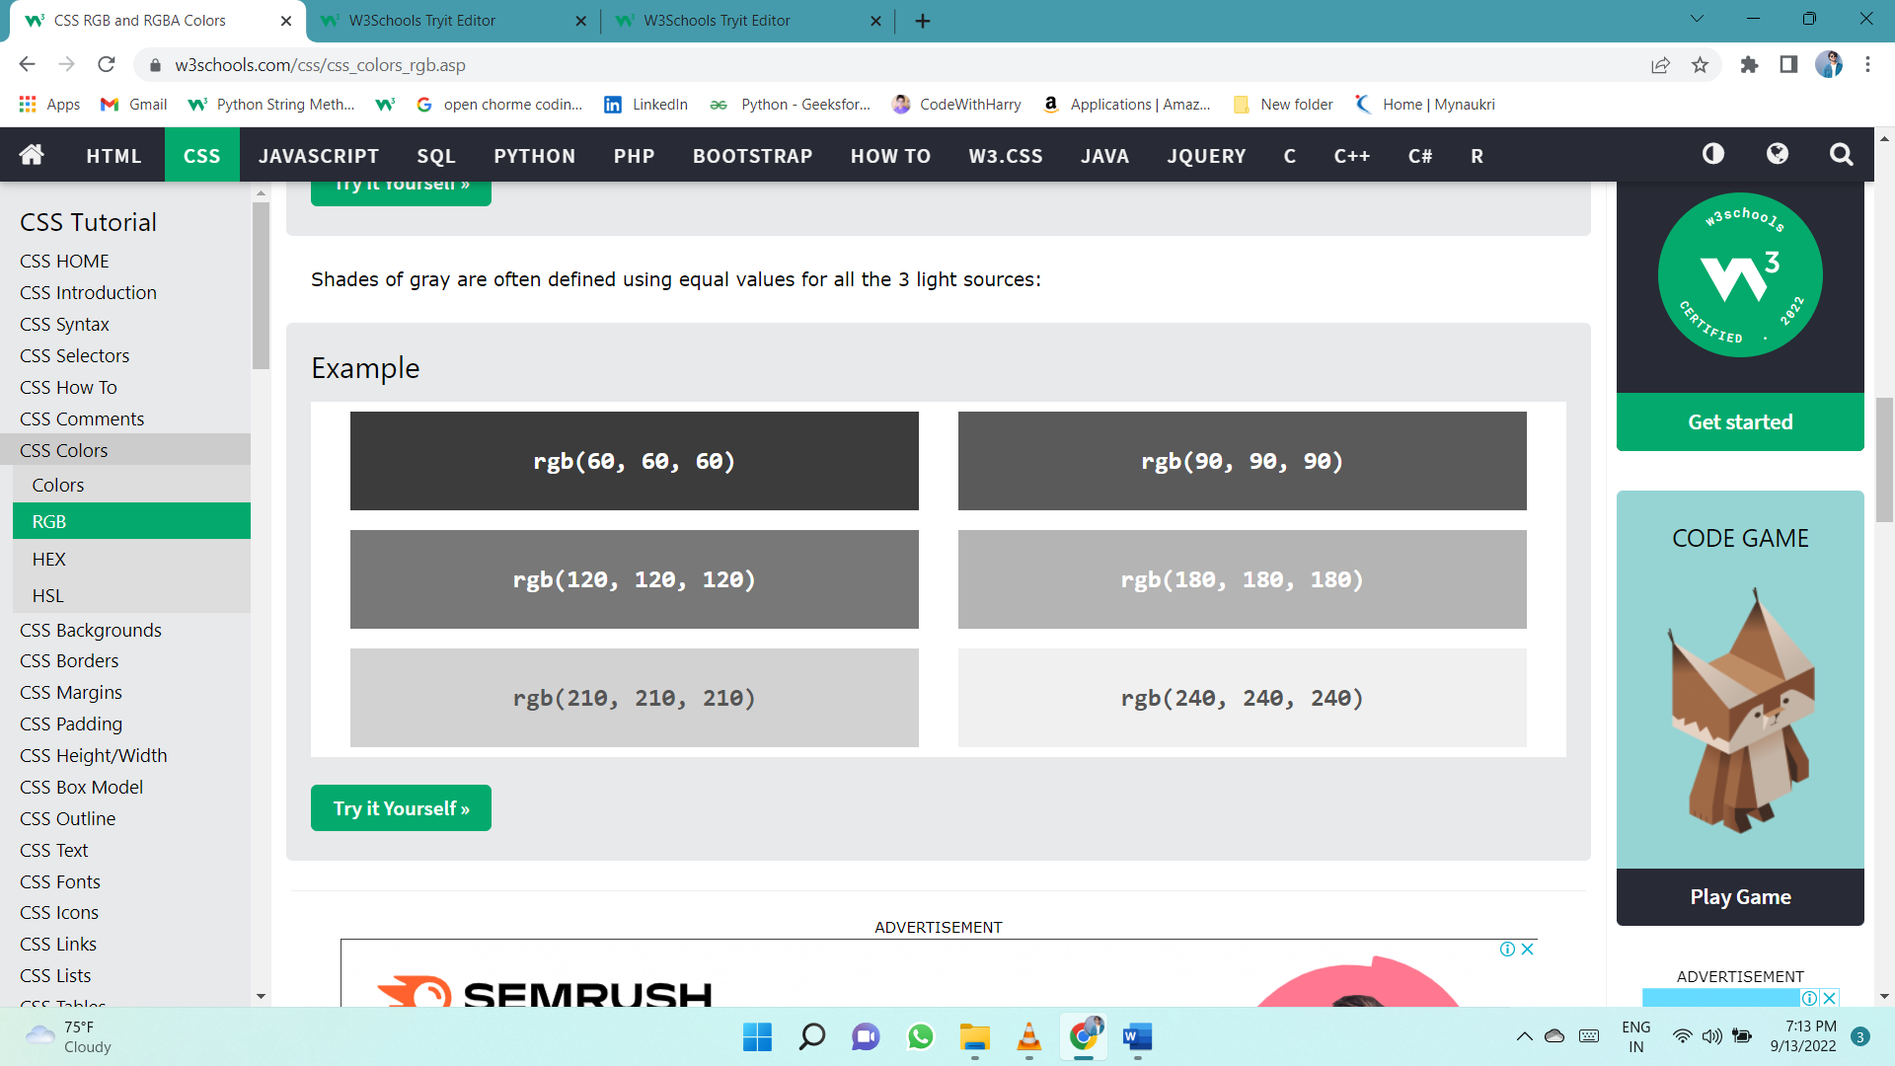

## RGBA Value (RED GREEN BLUE ALPHA)

RGBA color values are an extension of RGB color values with an alpha channel - which specifies the opacity for a color.

An RGBA color value is specified with:

**rgba(*red,* *green*, *blue, alpha*)**

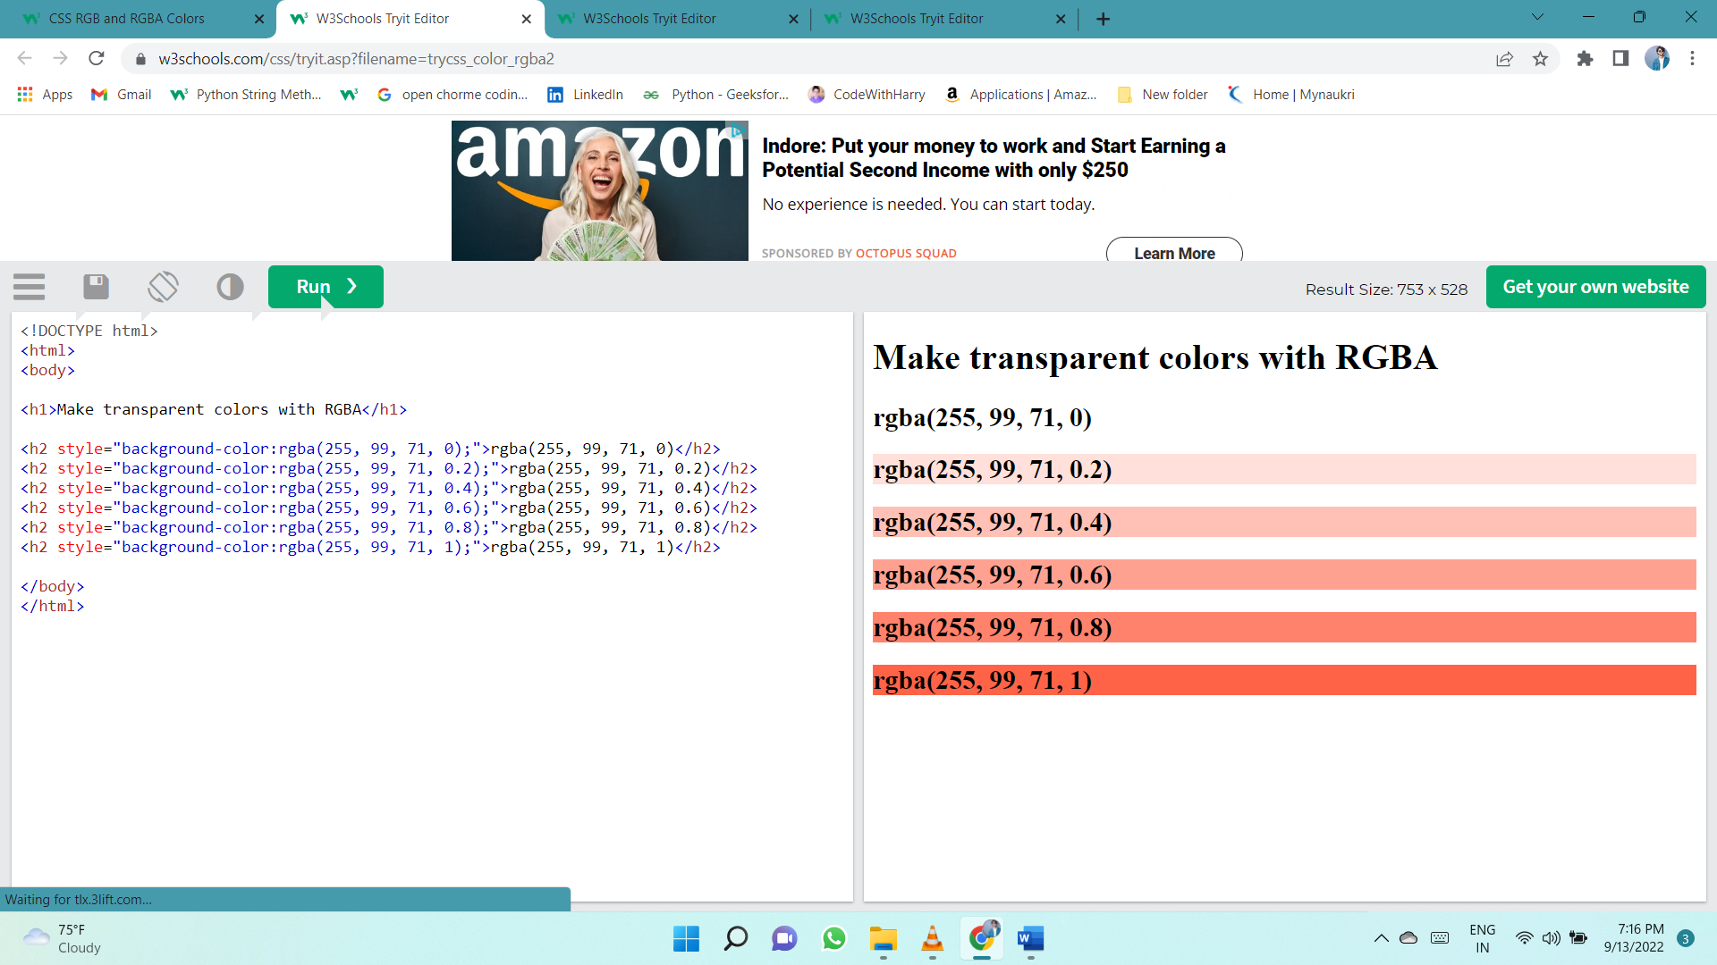The alpha parameter is a number between 0.0 (fully transparent) and 1.0 (not transparent at all):

## HEX Colors (hexadecimal)

A hexadecimal color is specified with: #RRGGBB, where the RR (red), GG (green) and BB (blue) hexadecimal integers specify the components of the color.

In CSS, a color can be specified using a hexadecimal value in the form:

**#rrggbb**

Where rr (red), gg (green) and bb (blue) are hexadecimal values between 00 and ff (same as decimal 0-255).

For example, #ff0000 is displayed as red, because red is set to its highest value (ff) and the others are set to the lowest value (00).

To display black, set all values to 00, like this: #000000.

To display white, set all values to ff, like this: #ffffff.

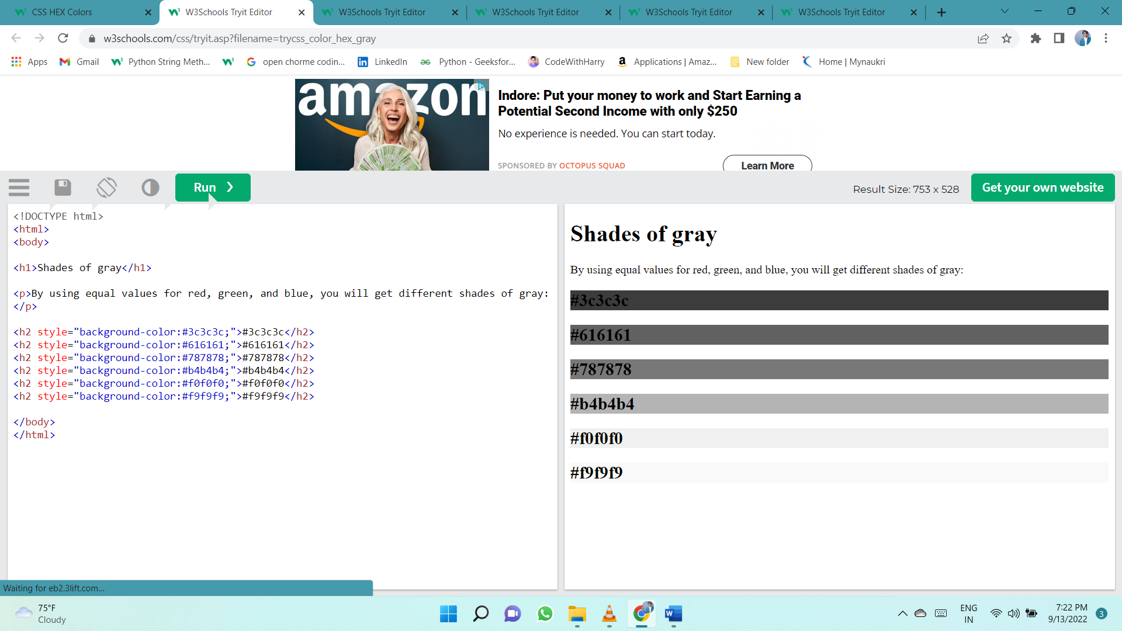

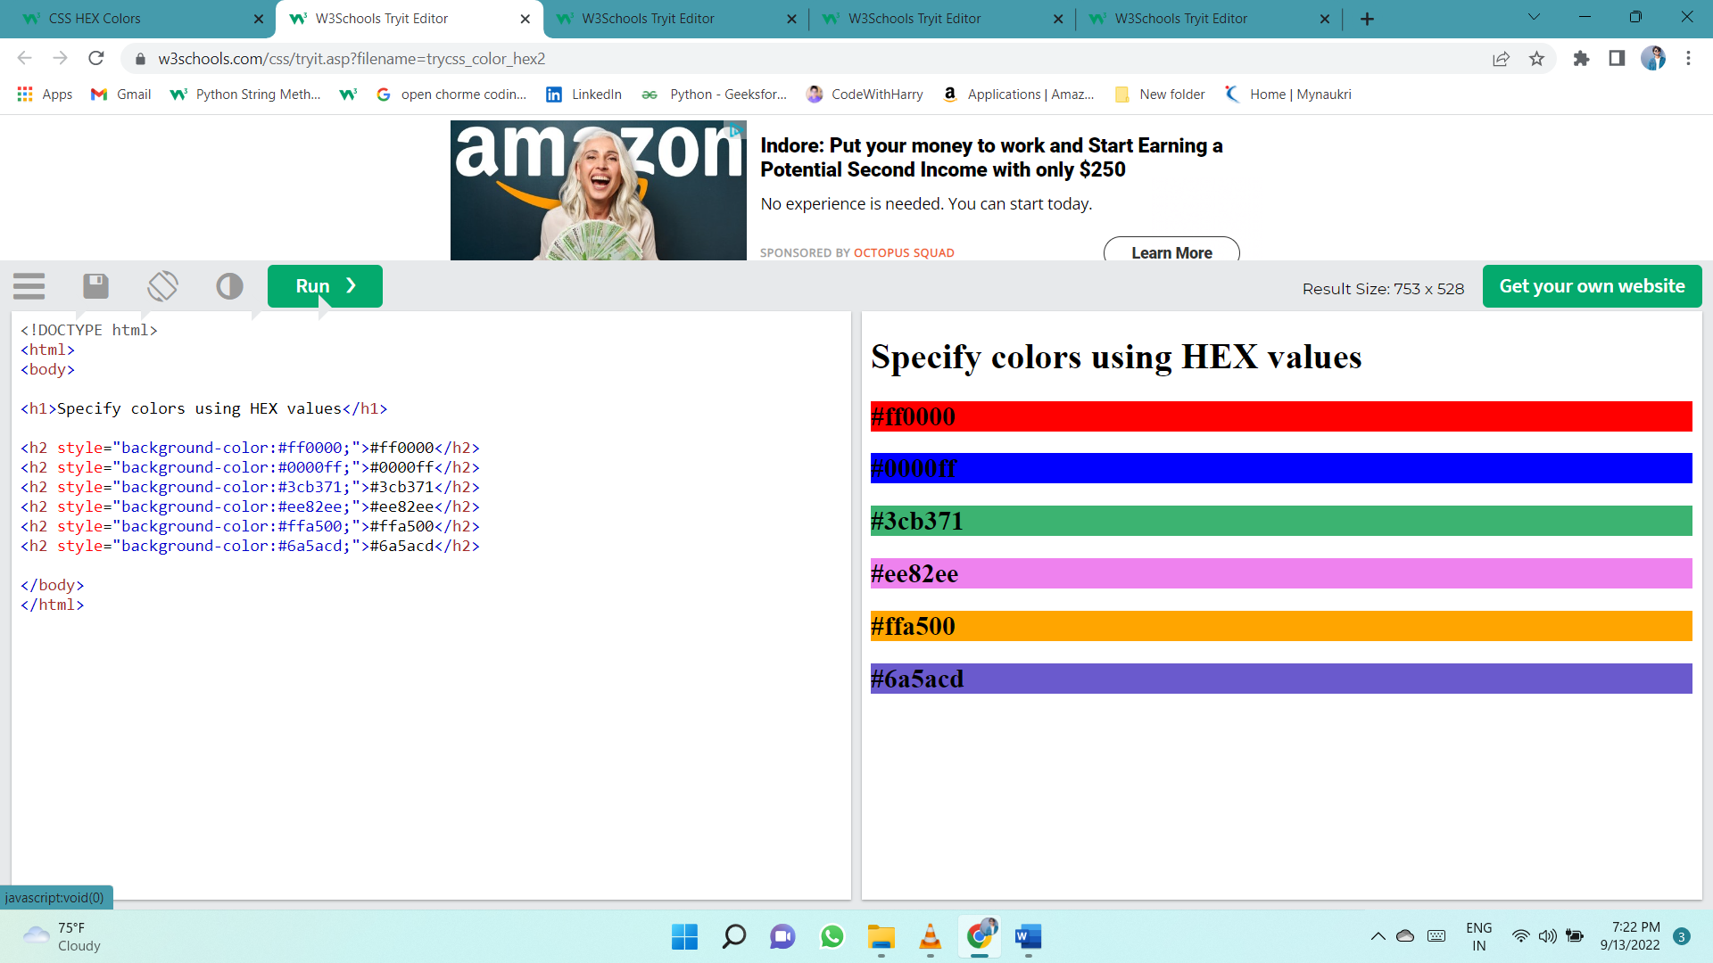

## 3 Digit HEX Value

Sometimes you will see a 3-digit hex code in the CSS source.

The 3-digit hex code is a shorthand for some 6-digit hex codes.

The 3-digit hex code has the following form:

**#rgb**

Where r, g, and b represent the red, green, and blue components with values between 0 and f.

The 3-digit hex code can only be used when both the values (RR, GG, and BB) are the same for each component. So, if we have #ff00cc, it can be written like this: #f0c.

body {  
  background-color: #fc9; /* same as #ffcc99 */  
}  
  
h1 {  
  color: #f0f; /* same as #ff00ff */  
}  
  
p {  
  color: #b58; /* same as #bb5588 */  
}

## HSL Colors (hue, saturation, lightness)

HSL stands for hue, saturation, and lightness.

In CSS, a color can be specified using hue, saturation, and lightness (HSL) in the form:

**hsl(hue, saturation, lightness)**

Hue is a degree on the color wheel from 0 to 360. 0 is red, 120 is green, and 240 is blue.

Saturation is a percentage value. 0% means a shade of gray, and 100% is the full color.

Lightness is also a percentage. 0% is black, 50% is neither light or dark, 100% is white

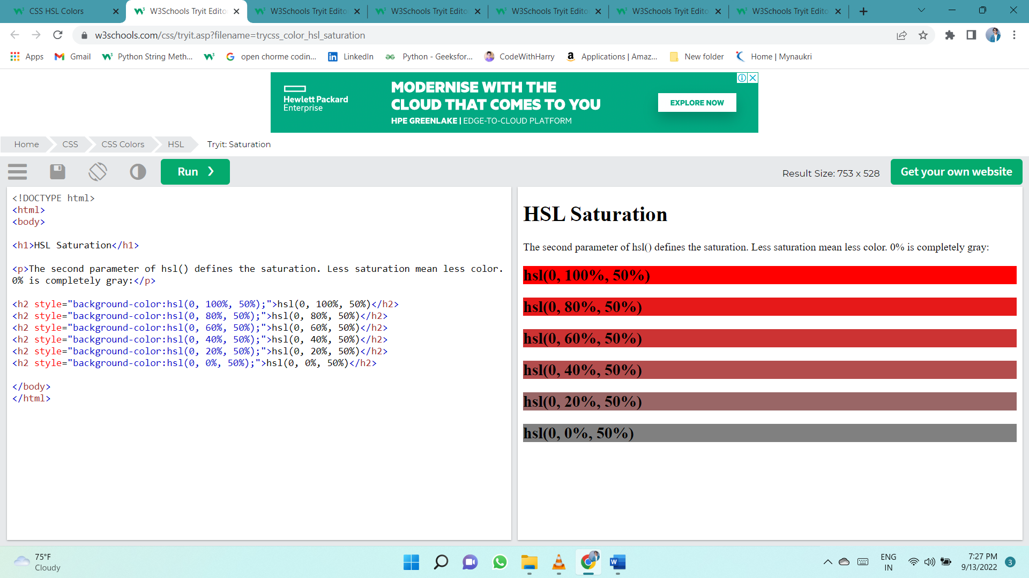

**hsla(*hue,* *saturation*, *lightness, alpha*)**

The alpha parameter is a number between 0.0 (fully transparent) and 1.0 (not transparent at all):

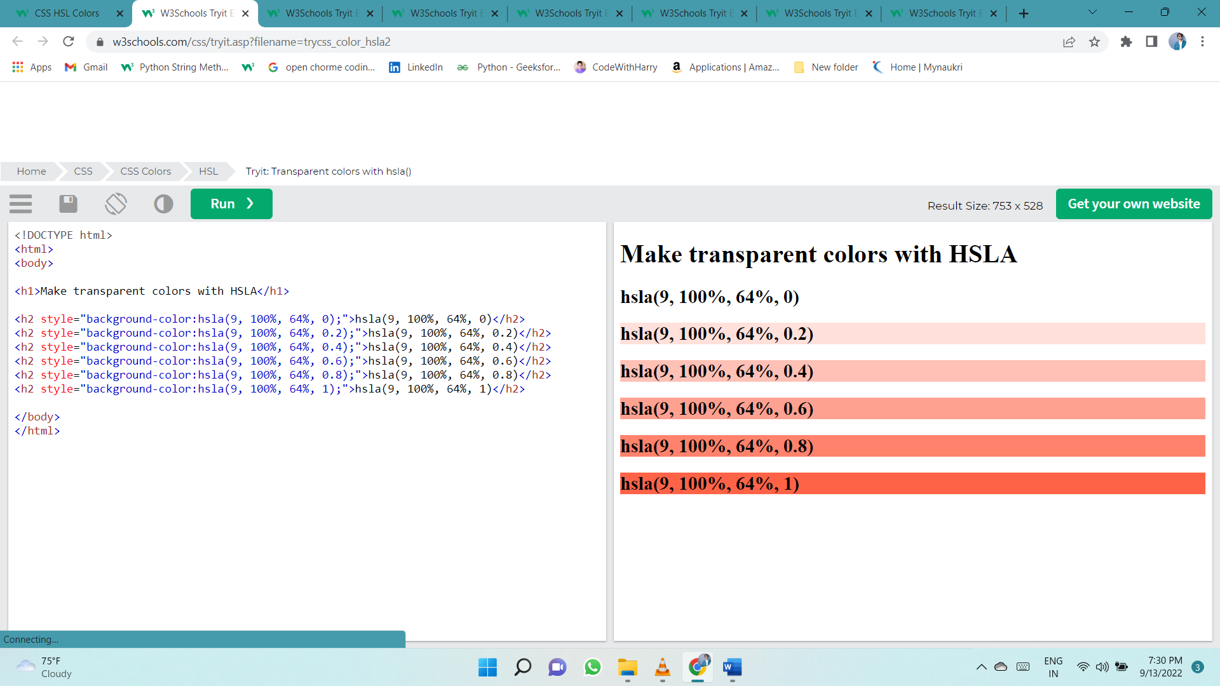

# Backgrounds COLOR

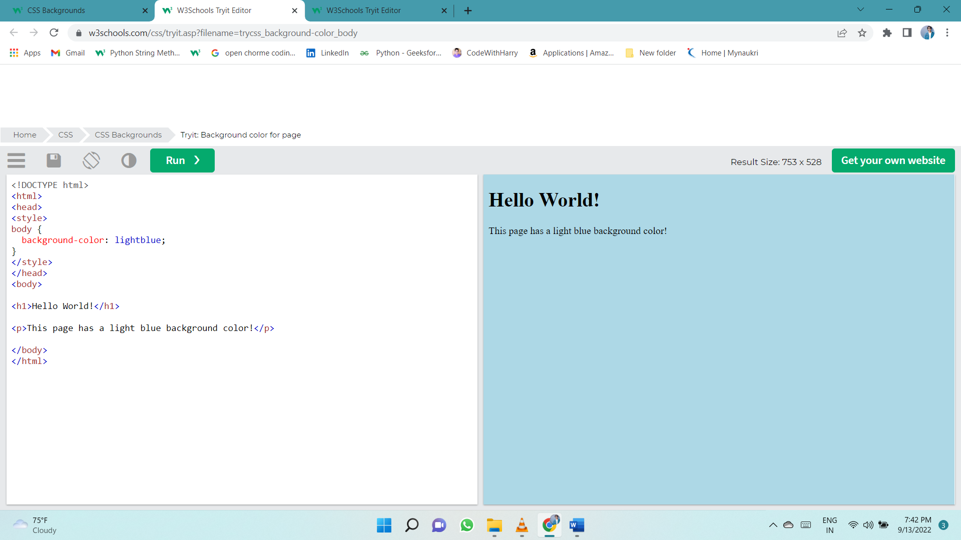The background-color property specifies the background color of an element.

## Opacity / Transparency

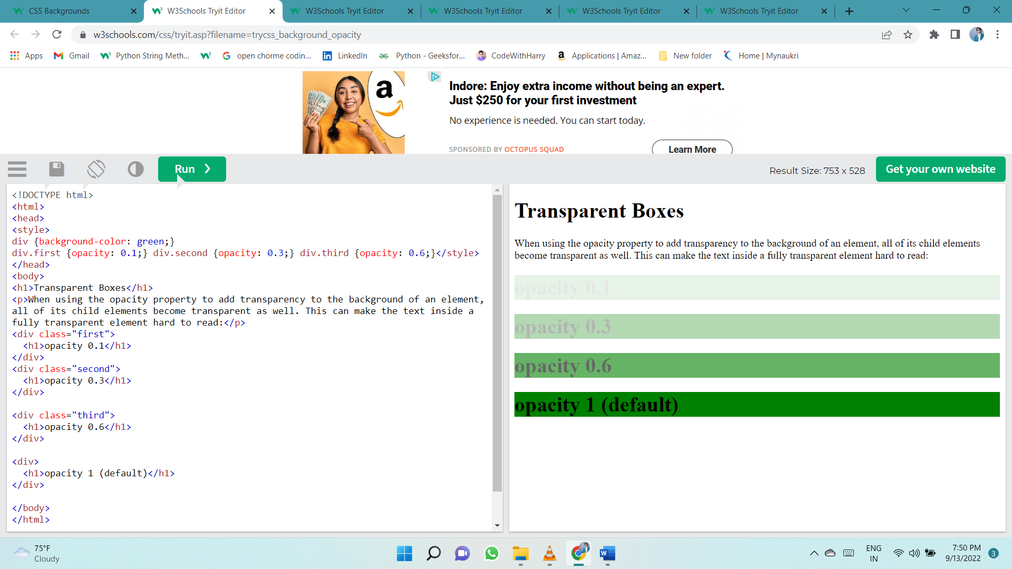The opacity property specifies the opacity/transparency of an element. It can take a value from 0.0 - 1.0. The lower value, the more transparent:

## Transparency using RGBA

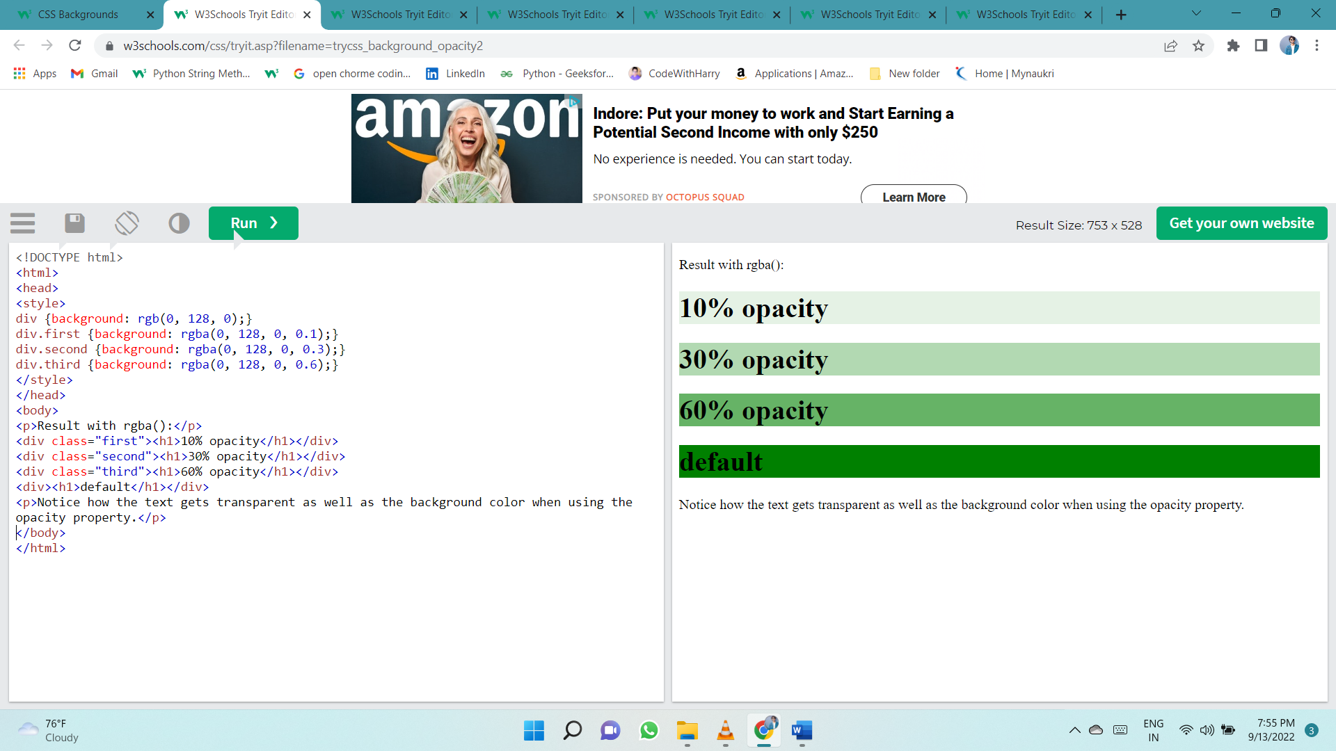If you do not want to apply opacity to child elements, like in our example above, use **RGBA** color values. The following example sets the opacity for the background color and not the text:

## background-image

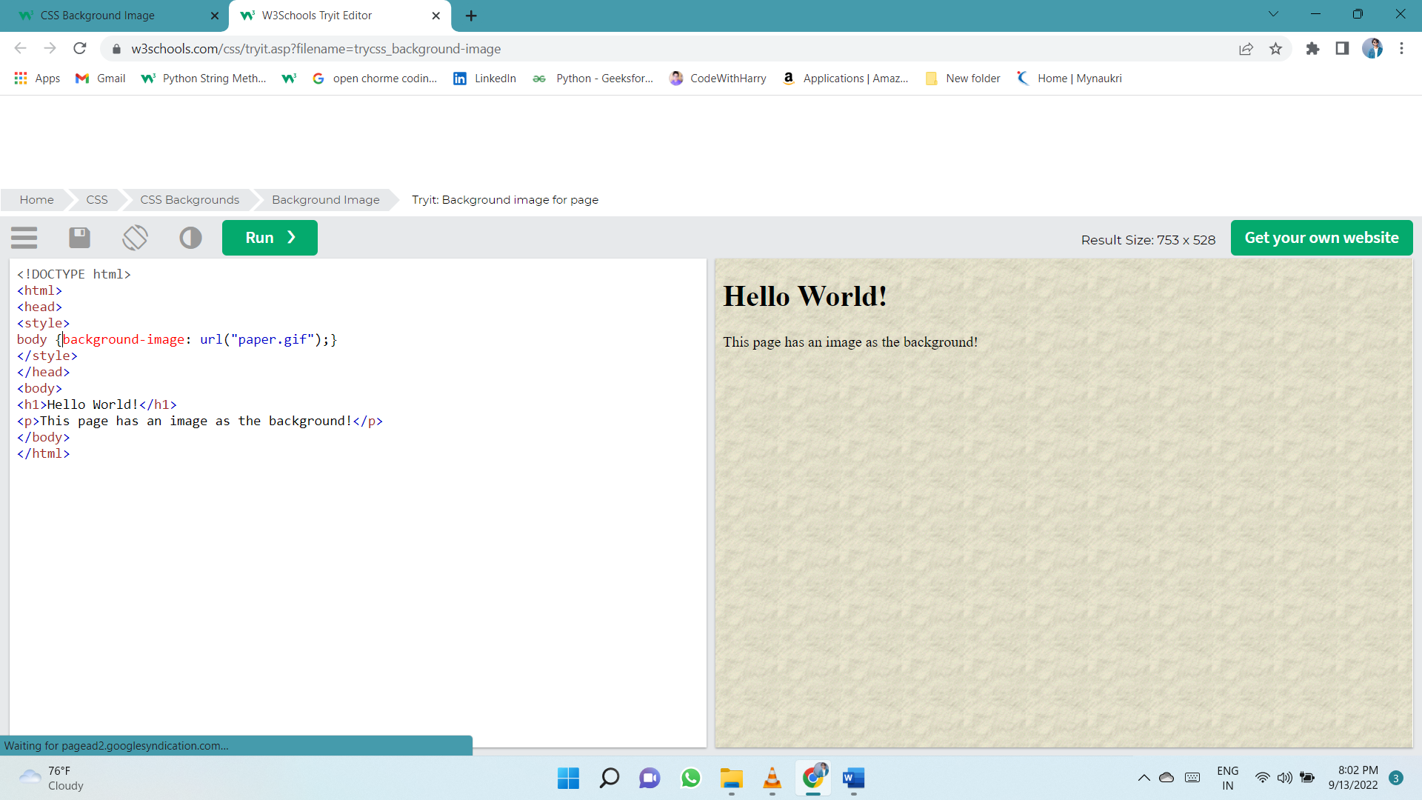The background-image property specifies an image to use as the background of an element.

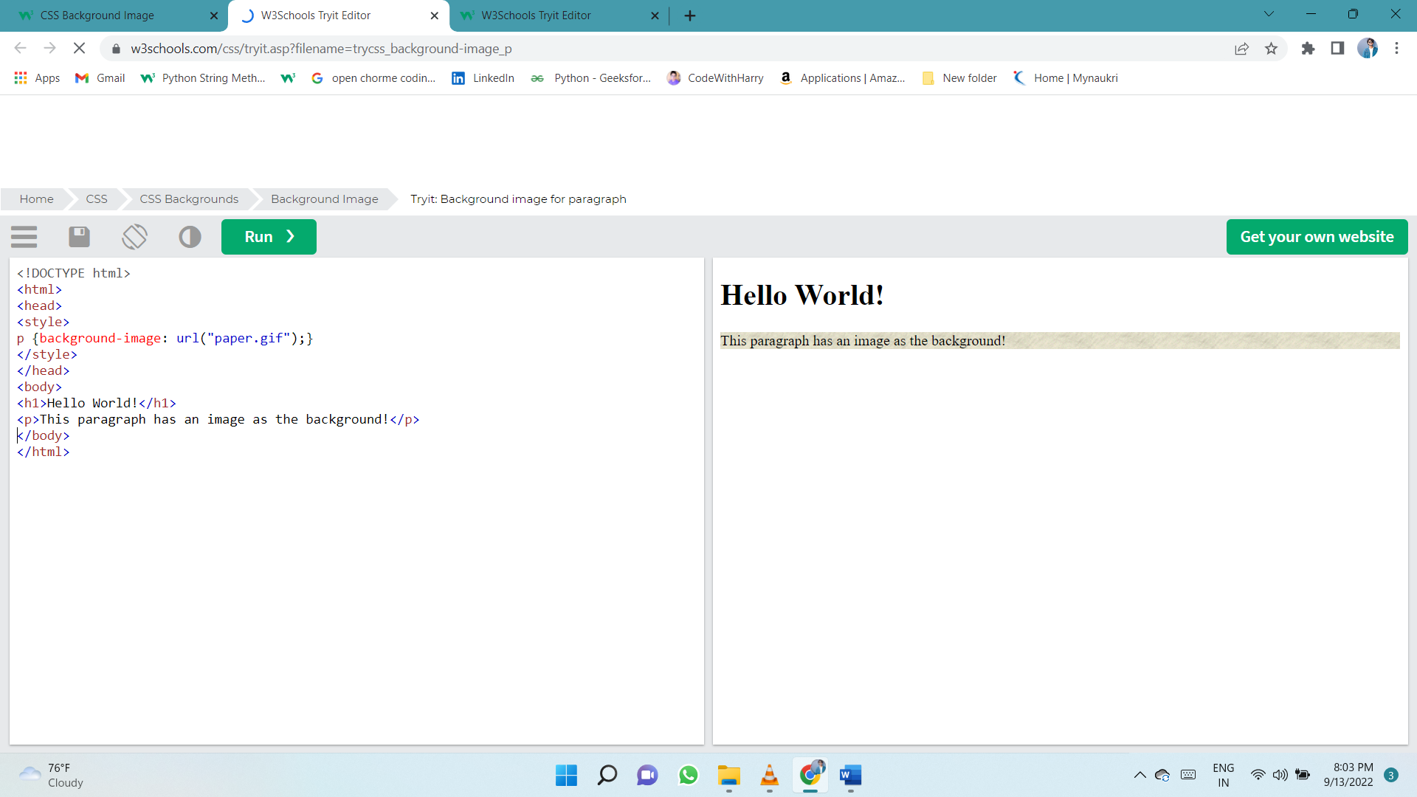

## background-repeat

By default, the background-image property repeats an image both horizontally and vertically.

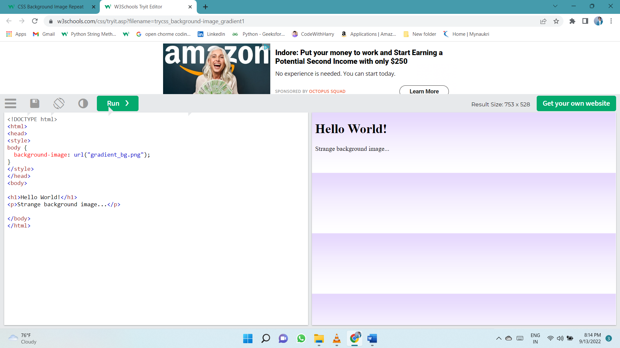Some images should be repeated only horizontally or vertically, or they will look strange, like this:

If the image above is repeated only horizontally (background-repeat: repeat-x;), the background will look better:

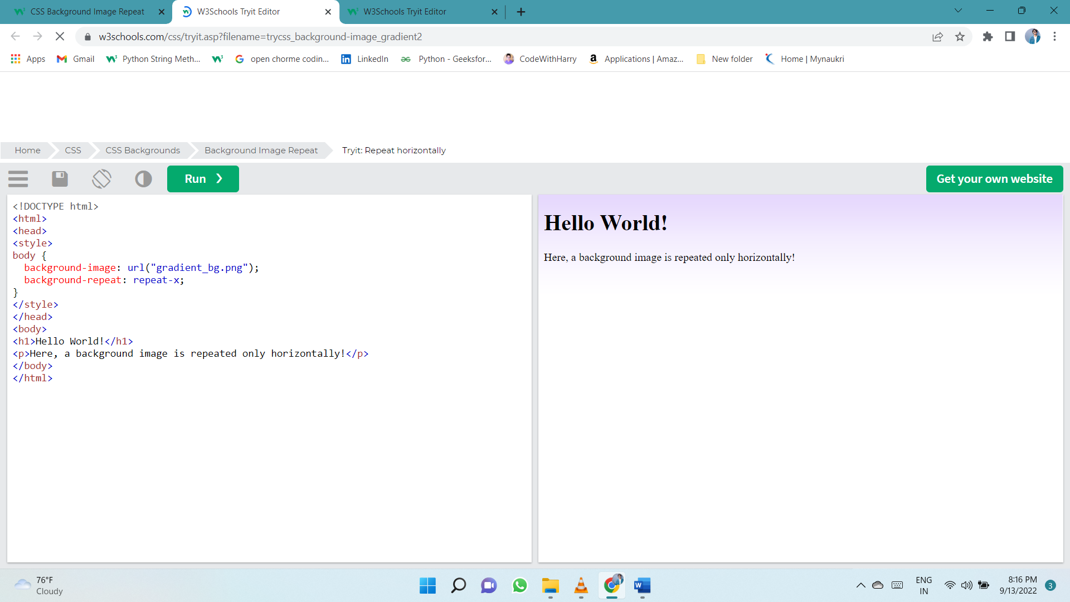

**Tip:** To repeat an image vertically, set background-repeat: repeat-y;

## background-repeat: no-repeat

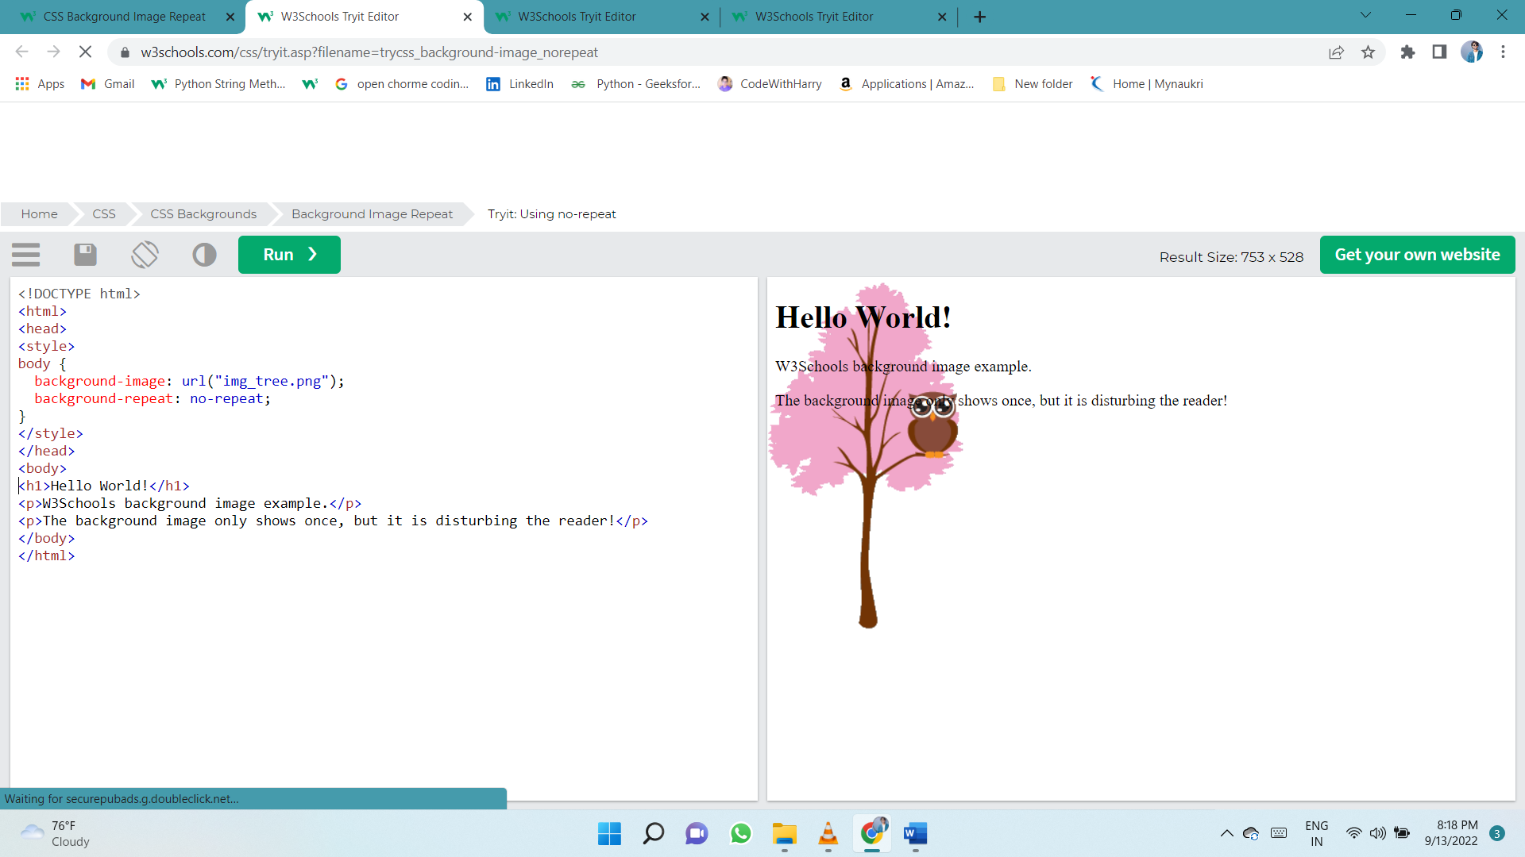Showing the background image only once is also specified by the background-repeat property:

## background-position

The background-position property is used to specify the position of the background image.

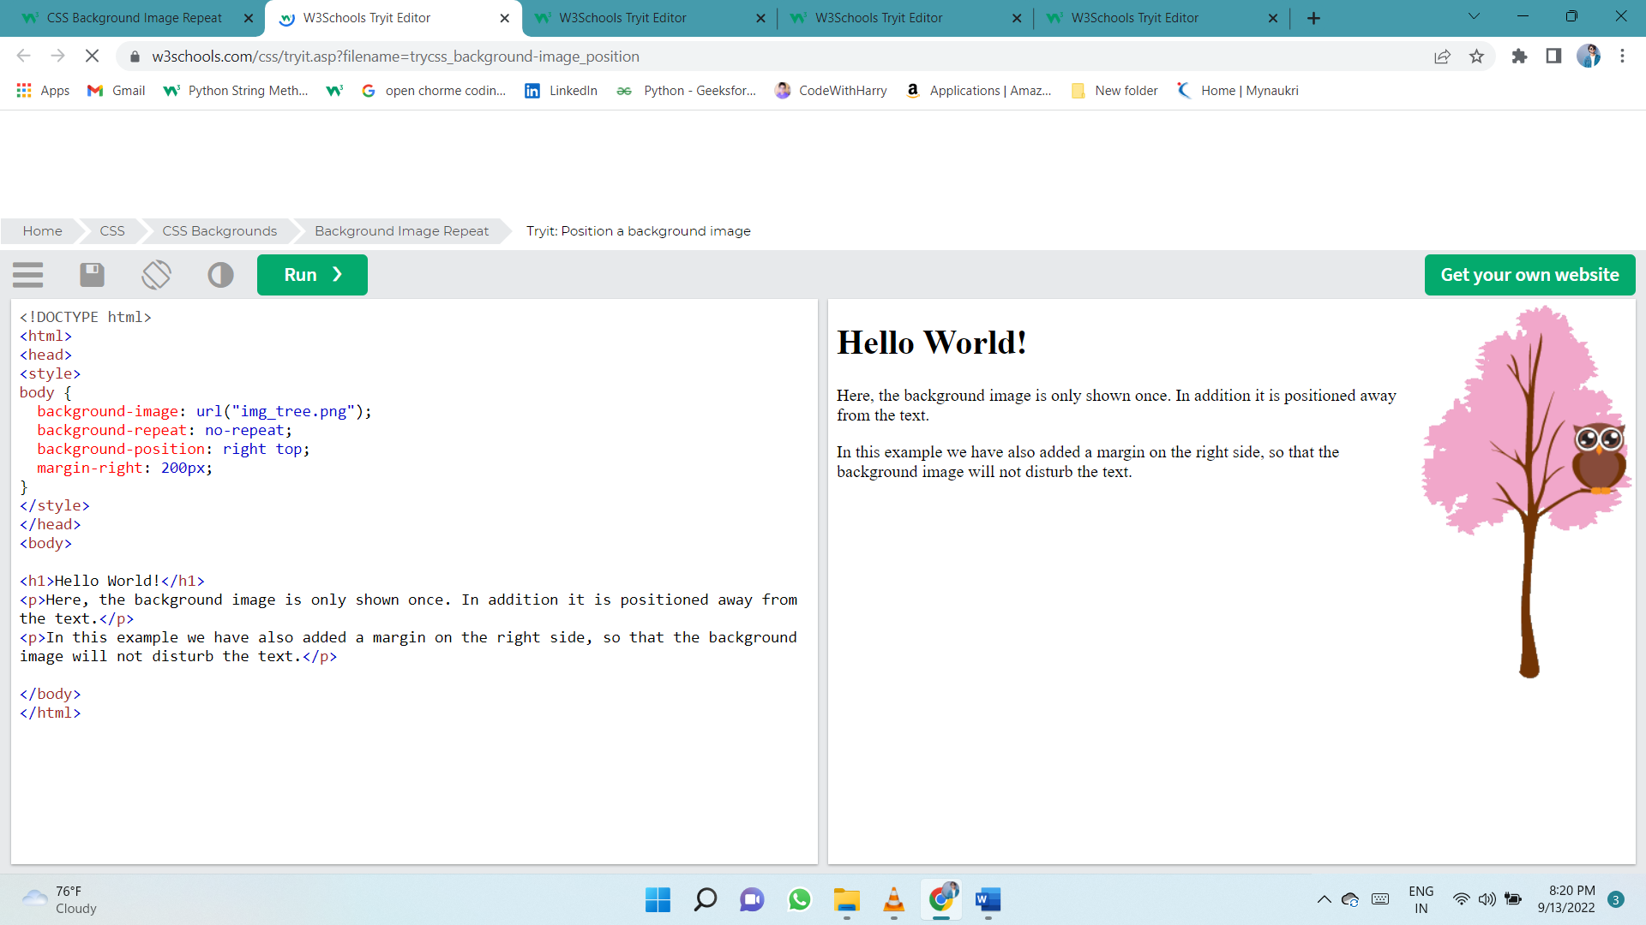

## background-attachment

The background-attachment property specifies whether the background image should scroll or be fixed (will not scroll with the rest of the page):

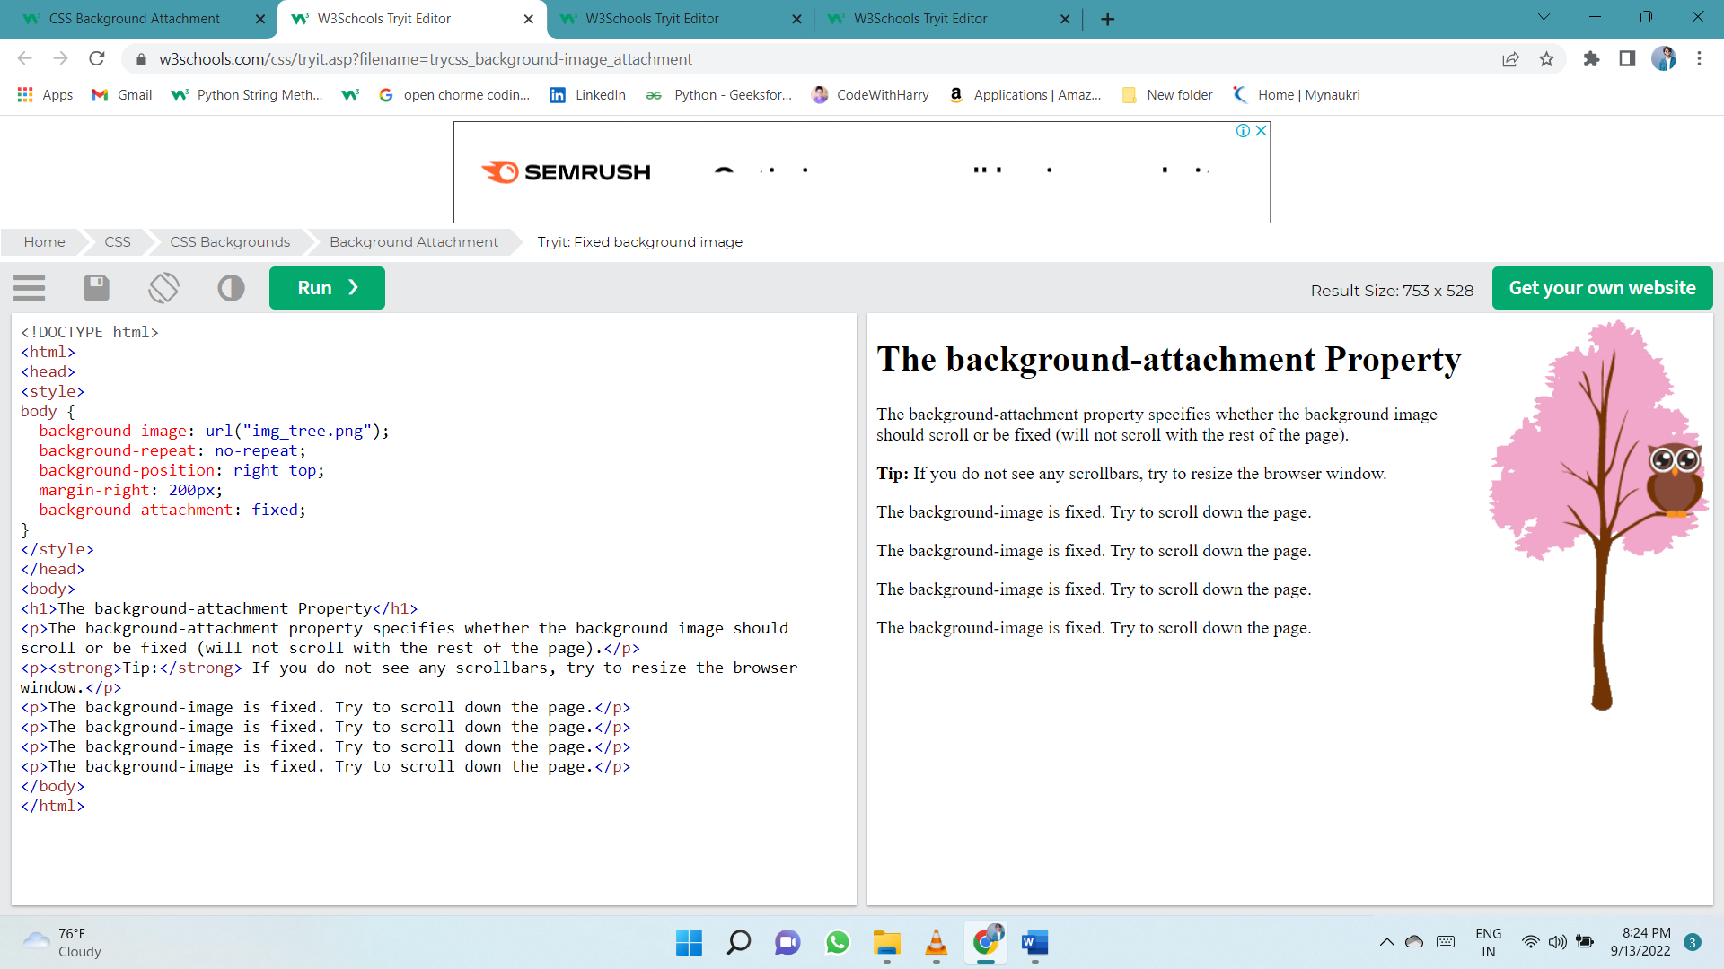Specify that the background image should be fixed:

Specify that the background image should scroll with the rest of the page: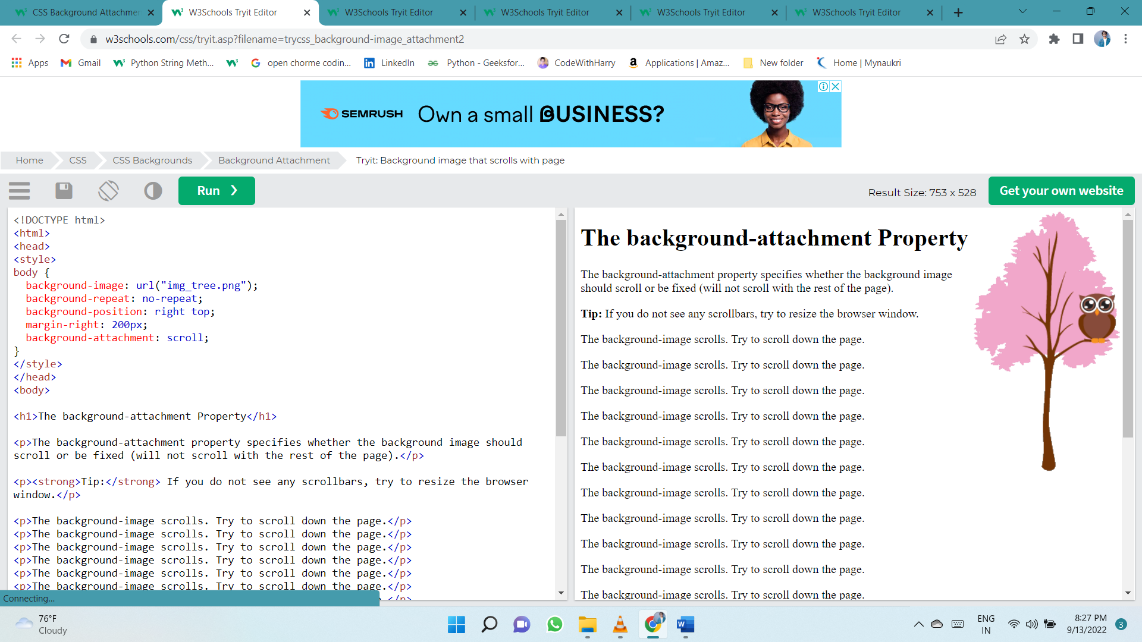

## background - Shorthand property

To shorten the code, it is also possible to specify all the background properties in one single property. This is called a shorthand property.

Instead of writing:

body {  
  background-color: #ffffff;  
  background-image: url("img_tree.png");  
  background-repeat: no-repeat;  
  background-position: right top;  
}

You can use the shorthand property background:

Use the shorthand property to set the background properties in one declaration:

body {  
  background: #ffffff url("img_tree.png") no-repeat right top;  
}

When using the shorthand property the order of the property values is:

* background-color
* background-image
* background-repeat
* background-attachment
* background-position

It does not matter if one of the property values is missing, as long as the other ones are in this order. Note that we do not use the background-attachment property in the examples above, as it does not have a value.

# Borders

The border-style property specifies what kind of border to display.

The following values are allowed:

* dotted - Defines a dotted border
* dashed - Defines a dashed border
* solid - Defines a solid border
* double - Defines a double border
* groove - Defines a 3D grooved border. The effect depends on the border-color value
* ridge - Defines a 3D ridged border. The effect depends on the border-color value
* inset - Defines a 3D inset border. The effect depends on the border-color value
* outset - Defines a 3D outset border. The effect depends on the border-color value
* none - Defines no border
* hidden - Defines a hidden border

The border-style property can have from one to four values (for the top border, right border, bottom border, and the left border).

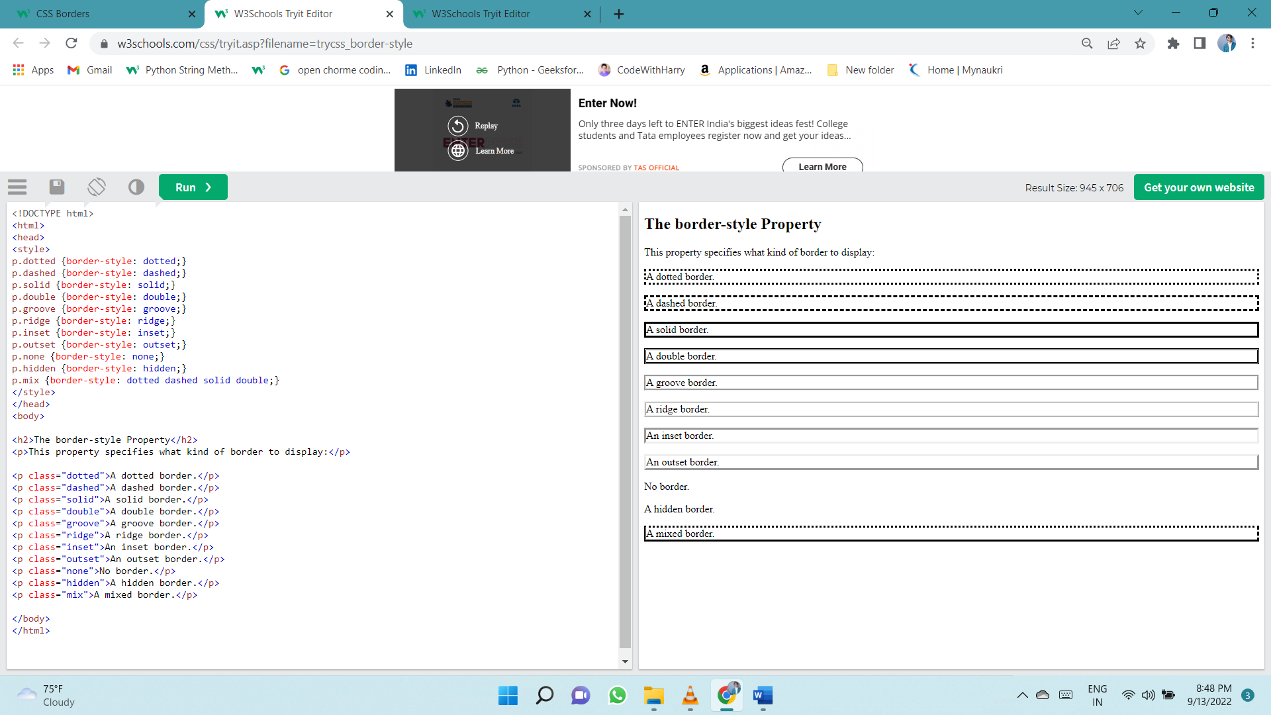

## Border Width

The border-width property specifies the width of the four borders.

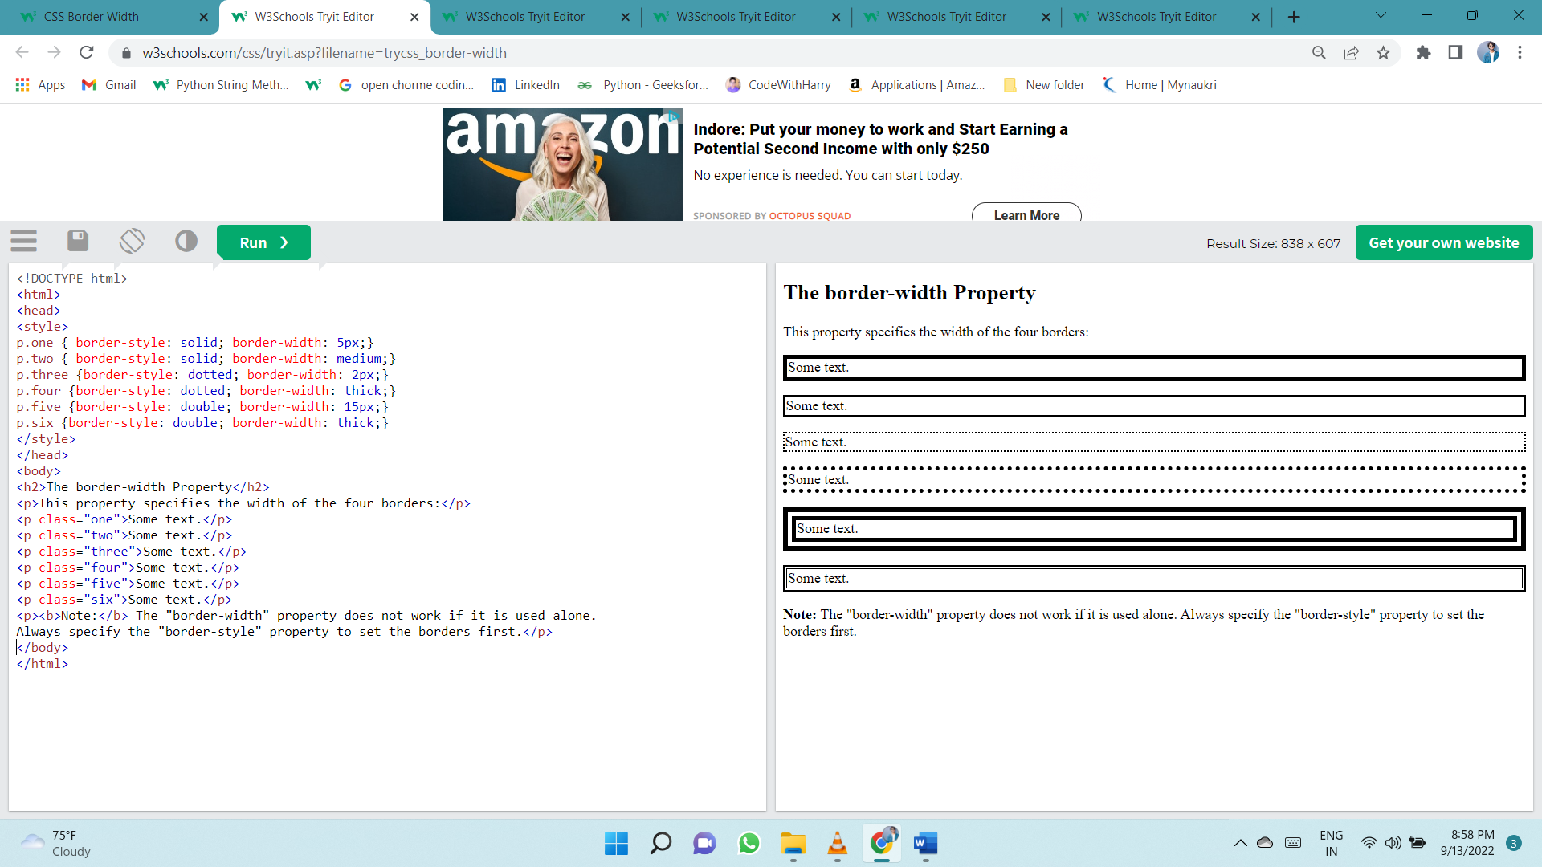The width can be set as a specific size (in px, pt, cm, em, etc) or by using one of the three pre-defined values: thin, medium, or thick:

## Specific Side Widths

The border-width property can have from one to four values (for the top border, right border, bottom border, and the left border):

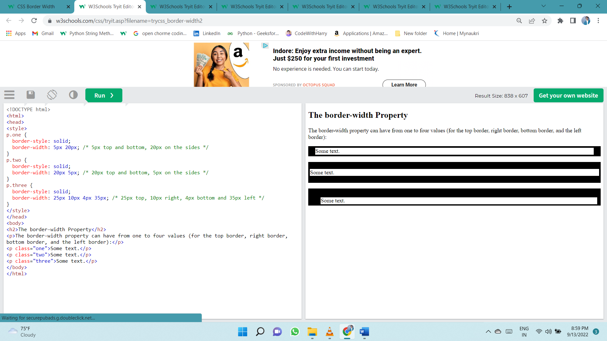

## Border Color

The border-color property is used to set the color of the four borders.

The color can be set by:

* name - specify a color name, like "red"
* HEX - specify a HEX value, like "#ff0000"
* RGB - specify a RGB value, like "rgb(255,0,0)"
* HSL - specify a HSL value, like "hsl(0, 100%, 50%)"
* transparent

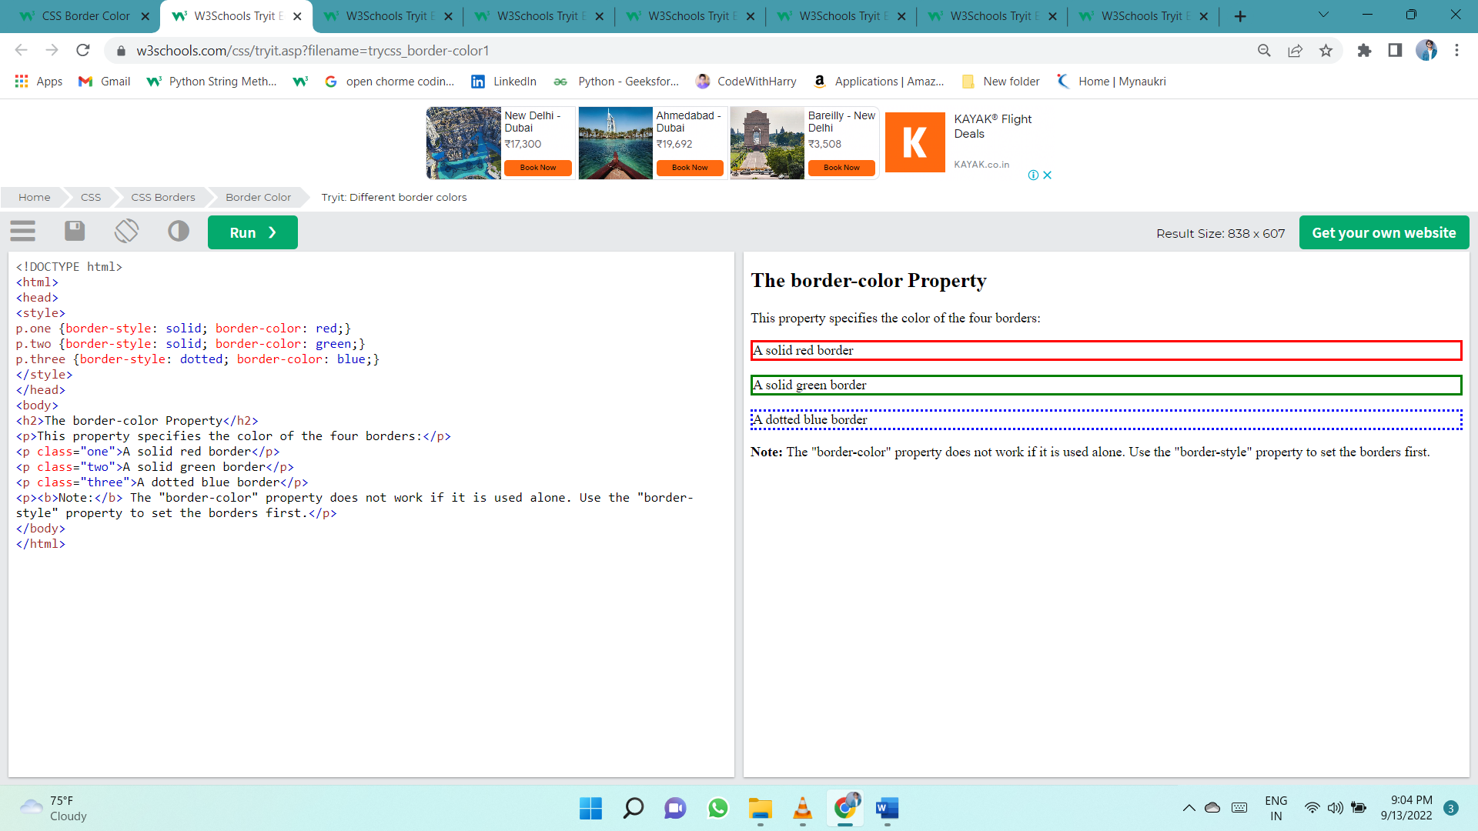**Note:** If border-color is not set, it inherits the color of the element.

## Specific Side Colors

The border-color property can have from one to four values (for the top border, right border, bottom border, and the left border).

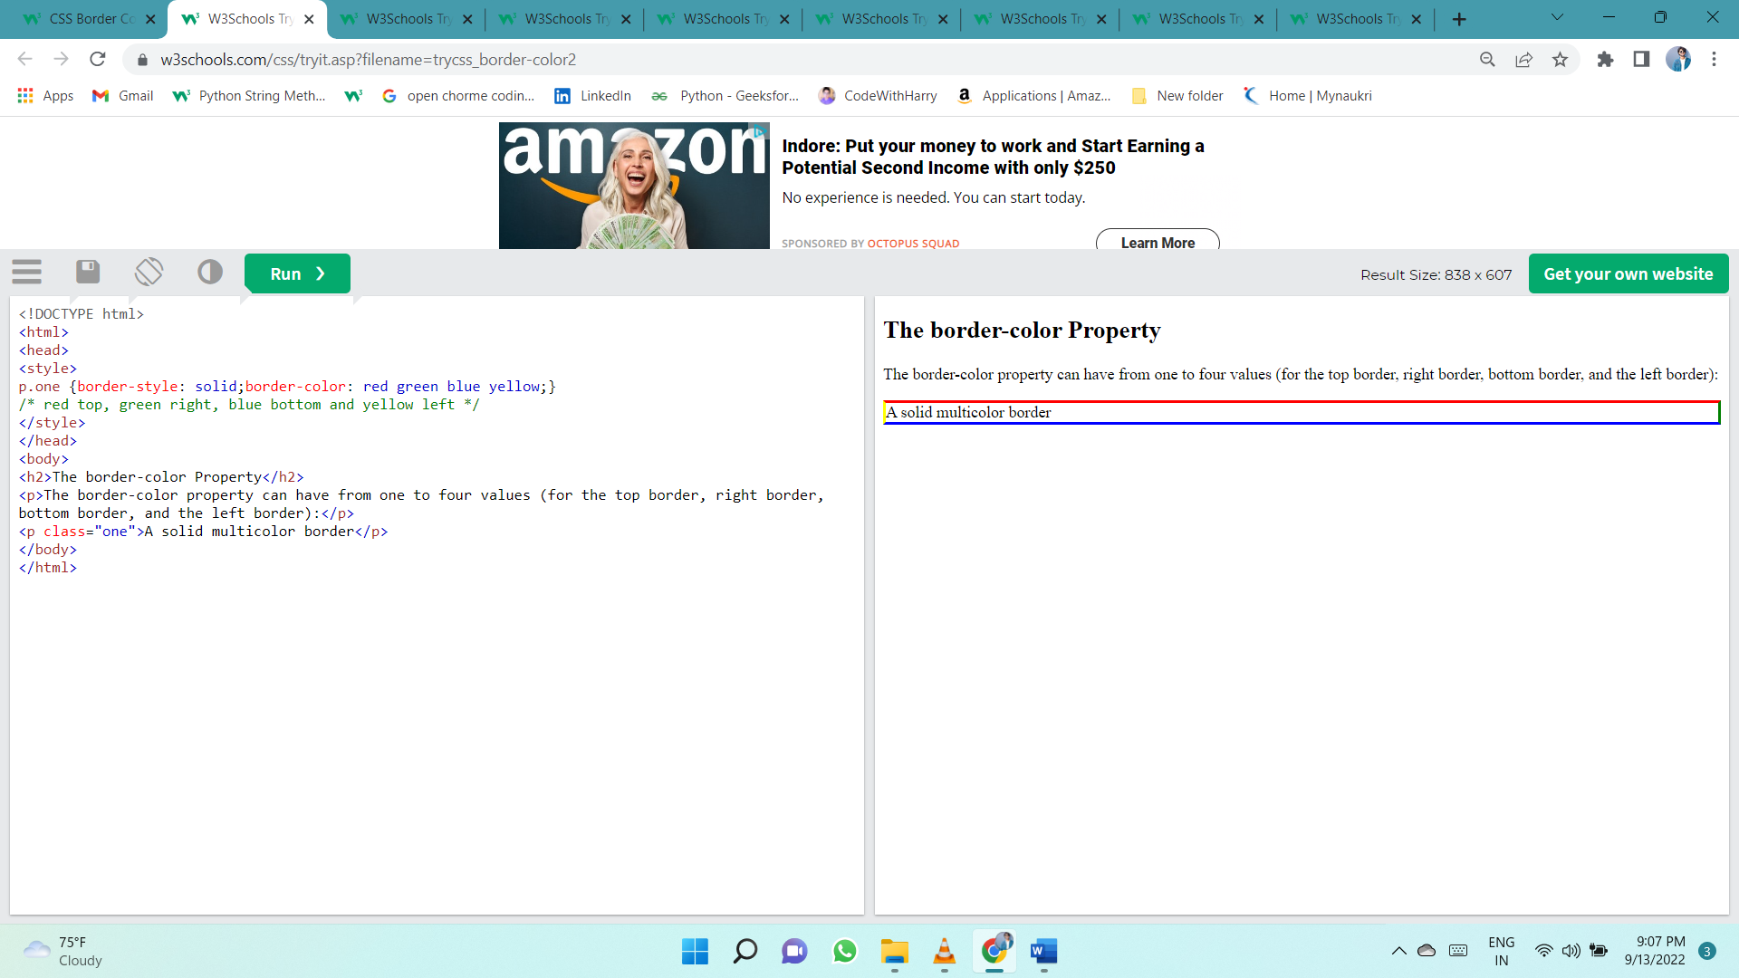

## Border - Individual Sides

In CSS, there are also properties for specifying each of the borders (top, right, bottom, and left):

p {  
  border-top-style: dotted;  
  border-right-style: solid;  
  border-bottom-style: dotted;  
  border-left-style: solid;  
}

Different Border Styles

The example above gives the same result as this:

p {  
  border-style: dotted solid;  
}

If the border-style property has four values:

* **border-style: dotted solid double dashed;**
  + top border is dotted
  + right border is solid
  + bottom border is double
  + left border is dashed

If the border-style property has three values:

* **border-style: dotted solid double;**
  + top border is dotted
  + right and left borders are solid
  + bottom border is double

If the border-style property has two values:

* **border-style: dotted solid;**
  + top and bottom borders are dotted
  + right and left borders are solid

If the border-style property has one value:

* **border-style: dotted;**
  + all four borders are dotted

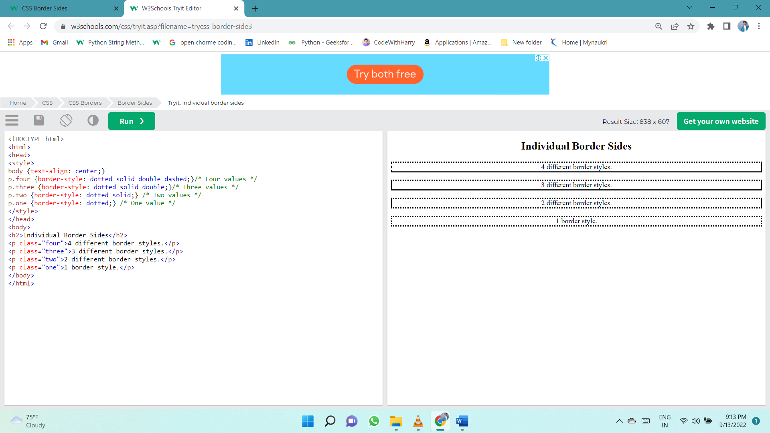

## Border - Shorthand Property

Like you saw in the previous page, there are many properties to consider when dealing with borders.

To shorten the code, it is also possible to specify all the individual border properties in one property.

The border property is a shorthand property for the following individual border properties:

* border-width
* border-style (required)
* border-color

p {  
  border: 5px solid red;  
}

## Rounded Borders

The border-radius property is used to add rounded borders to an element:

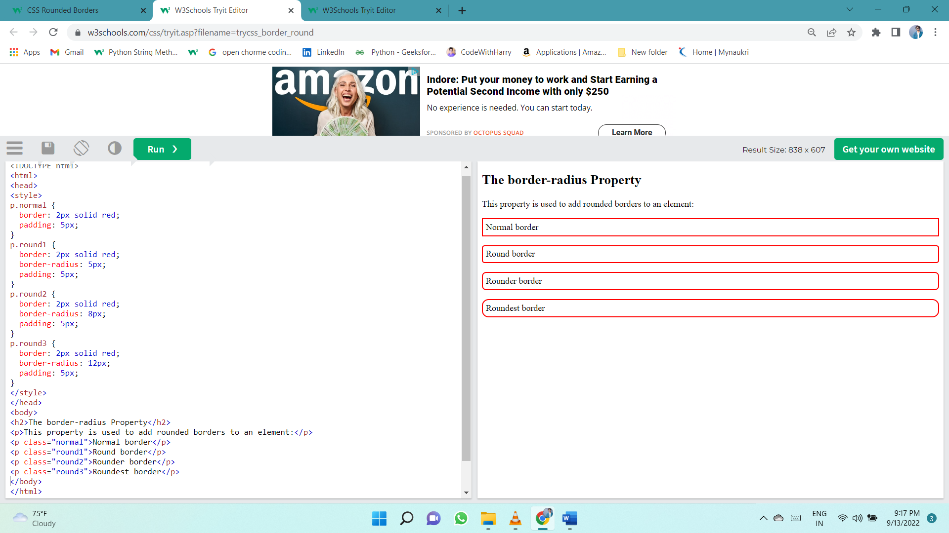

# Margins

The CSS margin properties are used to create space around elements, outside of any defined borders.

With CSS, you have full control over the margins. There are properties for setting the margin for each side of an element (top, right, bottom, and left).

## Margin - Individual Sides

CSS has properties for specifying the margin for each side of an element:

* margin-top
* margin-right
* margin-bottom
* margin-left

All the margin properties can have the following values:

* auto - the browser calculates the margin
* length - specifies a margin in px, pt, cm, etc.
* % - specifies a margin in % of the width of the containing element
* inherit - specifies that the margin should be inherited from the parent element

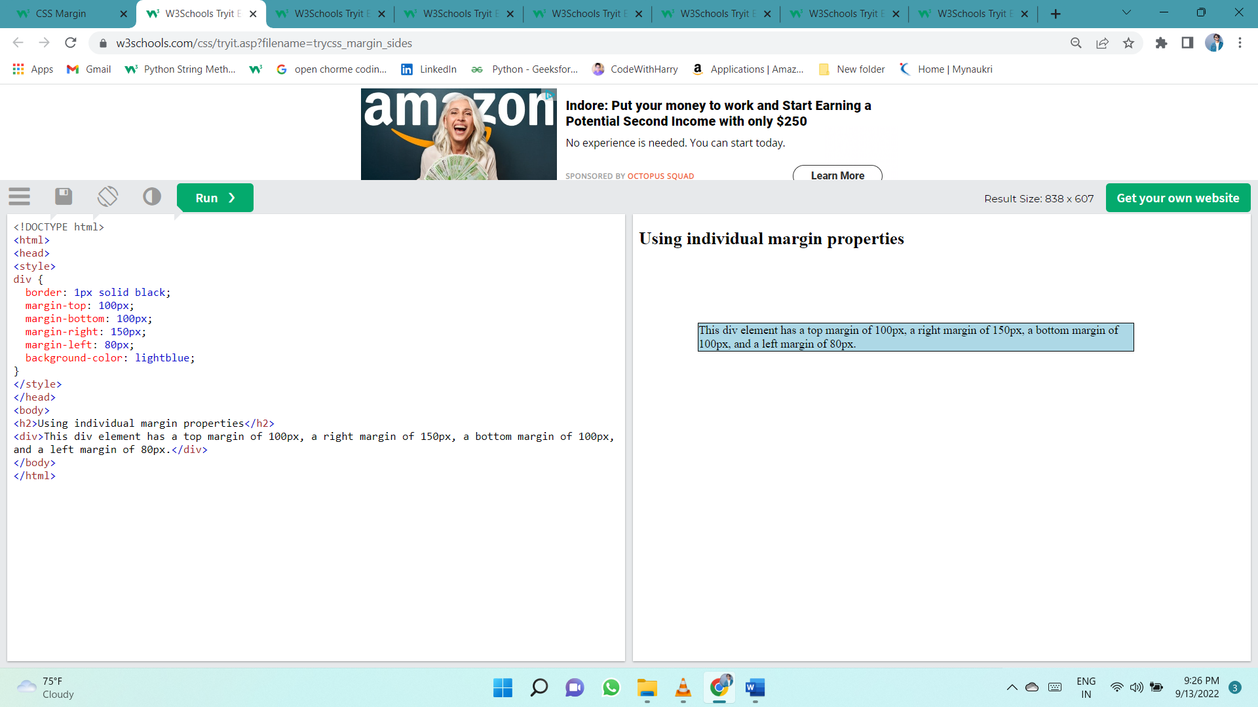**Tip:** Negative values are allowed.

## Margin - Shorthand Property

If the margin property has four values:

* **margin: 25px 50px 75px 100px;**
  + top margin is 25px
  + right margin is 50px
  + bottom margin is 75px
  + left margin is 100px

Use the margin shorthand property with four values:

p {  
  margin: 25px 50px 75px 100px;  
}

If the margin property has three values:

* **margin: 25px 50px 75px;**
  + top margin is 25px
  + right and left margins are 50px
  + bottom margin is 75px

Use the margin shorthand property with three values:

p {  
  margin: 25px 50px 75px;  
}

If the margin property has two values:

* **margin: 25px 50px;**
  + top and bottom margins are 25px
  + right and left margins are 50px

Use the margin shorthand property with two values:

p {  
  margin: 25px 50px;  
}

If the margin property has one value:

* **margin: 25px;**
  + all four margins are 25px

Use the margin shorthand property with one value:

p {  
  margin: 25px;  
}

## The auto MARGIN

You can set the margin property to auto to horizontally center the element within its container.

The element will then take up the specified width, and the remaining space will be split equally between the left and right margins.

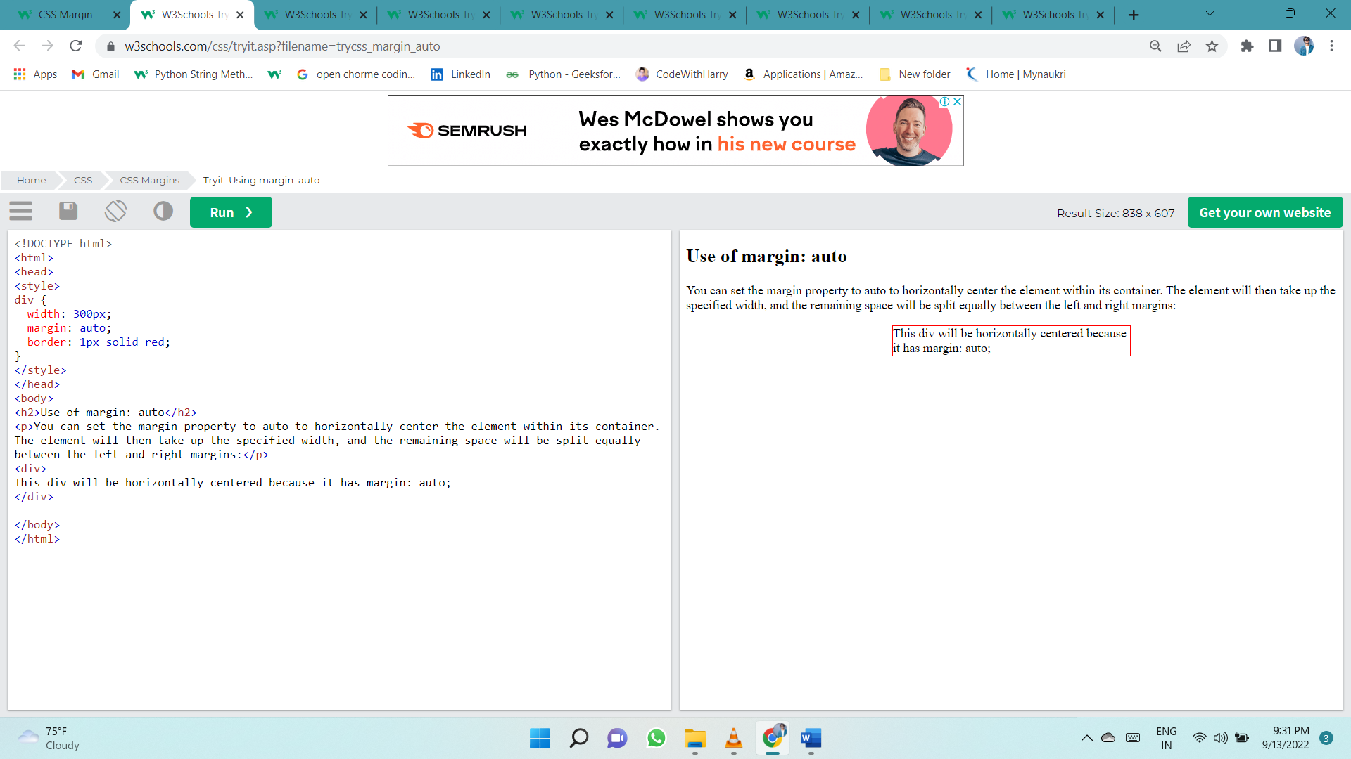

## The inherit Value

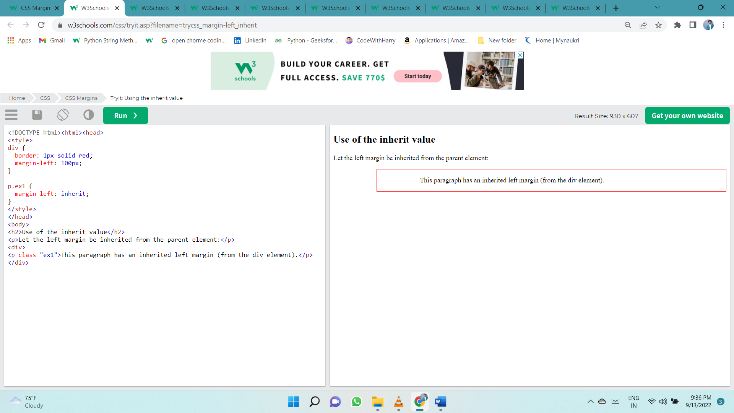This example lets the left margin of the <p class="ex1"> element be inherited from the parent element (<div>):

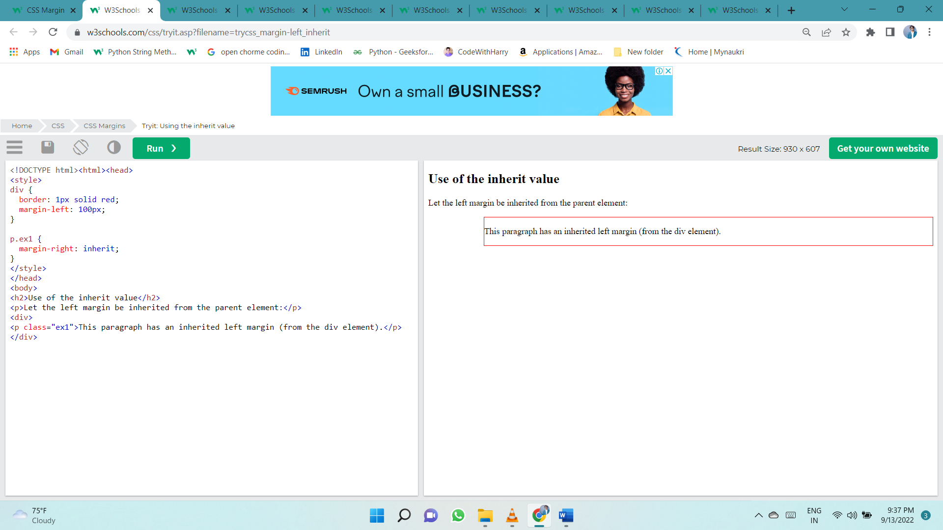

## Margin Collapse

Top and bottom margins of elements are sometimes collapsed into a single margin that is equal to the largest of the two margins.

This does not happen on left and right margins! Only top and bottom margins!

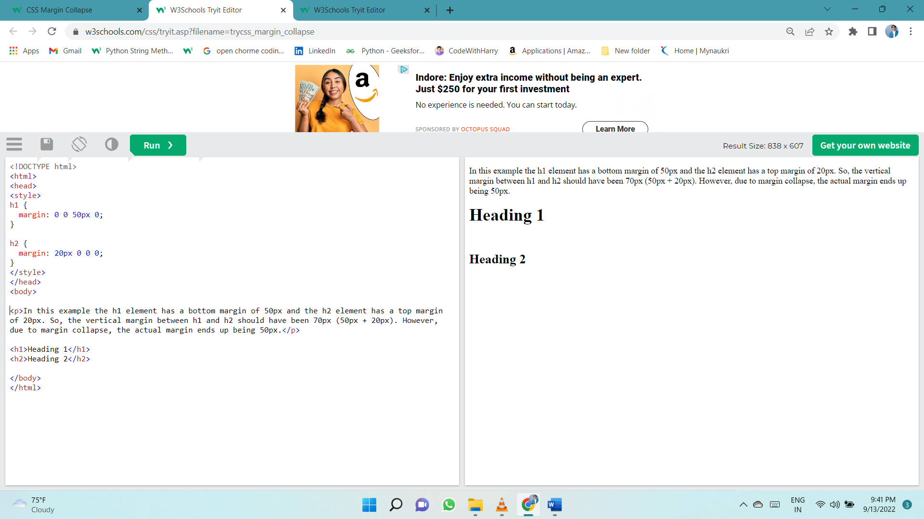

In the example above, the <h1> element has a bottom margin of 50px and the <h2> element has a top margin set to 20px.

Common sense would seem to suggest that the vertical margin between the <h1> and the <h2> would be a total of 70px (50px + 20px). But due to margin collapse, the actual margin ends up being 50px.

# Padding

The CSS padding properties are used to generate space around an element's content, inside of any defined borders.

With CSS, you have full control over the padding. There are properties for setting the padding for each side of an element (top, right, bottom, and left).

**Padding - Individual Sides**

CSS has properties for specifying the padding for each side of an element:

* padding-top
* padding-right
* padding-bottom
* padding-left

All the padding properties can have the following values:

* length - specifies a padding in px, pt, cm, etc.
* % - specifies a padding in % of the width of the containing element
* inherit - specifies that the padding should be inherited from the parent element

**Note:** Negative values are not allowed.

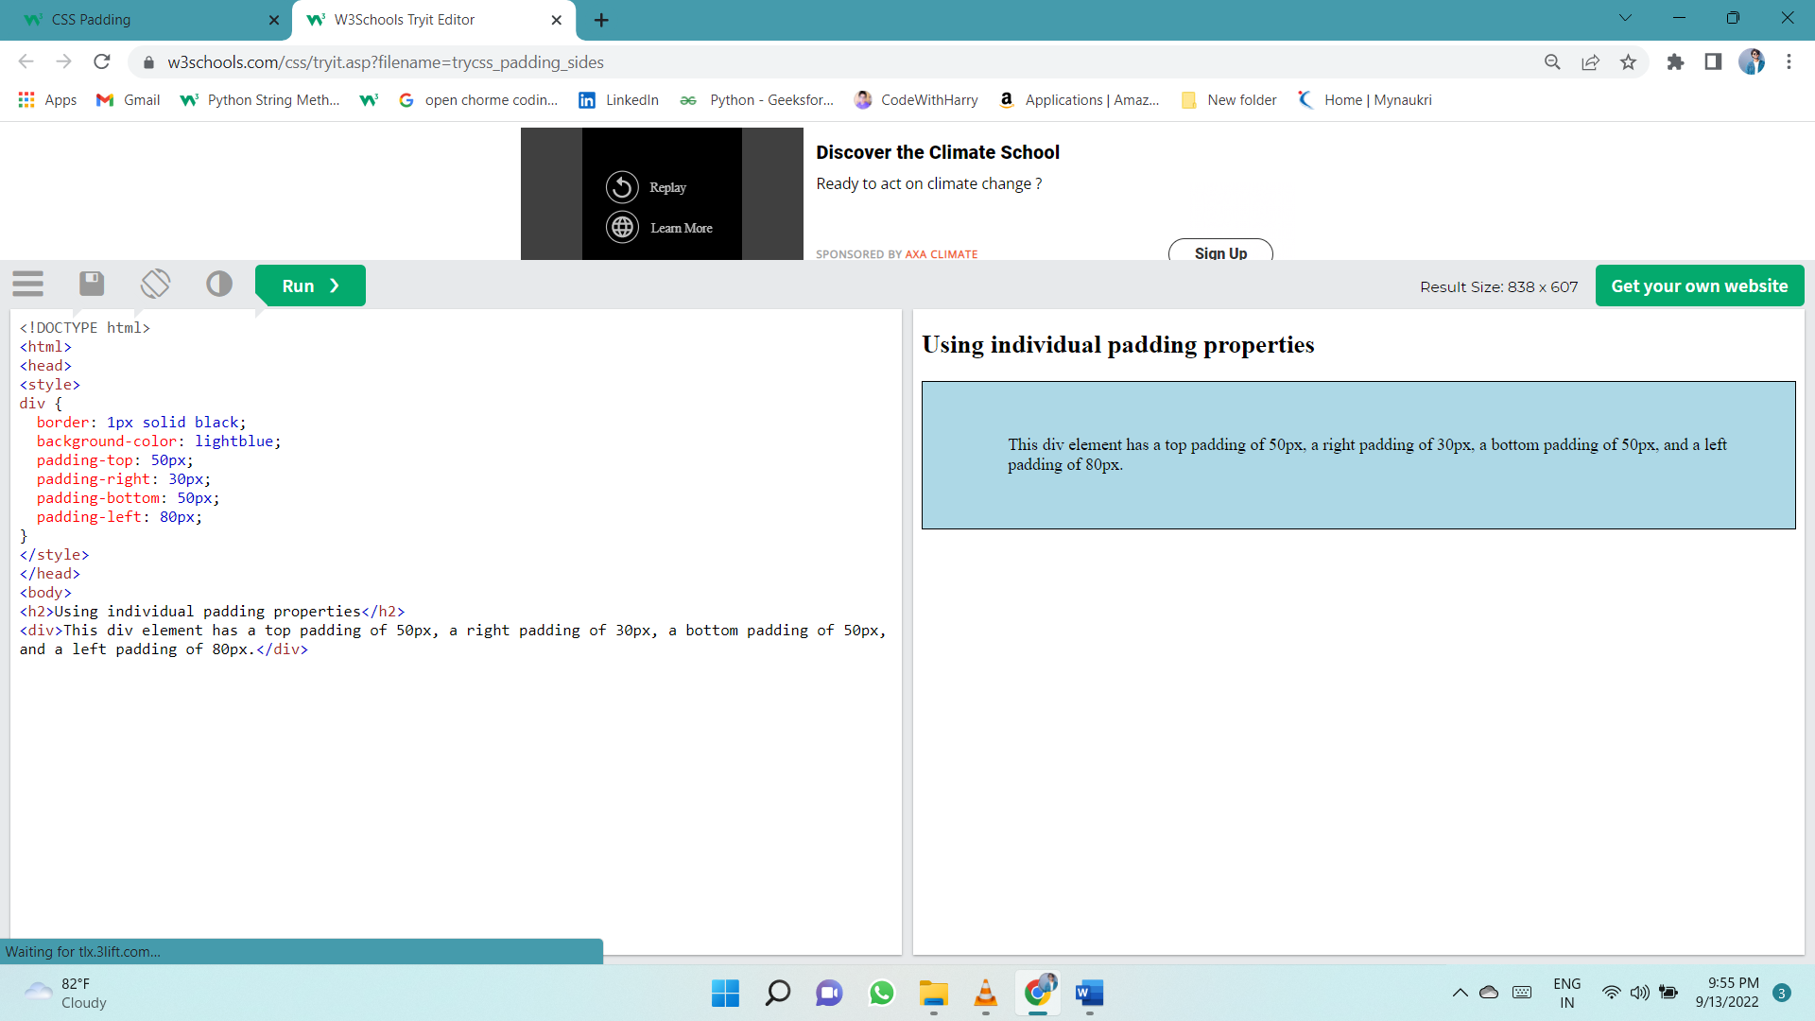

## Padding - Shorthand Property

To shorten the code, it is possible to specify all the padding properties in one property.

The padding property is a shorthand property for the following individual padding properties:

* padding-top
* padding-right
* padding-bottom
* padding-left

So, here is how it works:

If the padding property has four values:

* **padding: 25px 50px 75px 100px;**
  + top padding is 25px
  + right padding is 50px
  + bottom padding is 75px
  + left padding is 100px

Use the padding shorthand property with four values:

div {  
  padding: 25px 50px 75px 100px;  
}

If the padding property has three values:

* **padding: 25px 50px 75px;**
  + top padding is 25px
  + right and left paddings are 50px
  + bottom padding is 75px

Use the padding shorthand property with three values:

div {  
  padding: 25px 50px 75px;  
}

If the padding property has two values:

* **padding: 25px 50px;**
  + top and bottom paddings are 25px
  + right and left paddings are 50px

Use the padding shorthand property with two values:

div {  
  padding: 25px 50px;  
}

If the padding property has one value:

* **padding: 25px;**
  + all four paddings are 25px

Use the padding shorthand property with one value:

div {  
  padding: 25px;  
}

## Padding and Element Width

The CSS width property specifies the width of the element's content area. The content area is the portion inside the padding, border, and margin of an element ([the box model](https://www.w3schools.com/css/css_boxmodel.asp)).

So, if an element has a specified width, the padding added to that element will be added to the total width of the element. This is often an undesirable result.

Here, the <div> element is given a width of 300px. However, the actual width of the <div> element will be 350px (300px + 25px of left padding + 25px of right padding):

div {  
  width: 300px;  
  padding: 25px;  
}

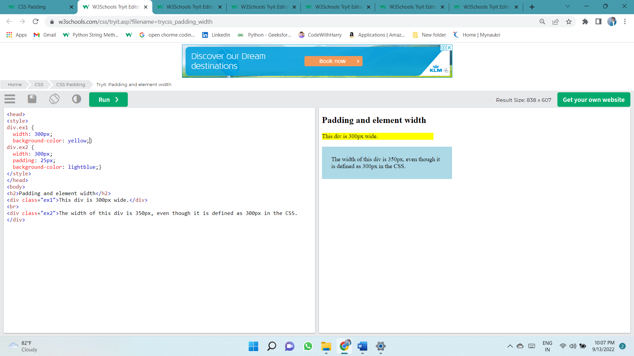

To keep the width at 300px, no matter the amount of padding, you can use the box-sizing property. This causes the element to maintain its actual width; if you increase the padding, the available content space will decrease.

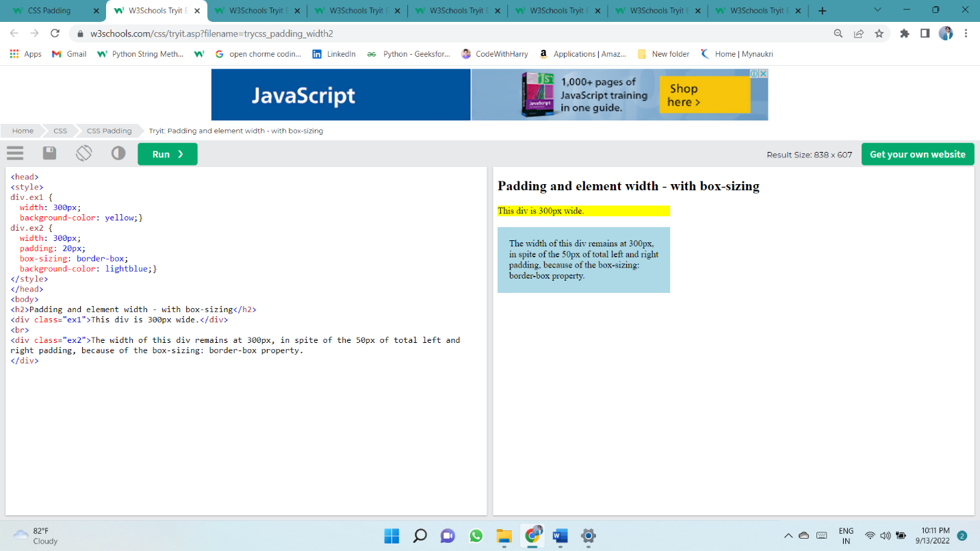

# Height, Width and Max-width

The CSS height and width properties are used to set the height and width of an element.

The CSS max-width property is used to set the maximum width of an element.

The height and width properties do not include padding, borders, or margins. It sets the height/width of the area inside the padding, border, and margin of the element.

**CSS height and width Values**

The height and width properties may have the following values:

* auto - This is default. The browser calculates the height and width
* length - Defines the height/width in px, cm, etc.
* % - Defines the height/width in percent of the containing block
* initial - Sets the height/width to its default value
* 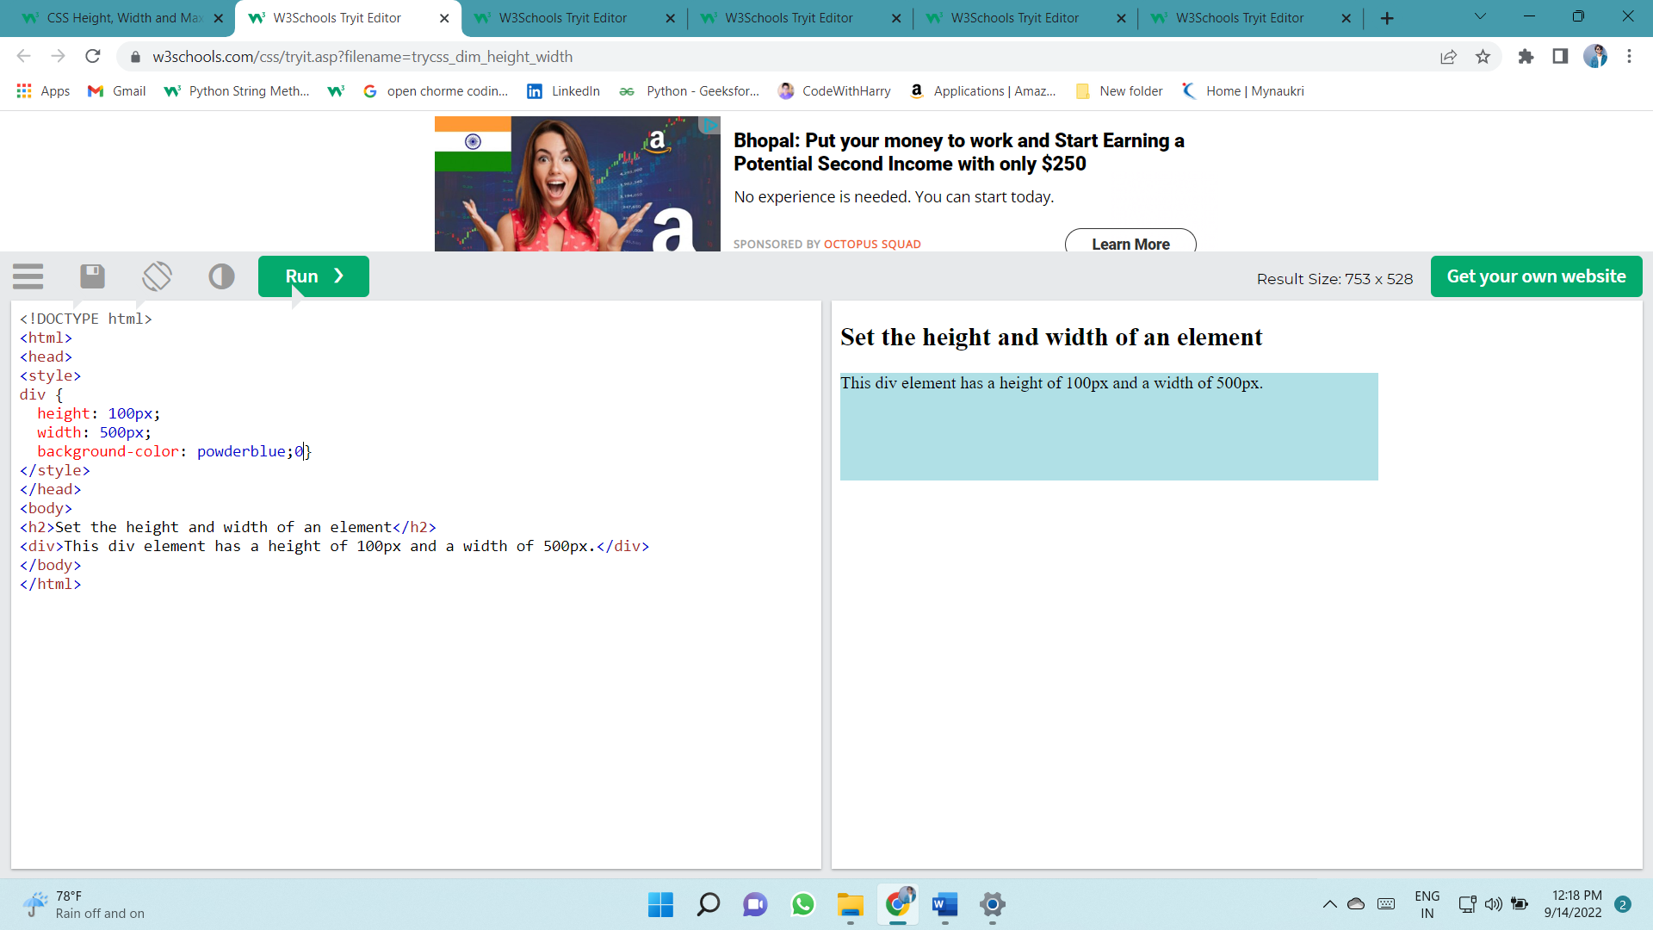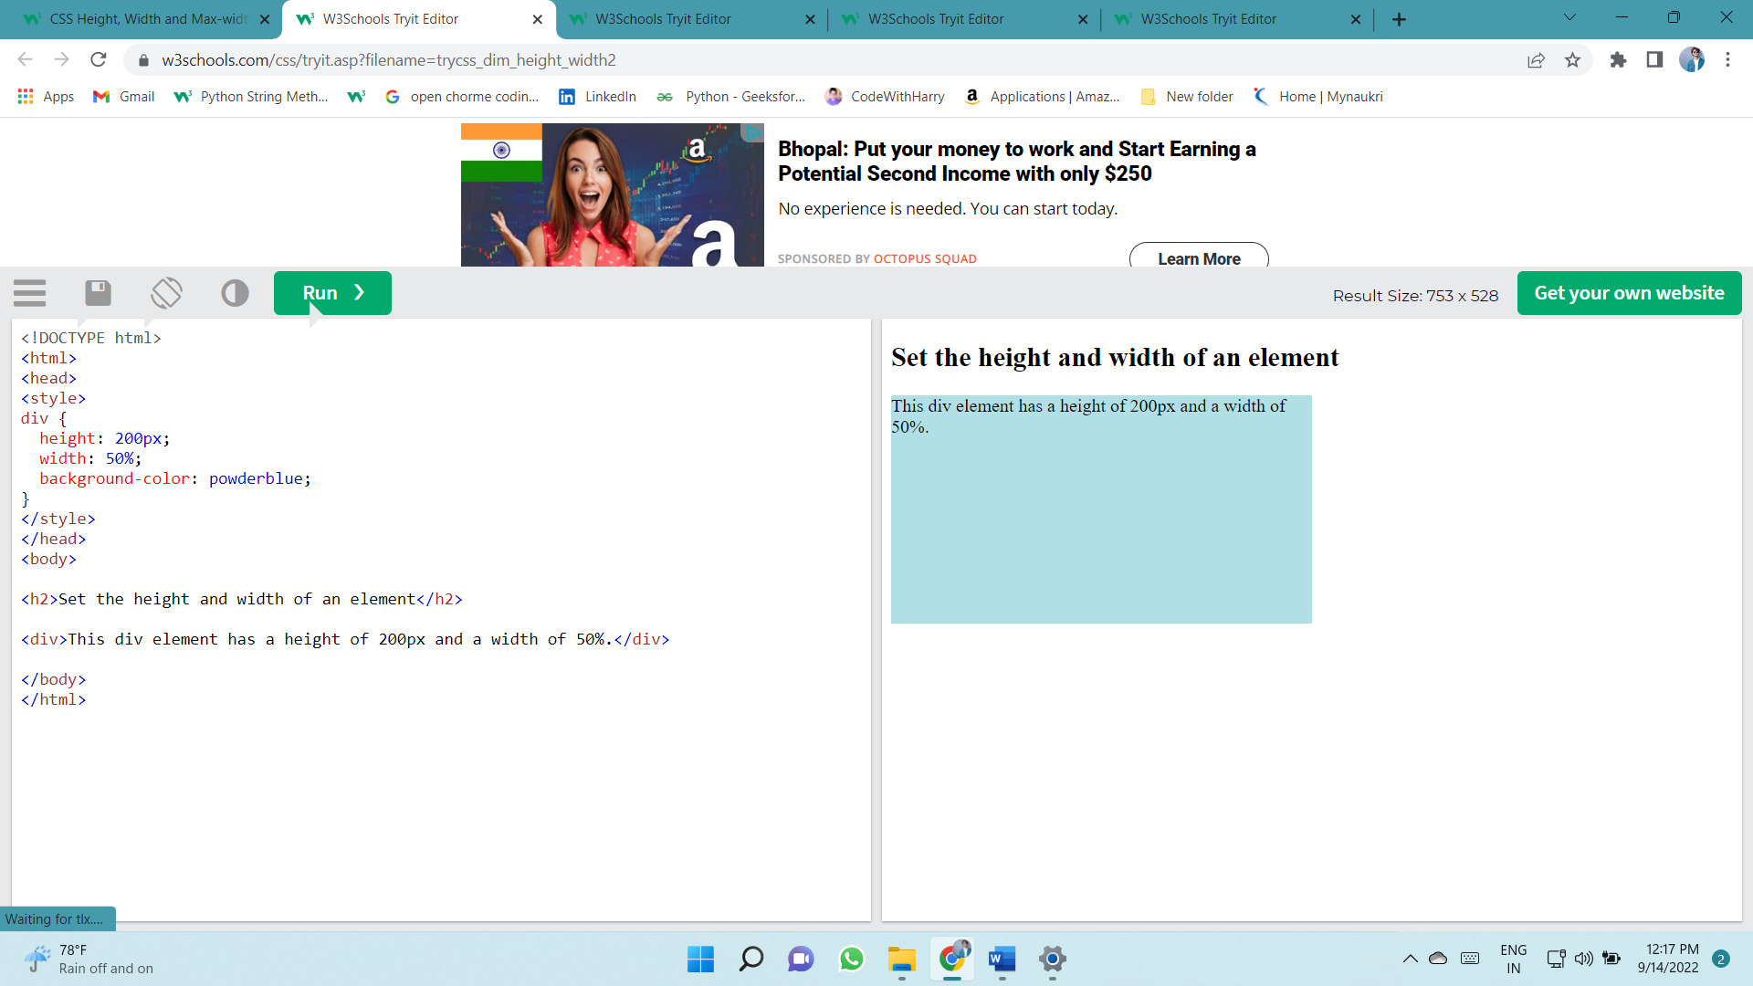inherit - The height/width will be inherited from its parent value

**Setting max-width**

The max-width property is used to set the maximum width of an element.

The max-width can be specified in length values, like px, cm, etc., or in percent (%) of the containing block, or set to none (this is default. Means that there is no maximum width).

The problem with the <div> above occurs when the browser window is smaller than the width of the element (500px). The browser then adds a horizontal scrollbar to the page.

Using max-width instead, in this situation, will improve the browser's handling of small windows.

**Tip:** Drag the browser window to smaller than 500px wide, to see the difference between the two divs!

**Note:** If you for some reason use both the width property and the max-width property on the same element, and the value of the width property is larger than the max-width property; the max-width property will be used (and the width property will be ignored).

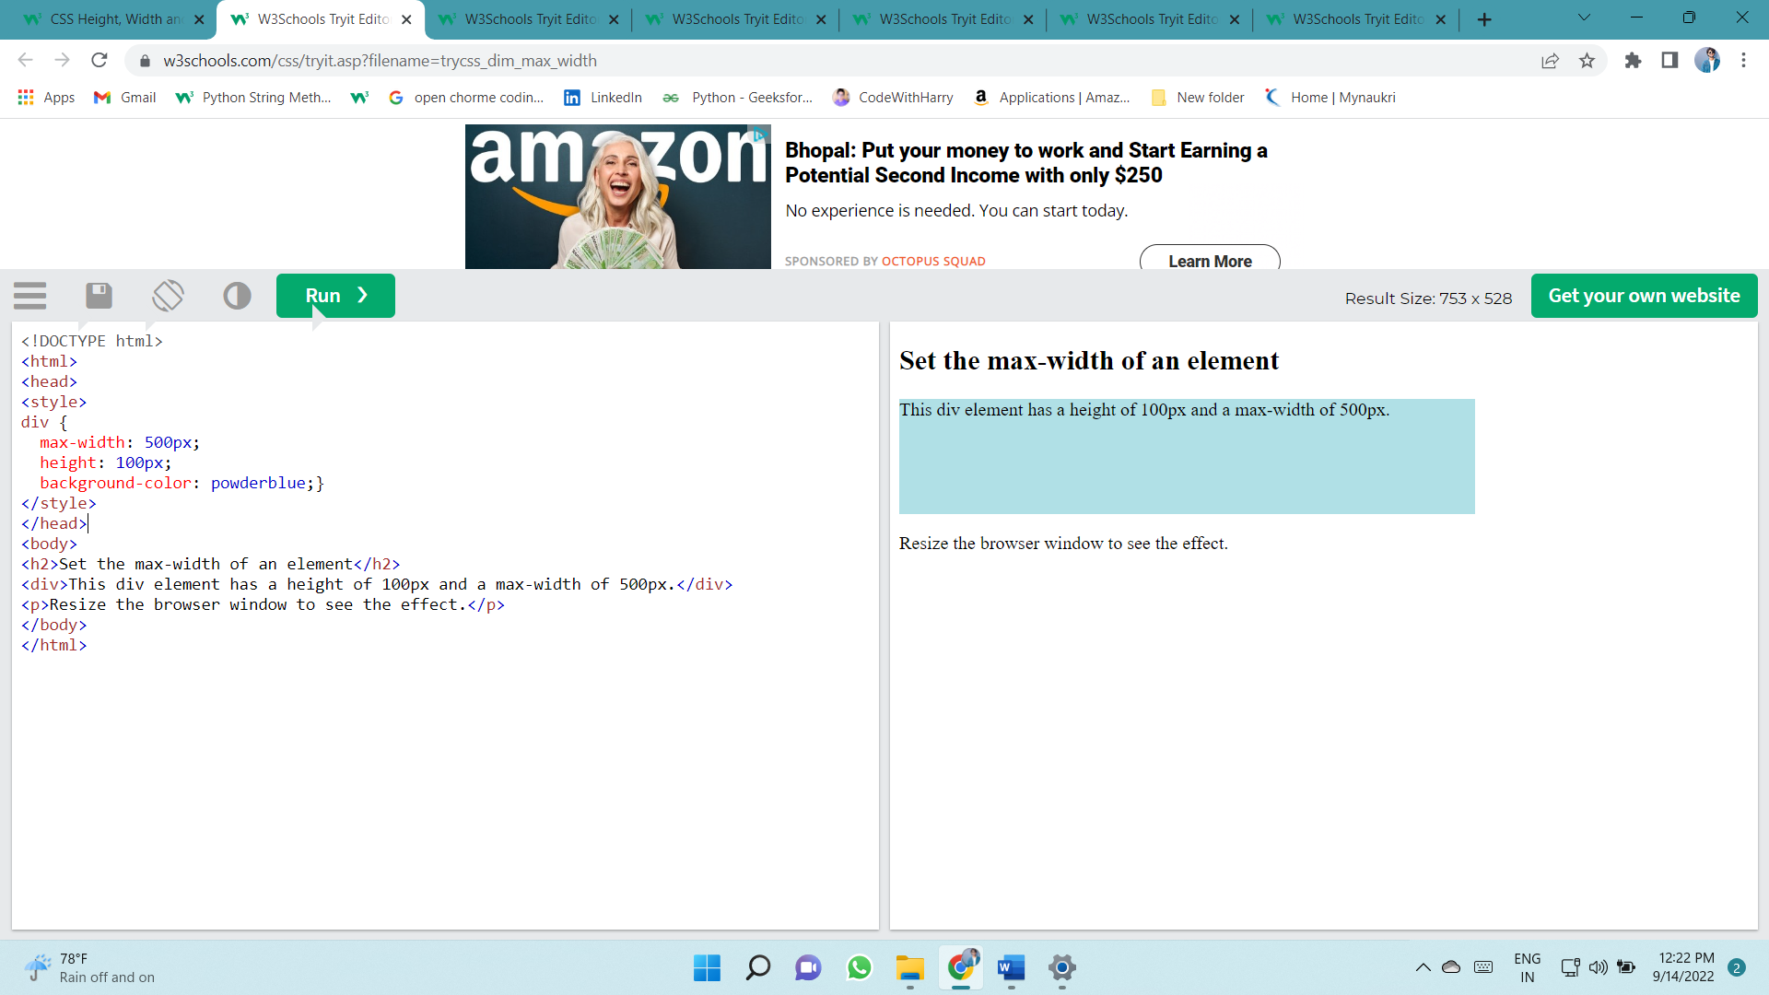

# Box Model

In CSS, the term "box model" is used when talking about design and layout.

The CSS box model is essentially a box that wraps around every HTML element. It consists of: margins, borders, padding, and the actual content.

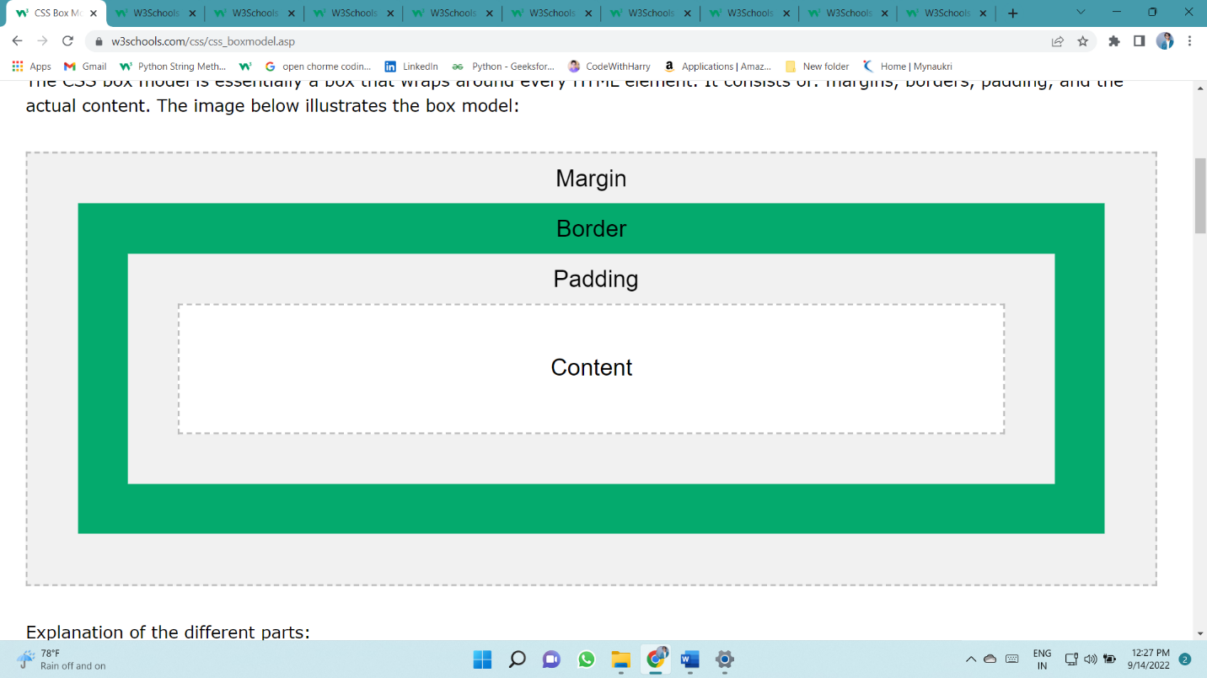The image below illustrates the box model:

Explanation of the different parts:

* **Content** - The content of the box, where text and images appear
* **Padding** - Clears an area around the content. The padding is transparent
* **Border** - A border that goes around the padding and content
* 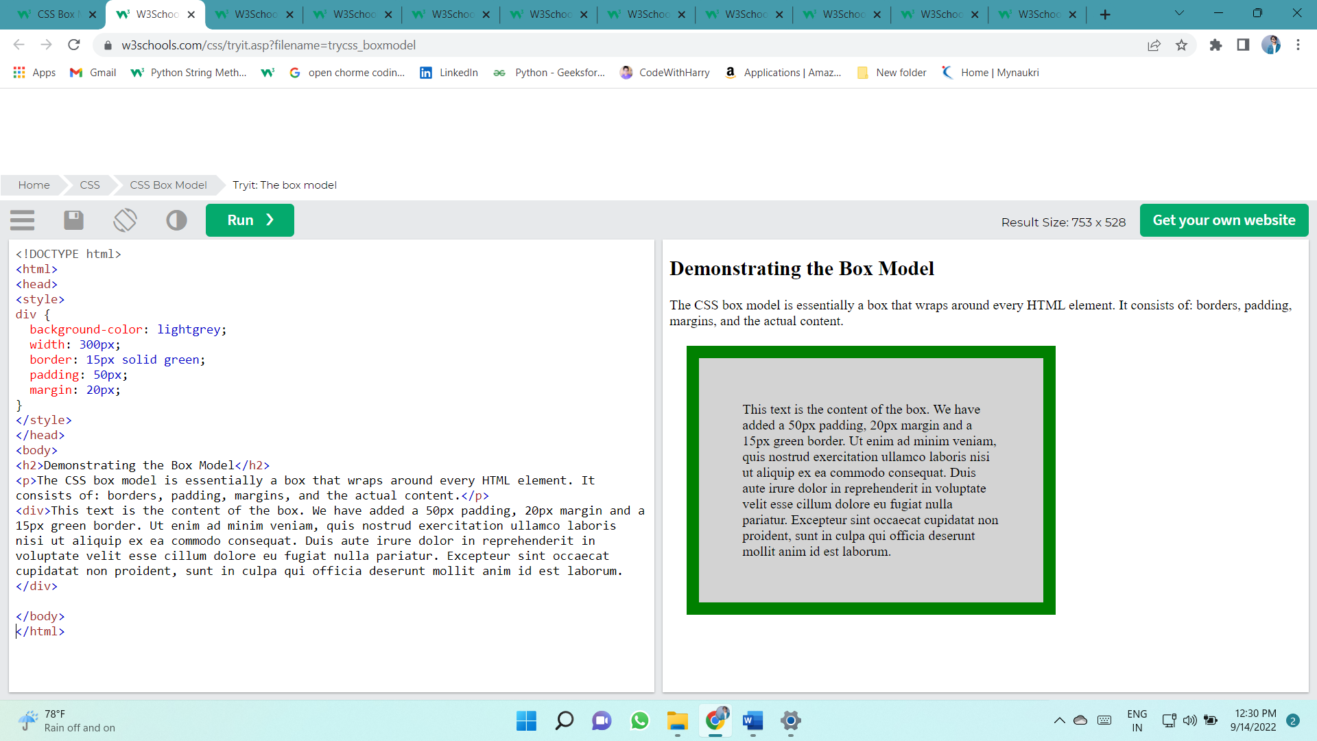**Margin** - Clears an area outside the border. The margin is transparent

**Width and Height of an Element**

In order to set the width and height of an element correctly in all browsers, you need to know how the box model works.

**Important:** When you set the width and height properties of an element with CSS, you just set the width and height of the **content area**. To calculate the full size of an element, you must also add padding, borders and margins.

This <div> element will have a total width of 350px:

div {  
  width: 320px;  
  padding: 10px;  
  border: 5px solid gray;  
  margin: 0;  
}

Here is the calculation:

320px (width)  
+ 20px (left + right padding)  
+ 10px (left + right border)  
+ 0px (left + right margin)  
**= 350px**

The total width of an element should be calculated like this:

Total element width = width + left padding + right padding + left border + right border + left margin + right margin

The total height of an element should be calculated like this:

Total element height = height + top padding + bottom padding + top border + bottom border + top margin + bottom margin

# Outline

An outline is a line drawn outside the element's border.

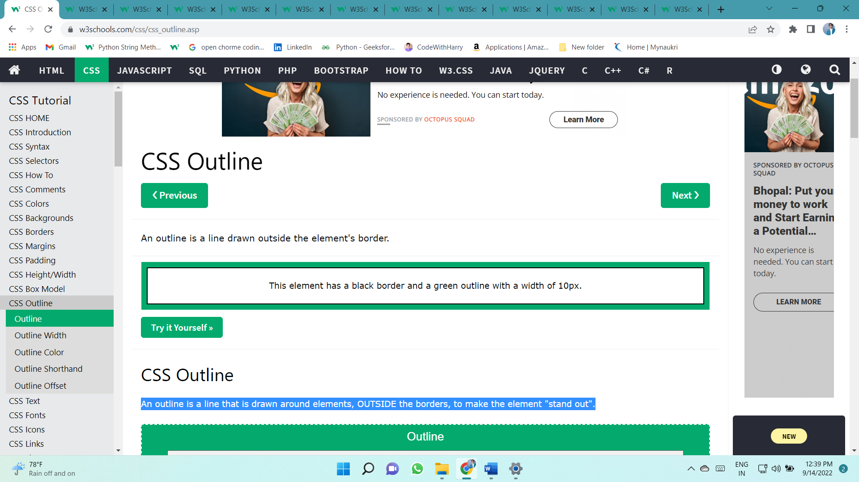An outline is a line that is drawn around elements, OUTSIDE the borders, to make the element "stand out".

CSS has the following outline properties:

* outline-style
* outline-color
* outline-width
* outline-offset
* outline

**CSS Outline Style**

The outline-style property specifies the style of the outline, and can have one of the following values:

* dotted - Defines a dotted outline
* dashed - Defines a dashed outline
* solid - Defines a solid outline
* double - Defines a double outline
* groove - Defines a 3D grooved outline
* ridge - Defines a 3D ridged outline
* inset - Defines a 3D inset outline
* outset - Defines a 3D outset outline
* none - Defines no outline
* hidden - Defines a hidden outline

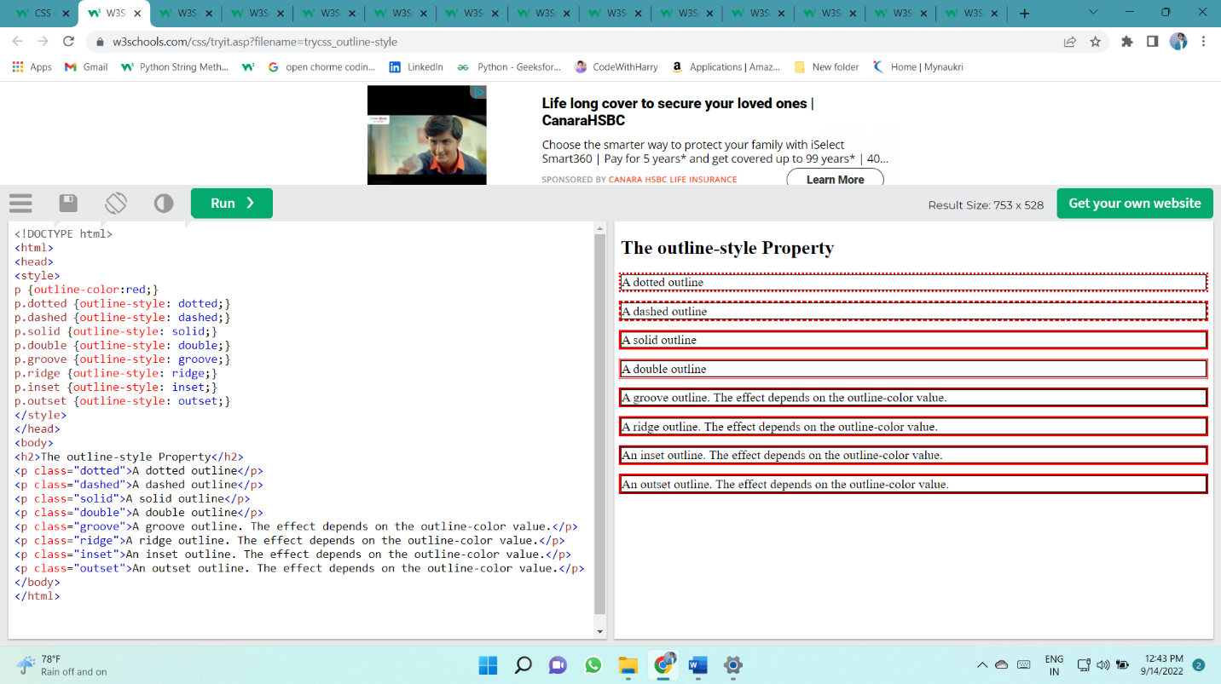

**CSS Outline Width**

The outline-width property specifies the width of the outline, and can have one of the following values:

* thin (typically 1px)
* medium (typically 3px)
* thick (typically 5px)
* 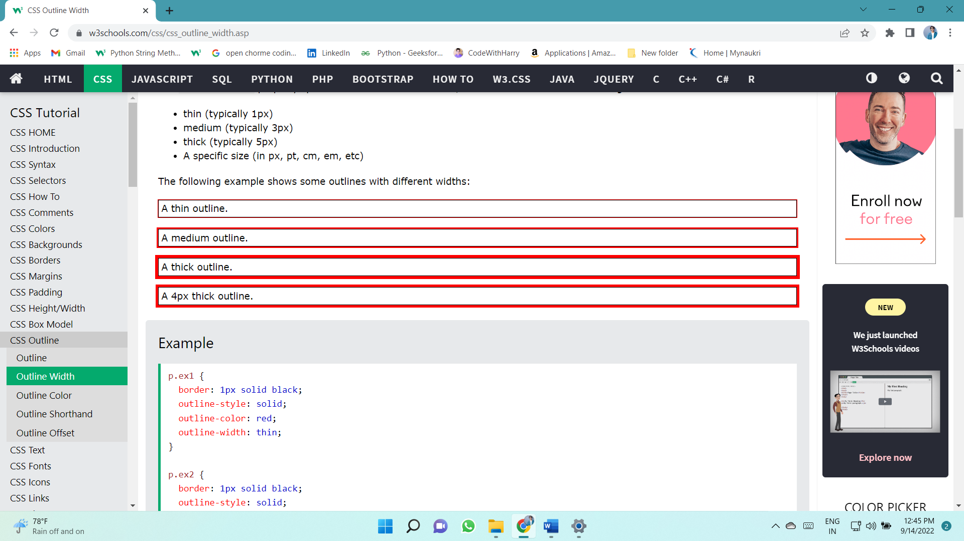A specific size (in px, pt, cm, em, etc)

**CSS Outline Color**

The outline-color property is used to set the color of the outline.

The color can be set by:

* name - specify a color name, like "red"
* HEX - specify a hex value, like "#ff0000"
* RGB - specify a RGB value, like "rgb(255,0,0)"
* HSL - specify a HSL value, like "hsl(0, 100%, 50%)"
* invert - performs a color inversion (which ensures that the outline is visible, regardless of color background)

**CSS Outline - Shorthand property**

The outline property is a shorthand property for setting the following individual outline properties:

* outline-width
* outline-style (required)
* outline-color

p.ex1 {outline: dashed;}  
p.ex2 {outline: dotted red;}  
p.ex3 {outline: 5px solid yellow;}  
p.ex4 {outline: thick ridge pink;}

**CSS Outline Offset**

The outline-offset property adds space between an outline and the edge/border of an element. The space between an element and its outline is transparent.

The following example specifies an outline 15px outside the border edge:

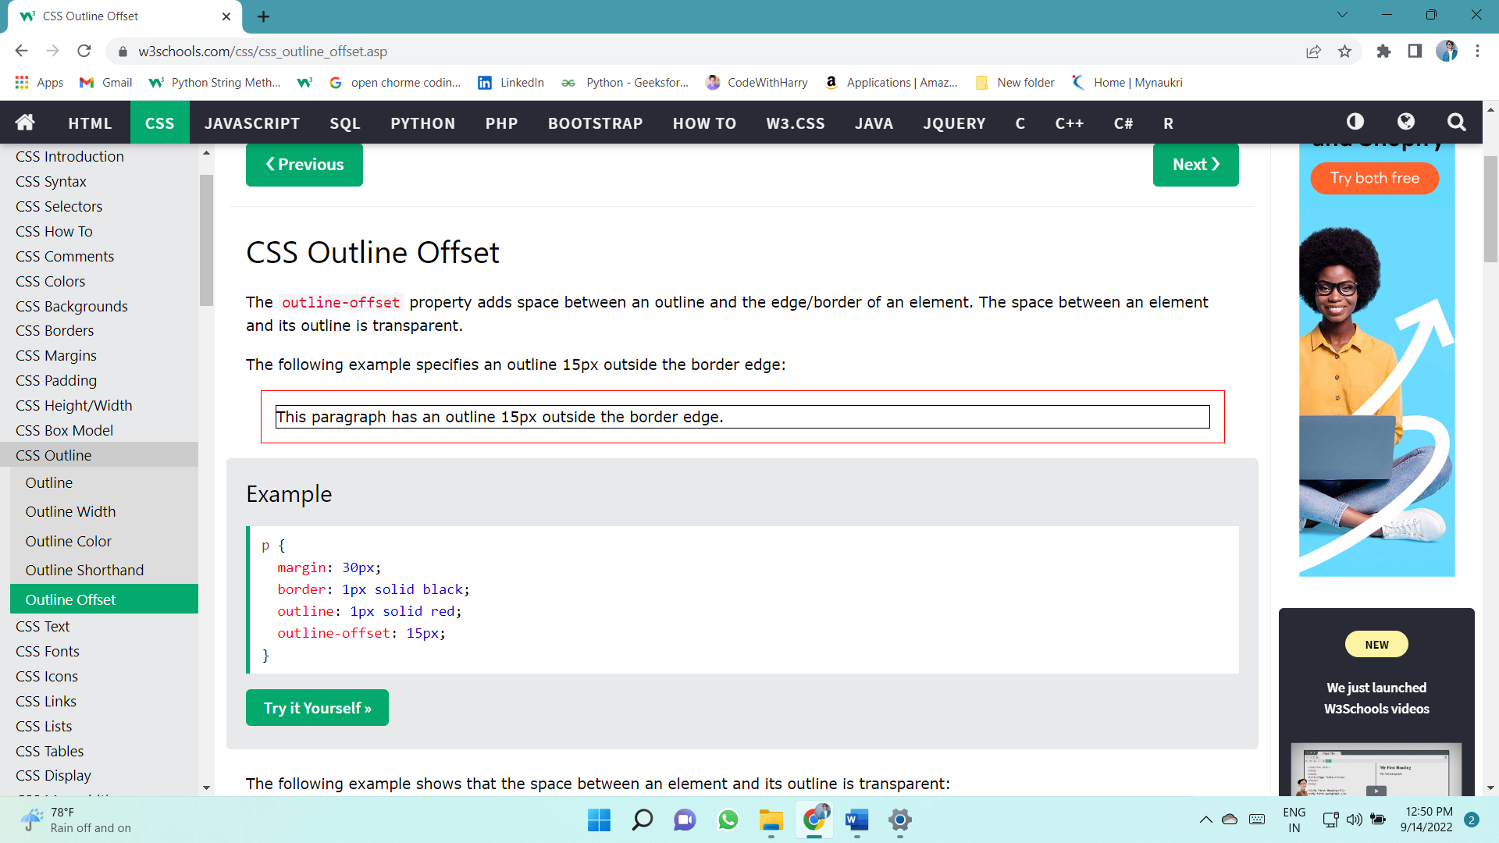

# Text

## TEXT COLOR

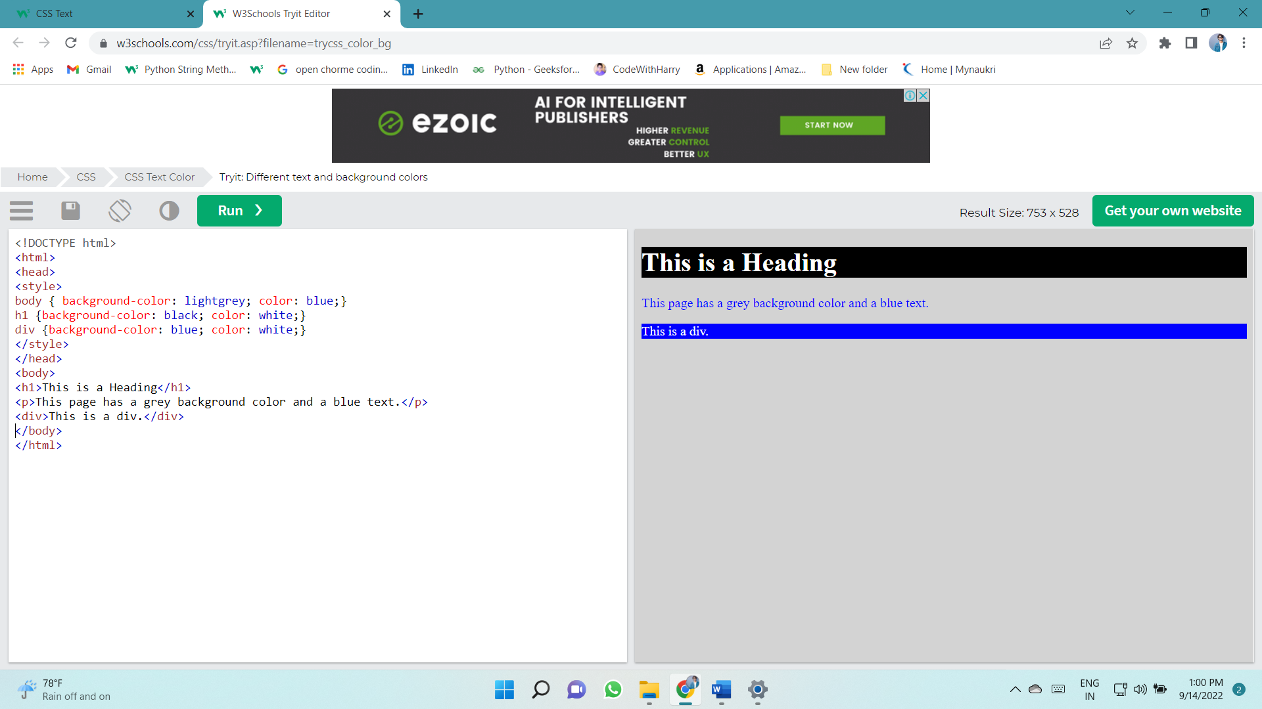

## Text Alignment and Text Direction

* text-align
* text-align-last
* direction
* unicode-bidi
* vertical-align

### Text Alignment

The text-align property is used to set the horizontal alignment of a text.

A text can be left or right aligned, centered, or justified.

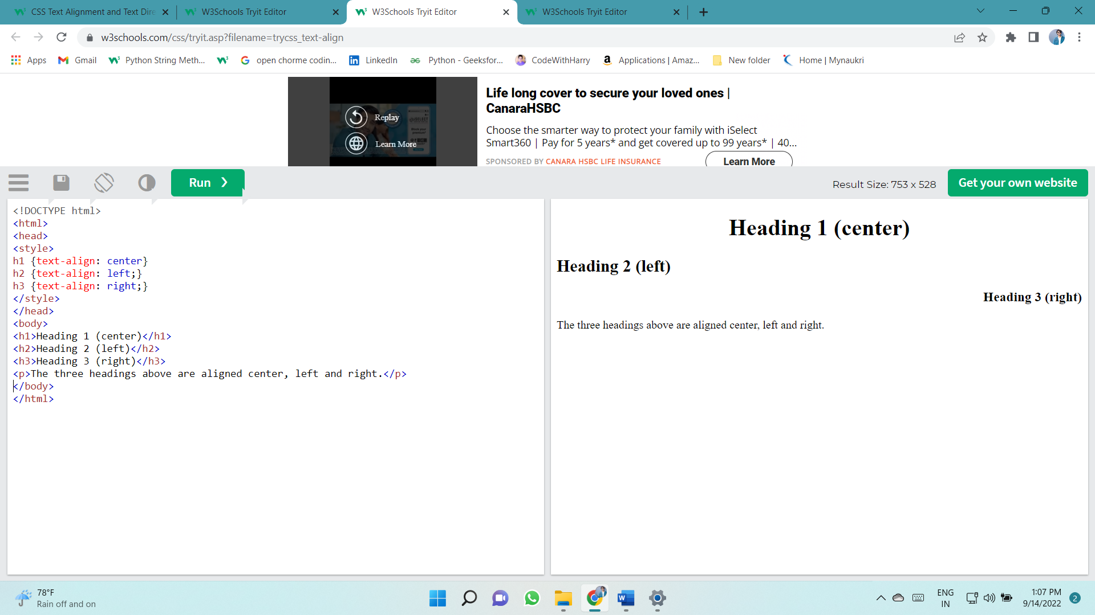The following example shows center aligned, and left and right aligned text (left alignment is default if text direction is left-to-right, and right alignment is default if text direction is right-to-left):

When the text-align property is set to "justify", each line is stretched so that every line has equal width, and the left and right margins are straight (like in magazines and newspapers):

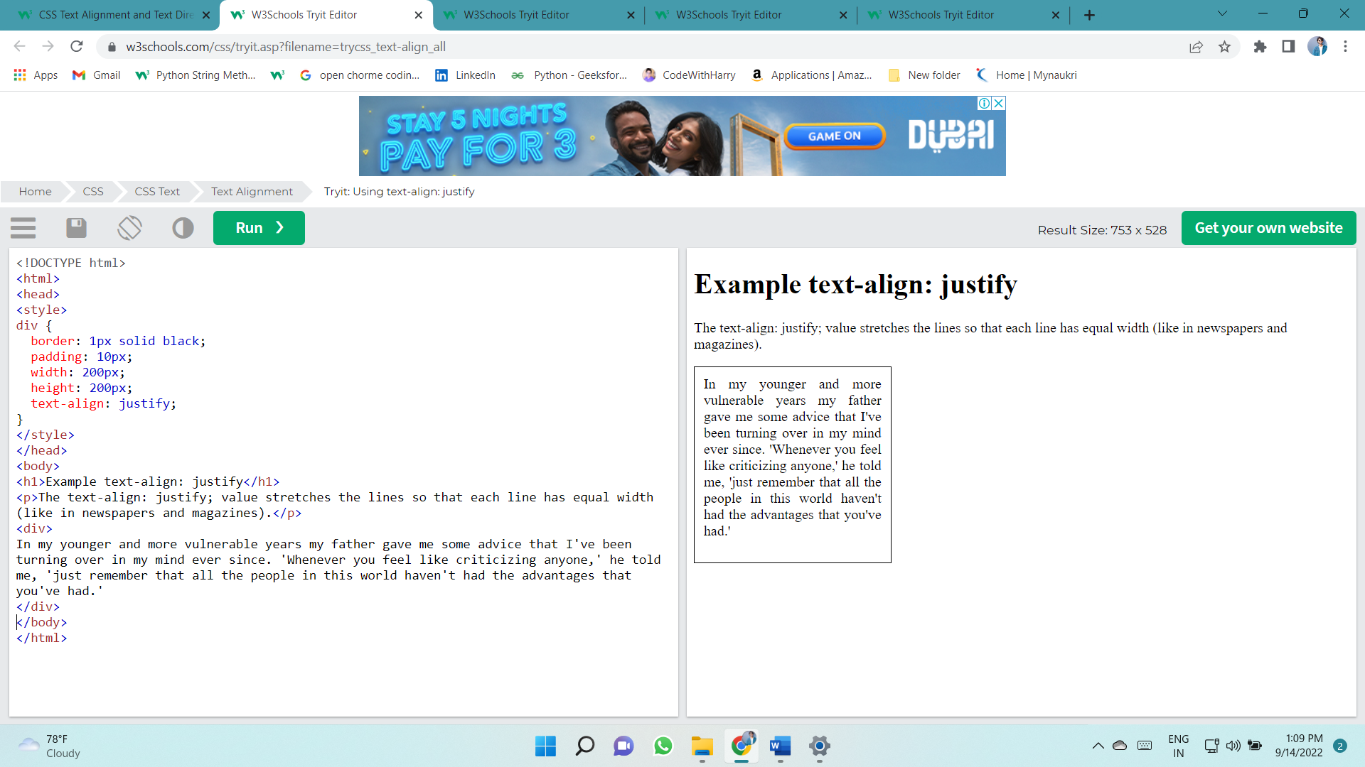

### Text Align Last

The text-align-last property specifies how to align the last line of a text.

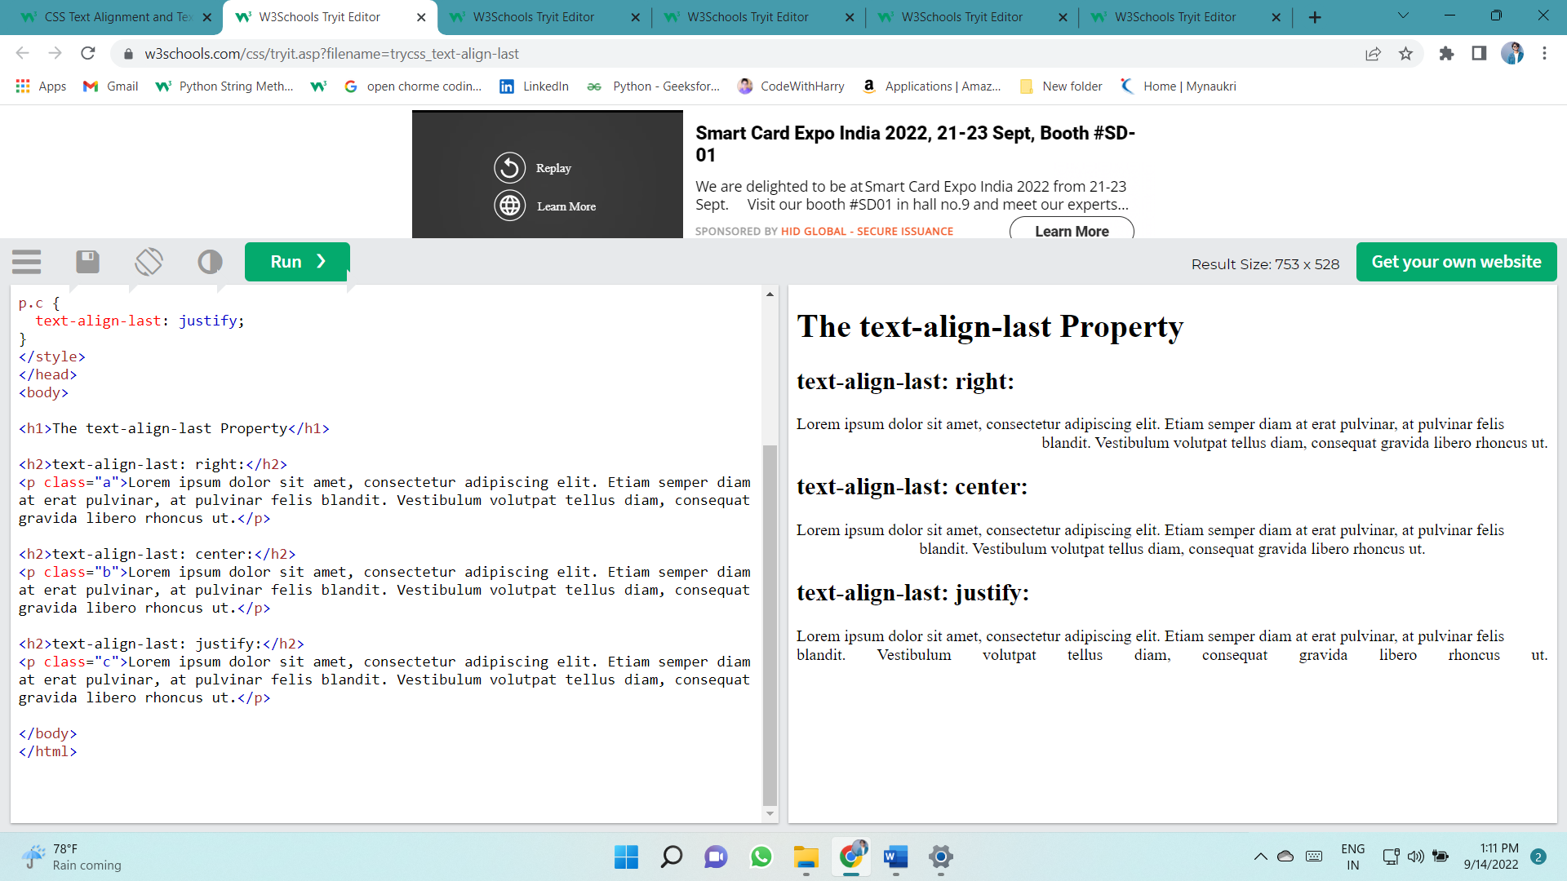

### Text Direction

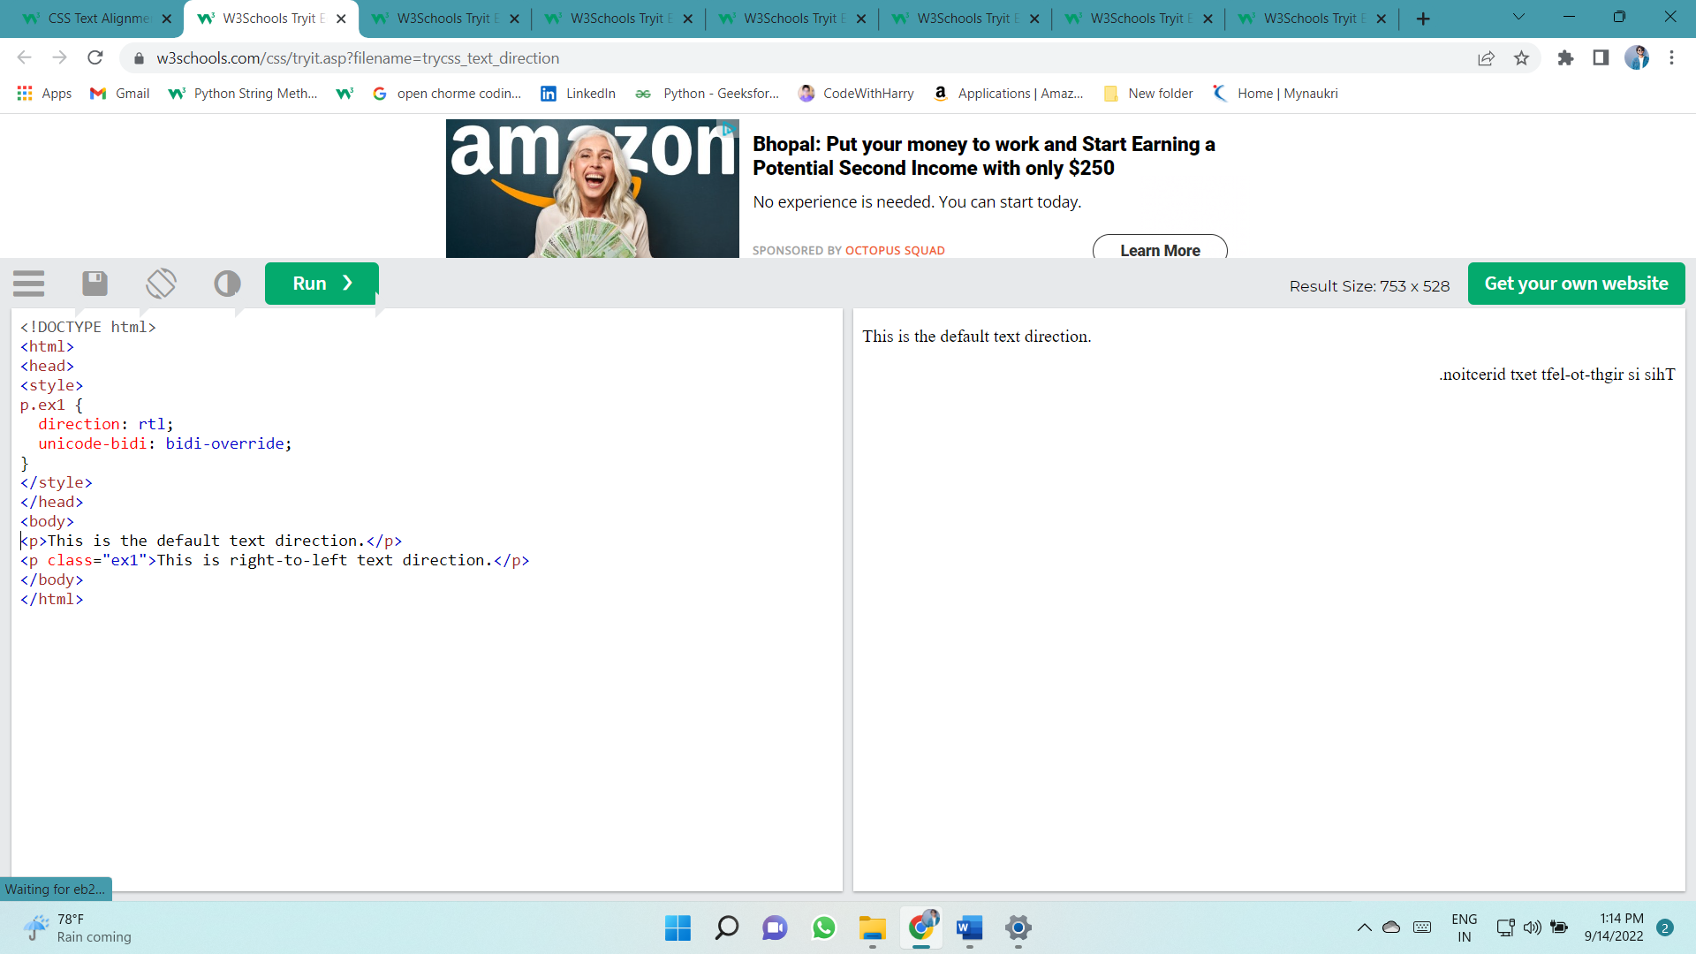The direction and unicode-bidi properties can be used to change the text direction of an element:

### Vertical Alignment

The vertical-align property sets the vertical alignment of an element.

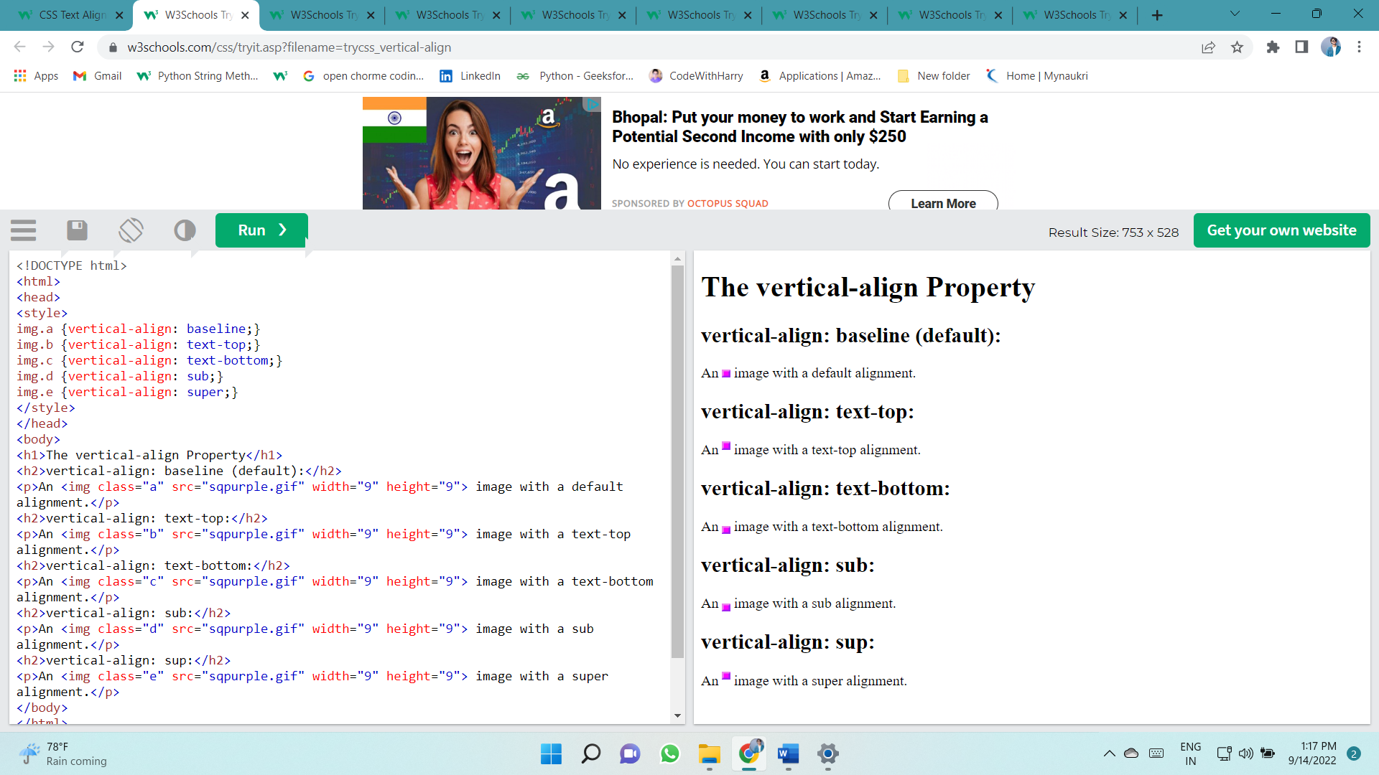

## Text Decoration

* text-decoration-line
* text-decoration-color
* text-decoration-style
* text-decoration-thickness
* text-decoration

### Decoration Line to Text

The text-decoration-line property is used to add a decoration line to text.

**Tip:** You can combine more than one value, like overline and underline to display lines both over and under a text.

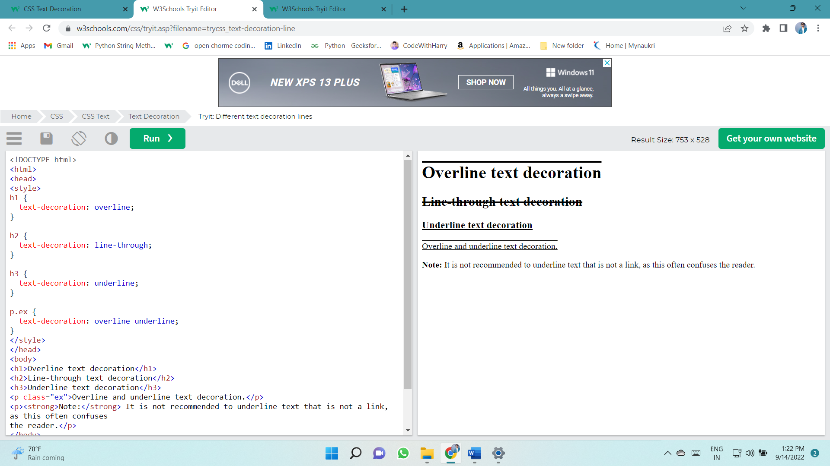

### Specify a Color for the Decoration Line

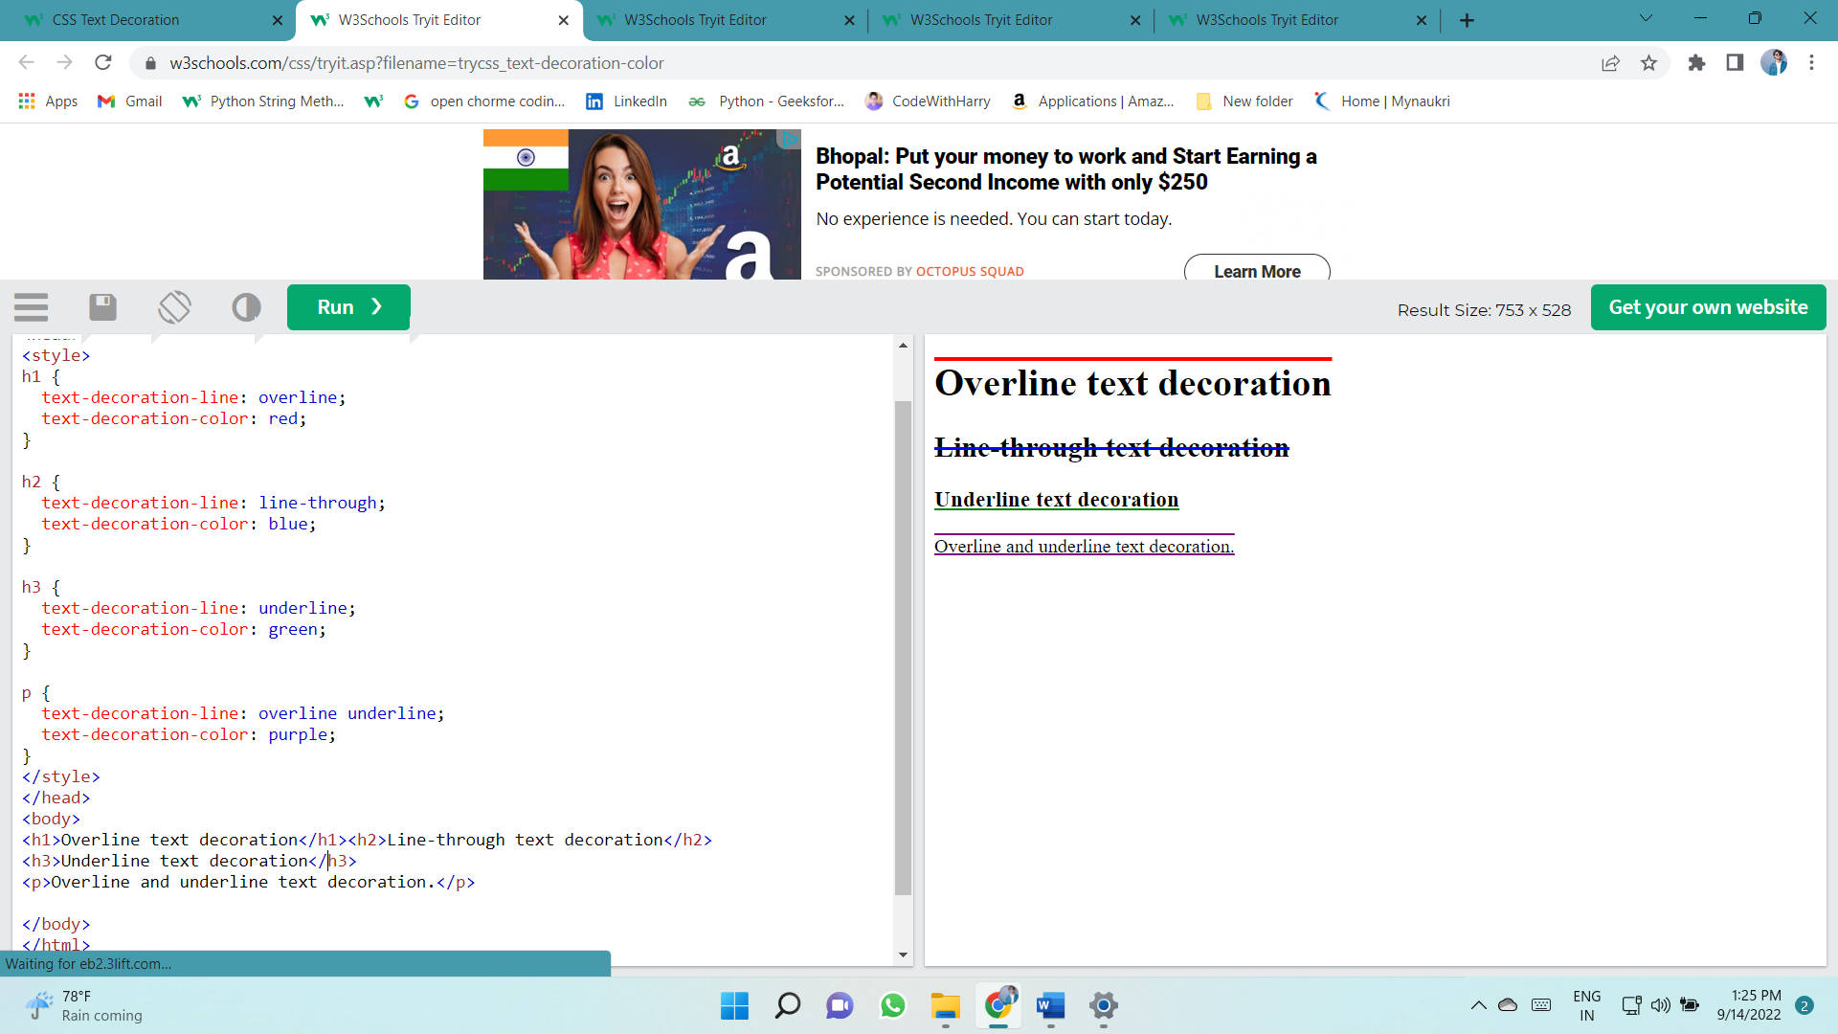The text-decoration-color property is used to set the color of the decoration line.

### Specify a Style for the Decoration Line

The text-decoration-style property is used to set the style of the decoration line.

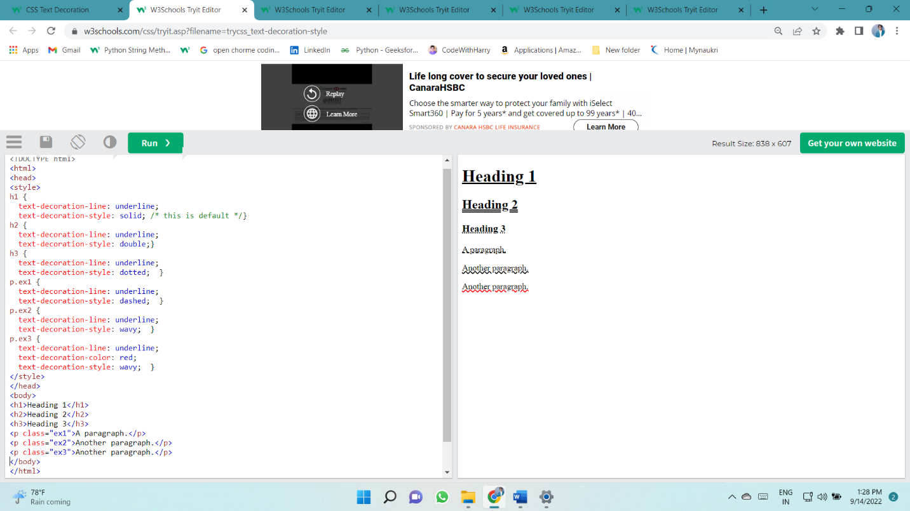

### Specify the Thickness for the Decoration Line

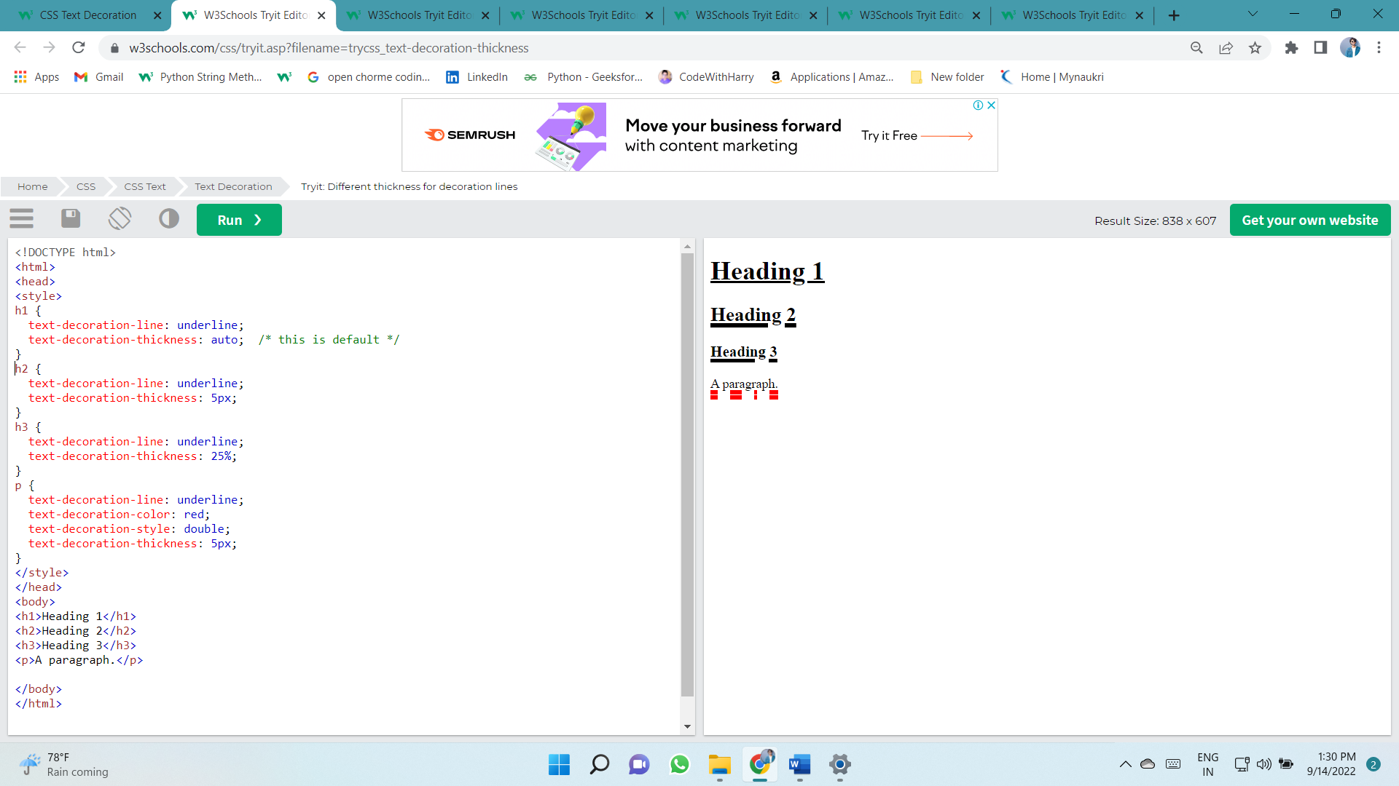The text-decoration-thickness property is used to set the thickness of the decoration line.

# The Shorthand Property

The text-decoration property is a shorthand property for:

* text-decoration-line (required)
* text-decoration-color (optional)
* text-decoration-style (optional)
* text-decoration-thickness (optional)

p {  
  text-decoration: underline red double 5px;  
}

### A Small Tip

All links in HTML are underlined by default. Sometimes you see that links are styled with no underline. The text-decoration: none; is used to remove the underline from links, like this:

a {  
  text-decoration: none;  
}

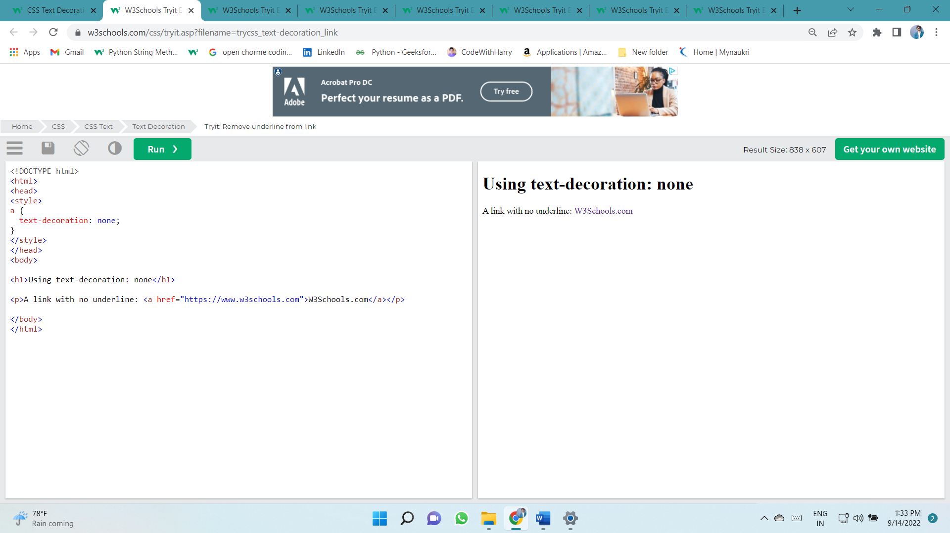

## Text Transformation

The text-transform property is used to specify uppercase and lowercase letters in a text.

It can be used to turn everything into uppercase or lowercase letters, or capitalize the first letter of each word:

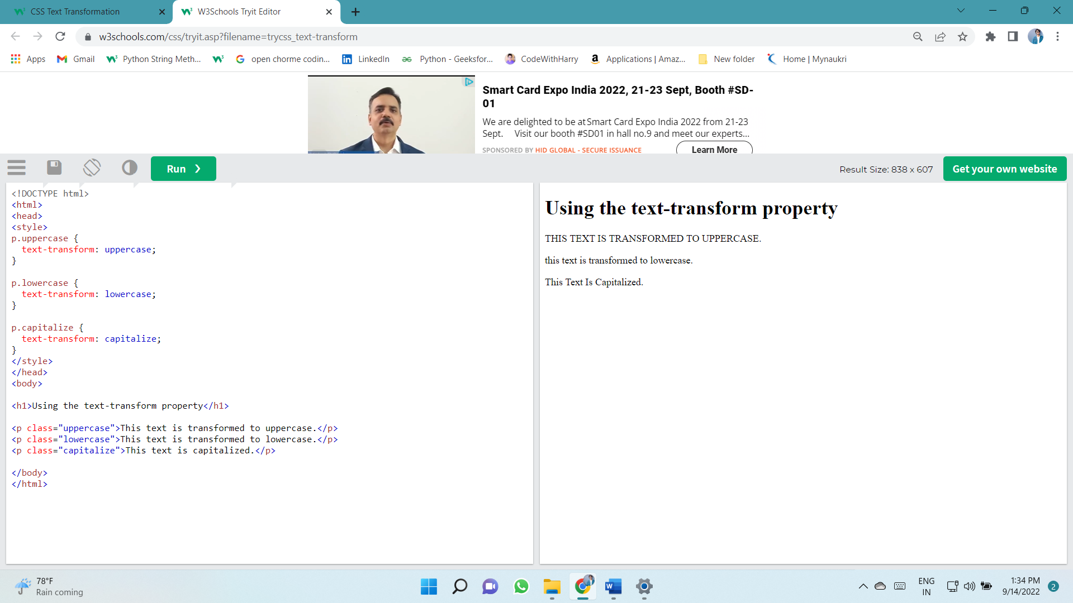

## Text Spacing

### Text Indentation, Letter Spacing, Line Height, Word Spacing, and White Space

* text-indent
* letter-spacing
* line-height
* word-spacing
* white-space

### Text Indentation

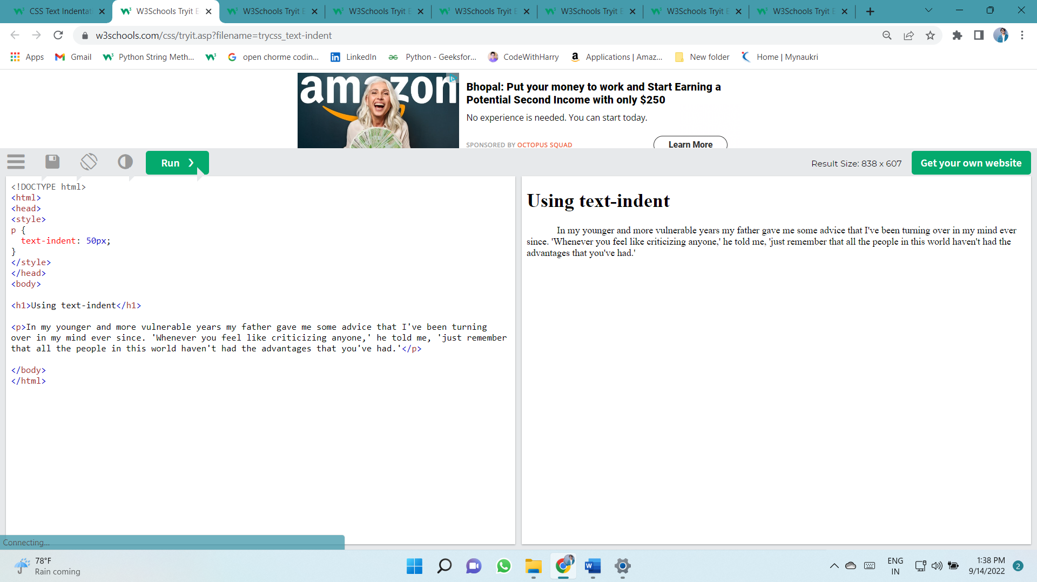The text-indent property is used to specify the indentation of the first line of a text:

### Letter Spacing

The letter-spacing property is used to specify the space between the characters in a text.

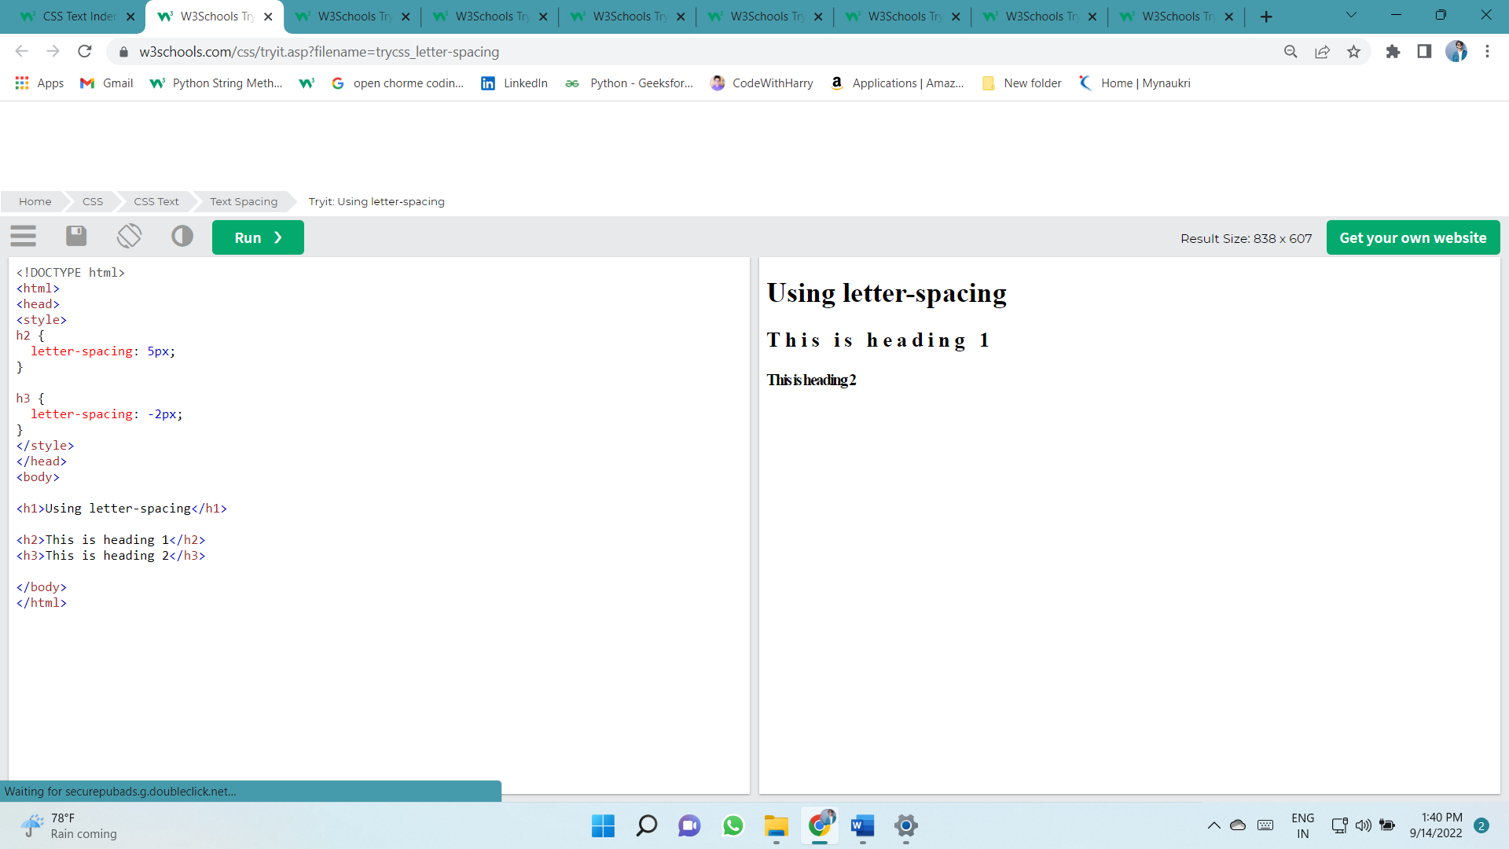

### Line Height

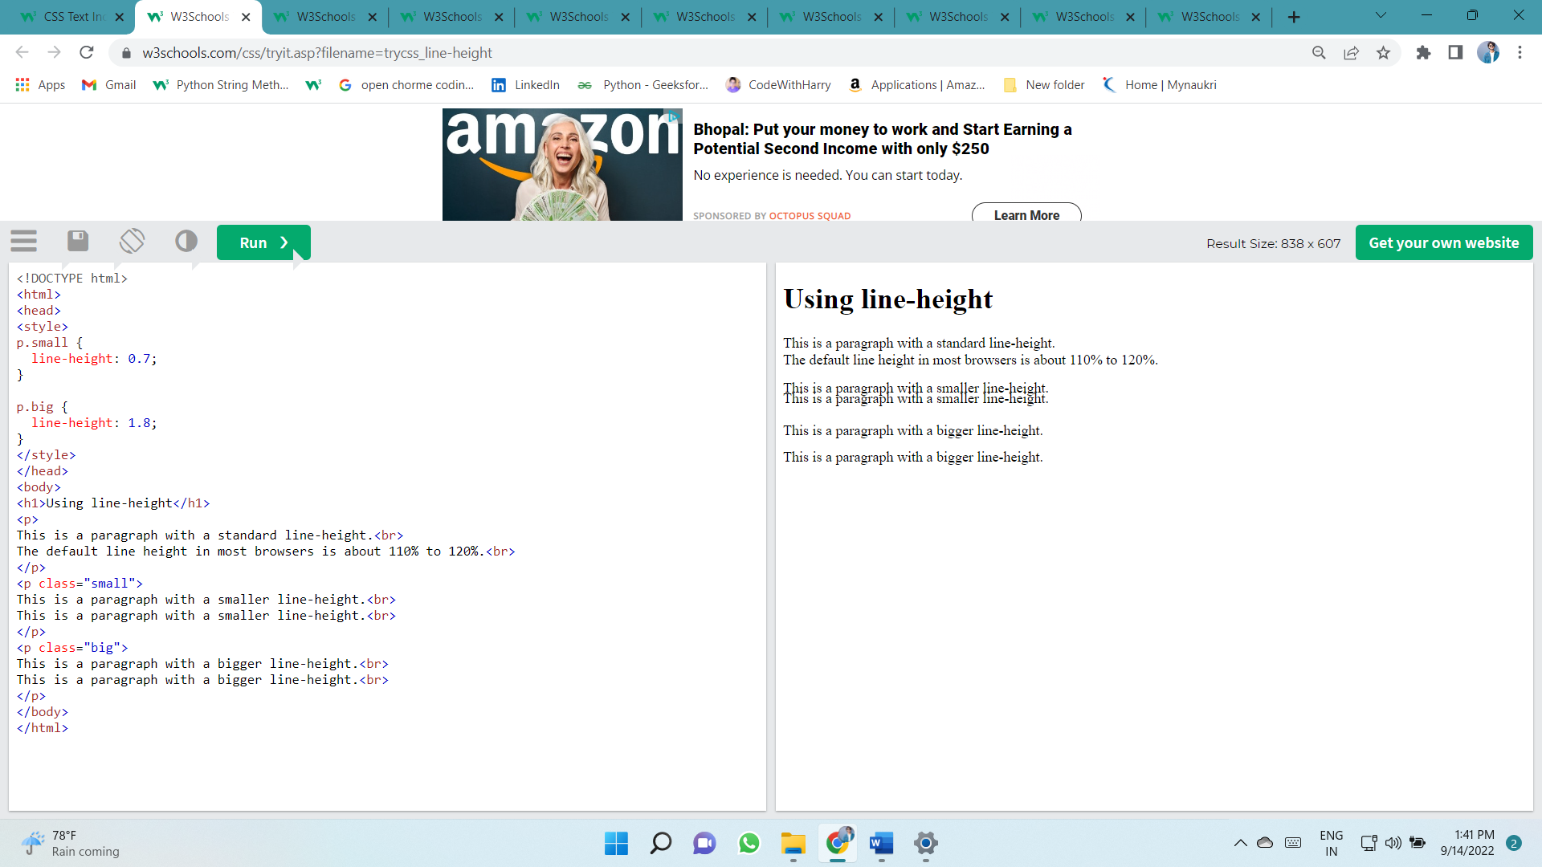The line-height property is used to specify the space between lines:

### Word Spacing

The word-spacing property is used to specify the space between the words in a text.

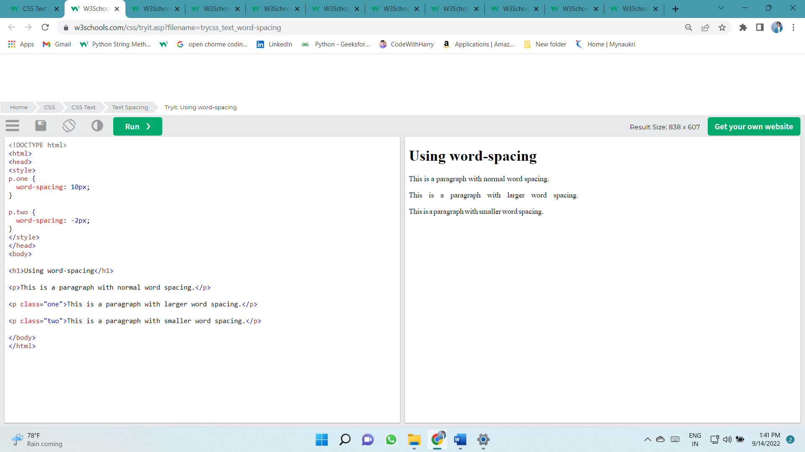

### White Space

The white-space property specifies how white-space inside an element is handled.

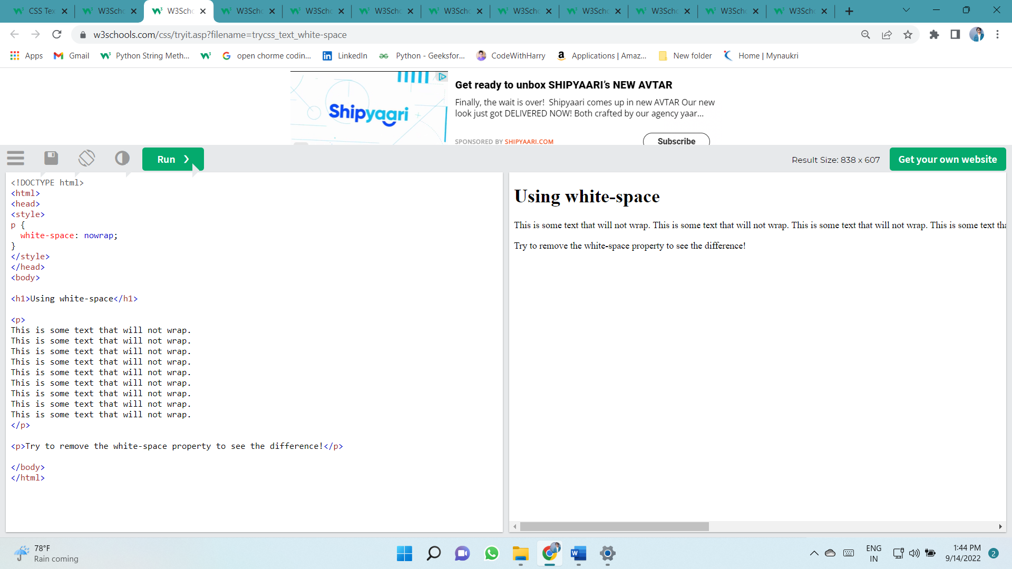

### Text Shadow

The text-shadow property adds shadow to text.

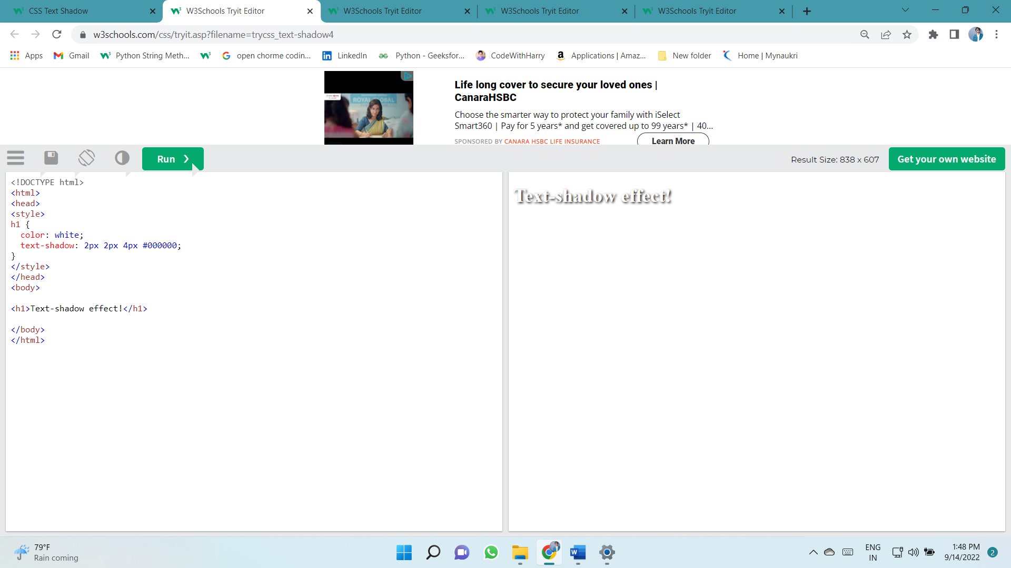

# Fonts

**Font Selection is Important**

Choosing the right font has a huge impact on how the readers experience a website.

The right font can create a strong identity for your brand.

Using a font that is easy to read is important. The font adds value to your text. It is also important to choose the correct color and text size for the font.

**Generic Font Families**

In CSS there are five generic font families:

1. **Serif** fonts have a small stroke at the edges of each letter. They create a sense of formality and elegance.
2. **Sans-serif** fonts have clean lines (no small strokes attached). They create a modern and minimalistic look.
3. **Monospace** fonts - here all the letters have the same fixed width. They create a mechanical look.
4. **Cursive** fonts imitate human handwriting.
5. **Fantasy** fonts are decorative/playful fonts.

All the different font names belong to one of the generic font families.

**Difference Between Serif and Sans-serif Fonts**

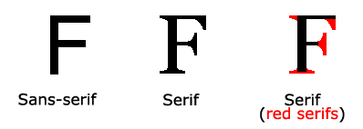

|  |  |
| --- | --- |
| **Generic Font Family** | **Examples of Font Names** |
| Serif | Times New Roman Georgia Garamond |
| Sans-serif | Arial Verdana Helvetica |
| Monospace | Courier New Lucida Console Monaco |
| Cursive | Brush Script MT Lucida Handwriting |
| Fantasy | Copperplate Papyrus |

**The CSS font-family Property**

In CSS, we use the font-family property to specify the font of a text.

**Note**: If the font name is more than one word, it must be in quotation marks, like: "Times New Roman".

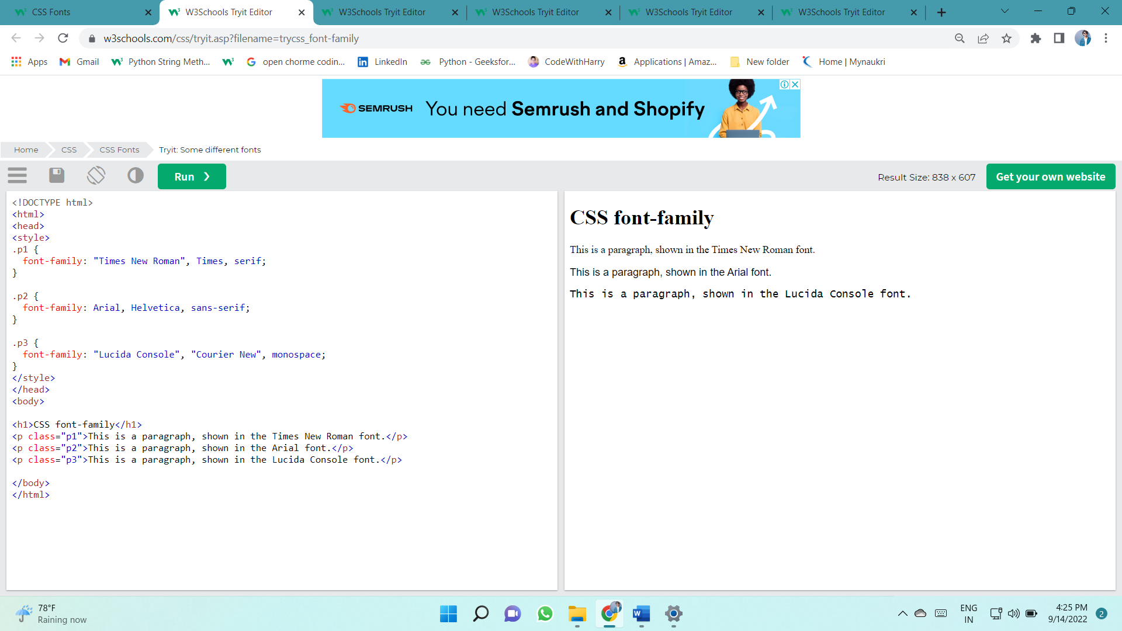

## Web Safe Fonts

## What are Web Safe Fonts?

Web safe fonts are fonts that are universally installed across all browsers and devices.

## Fallback Fonts

However, there are no 100% completely web safe fonts. There is always a chance that a font is not found or is not installed properly.

Therefore, it is very important to always use fallback fonts.

This means that you should add a list of similar "backup fonts" in the font-family property. If the first font does not work, the browser will try the next one, and the next one, and so on. Always end the list with a generic font family name.

Here, there are three font types: Tahoma, Verdana, and sans-serif. The second and third fonts are backups, in case the first one is not found.

p {  
font-family: Tahoma, Verdana, sans-serif;  
}

## Best Web Safe Fonts for HTML and CSS

The following list are the best web safe fonts for HTML and CSS:

* Arial (sans-serif)
* Verdana (sans-serif)
* Tahoma (sans-serif)
* Trebuchet MS (sans-serif)
* Times New Roman (serif)
* Georgia (serif)
* Garamond (serif)
* Courier New (monospace)
* Brush Script MT (cursive)

**Note:** Before you publish your website, always check how your fonts appear on different browsers and devices, and always use [fallback fonts](https://www.w3schools.com/css/css_font_fallbacks.asp)!

## Font Style

The font-style property is mostly used to specify italic text.

This property has three values:

* normal - The text is shown normally
* italic - The text is shown in italics
* 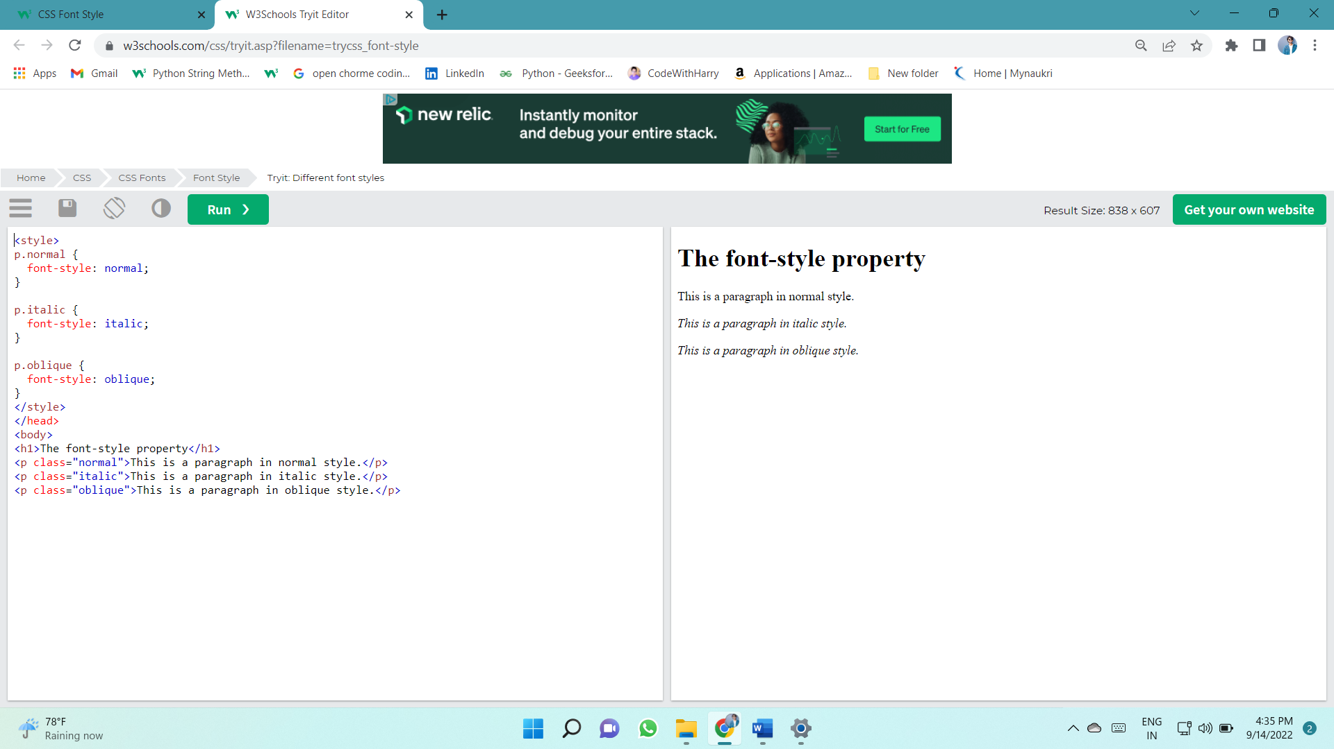oblique - The text is "leaning" (oblique is very similar to italic, but less supported)

## Font Weight

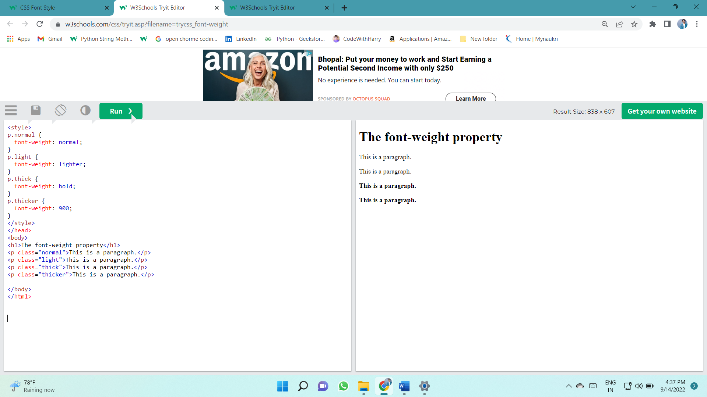The font-weight property specifies the weight of a font:

## Font Variant

The font-variant property specifies whether or not a text should be displayed in a small-caps font.

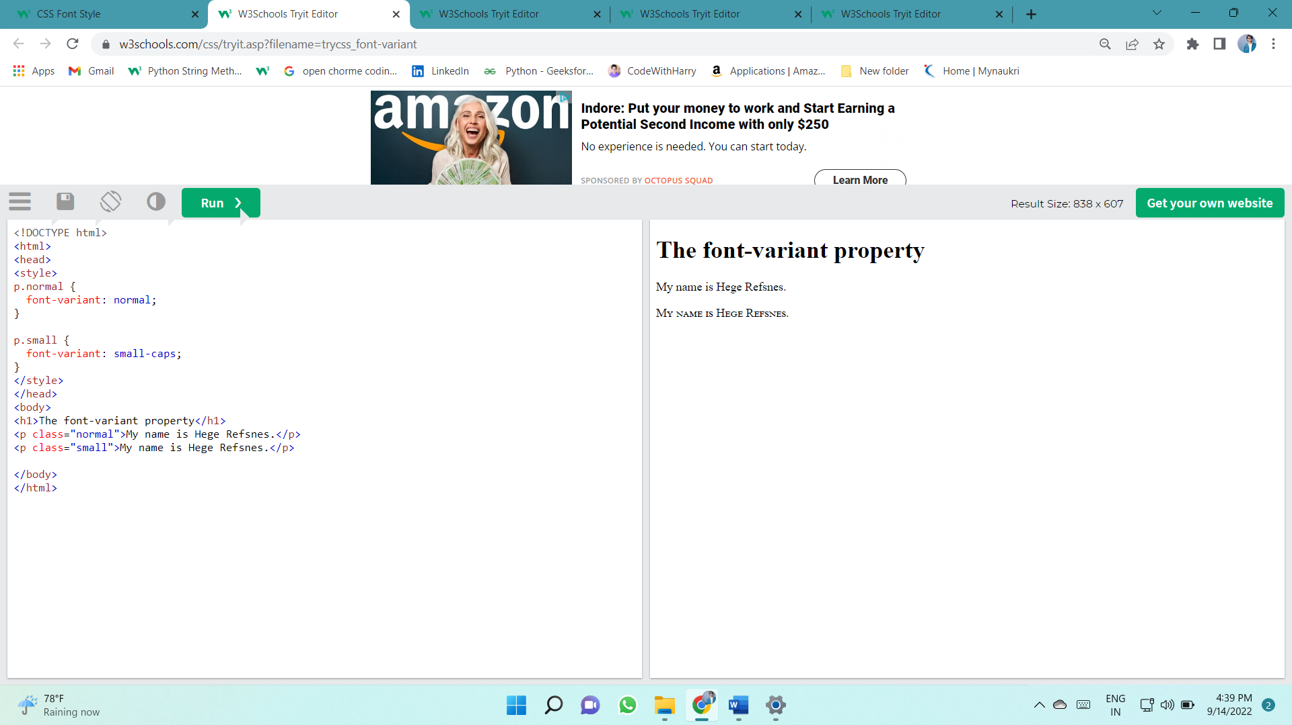In a small-caps font, all lowercase letters are converted to uppercase letters. However, the converted uppercase letters appears in a smaller font size than the original uppercase letters in the text.

## Font Size

The font-size property sets the size of the text.

Being able to manage the text size is important in web design. However, you should not use font size adjustments to make paragraphs look like headings, or headings look like paragraphs.

Always use the proper HTML tags, like <h1> - <h6> for headings and <p> for paragraphs.

The font-size value can be an absolute, or relative size.

Absolute size:

* Sets the text to a specified size
* Does not allow a user to change the text size in all browsers (bad for accessibility reasons)
* Absolute size is useful when the physical size of the output is known

Relative size:

* Sets the size relative to surrounding elements
* Allows a user to change the text size in browsers

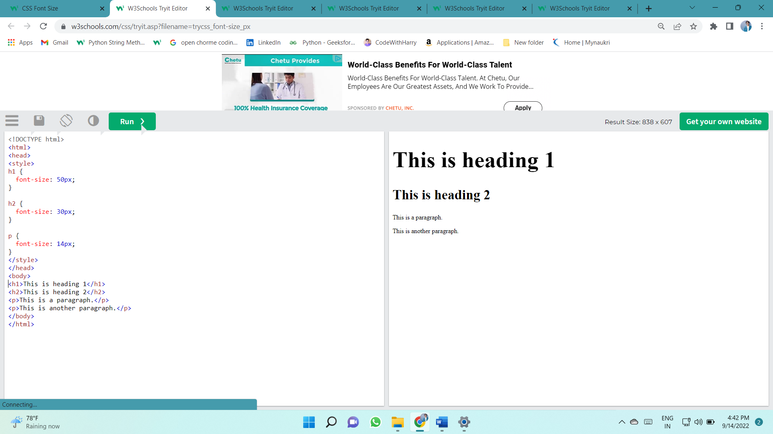**Note:** If you do not specify a font size, the default size for normal text, like paragraphs, is 16px (16px=1em).

**Set Font Size With Em**

To allow users to resize the text (in the browser menu), many developers use em instead of pixels.

1em is equal to the current font size. The default text size in browsers is 16px. So, the default size of 1em is 16px.

The size can be calculated from pixels to em using this formula: *pixels*/16=*em*

In the example above, the text size in em is the same as the previous example in pixels. However, with the em size, it is possible to adjust the text size in all browsers.

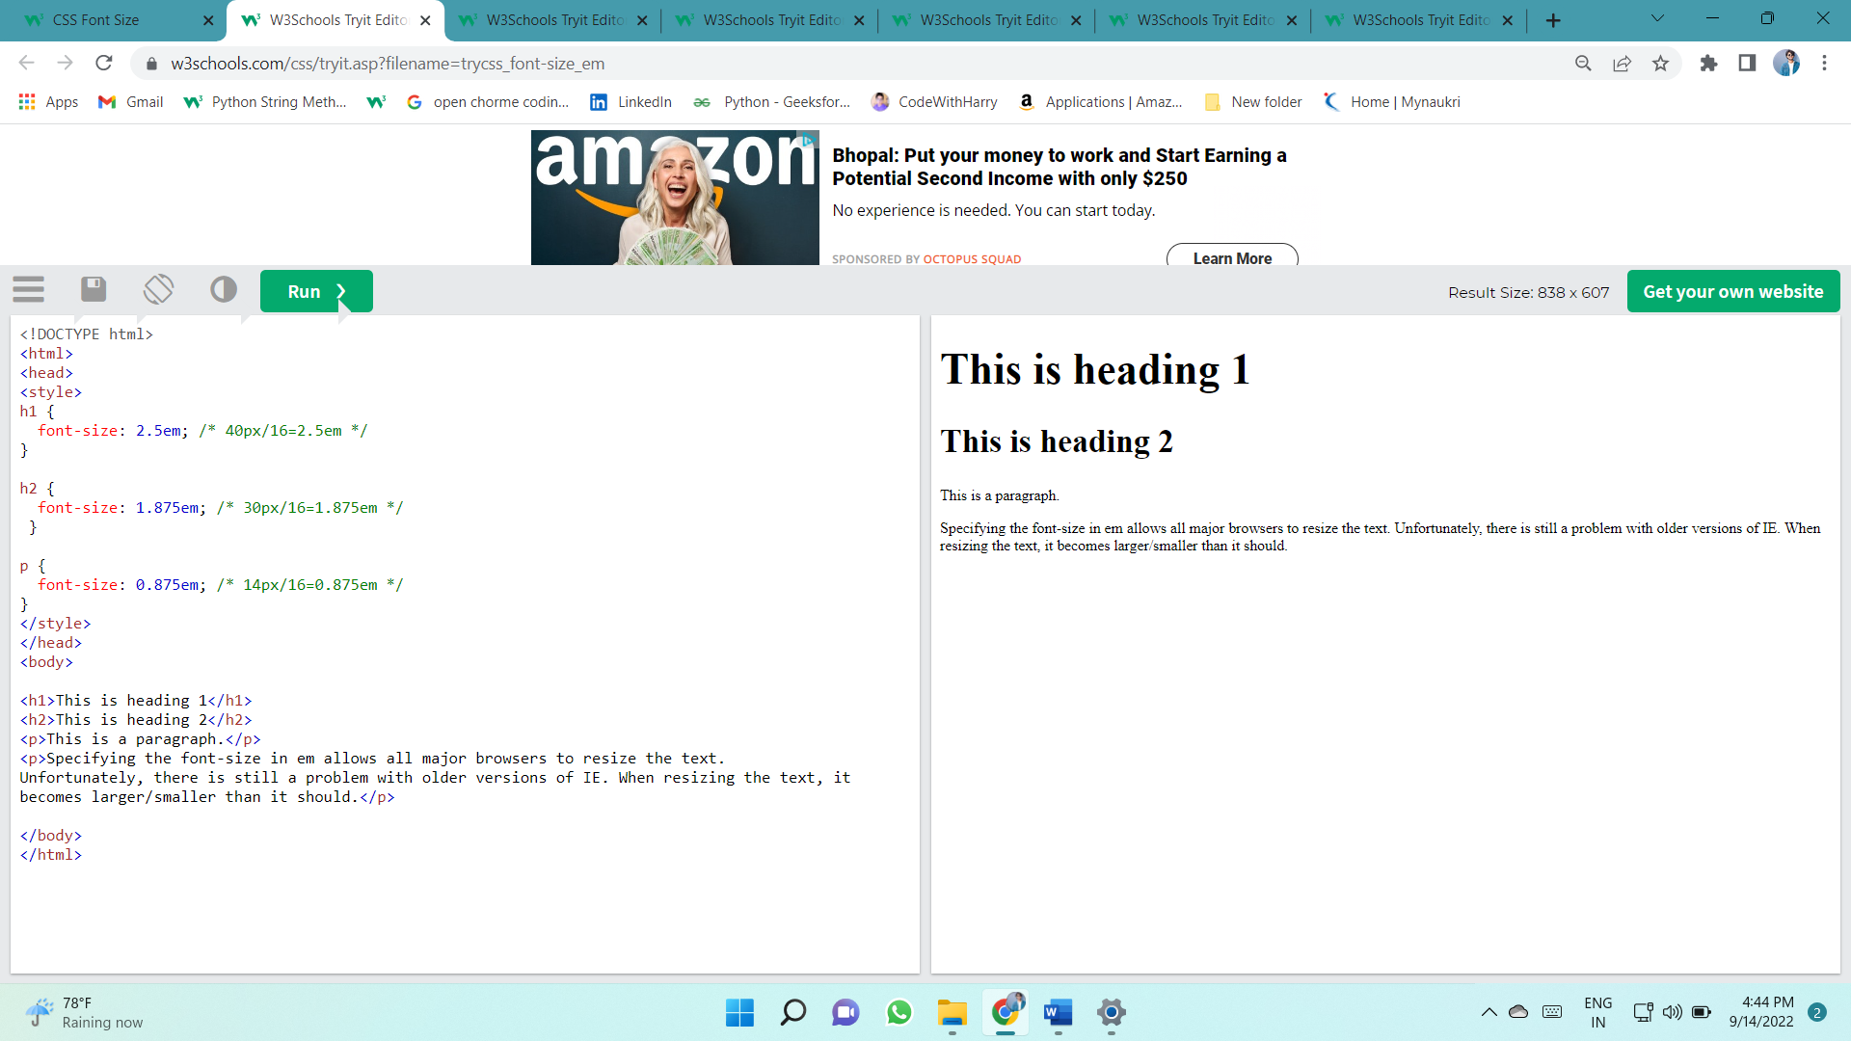

## Google Fonts

**Google Fonts**

If you do not want to use any of the standard fonts in HTML, you can use Google Fonts.

Google Fonts are free to use, and have more than 1000 fonts to choose from.

**How To Use Google Fonts**

Just add a special style sheet link in the <head> section and then refer to the font in the CSS.

Here, we want to use a font named "Sofia" from Google Fonts:

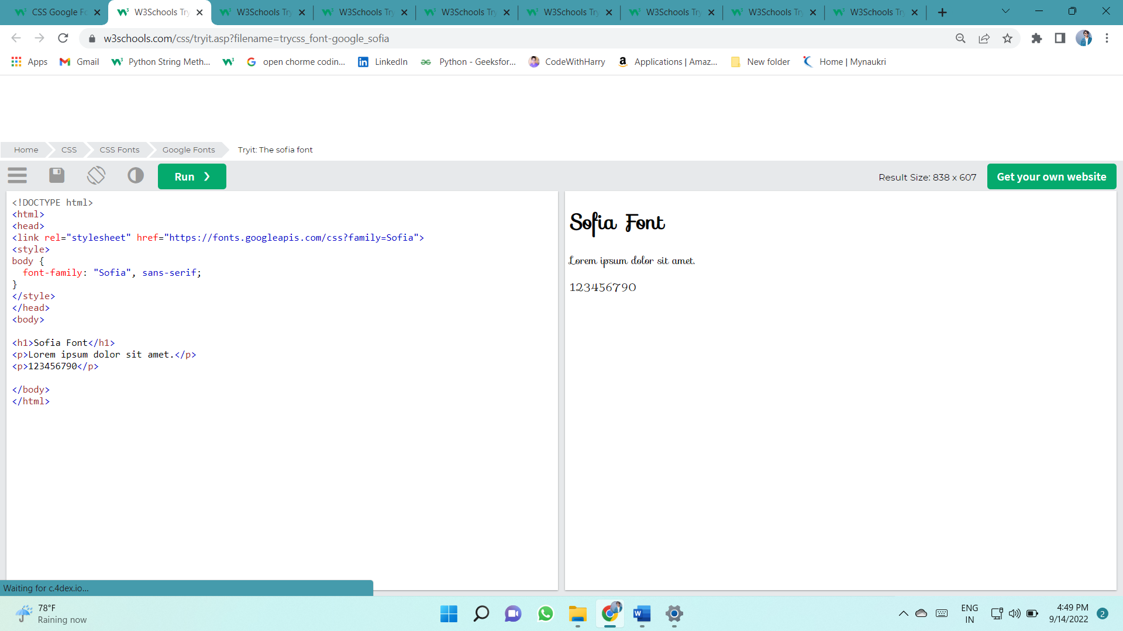

# CSS Links

**Styling Links**

Links can be styled with any CSS property (e.g. color, font-family, background, etc.).

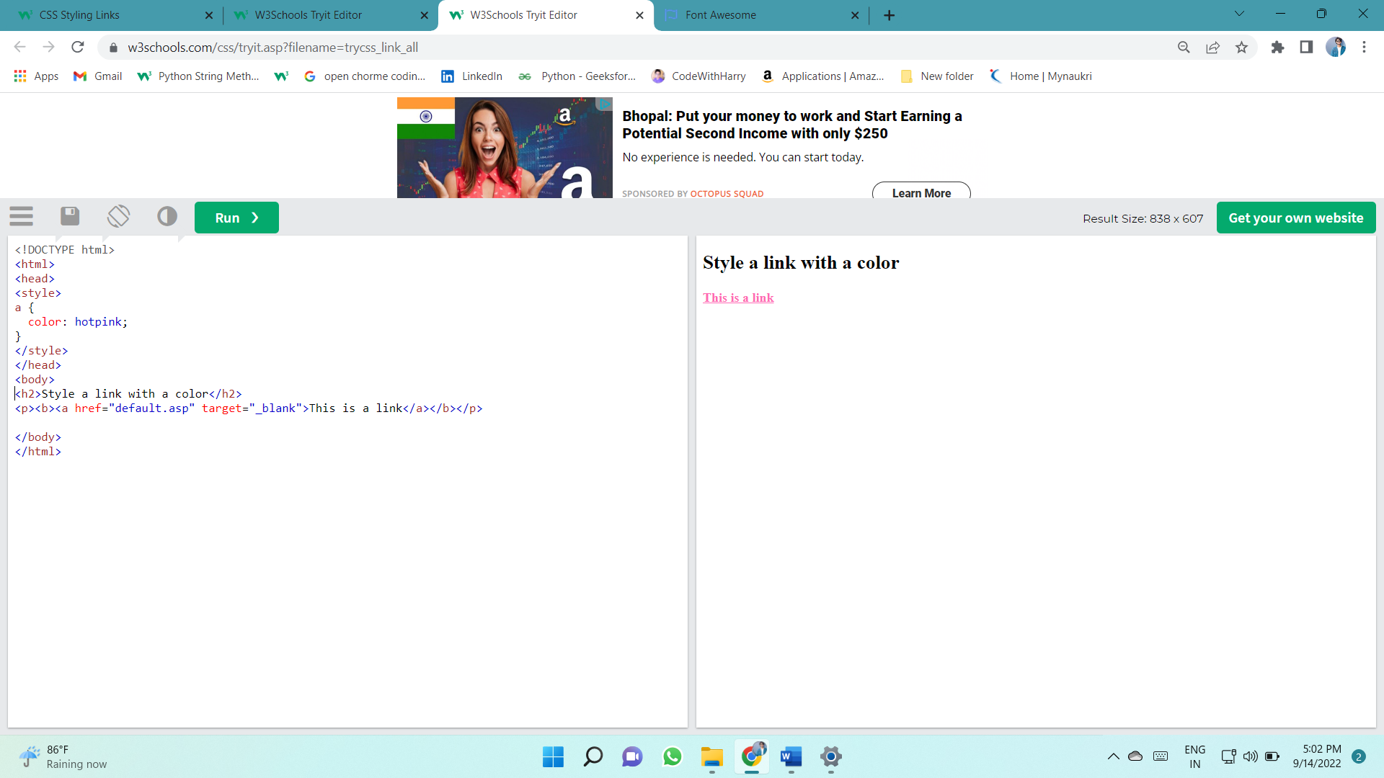

In addition, links can be styled differently depending on what **state** they are in.

The four links states are:

* a:link - a normal, unvisited link
* a:visited - a link the user has visited
* a:hover - a link when the user mouses over it
* a:active - a link the moment it is clicked

When setting the style for several link states, there are some order rules:

* a:hover MUST come after a:link and a:visited
* a:active MUST come after a:hover

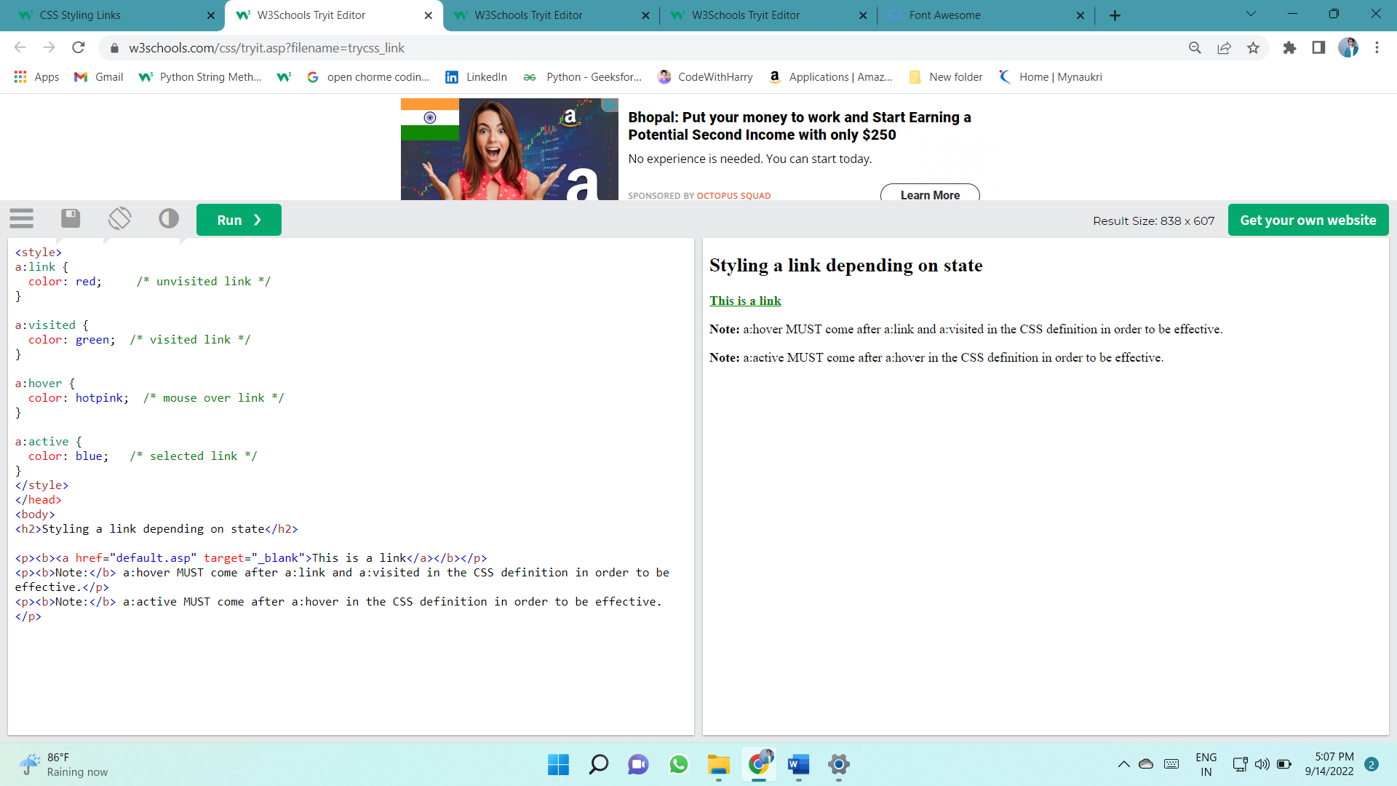

**Link Buttons**

This example demonstrates a more advanced example where we combine several CSS properties to display links as boxes/buttons:

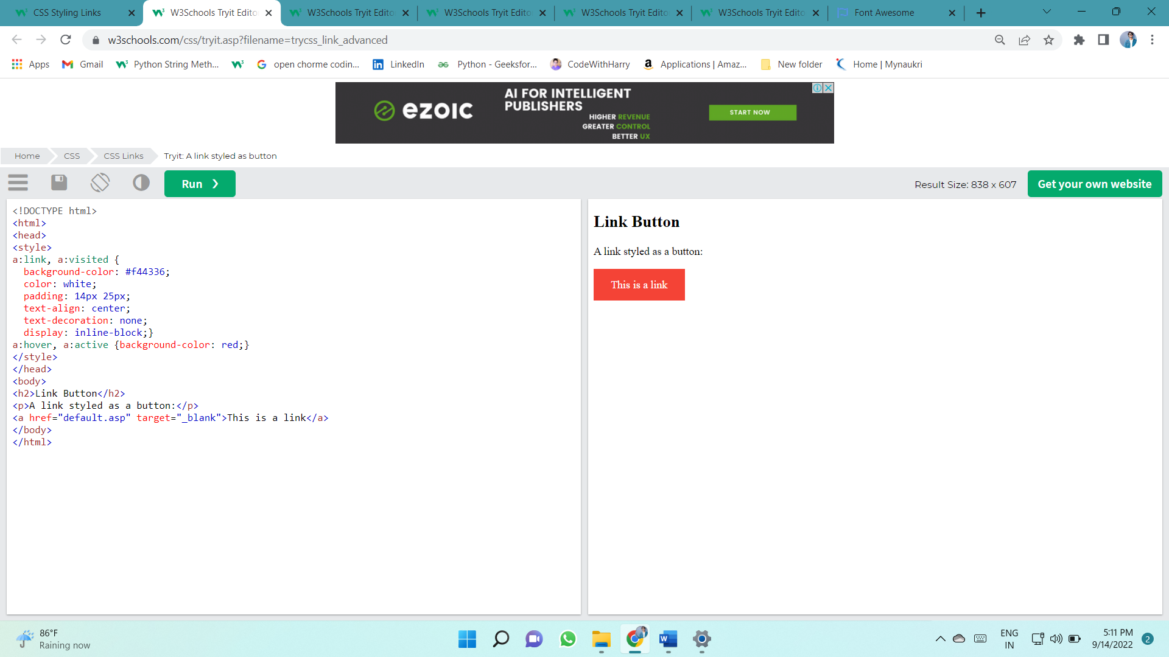

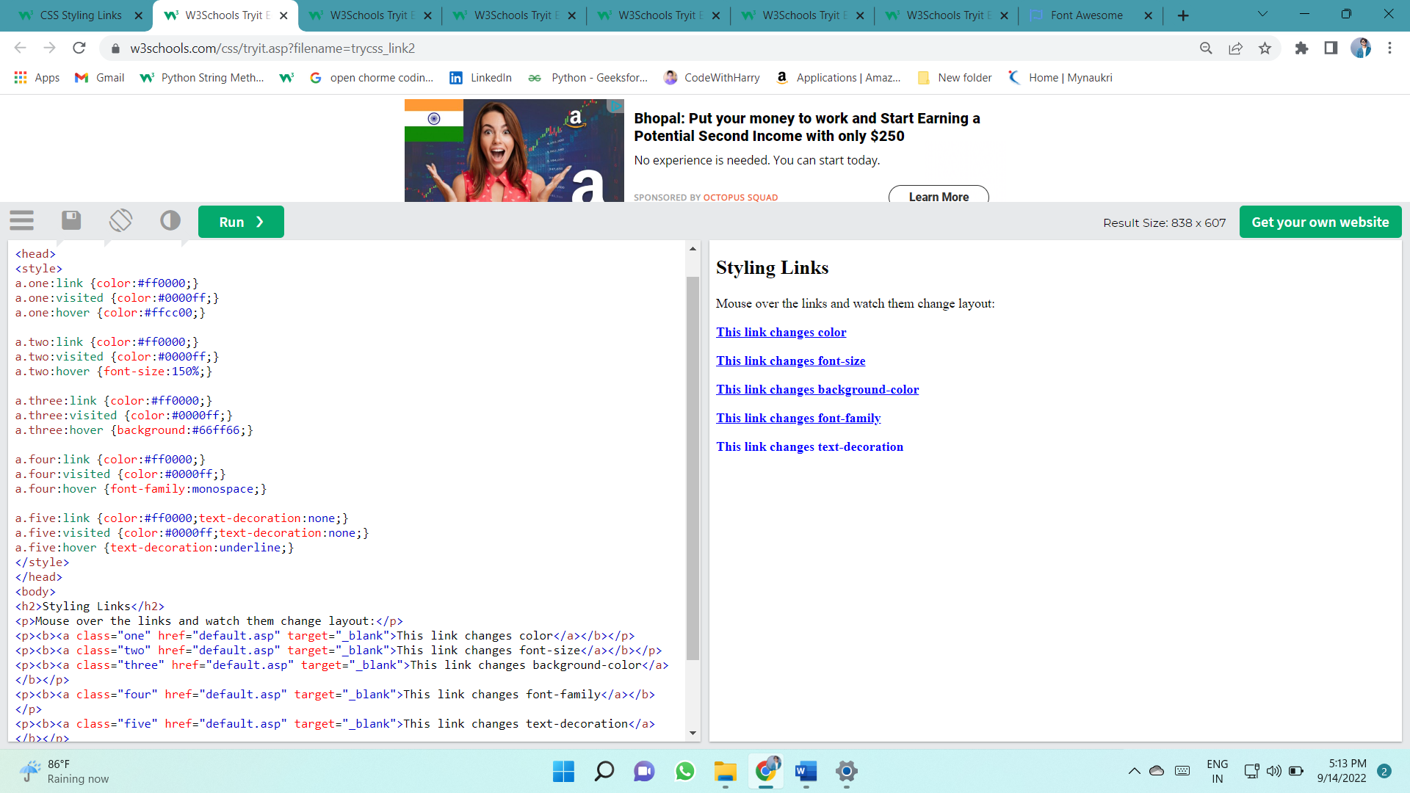This example demonstrates how to add other styles to hyperlinks:

# CURSOR

This example demonstrates the different types of cursors (can be useful for links):

<span style="cursor: auto">auto</span><br>  
<span style="cursor: crosshair">crosshair</span><br>  
<span style="cursor: default">default</span><br>  
<span style="cursor: e-resize">e-resize</span><br>  
<span style="cursor: help">help</span><br>  
<span style="cursor: move">move</span><br>  
<span style="cursor: n-resize">n-resize</span><br>  
<span style="cursor: ne-resize">ne-resize</span><br>  
<span style="cursor: nw-resize">nw-resize</span><br>  
<span style="cursor: pointer">pointer</span><br>  
<span style="cursor: progress">progress</span><br>  
<span style="cursor: s-resize">s-resize</span><br>  
<span style="cursor: se-resize">se-resize</span><br>  
<span style="cursor: sw-resize">sw-resize</span><br>  
<span style="cursor: text">text</span><br>  
<span style="cursor: w-resize">w-resize</span><br>  
<span style="cursor: wait">wait</span>

# List

**Unordered Lists:**

* Coffee
* Tea
* Coca Cola
* Coffee
* Tea
* Coca Cola

**Ordered Lists:**

1. Coffee
2. Tea
3. Coca Cola
4. Coffee
5. Tea
6. Coca Cola

**HTML Lists and CSS List Properties**

In HTML, there are two main types of lists:

* unordered lists (<ul>) - the list items are marked with bullets
* ordered lists (<ol>) - the list items are marked with numbers or letters

The CSS list properties allow you to:

* Set different list item markers for ordered lists
* Set different list item markers for unordered lists
* Set an image as the list item marker
* Add background colors to lists and list items

## **list-style-type**

The list-style-type property specifies the type of list item marker.

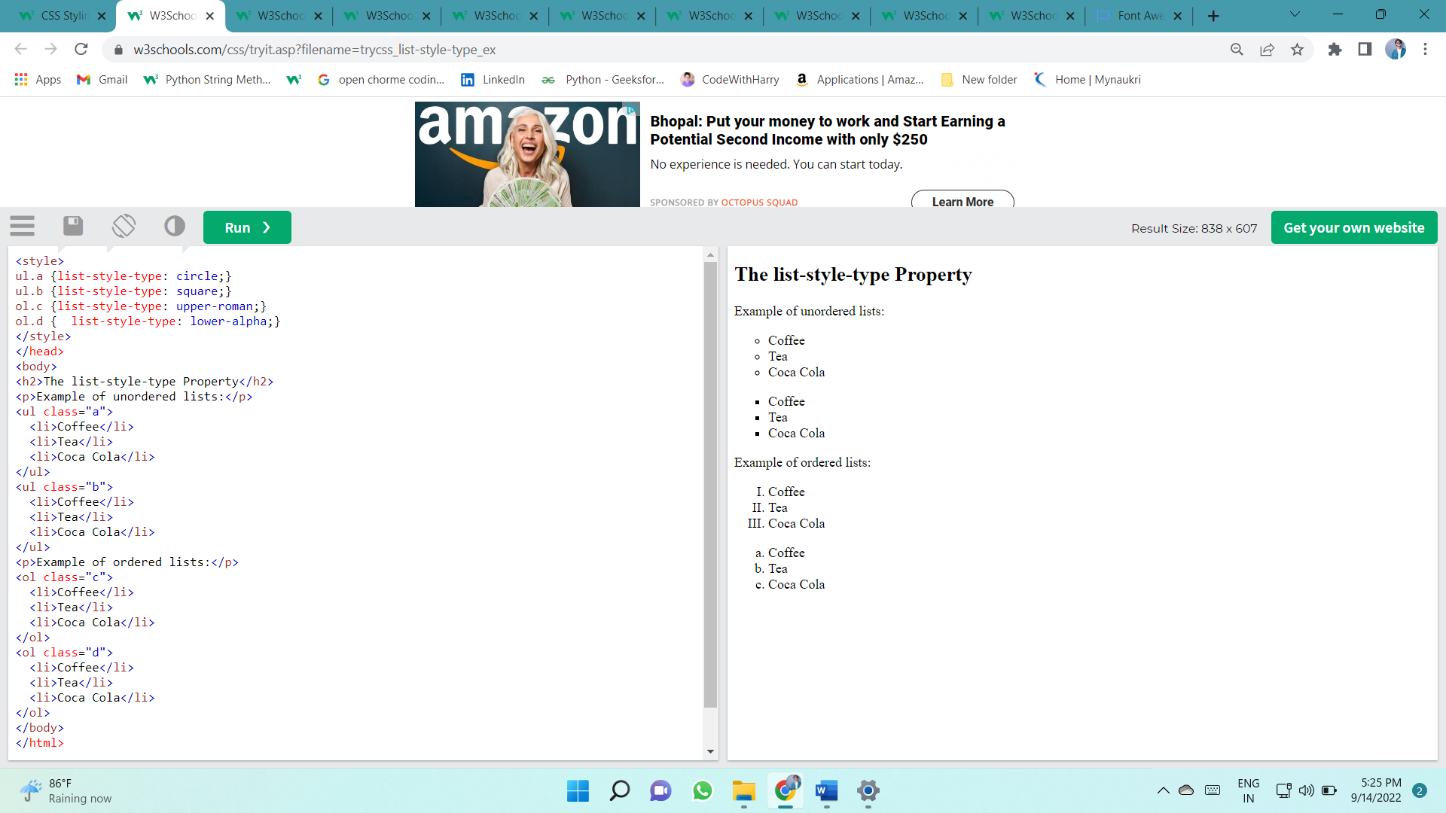The following example shows some of the available list item markers:

## list-style-image

The list-style-image property specifies an image as the list item marker:

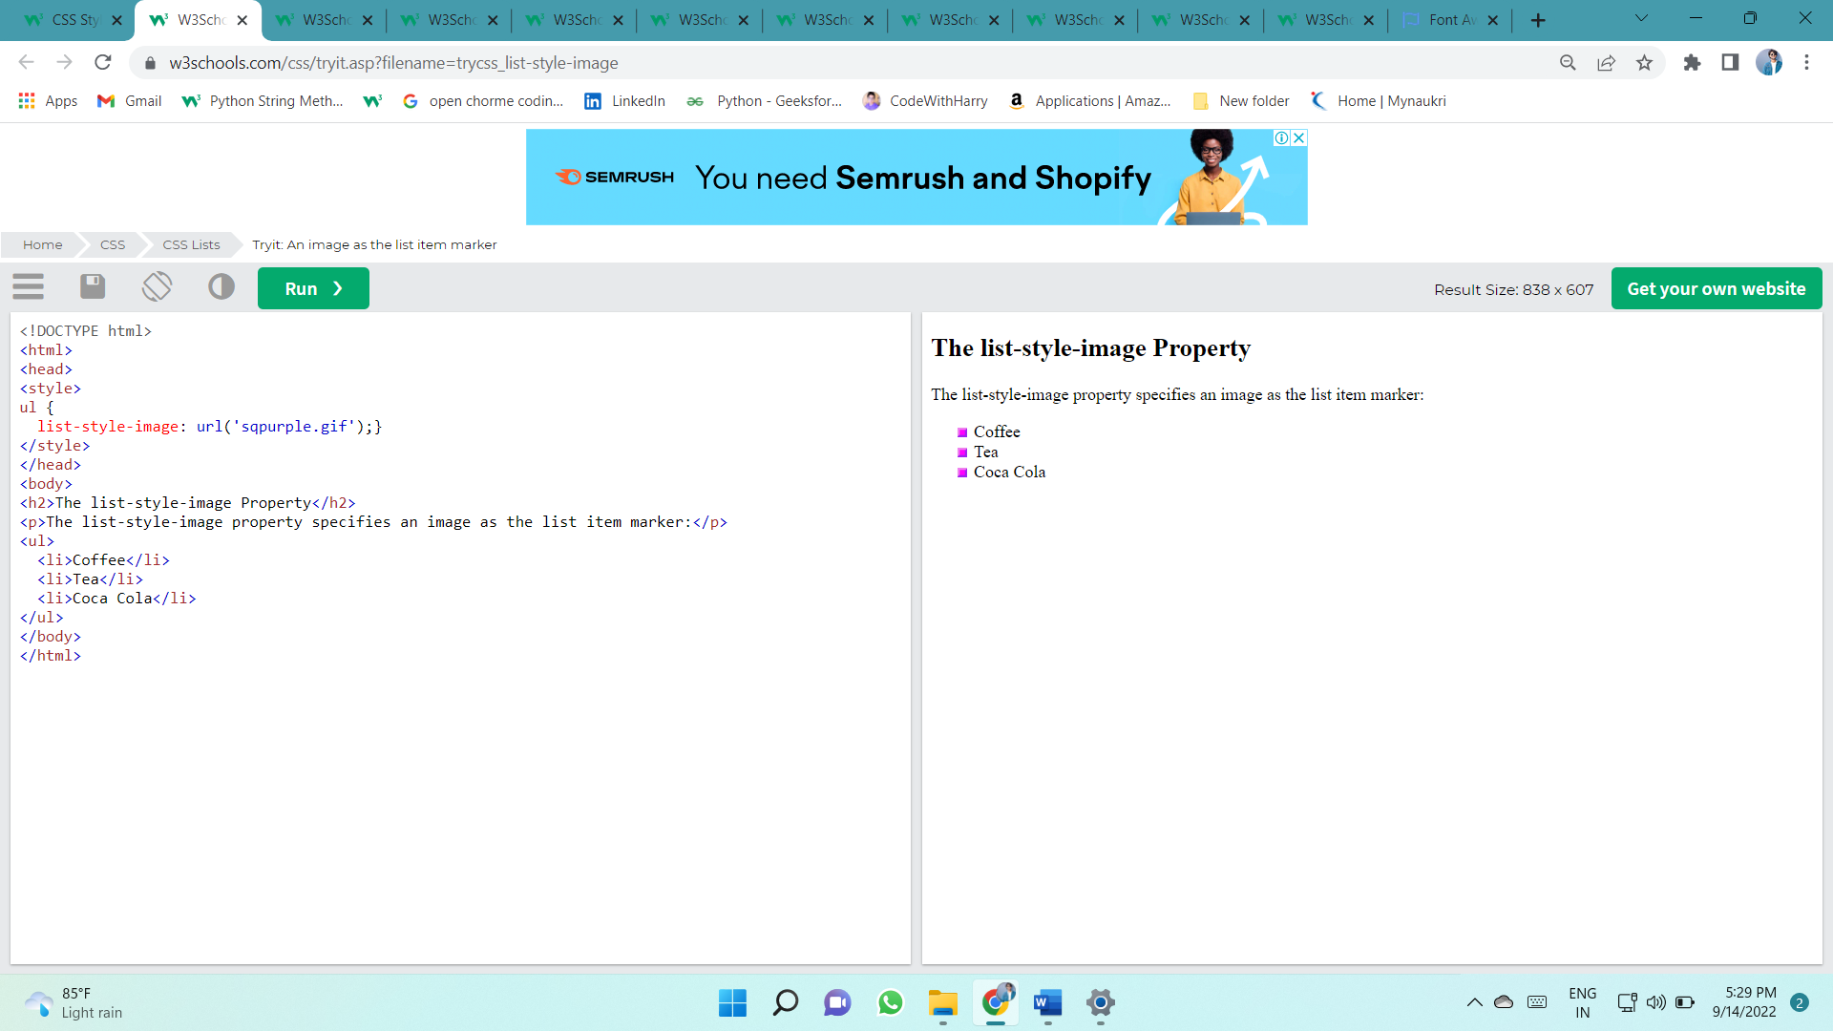

## list-style-position

ul.a {  
  list-style-position: outside;  
}  
  
ul.b {  
  list-style-position: inside;  
}

## Remove Default Settings

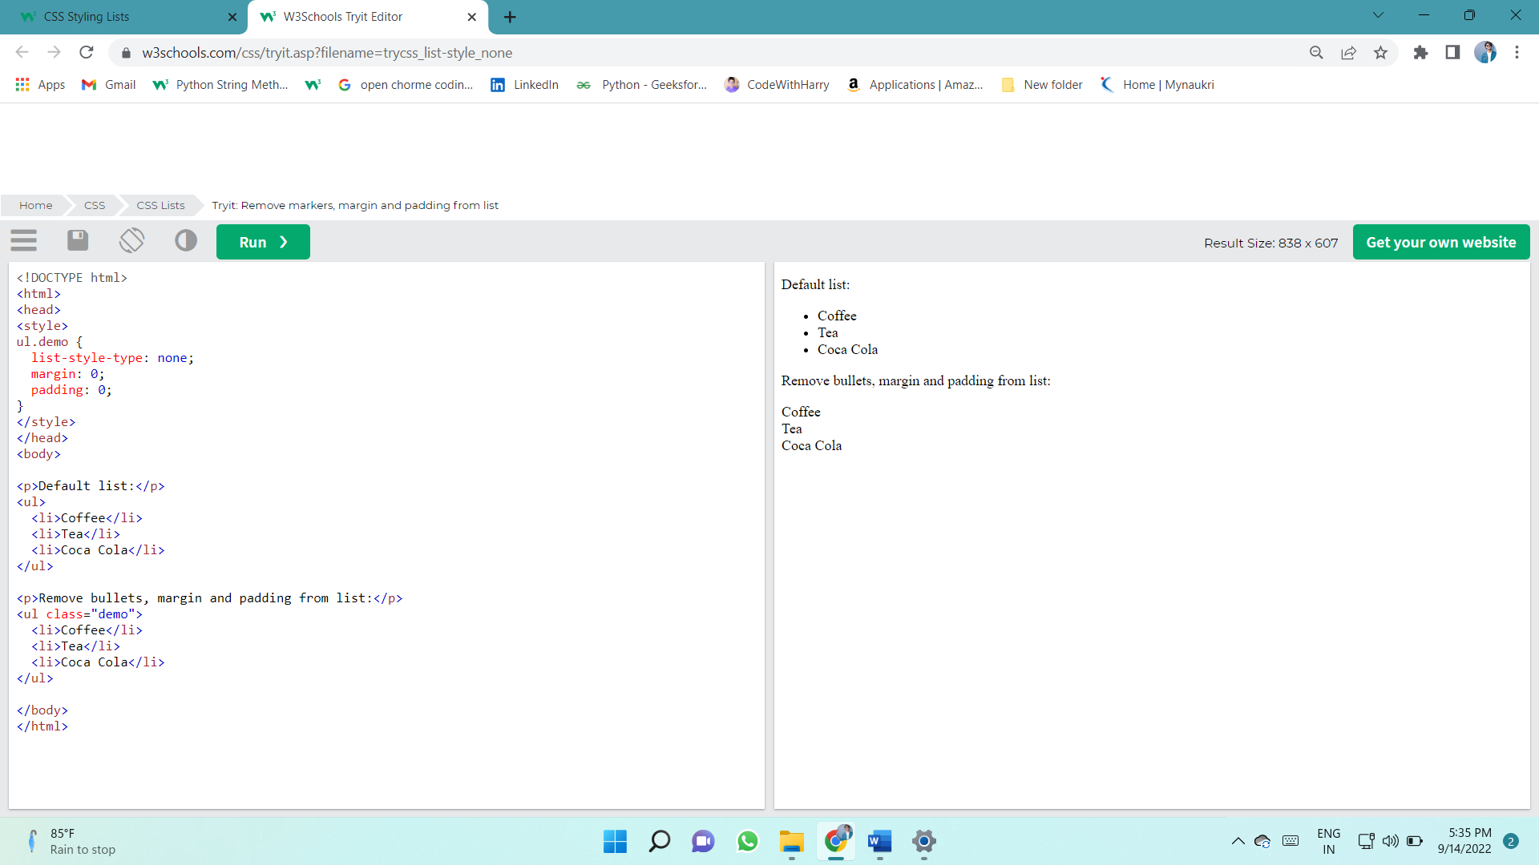The list-style-type:none property can also be used to remove the markers/bullets. Note that the list also has default margin and padding. To remove this, add margin:0 and padding:0 to <ul> or <ol>:

## Styling List With Colors

We can also style lists with colors, to make them look a little more interesting.

Anything added to the <ol> or <ul> tag, affects the entire list, while properties added to the <li> tag will affect the individual list items:

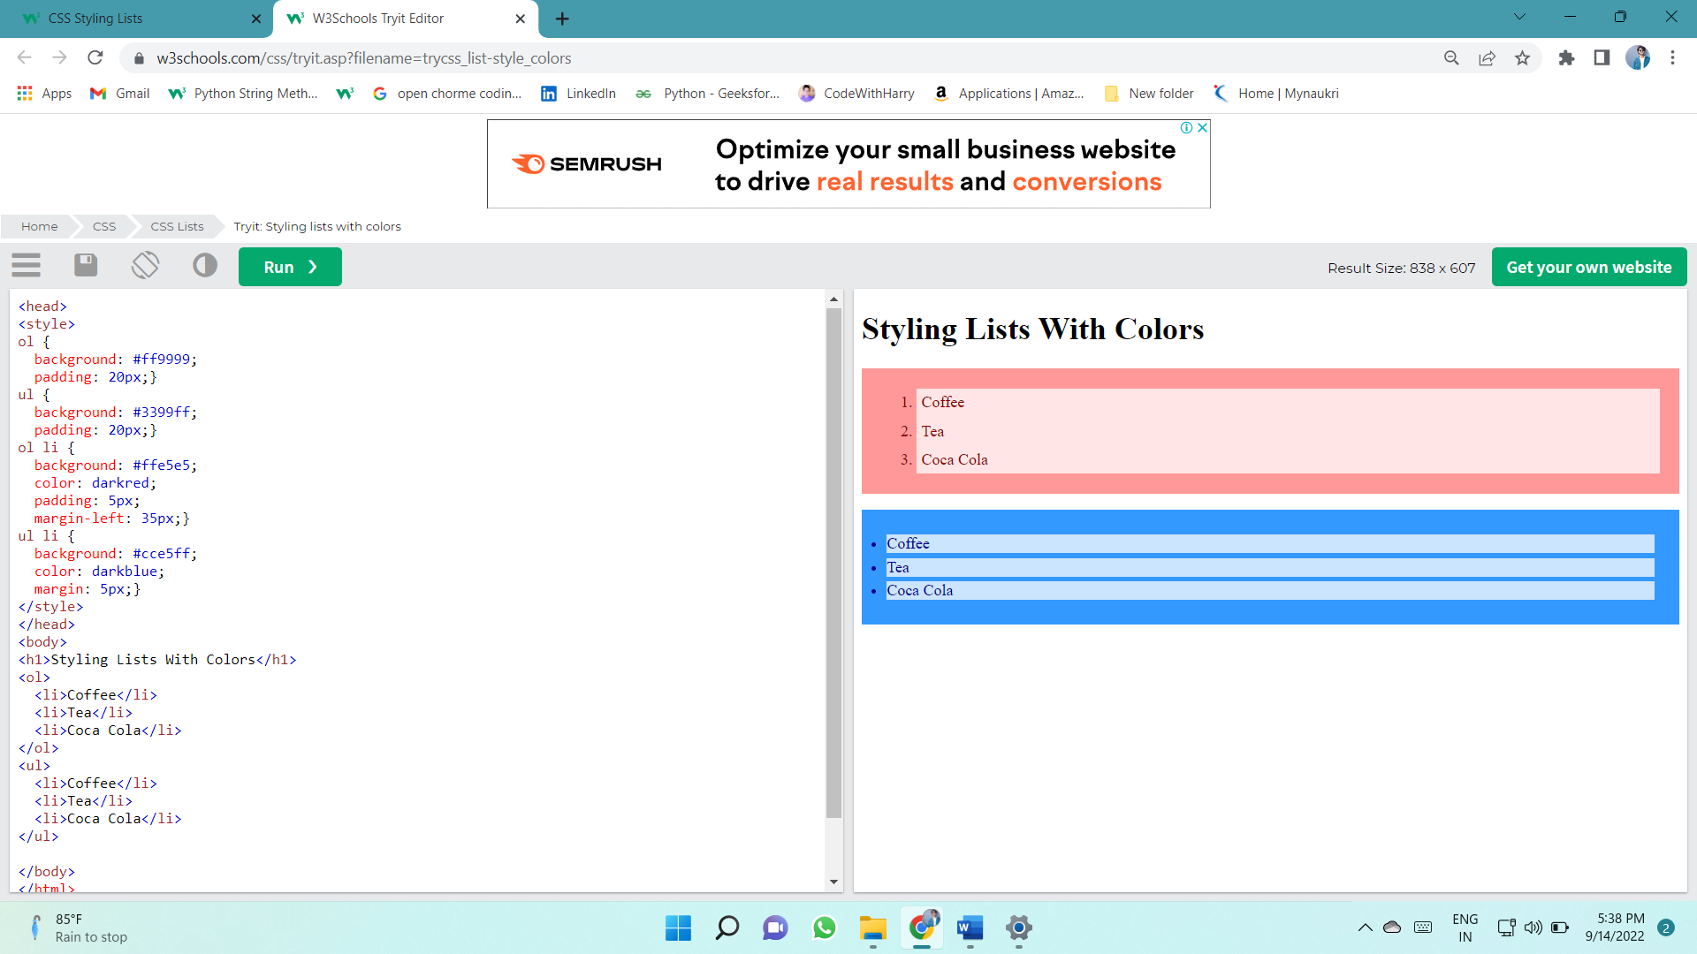

# Tables

## Table Borders

To specify table borders in CSS, use the border property.

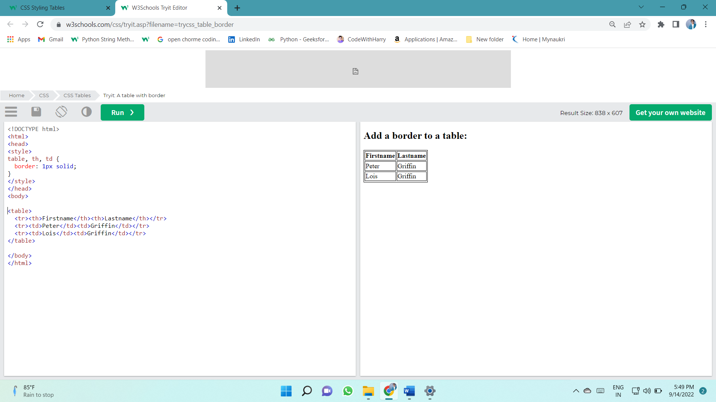The example below specifies a solid border for <table>, <th>, and <td> elements:

## TABEL WIDTH

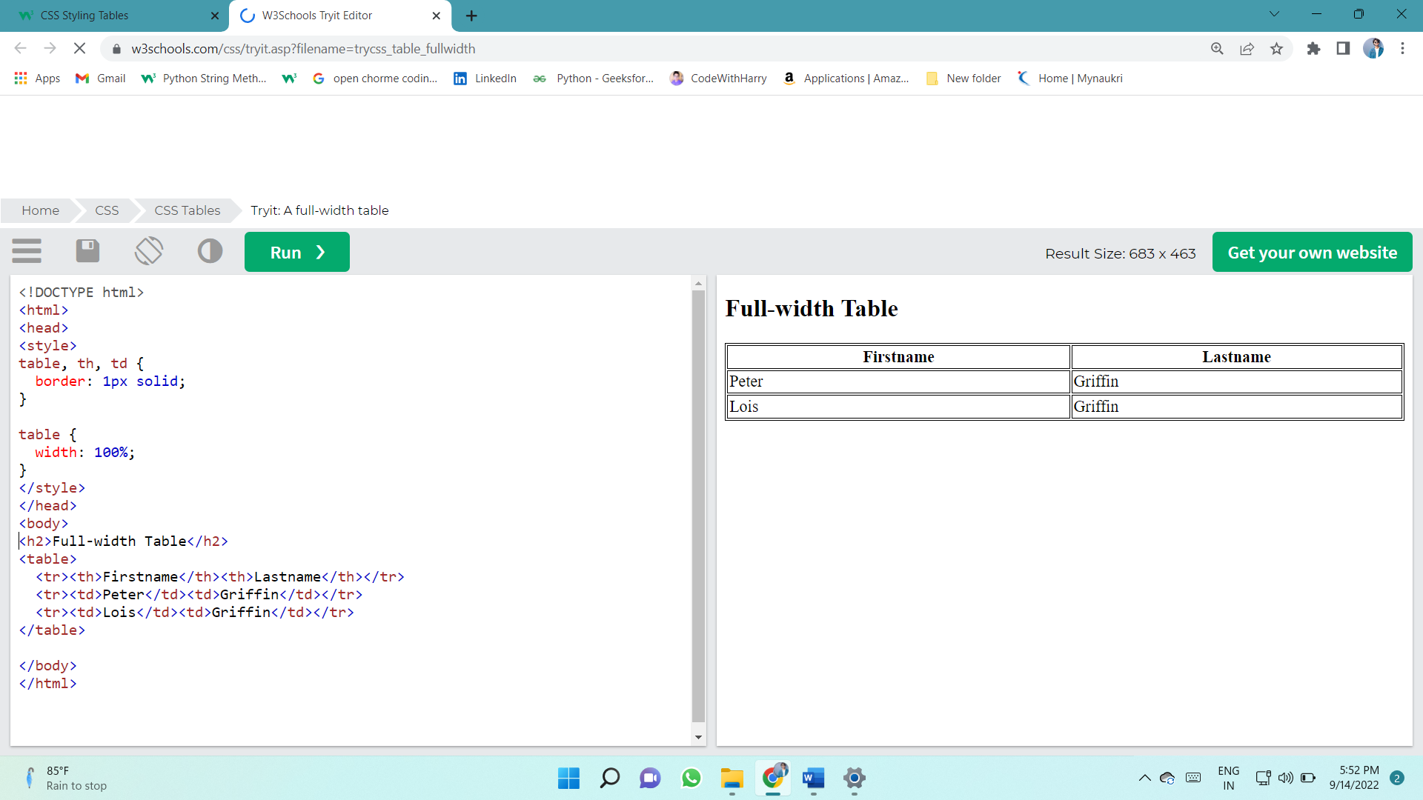

## Collapse Table Borders

The border-collapse property sets whether the table borders should be collapsed into a single border:

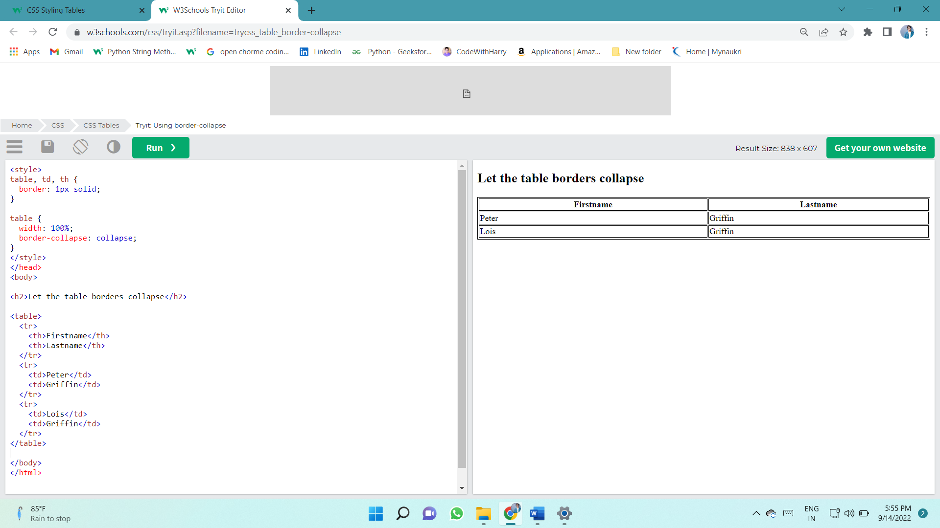

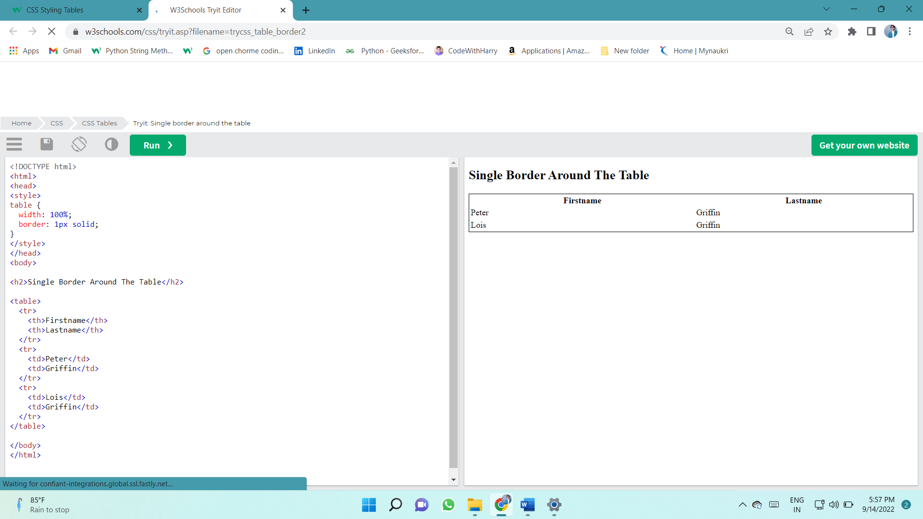

# Table

**Table Width and Height**

The width and height of a table are defined by the width and height properties.

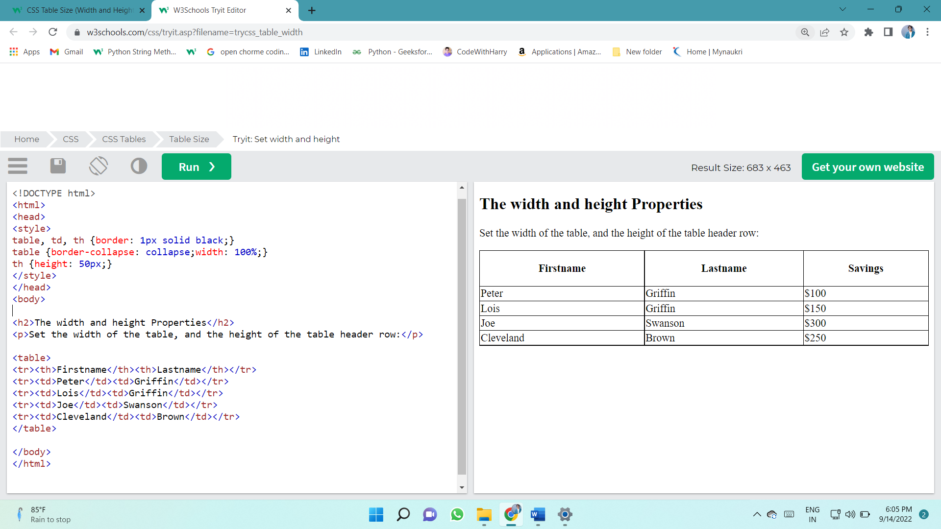

## Table Alignment

### Horizontal Alignment

The text-align property sets the horizontal alignment (like left, right, or center) of the content in <th> or <td>.

By default, the content of <th> elements are center-aligned and the content of <td> elements are left-aligned.

To center-align the content of  <td> elements as well, use text-align: center:

|  |  |  |
| --- | --- | --- |
| **Firstname** | **Lastname** | **Savings** |
| Peter | Griffin | $100 |
| Lois | Griffin | $150 |
| Joe | Swanson | $300 |

td {  
  text-align: center;  
}

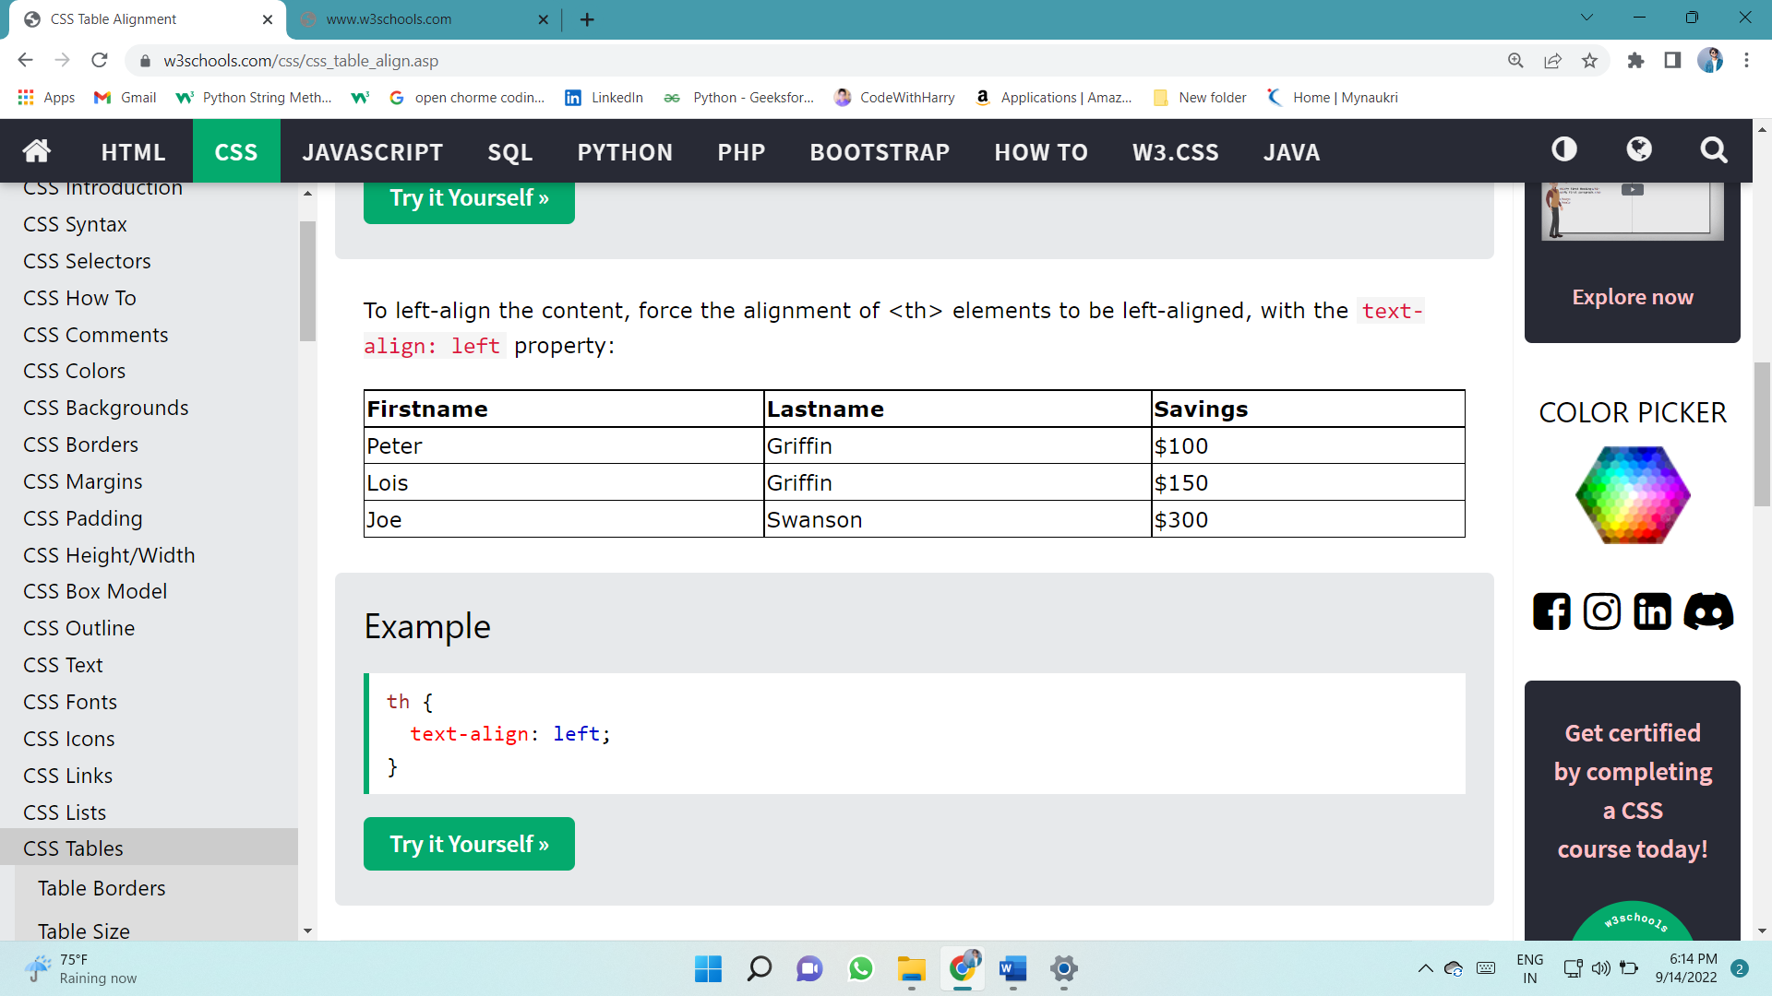

### Vertical Alignment

The vertical-align property sets the vertical alignment (like top, bottom, or middle) of the content in <th> or <td>.

By default, the vertical alignment of the content in a table is middle (for both <th> and <td> elements).

The following example sets the vertical text alignment to bottom for <td> elements:

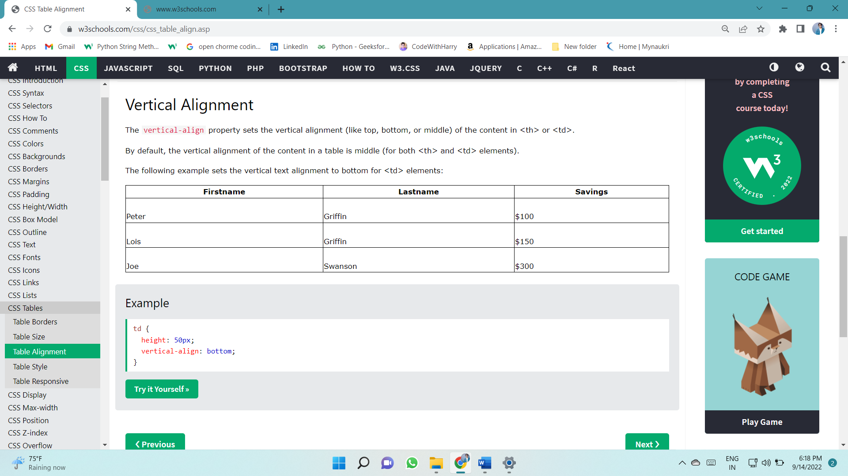

## Table Style

### Table Padding

To control the space between the border and the content in a table, use the padding property on <td> and <th> elements:

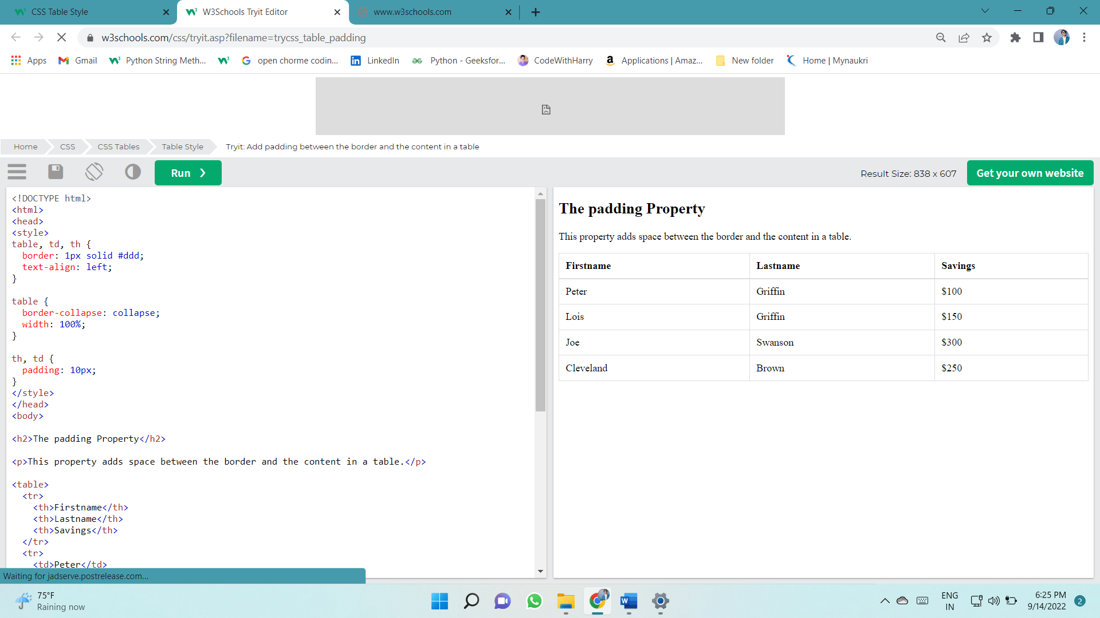

### Horizontal Dividers

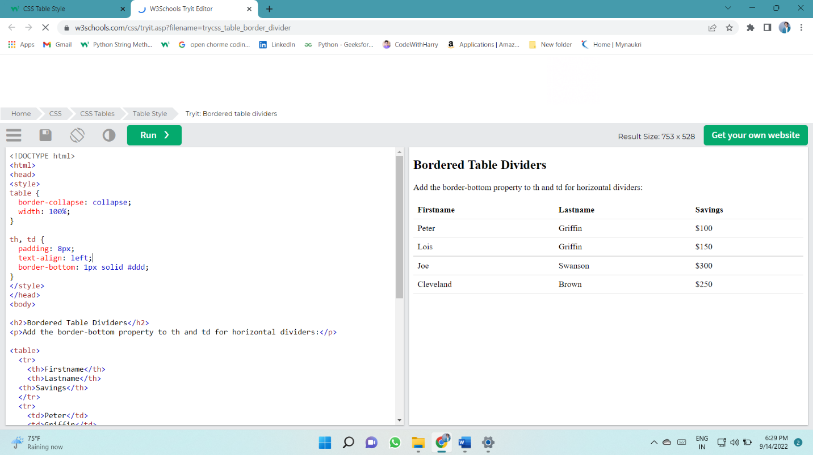Add the border-bottom property to <th> and <td> for horizontal dividers:

### Hoverable Table

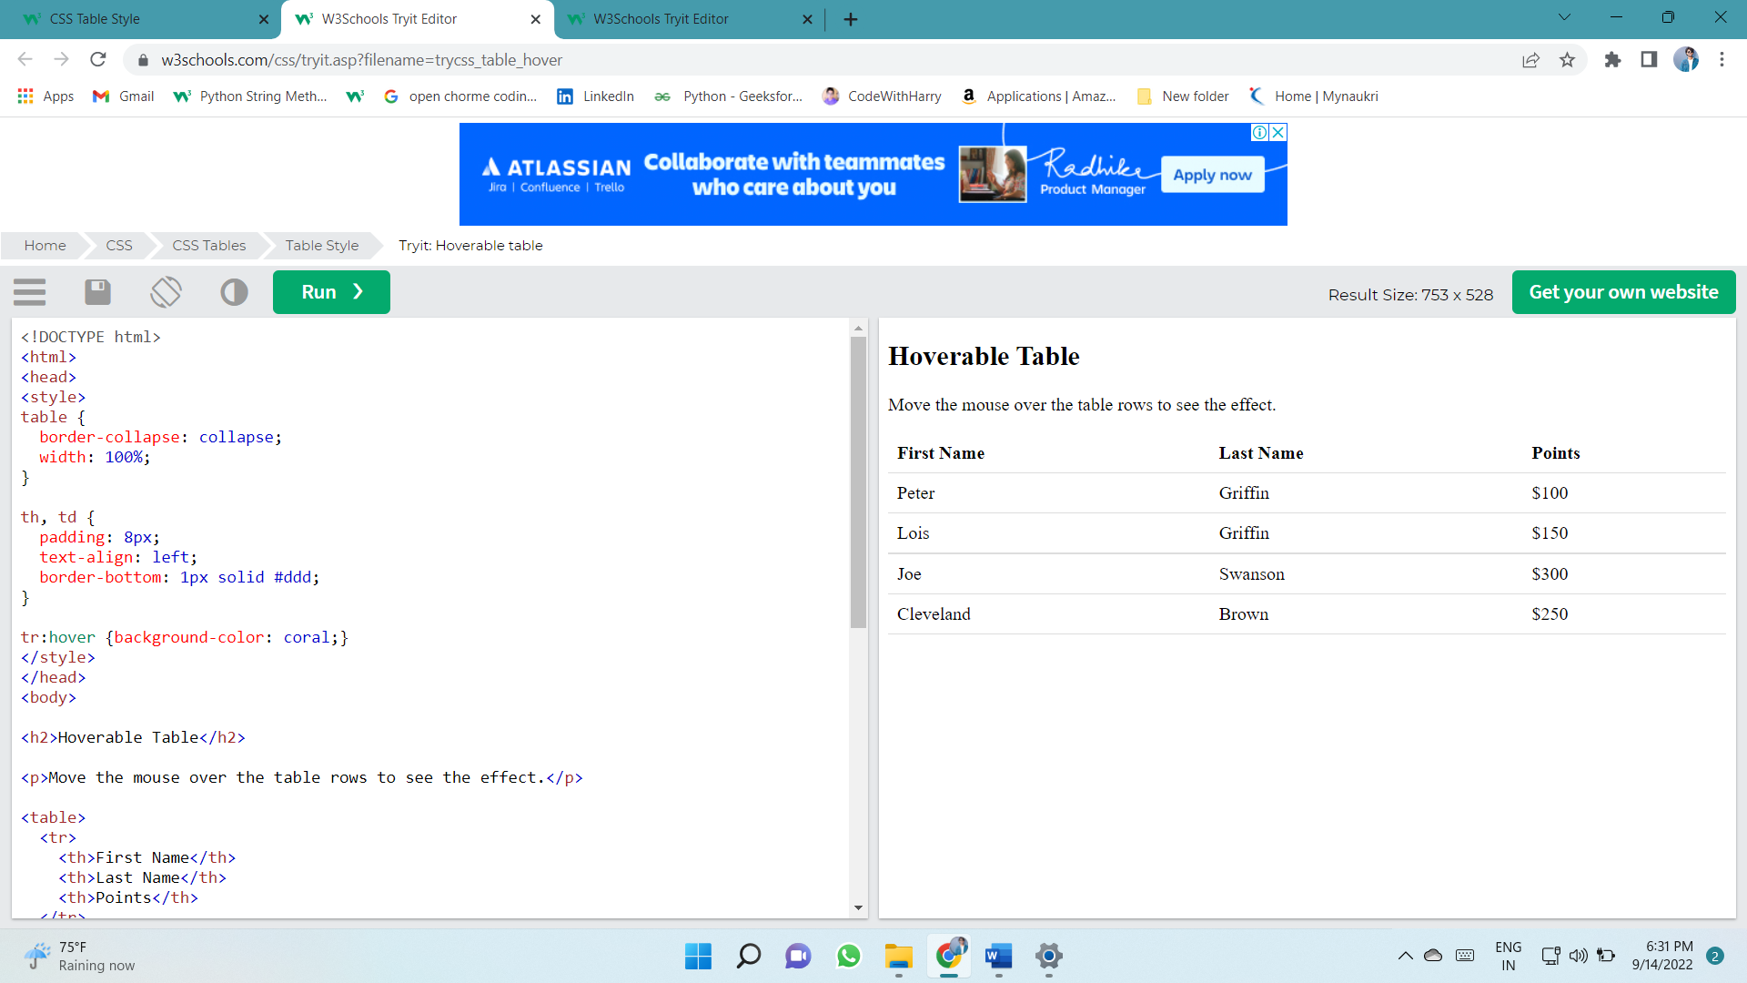Use the :hover selector on <tr> to highlight table rows on mouse over:

### Striped Tables

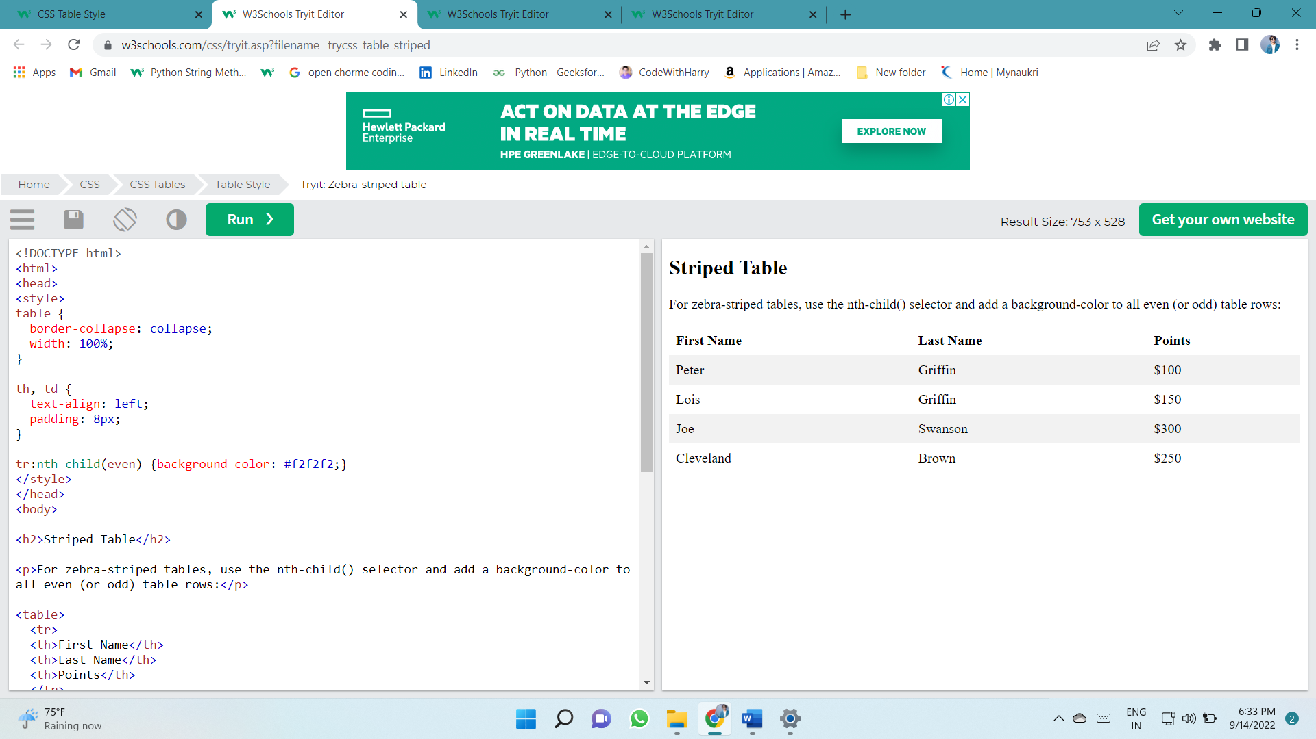For zebra-striped tables, use the nth-child() selector and add a background-color to all even (or odd) table rows:

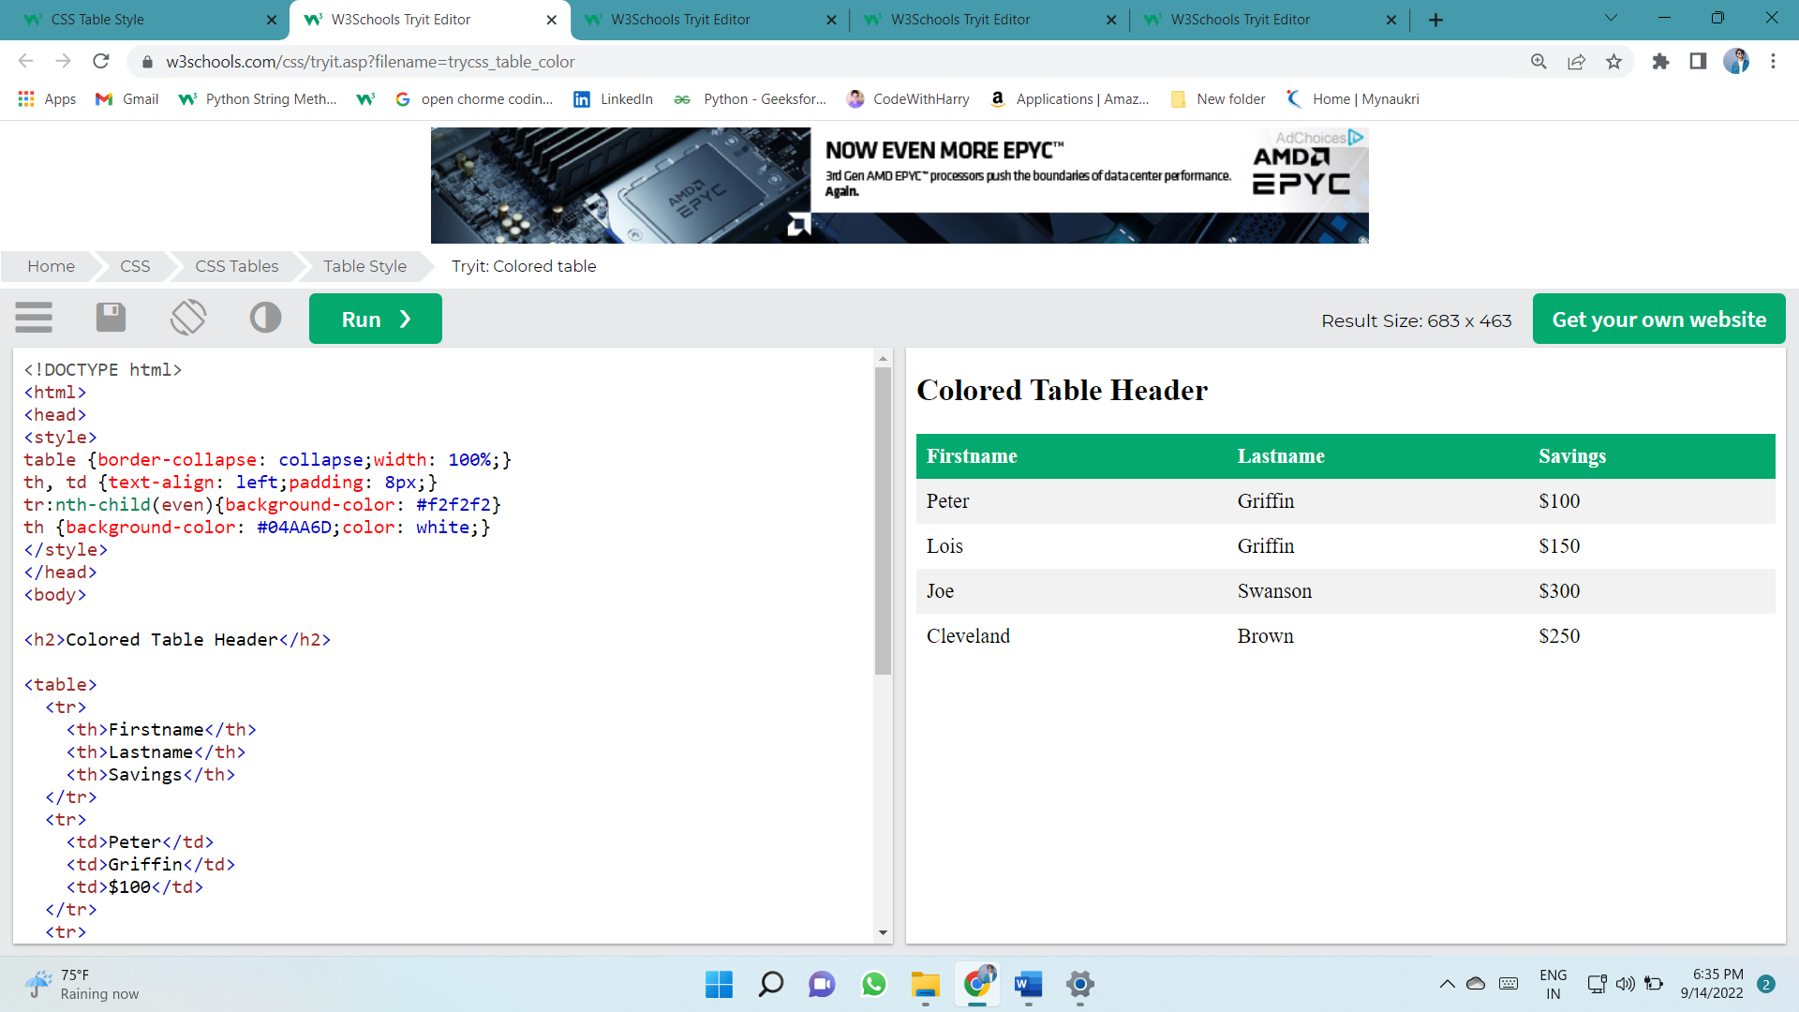

### Responsive Table

A responsive table will display a horizontal scroll bar if the screen is too small to display the full content:

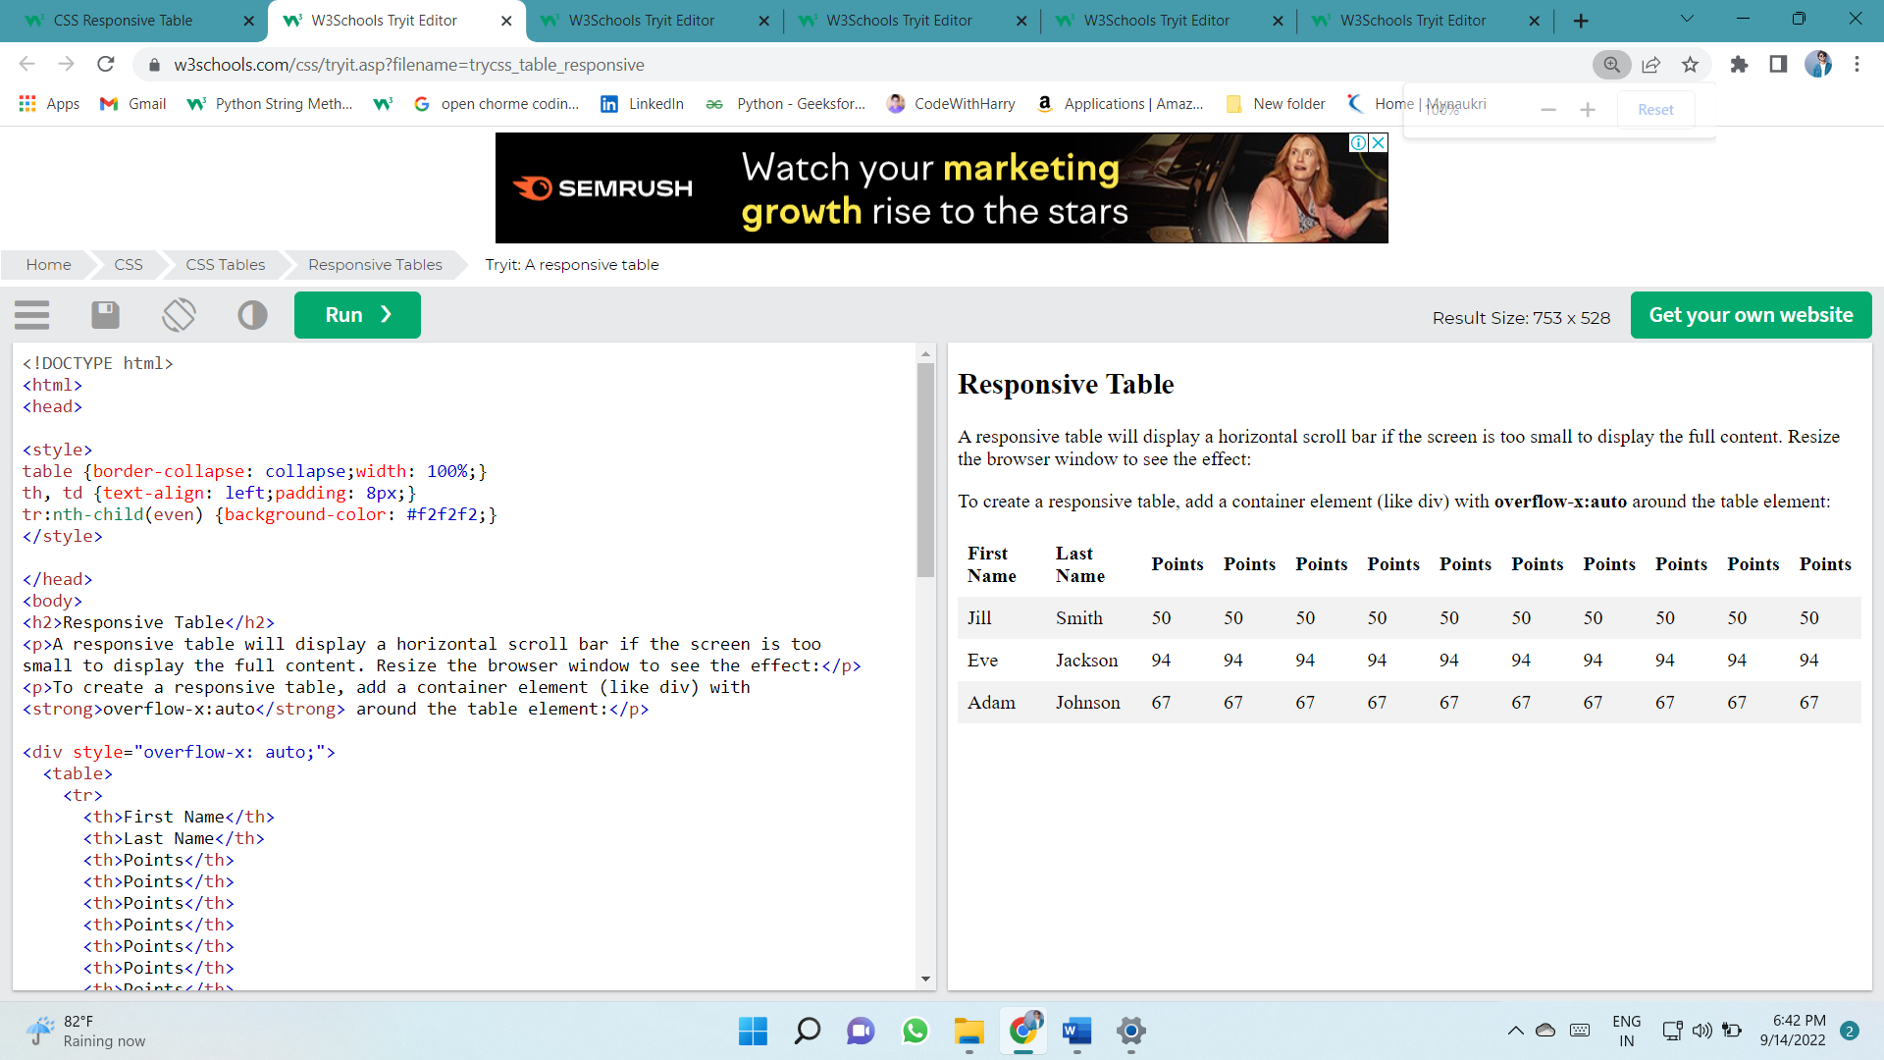Add a container element (like <div>) with overflow-x:auto around the <table> element to make it responsive:

# DISPLAY

## The display Property

The display property specifies if/how an element is displayed.

Every HTML element has a default display value depending on what type of element it is. The default display value for most elements is block or inline.

### Block-level Elements

A block-level element always starts on a new line and takes up the full width available (stretches out to the left and right as far as it can).

The <div> element is a block-level element.

Examples of block-level elements:

* <div>
* <h1> - <h6>
* <p>
* <form>
* <header>
* <footer>
* <section>

### Inline Elements

An inline element does not start on a new line and only takes up as much width as necessary.

This is an inline <span> element inside a paragraph.

Examples of inline elements:

* <span>
* <a>
* <img>

### Display: none;

display: none; is commonly used with JavaScript to hide and show elements without deleting and recreating them.

Take a look at our last example on this page if you want to know how this can be achieved.

The <script> element uses display: none; as default.

### Override The Default Display Value

As mentioned, every element has a default display value. However, you can override this.

Changing an inline element to a block element, or vice versa, can be useful for making the page look a specific way, and still follow the web standards.

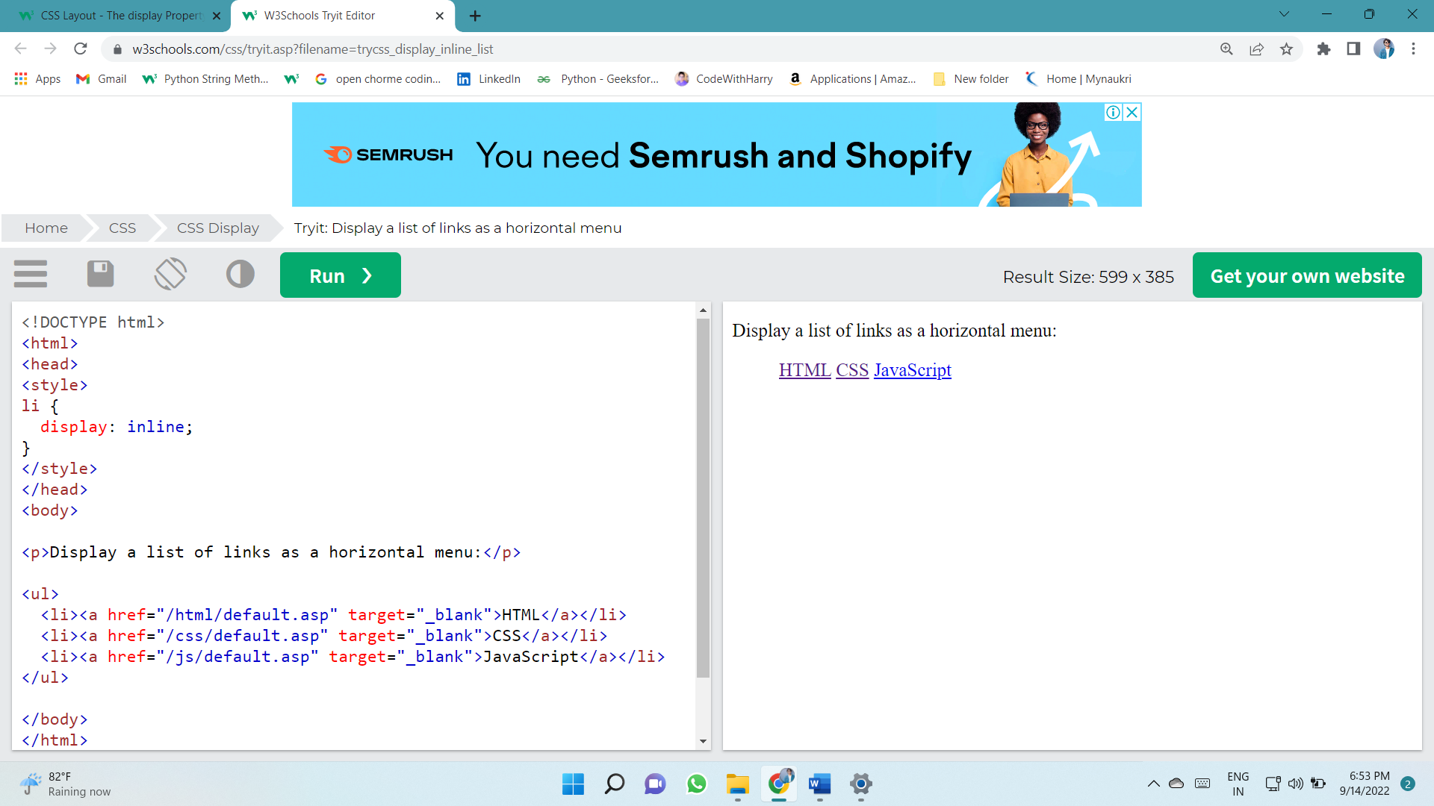A common example is making inline <li> elements for horizontal menus:

**Note:** Setting the display property of an element only changes **how the element is displayed**, NOT what kind of element it is. So, an inline element with display: block; is not allowed to have other block elements inside it.

The following example displays <span> elements as block elements:

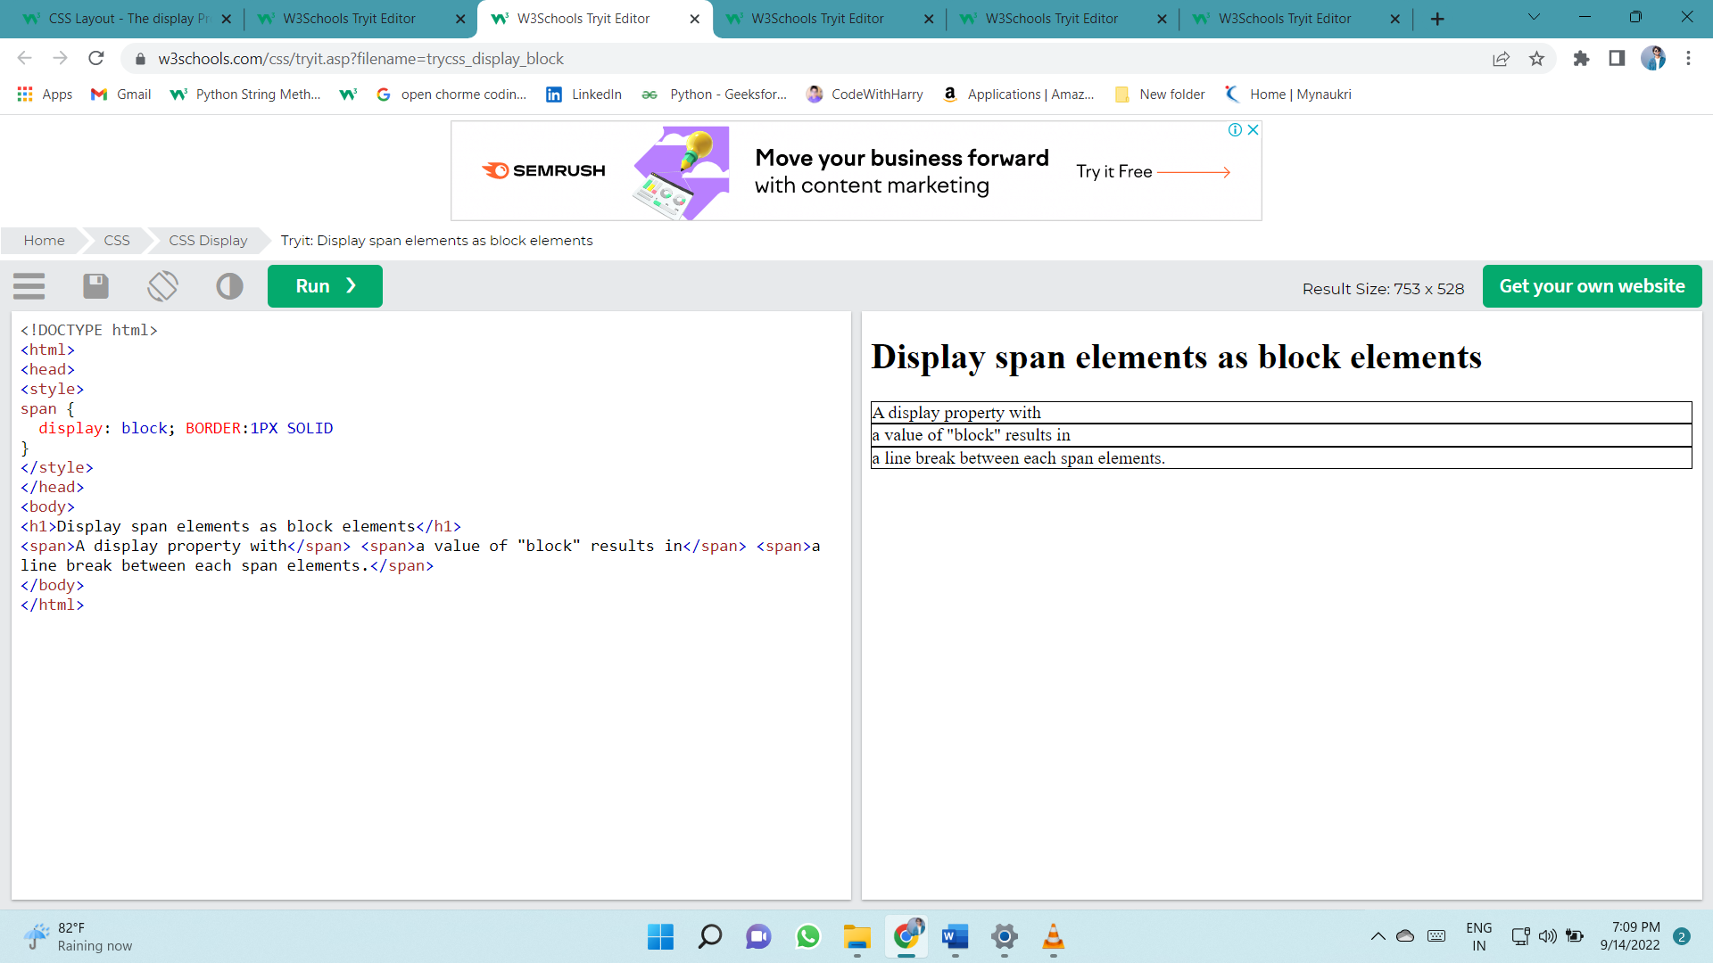

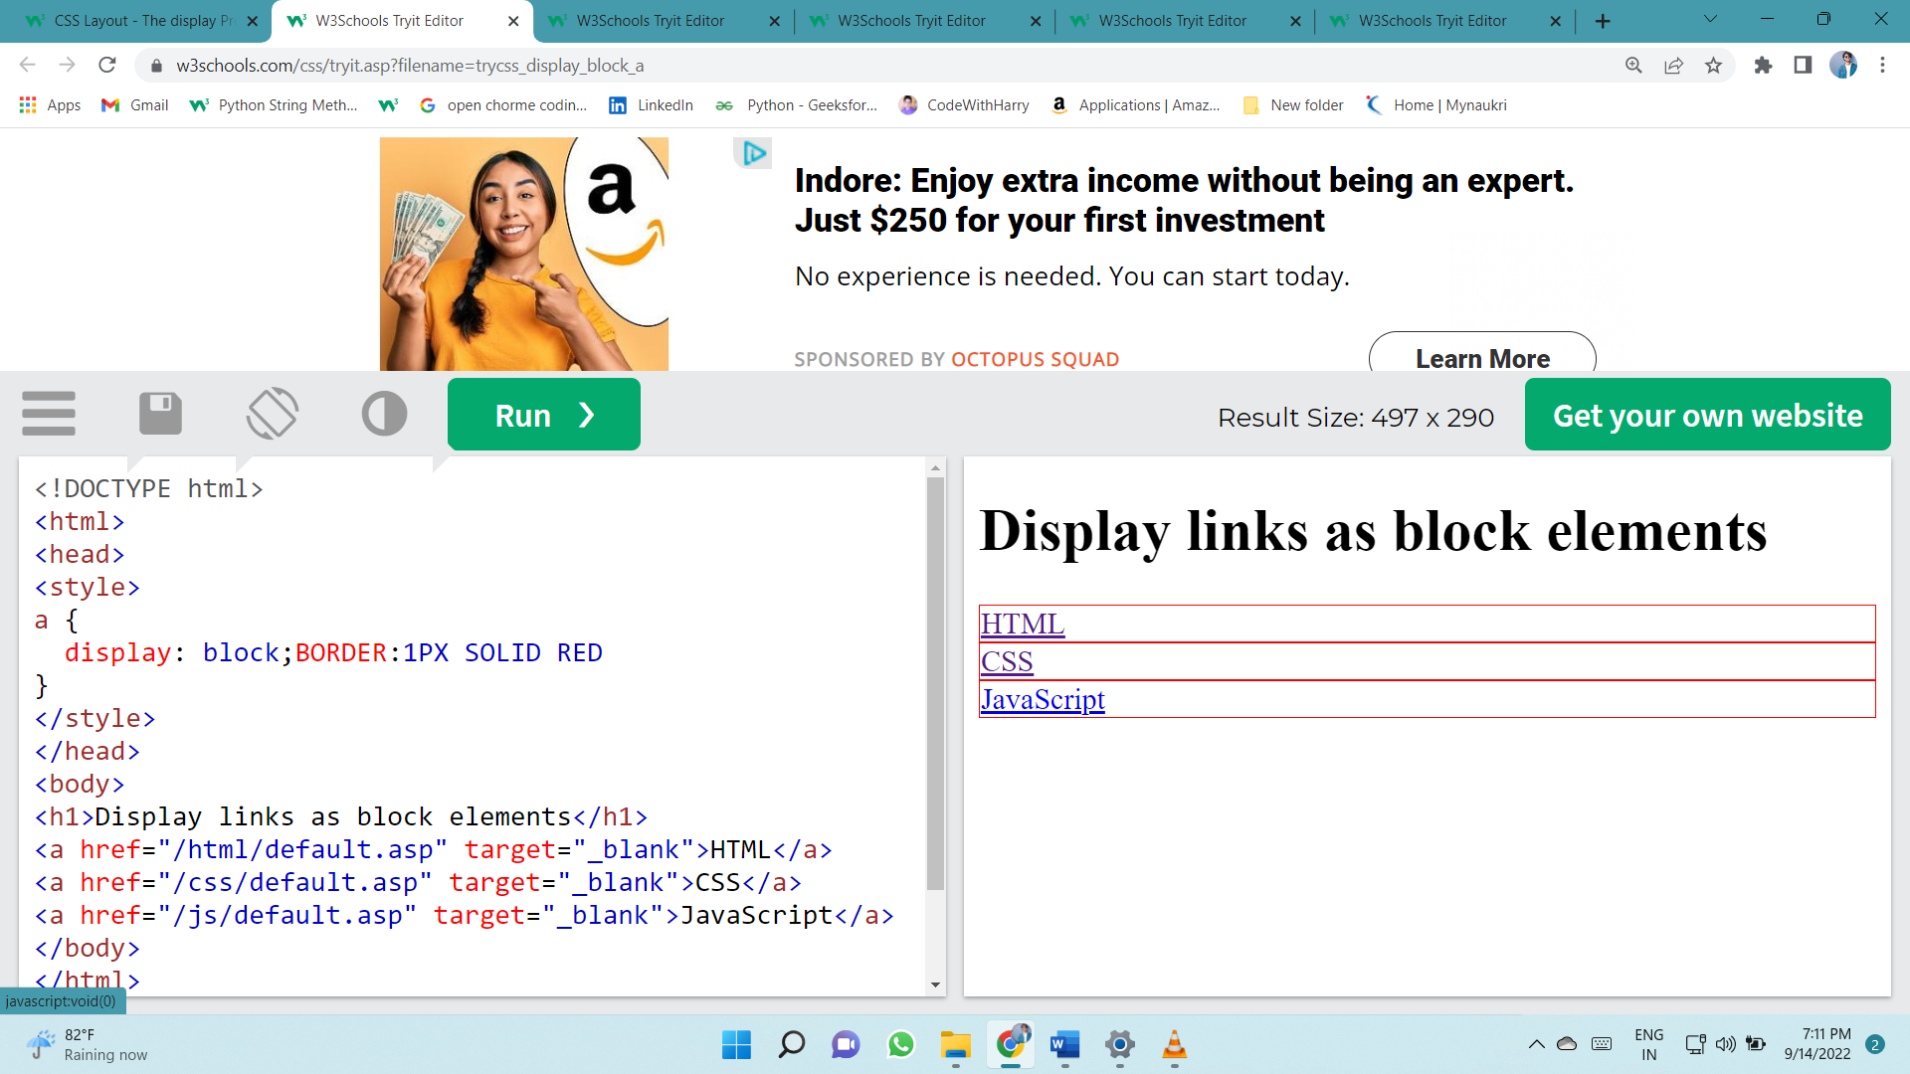The following example displays <a> elements as block elements:

### Hide an Element - display:none or visibility:hidden?

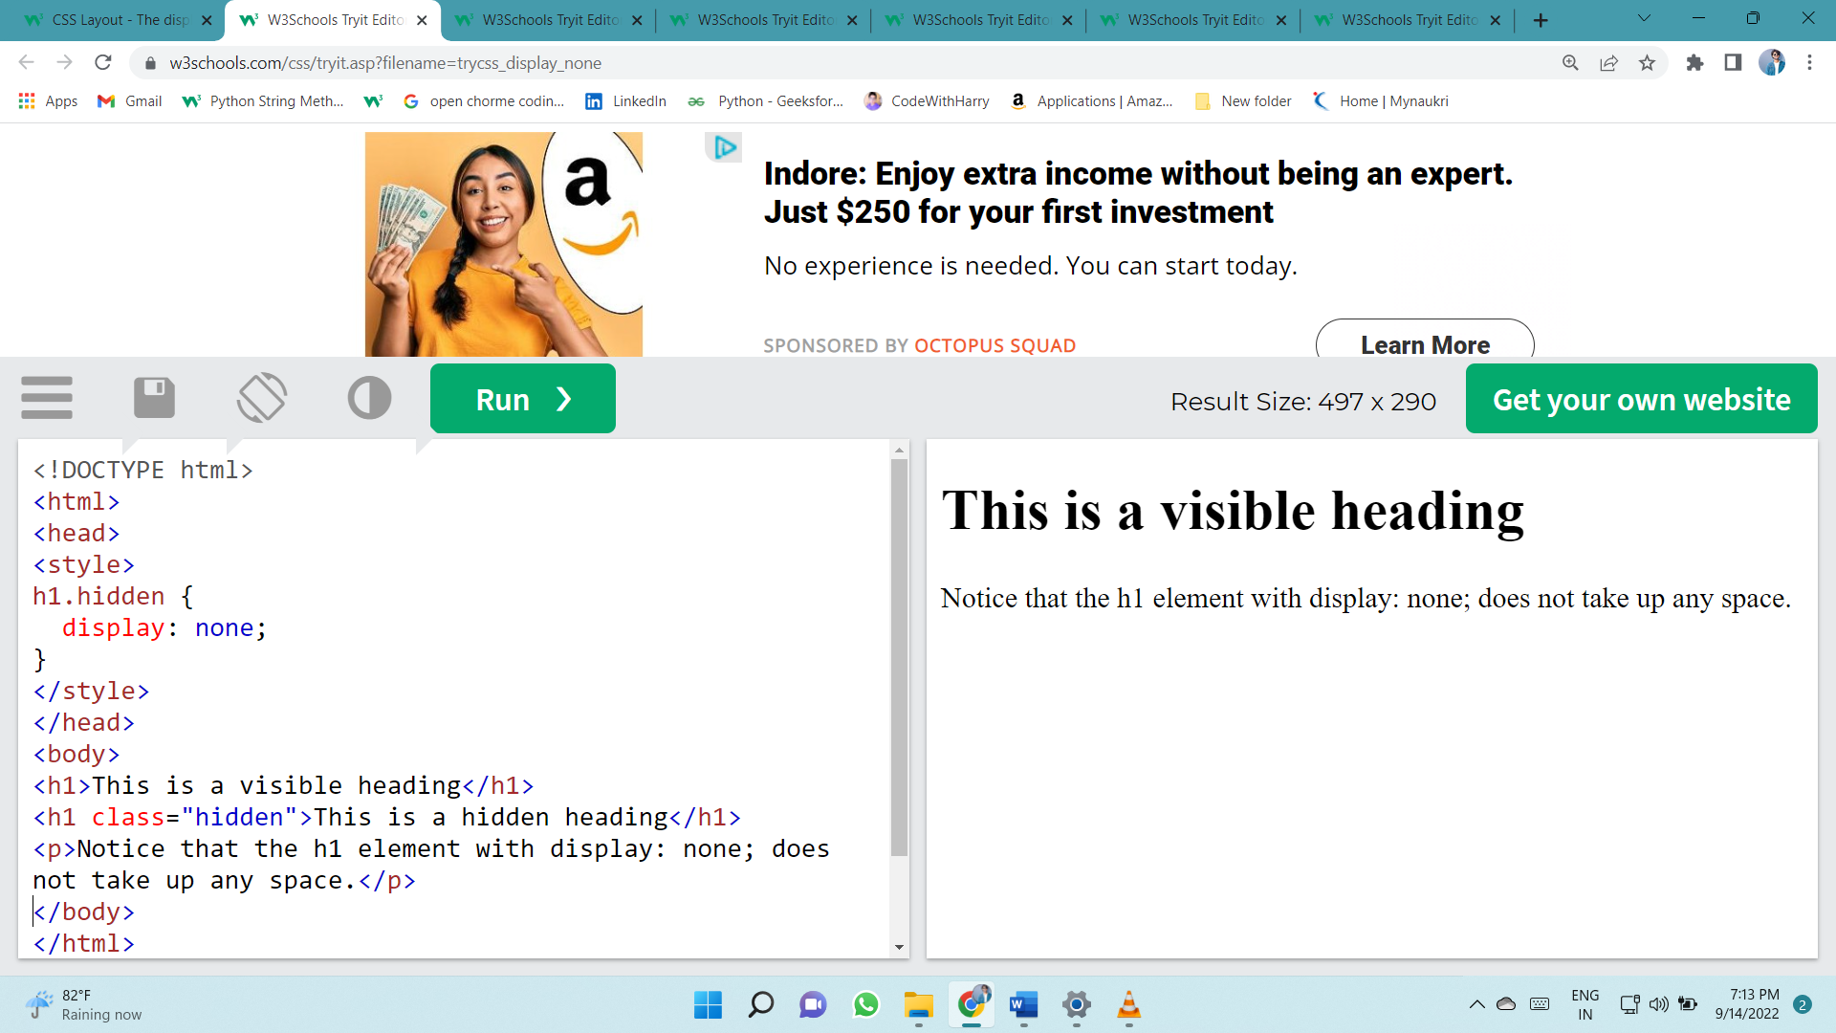Hiding an element can be done by setting the display property to none. The element will be hidden, and the page will be displayed as if the element is not there:

visibility:hidden; also hides an element.

However, the element will still take up the same space as before. The element will be hidden, but still affect the layout:

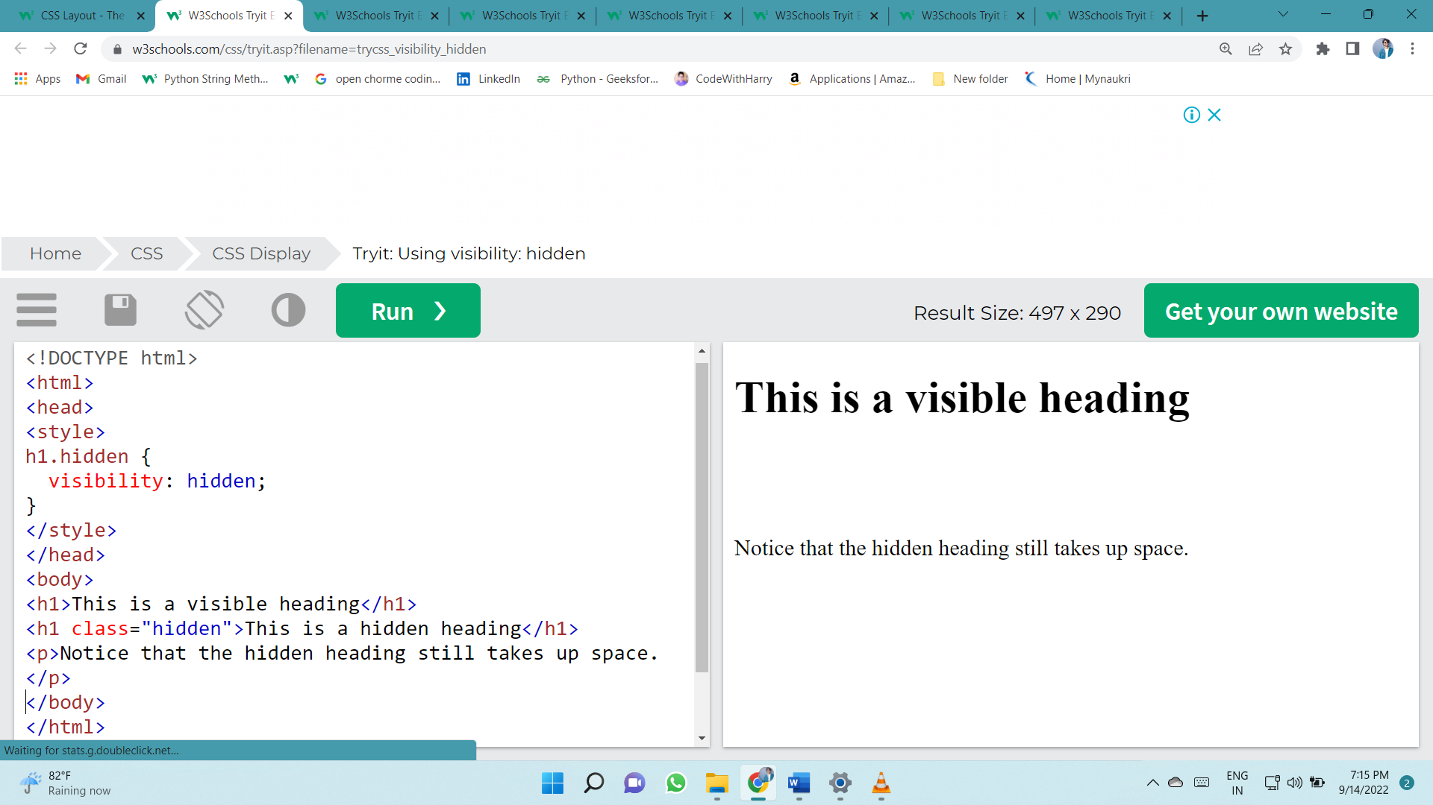

# Layout - width and max-width

### Using width, max-width and margin: auto;

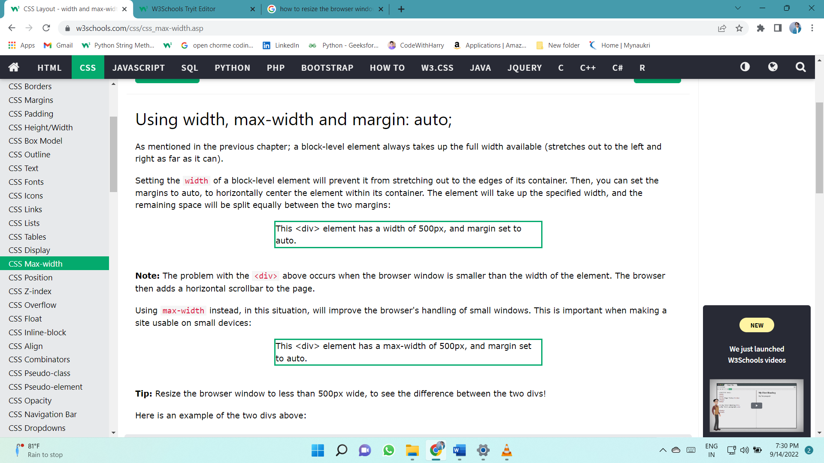

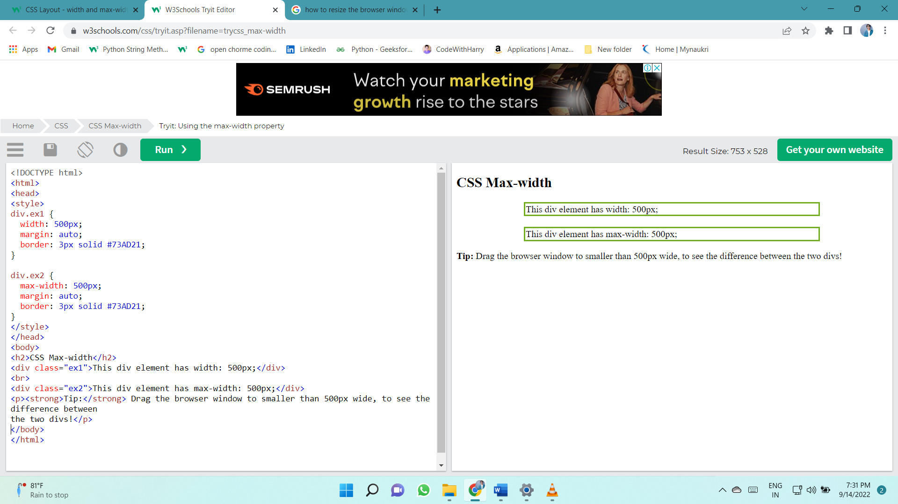

# POSITION

**The position Property**

The position property specifies the type of positioning method used for an element.

There are five different position values:

* static
* relative
* fixed
* absolute
* sticky

Elements are then positioned using the top, bottom, left, and right properties.

However, these properties will not work unless the position property is set first. They also work differently depending on the position value.

## position: static;

HTML elements are positioned static by default.

Static positioned elements are not affected by the top, bottom, left, and right properties.

An element with position: static; is not positioned in any special way; it is always positioned according to the normal flow of the page:

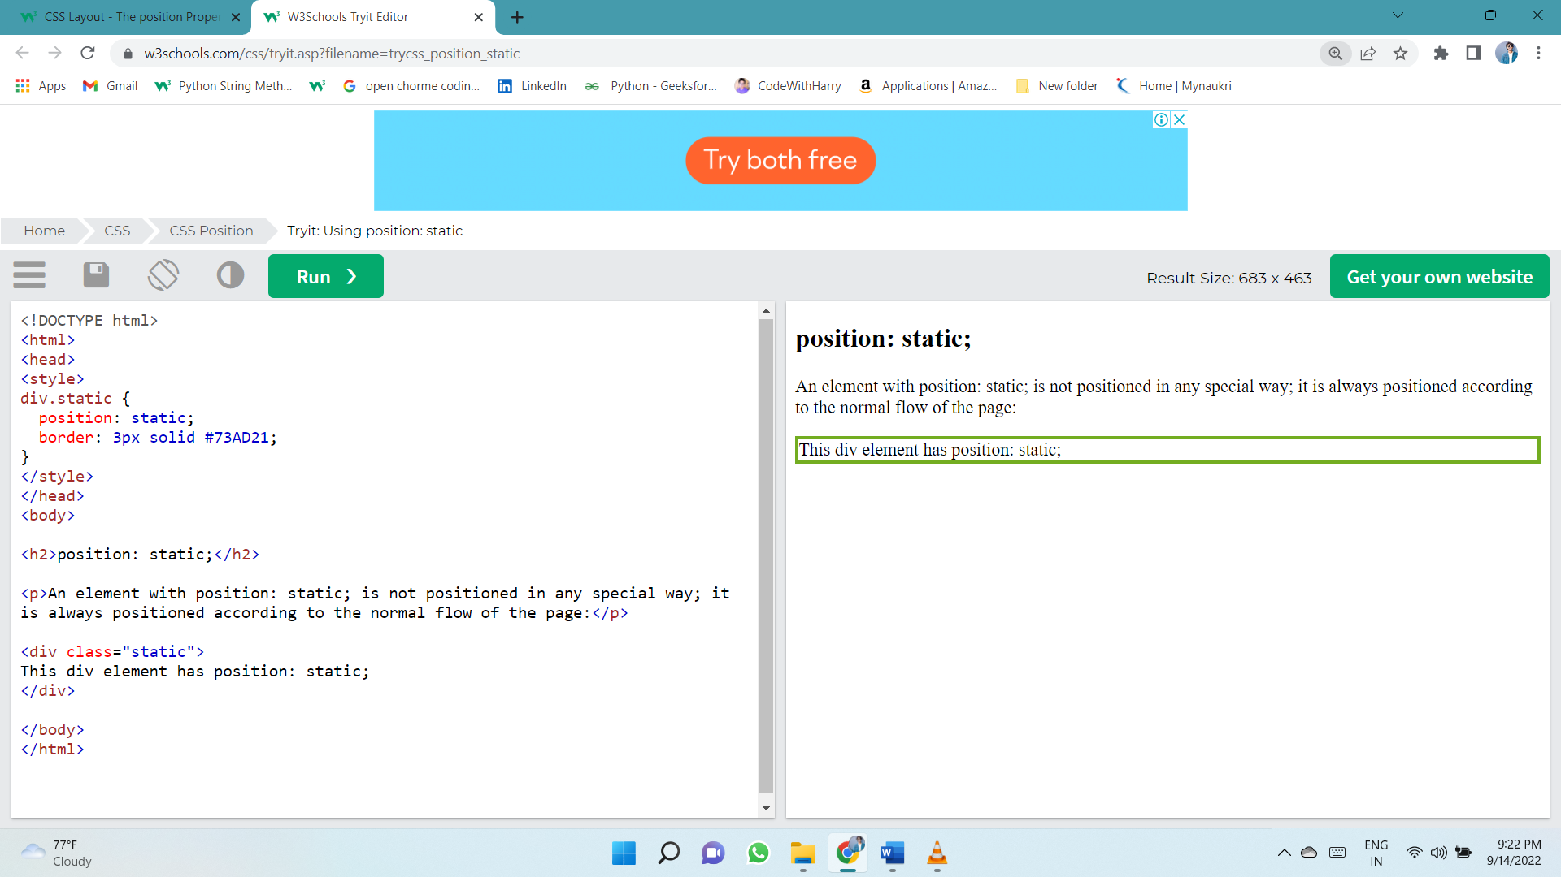

## position: relative;

An element with position: relative; is positioned relative to its normal position.

Setting the top, right, bottom, and left properties of a relatively-positioned element will cause it to be adjusted away from its normal position.

Other content will not be adjusted to fit into any gap left by the element.

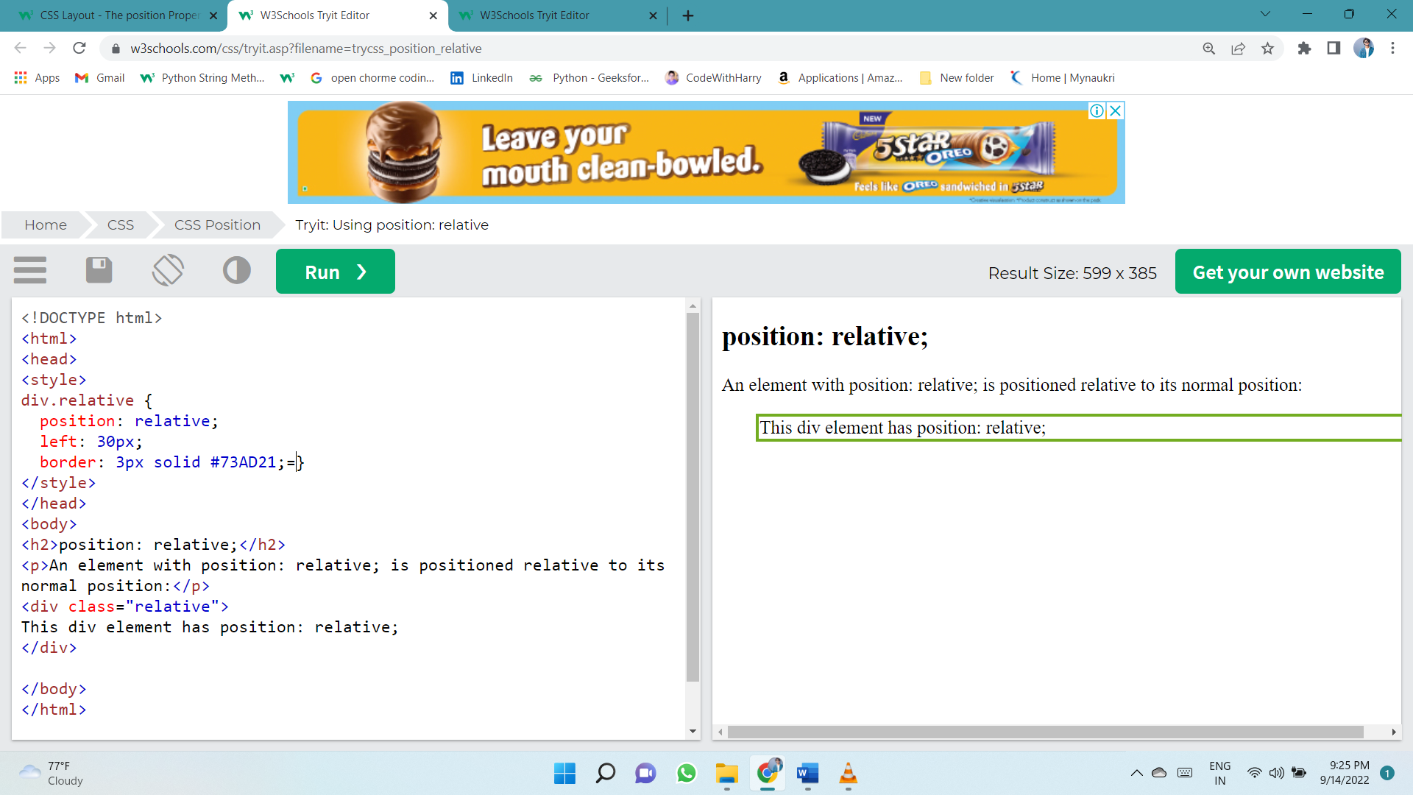

## position: fixed;

An element with position: fixed; is positioned relative to the viewport, which means it always stays in the same place even if the page is scrolled. The top, right, bottom, and left properties are used to position the element.

A fixed element does not leave a gap in the page where it would normally have been located.

Notice the fixed element in the lower-right corner of the page. Here is the CSS that is used:

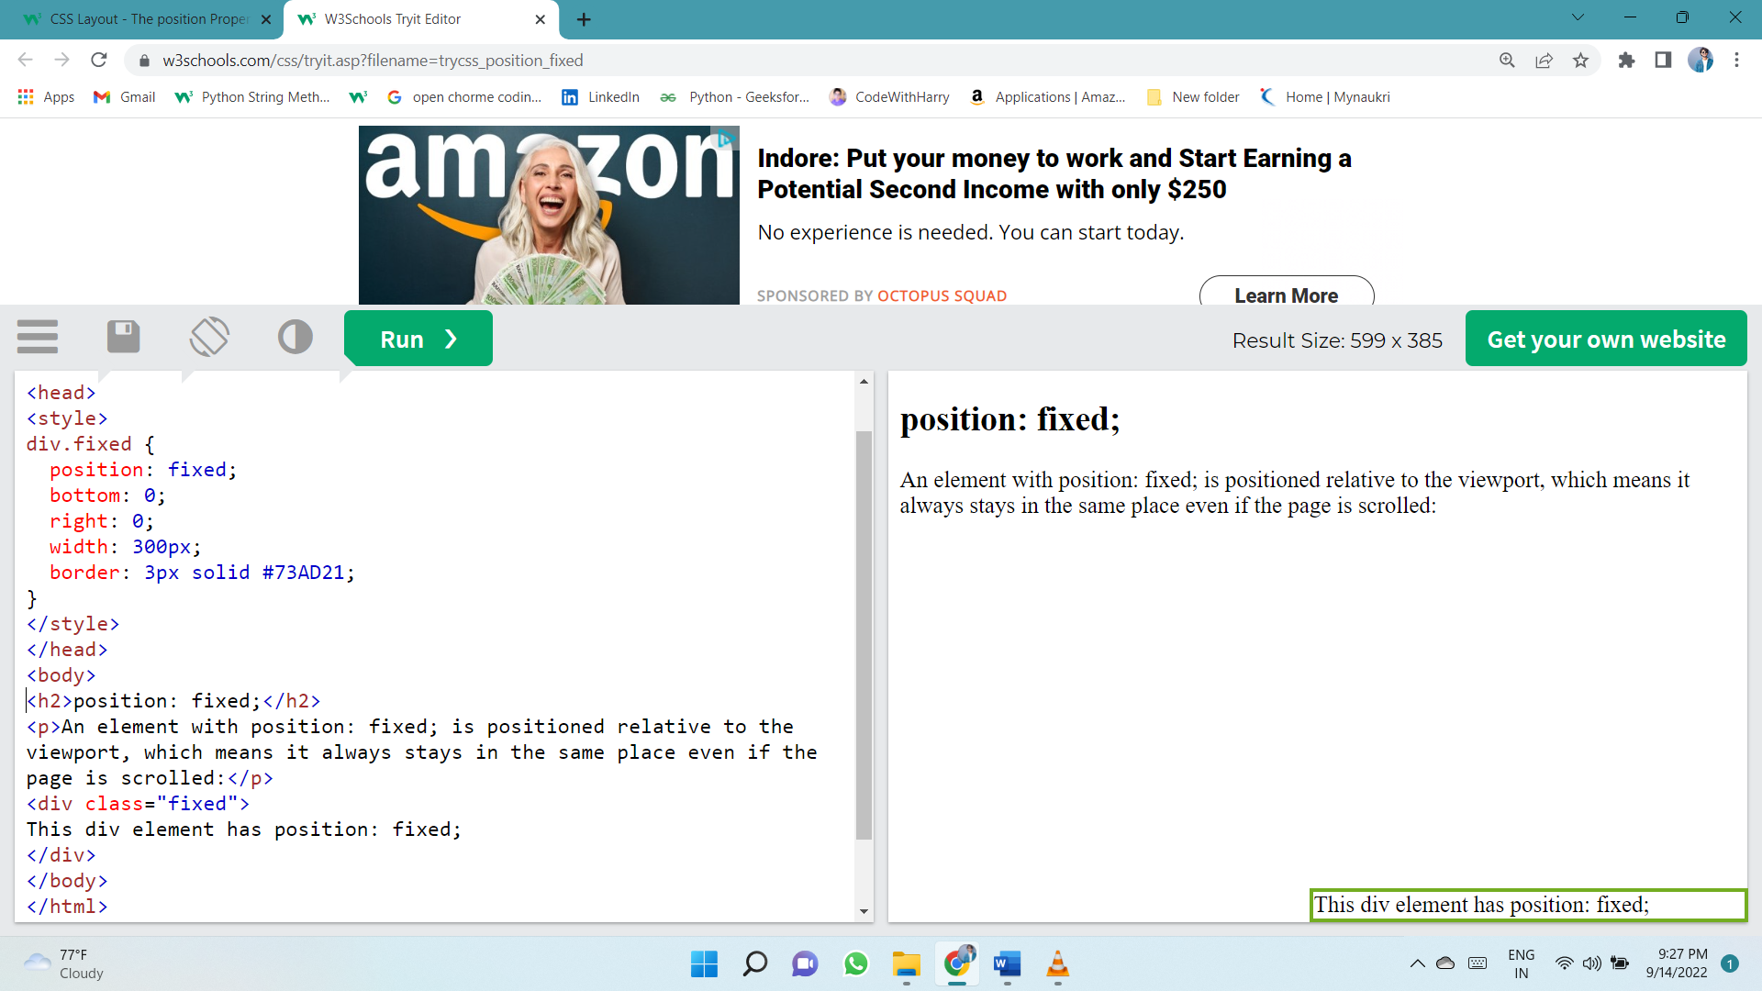

## position: absolute;

An element with position: absolute; is positioned relative to the nearest positioned ancestor (instead of positioned relative to the viewport, like fixed).

However; if an absolute positioned element has no positioned ancestors, it uses the document body, and moves along with page scrolling.

**Note:** Absolute positioned elements are removed from the normal flow, and can overlap elements.

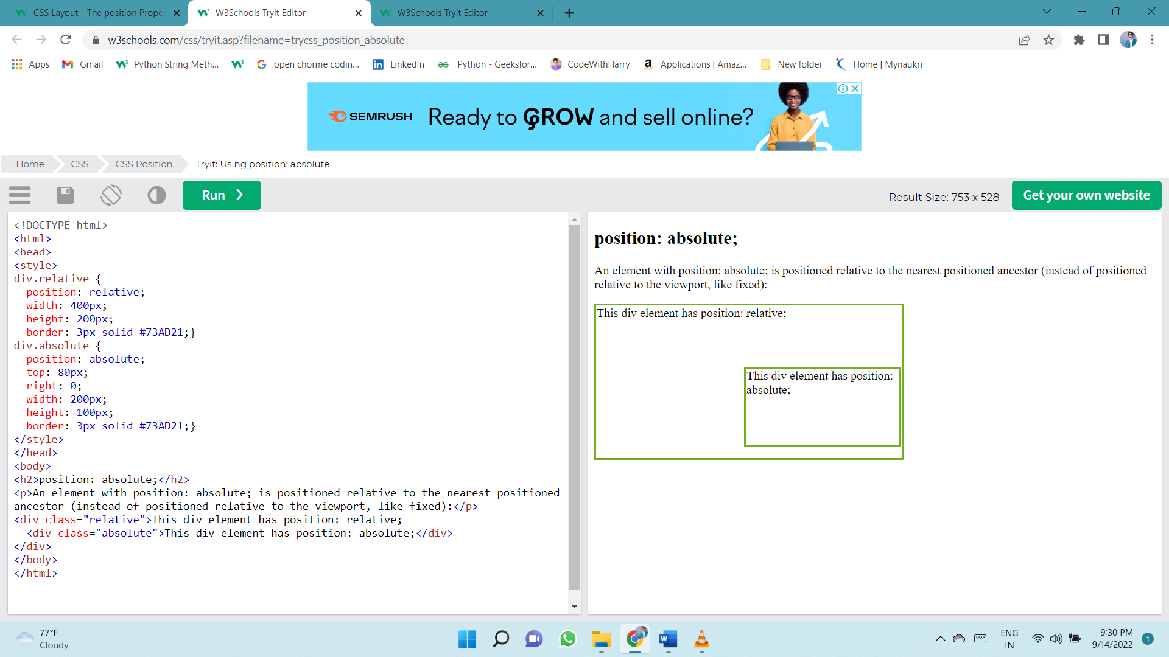

## position: sticky;

An element with position: sticky; is positioned based on the user's scroll position.

A sticky element toggles between relative and fixed, depending on the scroll position. It is positioned relative until a given offset position is met in the viewport - then it "sticks" in place (like position:fixed).

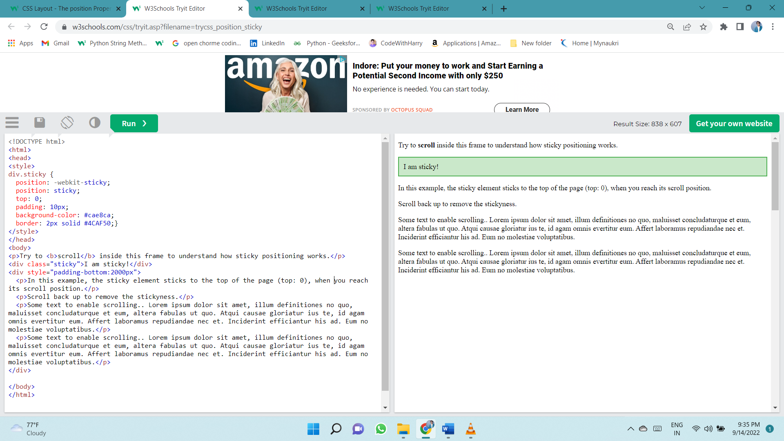

# Z-INDEX

The z-index Property

When elements are positioned, they can overlap other elements.

The z-index property specifies the stack order of an element (which element should be placed in front of, or behind, the others).

An element can have a positive or negative stack order:

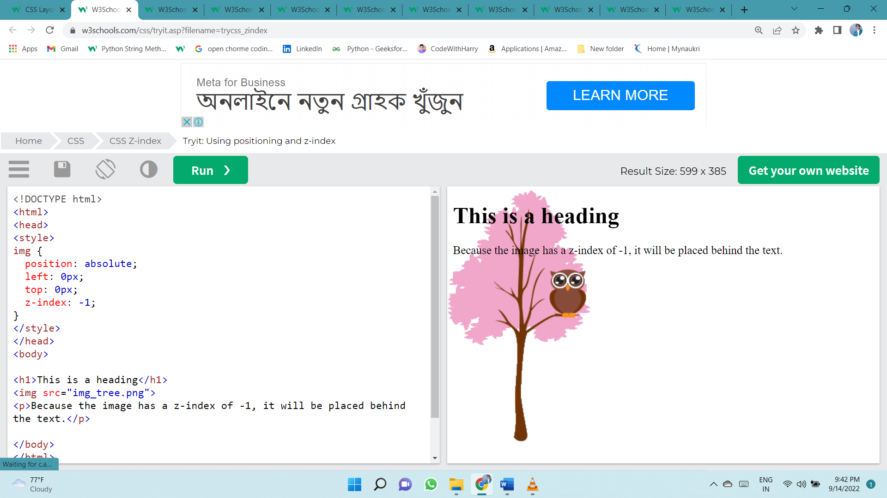

**Note:** z-index only works on [positioned elements](https://www.w3schools.com/css/css_positioning.asp) (position: absolute, position: relative, position: fixed, or position: sticky) and [flex items](https://www.w3schools.com/css/css3_flexbox.asp) (elements that are direct children of display: flex elements).

# OVERFLOW

The overflow property specifies whether to clip the content or to add scrollbars when the content of an element is too big to fit in the specified area.

The overflow property has the following values:

* visible - Default. The overflow is not clipped. The content renders outside the element's box
* hidden - The overflow is clipped, and the rest of the content will be invisible
* scroll - The overflow is clipped, and a scrollbar is added to see the rest of the content
* auto - Similar to scroll, but it adds scrollbars only when necessary

**Note:** The overflow property only works for block elements with a specified height.

## overflow: visible

By default, the overflow is visible, meaning that it is not clipped and it renders outside the element's box:

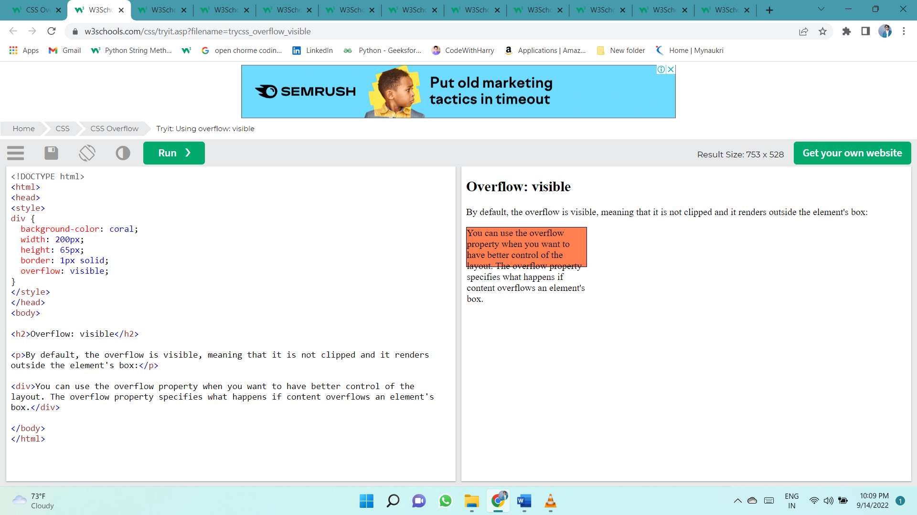

## overflow: scroll

Setting the value to scroll, the overflow is clipped and a scrollbar is added to scroll inside the box. Note that this will add a scrollbar both horizontally and vertically (even if you do not need it):

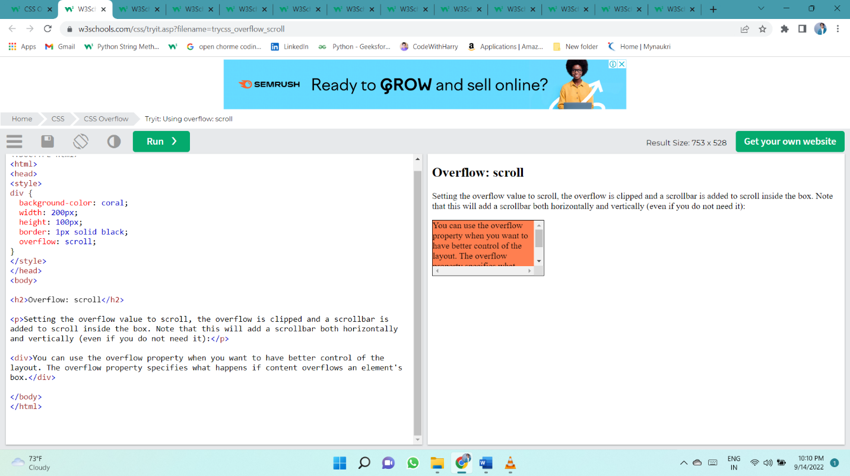

## overflow: auto

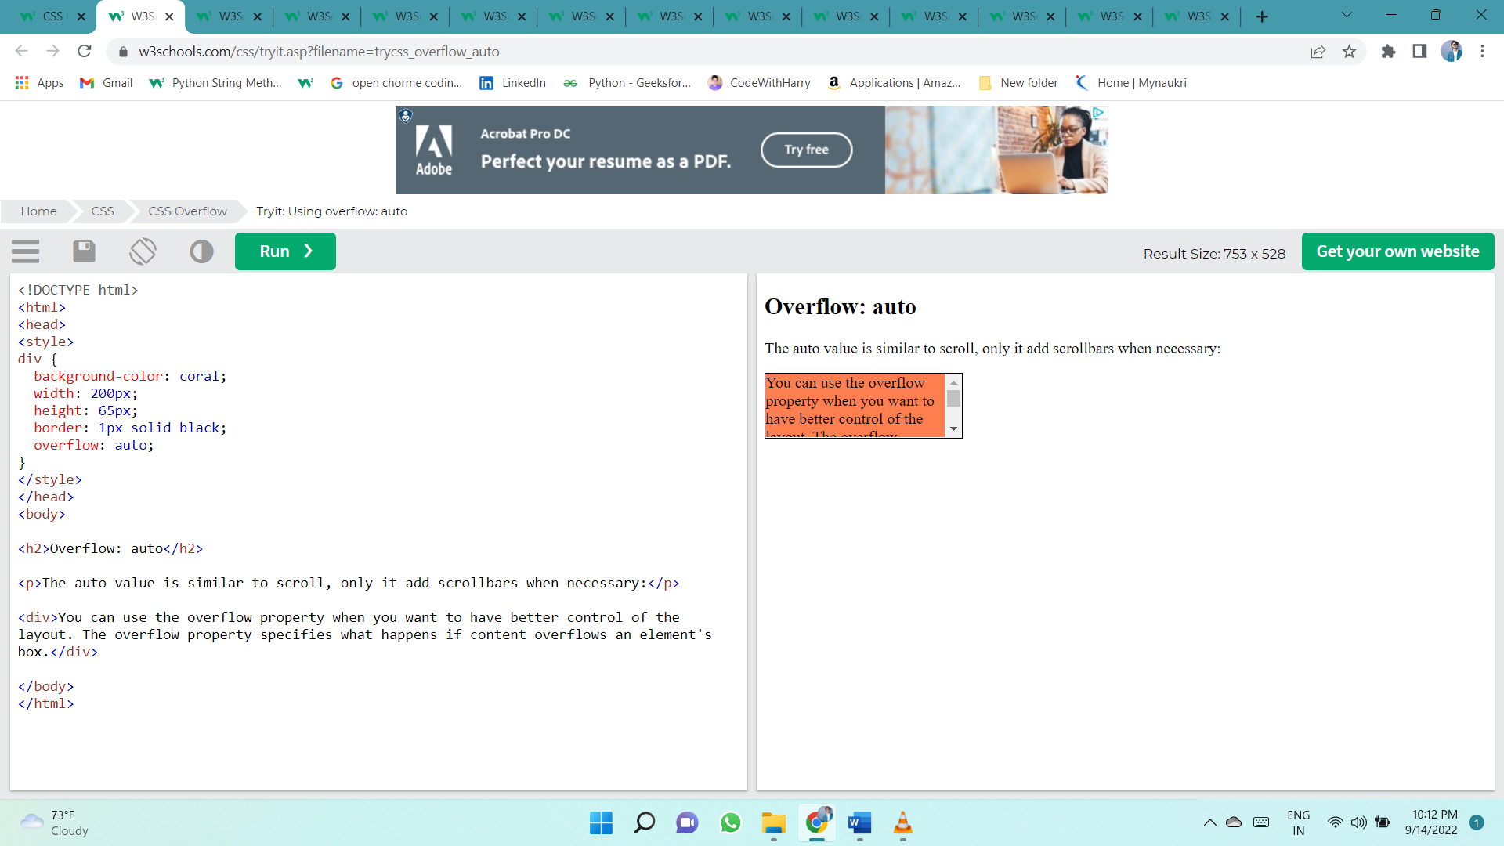The auto value is similar to scroll, but it adds scrollbars only when necessary:

## overflow-x and overflow-y

The overflow-x and overflow-y properties specifies whether to change the overflow of content just horizontally or vertically (or both):

overflow-x specifies what to do with the left/right edges of the content.  
overflow-y specifies what to do with the top/bottom edges of the content.

div {  
  overflow-x: hidden; /* Hide horizontal scrollbar */  
  overflow-y: scroll; /* Add vertical scrollbar */  
}

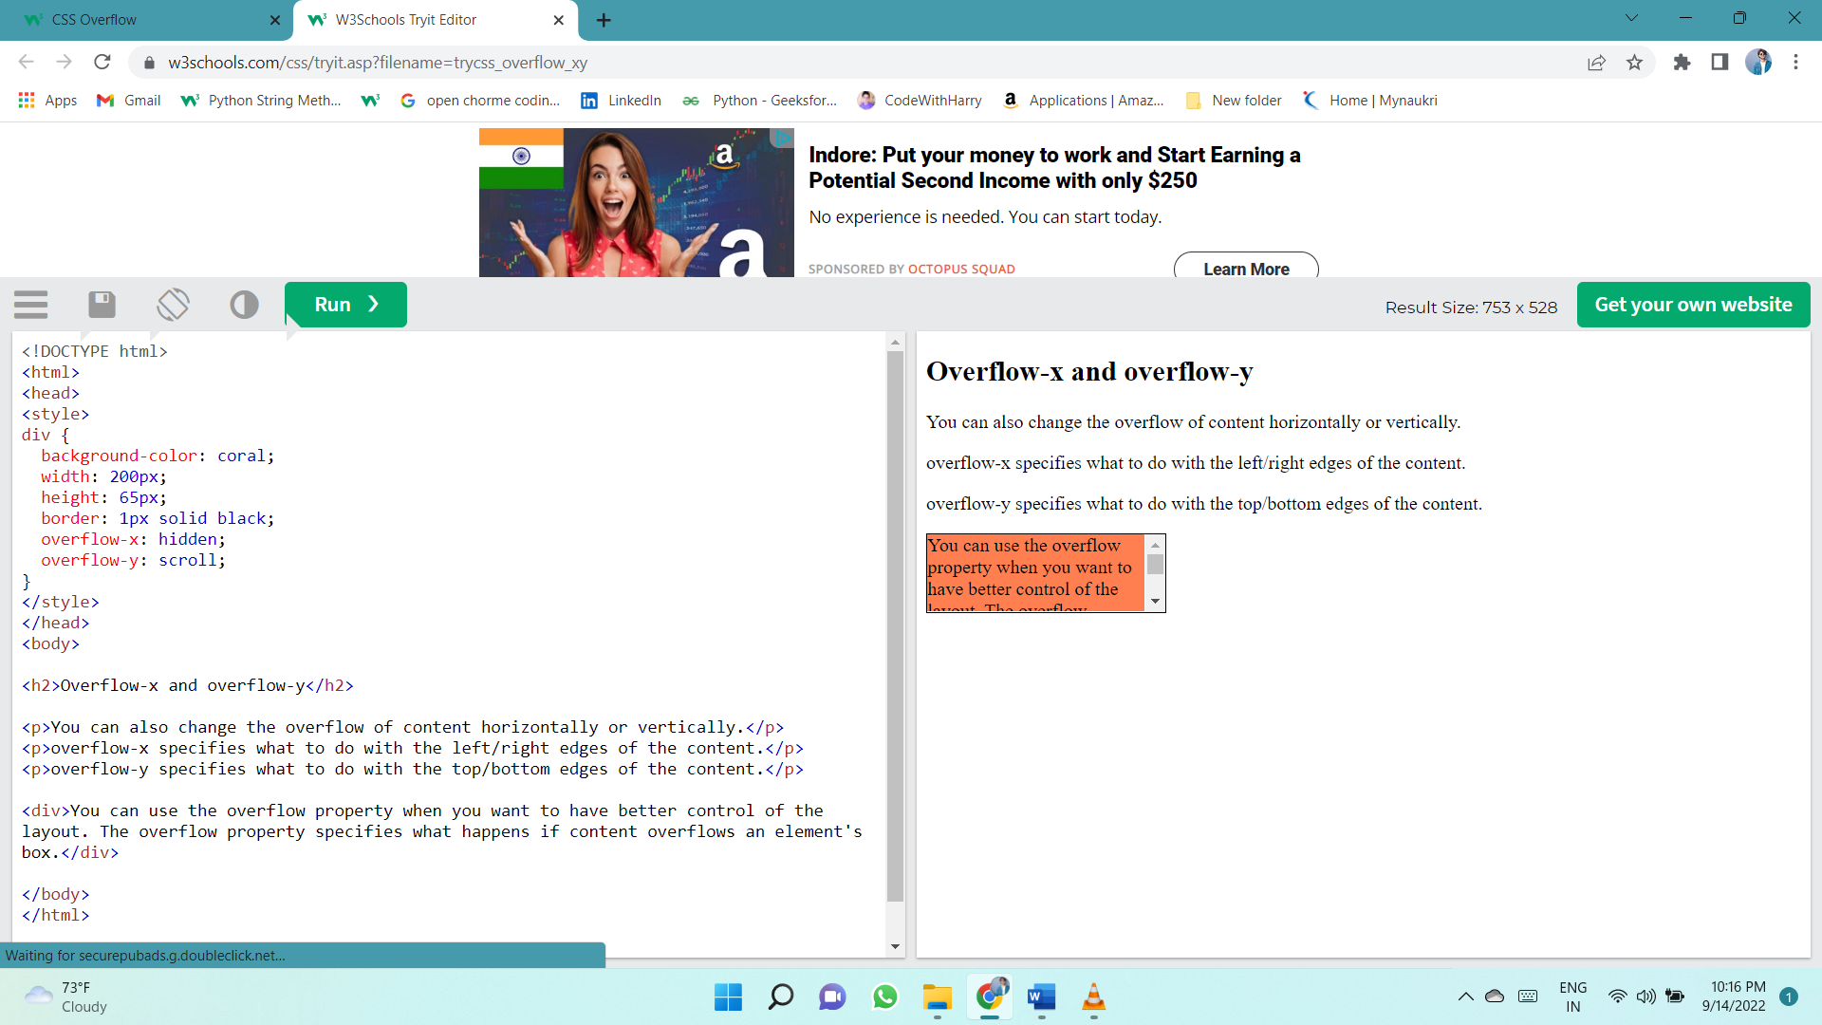

# FLOAT AND CLEAR

The CSS float property specifies how an element should float.

The CSS clear property specifies what elements can float beside the cleared element and on which side.

## The float Property

The float property is used for positioning and formatting content e.g. let an image float left to the text in a container.

The float property can have one of the following values:

* left - The element floats to the left of its container
* right - The element floats to the right of its container
* none - The element does not float (will be displayed just where it occurs in the text). This is default
* 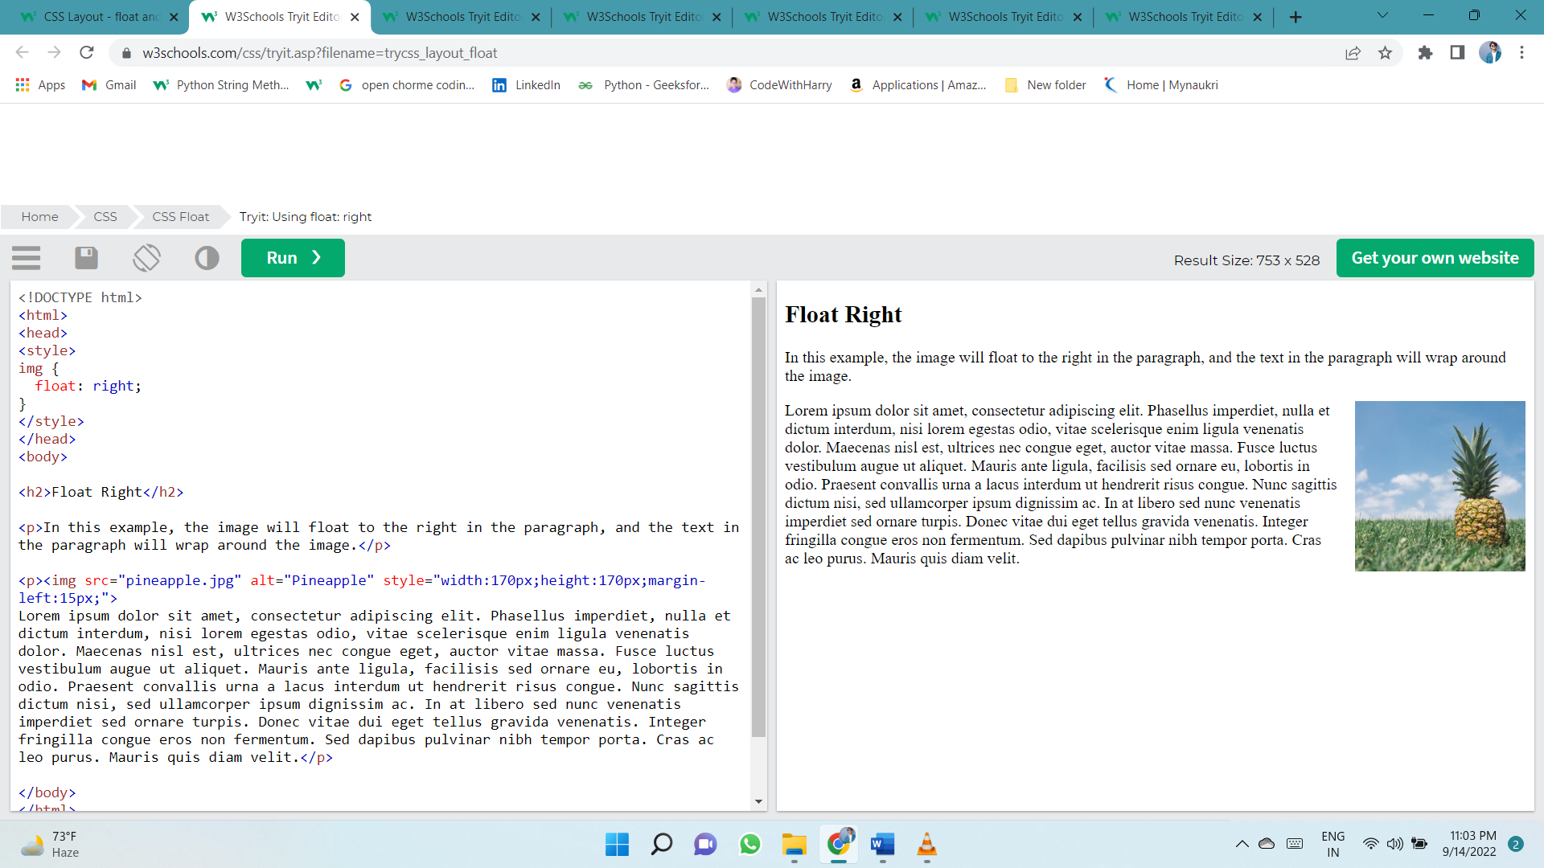inherit - The element inherits the float value of its parent

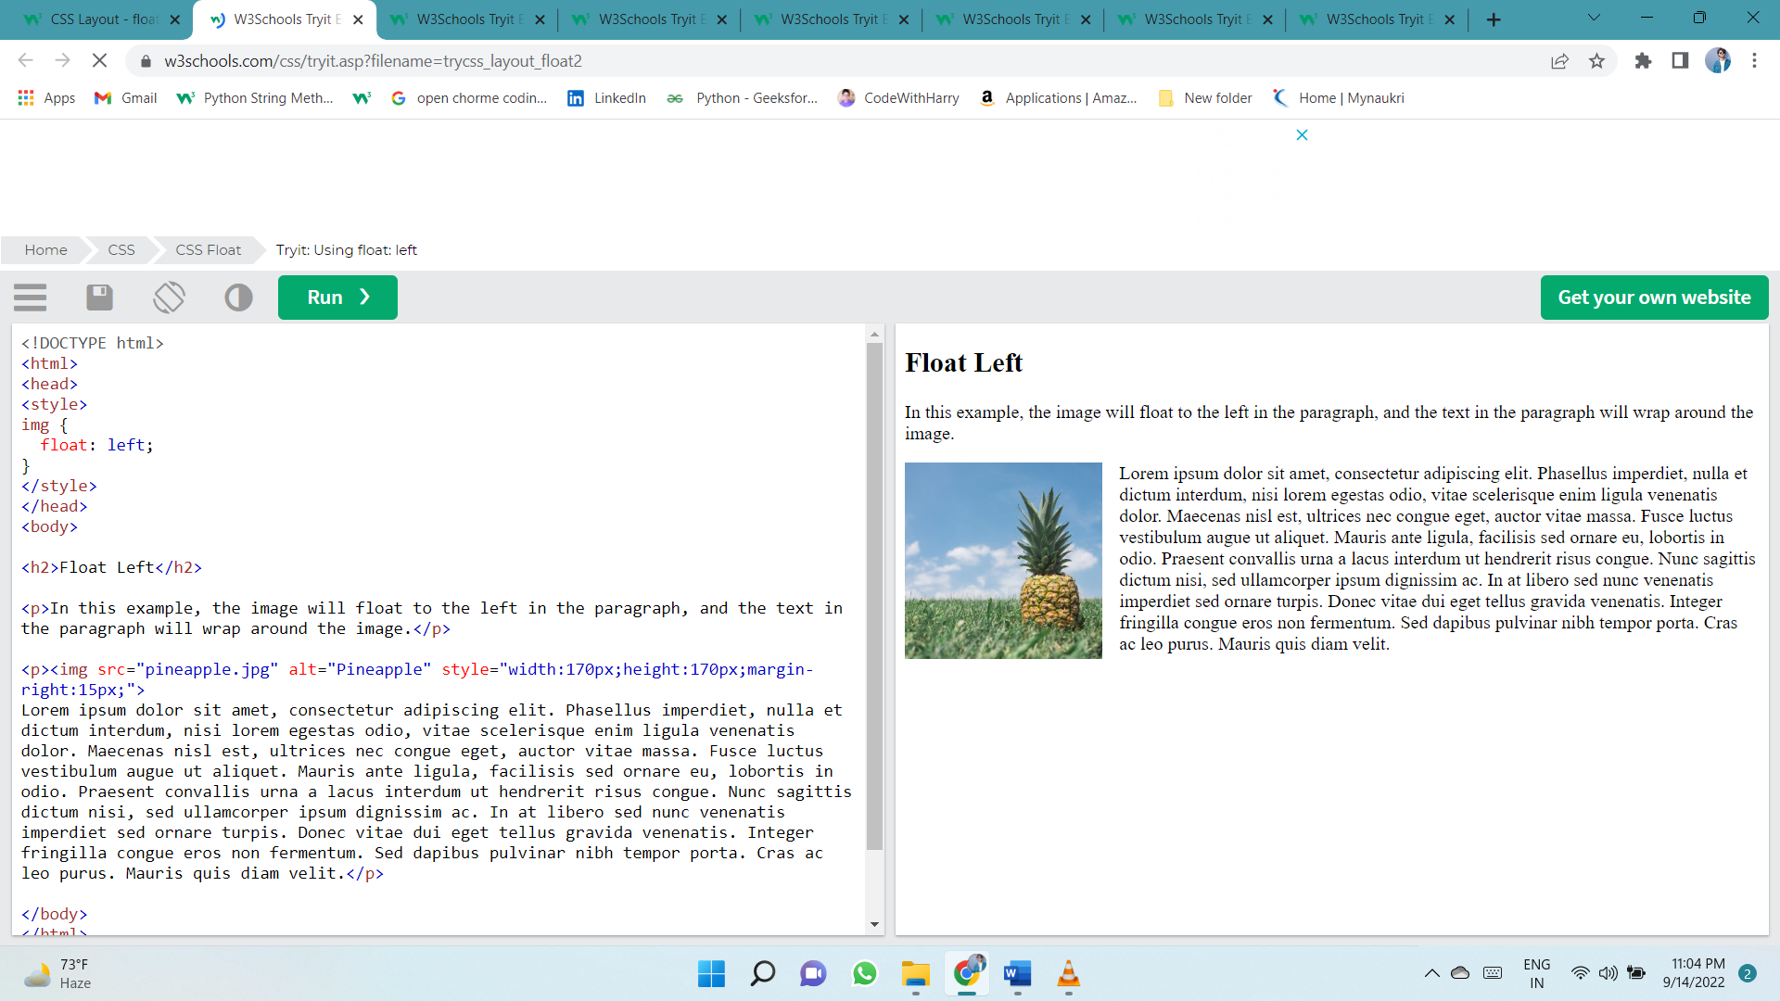

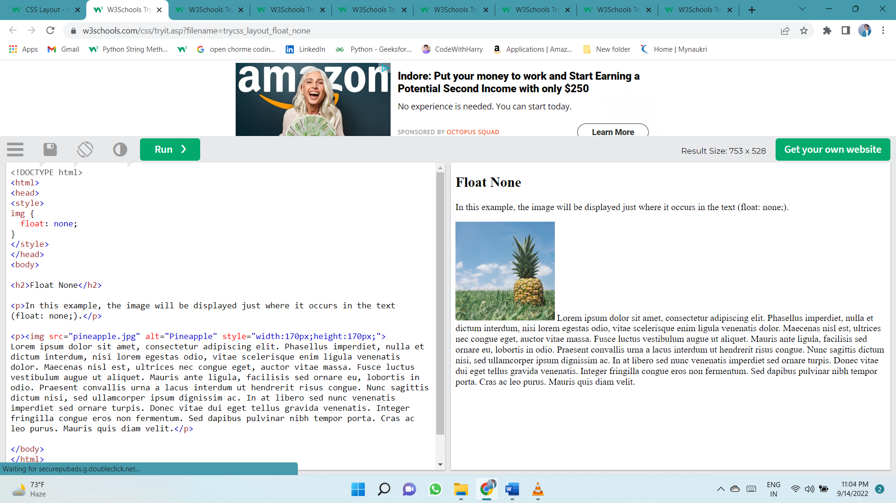

## The clear Property

When we use the float property, and we want the next element below (not on right or left), we will have to use the clear property.

The clear property specifies what should happen with the element that is next to a floating element.

The clear property can have one of the following values:

* none - The element is not pushed below left or right floated elements. This is default
* left - The element is pushed below left floated elements
* right - The element is pushed below right floated elements
* both - The element is pushed below both left and right floated elements
* inherit - The element inherits the clear value from its parent

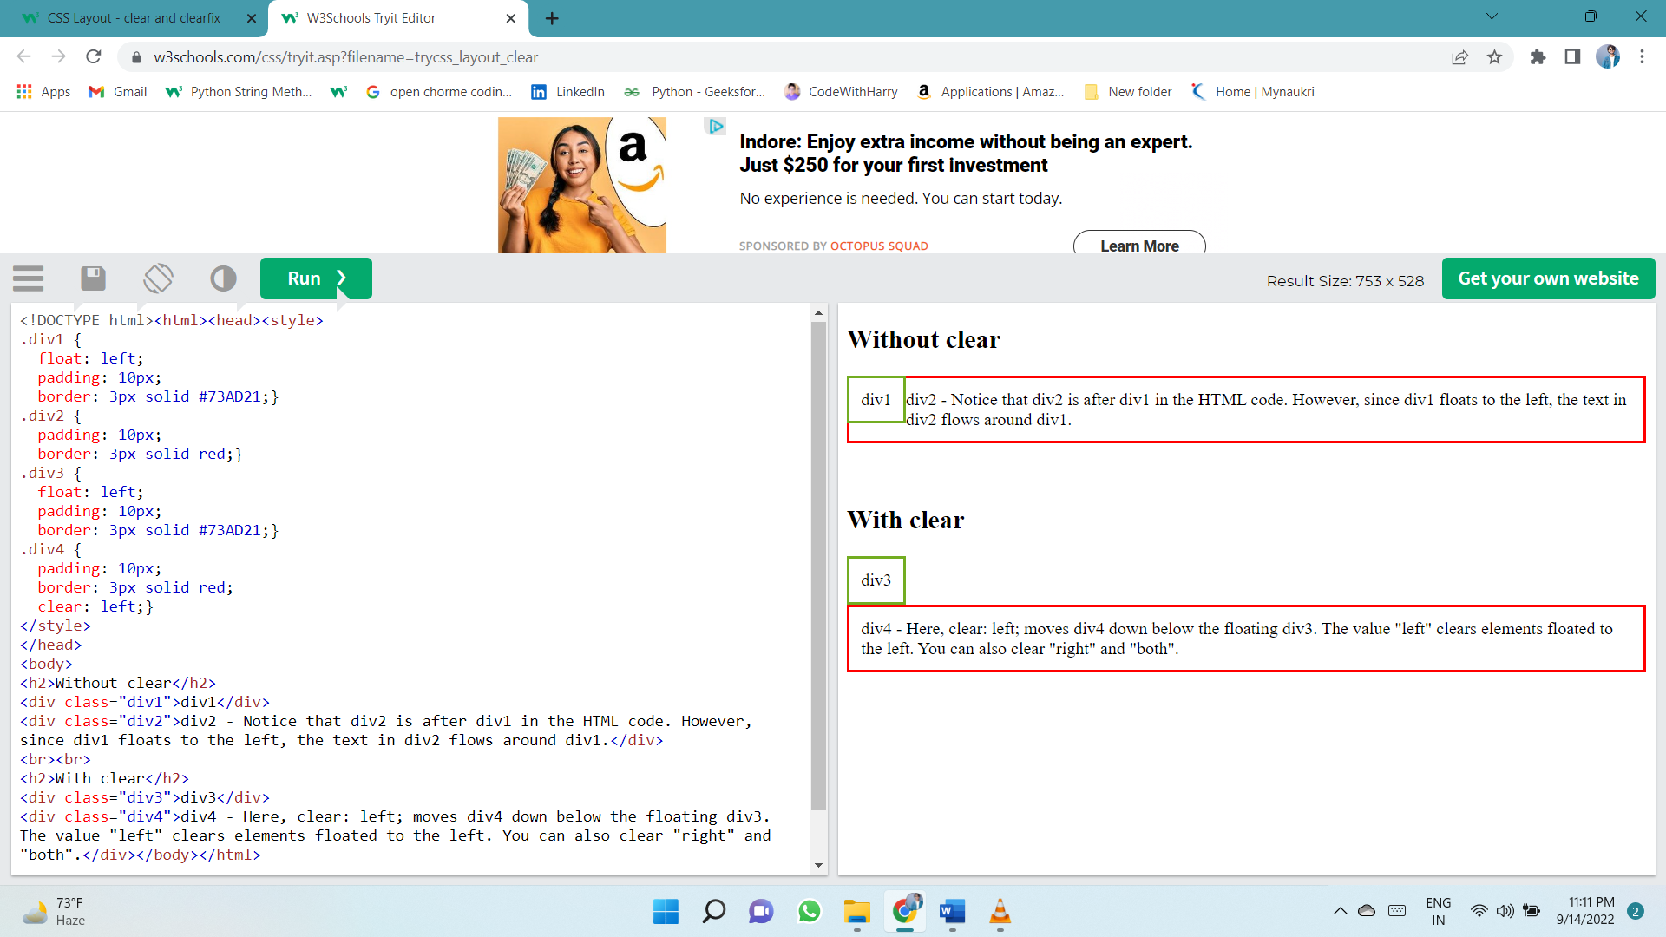

## The clearfix Hack

If a floated element is taller than the containing element, it will "overflow" outside of its container. We can then add a clearfix hack to solve this problem:

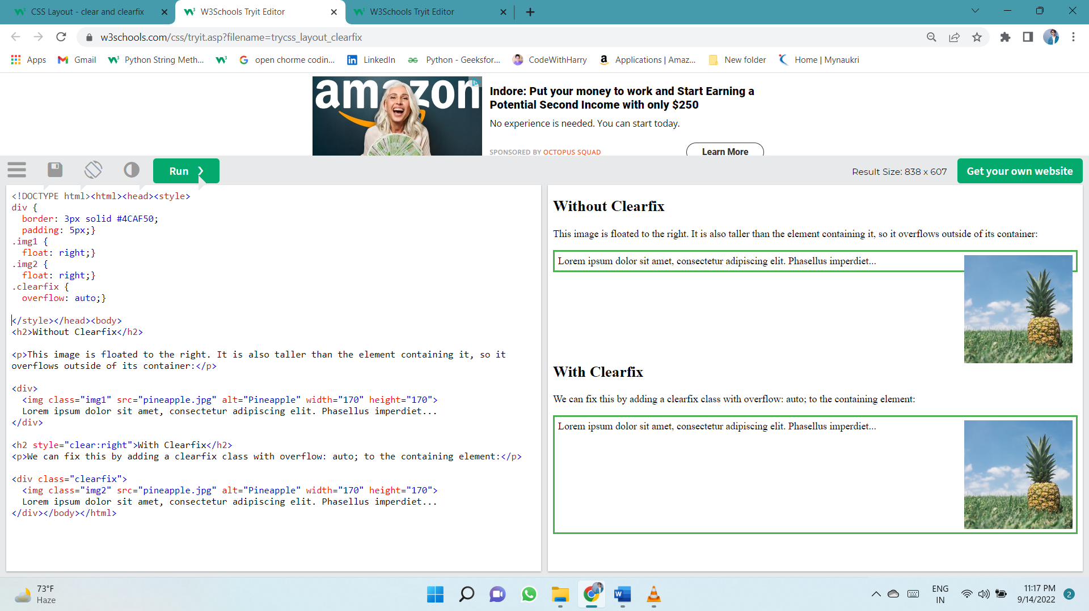

The overflow: auto clearfix works well as long as you are able to keep control of your margins and padding (else you might see scrollbars). The **new, modern clearfix hack** however, is safer to use, and the following code is used for most webpages:

# INLINE-BLOCK

Compared to display: inline, the major difference is that display: inline-block allows to set a width and height on the element.

Also, with display: inline-block, the top and bottom margins/paddings are respected, but with display: inline they are not.

Compared to display: block, the major difference is that display: inline-block does not add a line-break after the element, so the element can sit next to other elements.

The following example shows the different behavior of display: inline, display: inline-block and display: block:

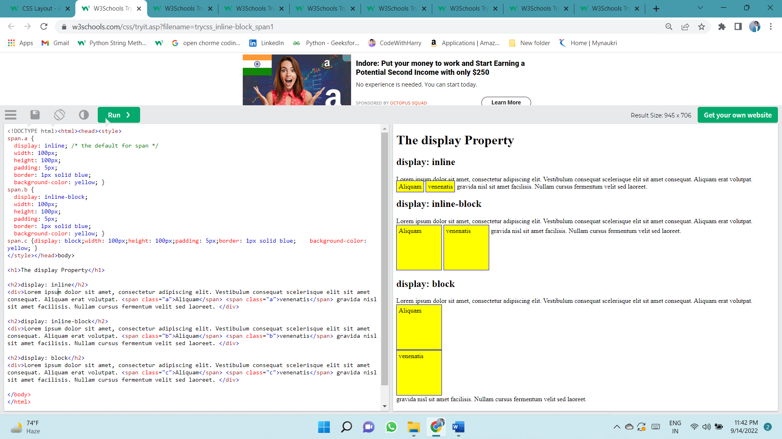

## Using inline-block to Create Navigation Links

One common use for display: inline-block is to display list items horizontally instead of vertically. The following example creates horizontal navigation links:

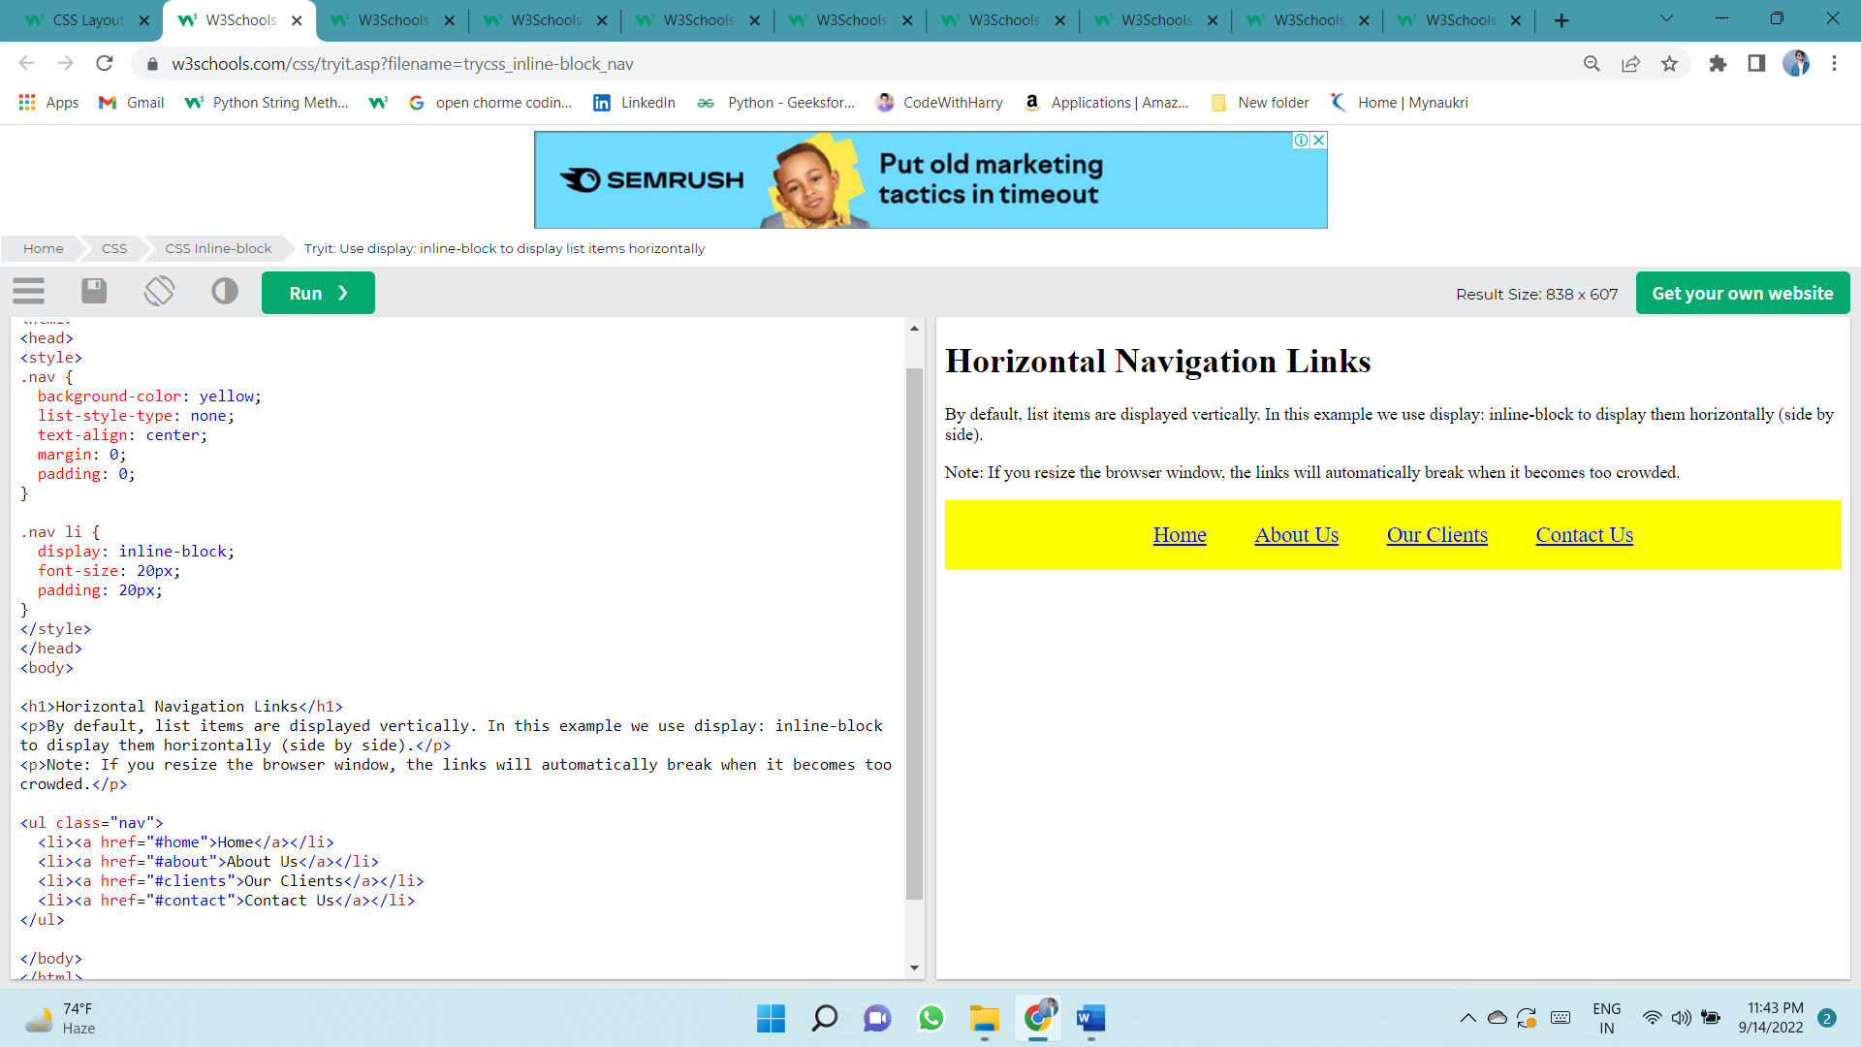

# Z-INDEX

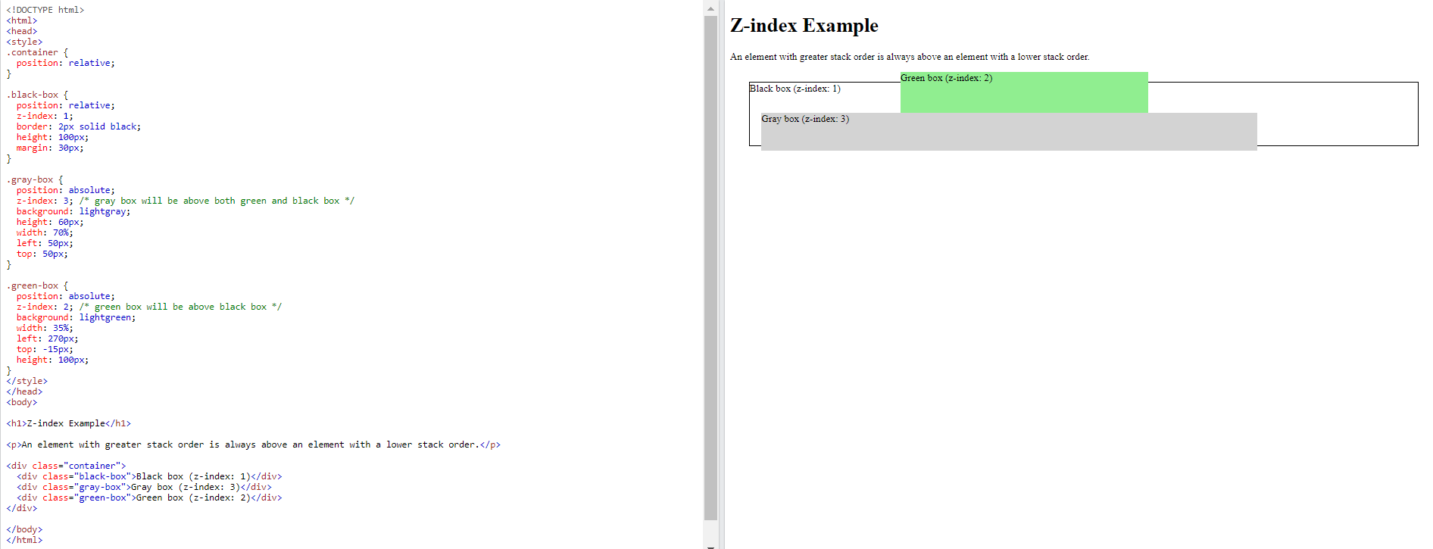Here we see that an element with greater stack order is always above an element with a lower stack order:

# Combinators Selector

A combinator is something that explains the relationship between the selectors.

A CSS selector can contain more than one simple selector. Between the simple selectors, we can include a combinator.

There are four different combinators in CSS:

* descendant selector (space)
* child selector (>)
* adjacent sibling selector (+)
* general sibling selector (~)

## Descendant Selector

The descendant selector matches all elements that are descendants of a specified element.

The following example selects all <p> elements inside <div> elements:

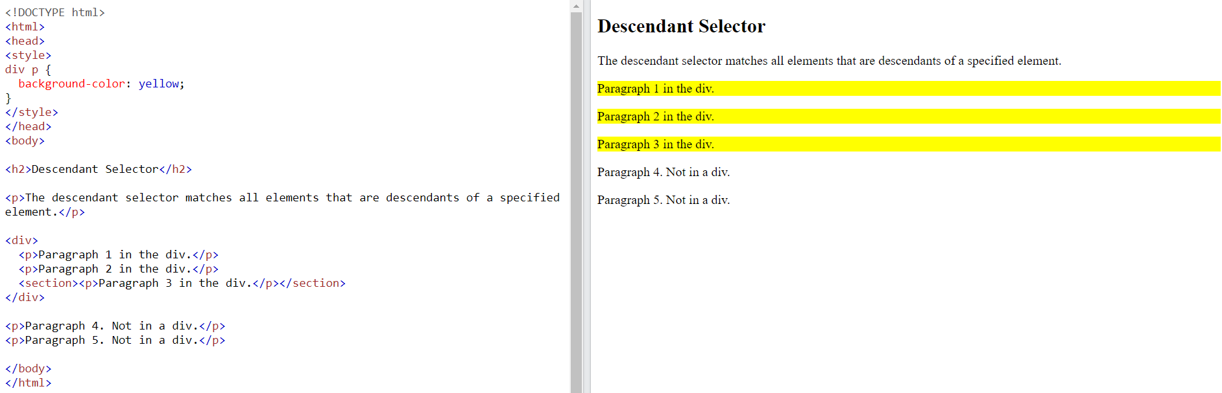

## Child Selector (>)

The child selector selects all elements that are the children of a specified element.

The following example selects all <p> elements that are children of a <div> element:

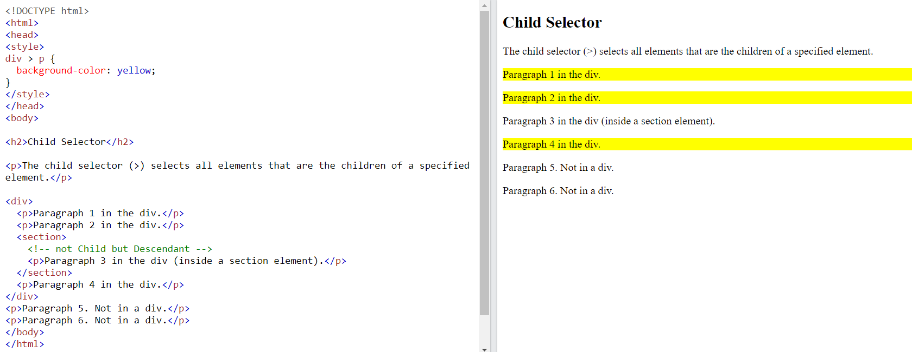

## Adjacent Sibling Selector (+)

The adjacent sibling selector is used to select an element that is directly after another specific element.

Sibling elements must have the same parent element, and "adjacent" means "immediately following".

The following example selects the first <p> element that are placed immediately after <div> elements:

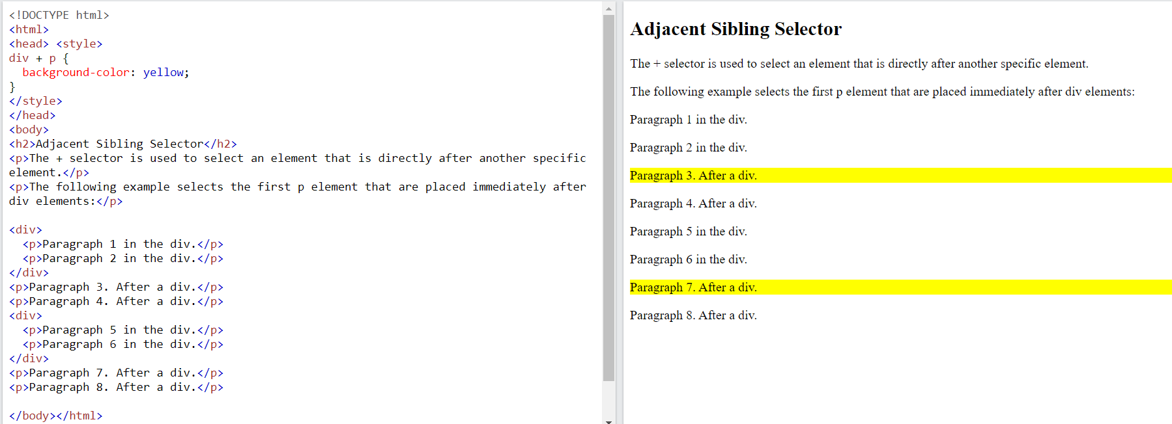

## General Sibling Selector (~)

The general sibling selector selects all elements that are next siblings of a specified element.

The following example selects all <p> elements that are next siblings of <div> elements:

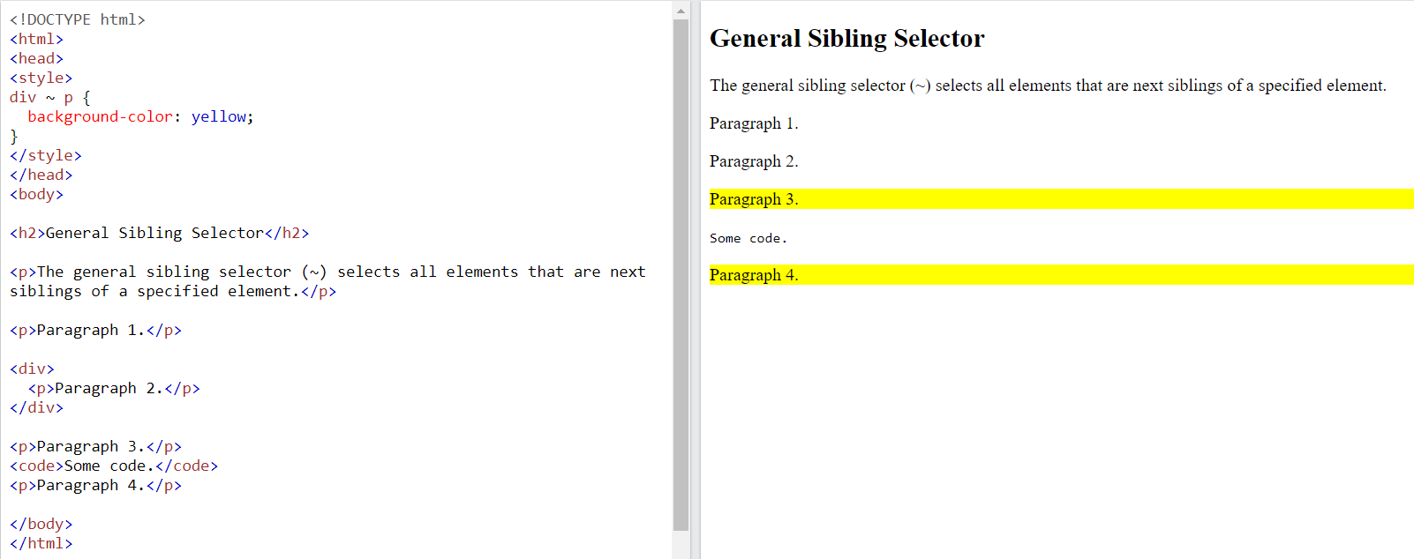

# Pseudo-classes

A pseudo-class is used to define a special state of an element.

For example, it can be used to:

* Style an element when a user mouses over it
* Style visited and unvisited links differently
* Style an element when it gets focus

Syntax

The syntax of pseudo-classes:

selector:pseudo-class {  
  property: value;  
}

## Anchor Pseudo-classes

Links can be displayed in different ways:

/* unvisited link */  
a:link {  
  color: #FF0000; }

/* visited link */  
a:visited {  
  color: #00FF00;}

/* mouse over link */  
a:hover {  
  color: #FF00FF; }  
  
/* selected link */  
a:active {  
  color: #0000FF; }

**Note:** a:hover MUST come after a:link and a:visited in the CSS definition in order to be effective! a:active MUST come after a:hover in the CSS definition in order to be effective! Pseudo-class names are not case-sensitive.

## Pseudo-classes and HTML Classes

Pseudo-classes can be combined with HTML classes:

When you hover over the link in the example, it will change color:

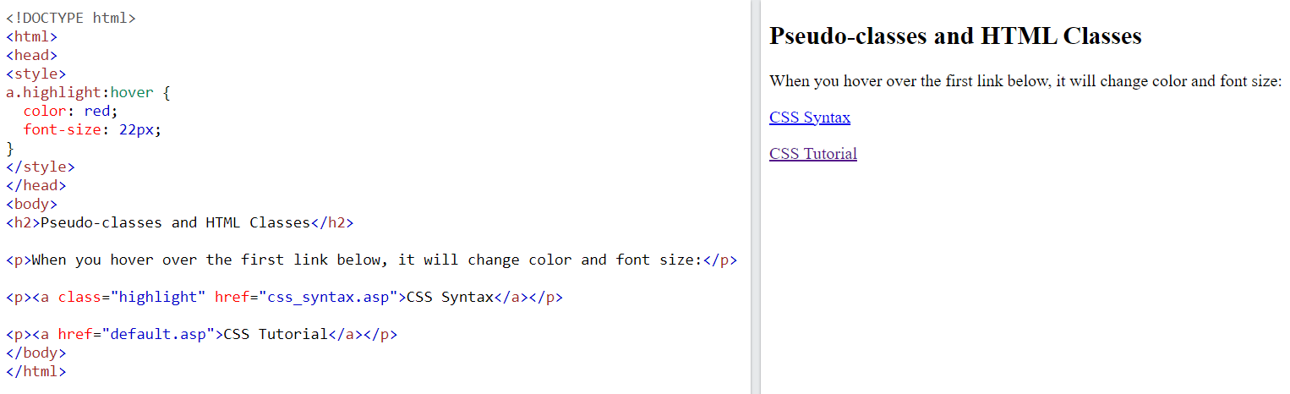

**Hover on <div>**

An example of using the :hover pseudo-class on a <div> element:

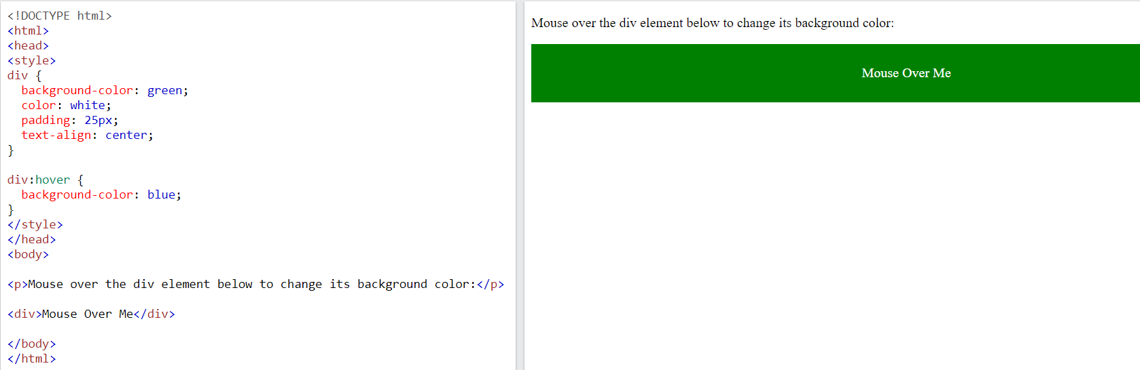

## Simple Tooltip Hover

Hover over a <div> element to show a <p> element (like a tooltip):

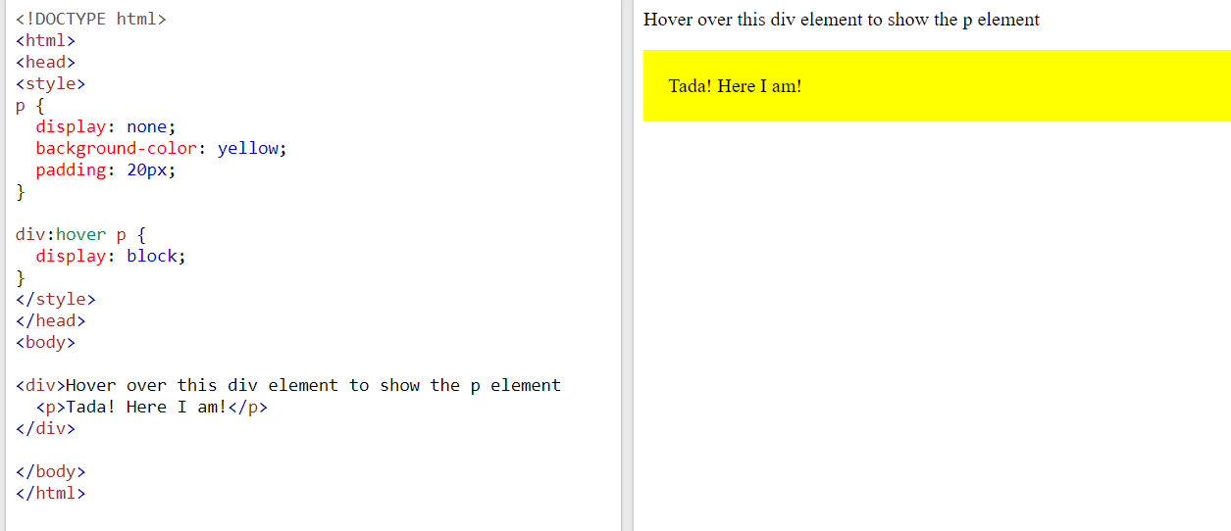

## :first-child Pseudo-class

The :first-child pseudo-class matches a specified element that is the first child of another element.

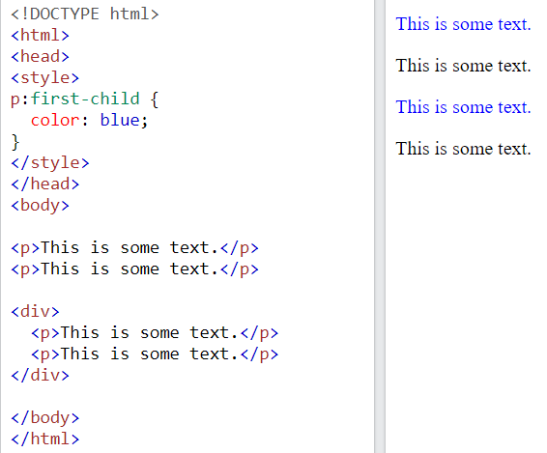

### Match the first <i> element in all <p> elements

In the following example, the selector matches the first <i> element in all <p> elements:

p i:first-child {  
  color: blue;  
}

### Match all <i> elements in all first child <p> elements

In the following example, the selector matches all <i> elements in <p> elements that are the first child of another element:

p:first-child i {  
  color: blue;  
}

# All CSS Pseudo Classes

|  |  |  |
| --- | --- | --- |
| **Selector** | **Example** | **Example description** |
| [:active](https://www.w3schools.com/cssref/sel_active.asp) | a:active | Selects the active link |
| [:checked](https://www.w3schools.com/cssref/sel_checked.asp) | input:checked | Selects every checked <input> element |
| [:disabled](https://www.w3schools.com/cssref/sel_disabled.asp) | input:disabled | Selects every disabled <input> element |
| [:empty](https://www.w3schools.com/cssref/sel_empty.asp) | p:empty | Selects every <p> element that has no children |
| [:enabled](https://www.w3schools.com/cssref/sel_enabled.asp) | input:enabled | Selects every enabled <input> element |
| [:first-child](https://www.w3schools.com/cssref/sel_firstchild.asp) | p:first-child | Selects every <p> elements that is the first child of its parent |
| [:first-of-type](https://www.w3schools.com/cssref/sel_first-of-type.asp) | p:first-of-type | Selects every <p> element that is the first <p> element of its parent |
| [:focus](https://www.w3schools.com/cssref/sel_focus.asp) | input:focus | Selects the <input> element that has focus |
| [:hover](https://www.w3schools.com/cssref/sel_hover.asp) | a:hover | Selects links on mouse over |
| [:in-range](https://www.w3schools.com/cssref/sel_in-range.asp) | input:in-range | Selects <input> elements with a value within a specified range |
| [:invalid](https://www.w3schools.com/cssref/sel_invalid.asp) | input:invalid | Selects all <input> elements with an invalid value |
| [:lang(*language*)](https://www.w3schools.com/cssref/sel_lang.asp) | p:lang(it) | Selects every <p> element with a lang attribute value starting with "it" |
| [:last-child](https://www.w3schools.com/cssref/sel_last-child.asp) | p:last-child | Selects every <p> elements that is the last child of its parent |
| [:last-of-type](https://www.w3schools.com/cssref/sel_last-of-type.asp) | p:last-of-type | Selects every <p> element that is the last <p> element of its parent |
| [:link](https://www.w3schools.com/cssref/sel_link.asp) | a:link | Selects all unvisited links |
| [:not(selector)](https://www.w3schools.com/cssref/sel_not.asp) | :not(p) | Selects every element that is not a <p> element |
| [:nth-child(n)](https://www.w3schools.com/cssref/sel_nth-child.asp) | p:nth-child(2) | Selects every <p> element that is the second child of its parent |
| [:nth-last-child(n)](https://www.w3schools.com/cssref/sel_nth-last-child.asp) | p:nth-last-child(2) | Selects every <p> element that is the second child of its parent, counting from the last child |
| [:nth-last-of-type(n)](https://www.w3schools.com/cssref/sel_nth-last-of-type.asp) | p:nth-last-of-type(2) | Selects every <p> element that is the second <p> element of its parent, counting from the last child |
| [:nth-of-type(n)](https://www.w3schools.com/cssref/sel_nth-of-type.asp) | p:nth-of-type(2) | Selects every <p> element that is the second <p> element of its parent |
| [:only-of-type](https://www.w3schools.com/cssref/sel_only-of-type.asp) | p:only-of-type | Selects every <p> element that is the only <p> element of its parent |
| [:only-child](https://www.w3schools.com/cssref/sel_only-child.asp) | p:only-child | Selects every <p> element that is the only child of its parent |
| [:optional](https://www.w3schools.com/cssref/sel_optional.asp) | input:optional | Selects <input> elements with no "required" attribute |
| [:out-of-range](https://www.w3schools.com/cssref/sel_out-of-range.asp) | input:out-of-range | Selects <input> elements with a value outside a specified range |
| [:read-only](https://www.w3schools.com/cssref/sel_read-only.asp) | input:read-only | Selects <input> elements with a "readonly" attribute specified |
| [:read-write](https://www.w3schools.com/cssref/sel_read-write.asp) | input:read-write | Selects <input> elements with no "readonly" attribute |
| [:required](https://www.w3schools.com/cssref/sel_required.asp) | input:required | Selects <input> elements with a "required" attribute specified |
| [:root](https://www.w3schools.com/cssref/sel_root.asp) | root | Selects the document's root element |
| [:target](https://www.w3schools.com/cssref/sel_target.asp) | #news:target | Selects the current active #news element (clicked on a URL containing that anchor name) |
| [:valid](https://www.w3schools.com/cssref/sel_valid.asp) | input:valid | Selects all <input> elements with a valid value |
| [:visited](https://www.w3schools.com/cssref/sel_visited.asp) | a:visited | Selects all visited links |

# Pseudo-Elements

A CSS pseudo-element is used to style specified parts of an element.

For example, it can be used to:

* Style the first letter, or line, of an element
* Insert content before, or after, the content of an element

Syntax

The syntax of pseudo-elements:

selector::pseudo-element {  
  property: value;  
}

## The ::first-line Pseudo-element

The ::first-line pseudo-element is used to add a special style to the first line of a text.

The following example formats the first line of the text in all <p> elements:

It change the color of first line .

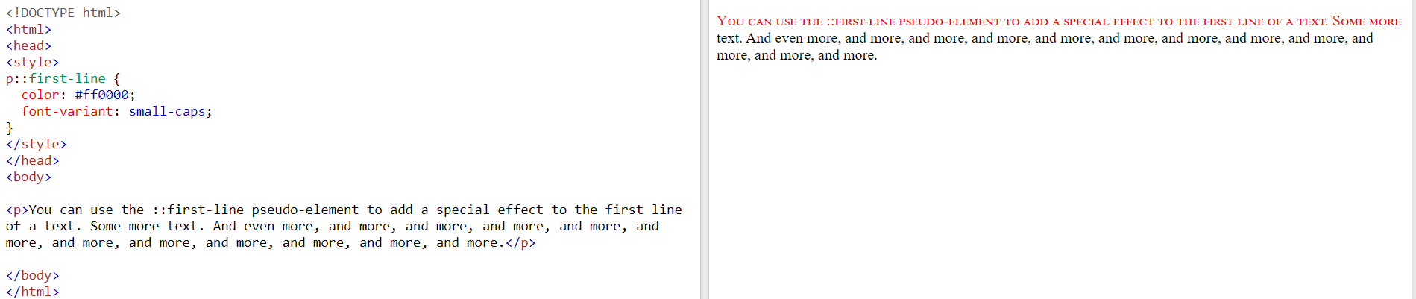

**Note:** The ::first-line pseudo-element can only be applied to block-level elements.

The following properties apply to the ::first-line pseudo-element:

* font properties
* color properties
* background properties
* word-spacing
* letter-spacing
* text-decoration
* vertical-align
* text-transform
* line-height
* clear

**Notice the double colon notation -**::first-line versus :first-line  
  
The double colon replaced the single-colon notation for pseudo-elements in CSS3. This was an attempt from W3C to distinguish between **pseudo-classes** and **pseudo-elements**.  
  
The single-colon syntax was used for both pseudo-classes and pseudo-elements in CSS2 and CSS1.  
  
For backward compatibility, the single-colon syntax is acceptable for CSS2 and CSS1 pseudo-elements.

## ::first-letter Pseudo-element

The ::first-letter pseudo-element is used to add a special style to the first letter of a text.

The following example formats the first letter of the text in all <p> elements:

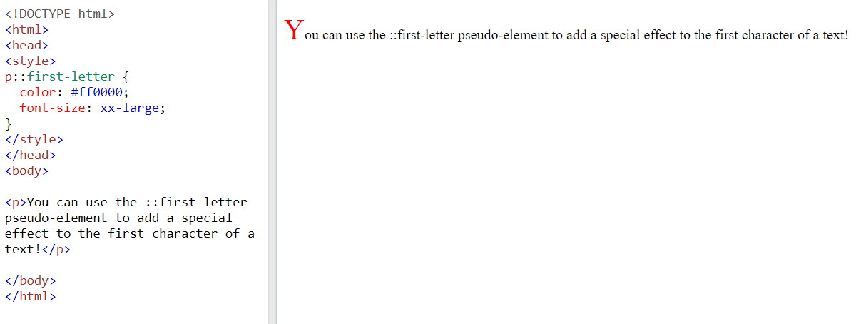

**Note:** The ::first-letter pseudo-element can only be applied to block-level elements.

The following properties apply to the ::first-letter pseudo- element:

* font properties
* color properties
* background properties
* margin properties
* padding properties
* border properties
* text-decoration
* vertical-align (only if "float" is "none")
* text-transform
* line-height
* float
* clear

## Pseudo-elements and HTML Classes

Pseudo-elements can be combined with HTML classes:

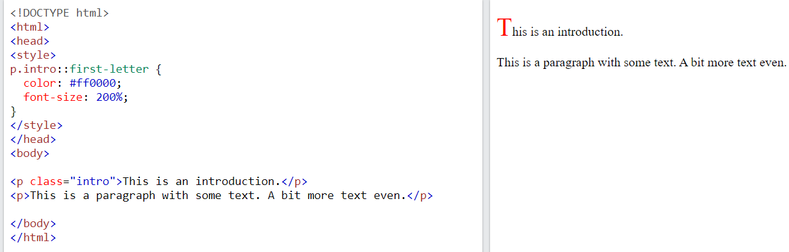

The example above will display the first letter of paragraphs with class="intro", in red and in a larger size.

## Multiple Pseudo-elements

Several pseudo-elements can also be combined.

In the following example, the first letter of a paragraph will be red, in an xx-large font size. The rest of the first line will be blue, and in small-caps. The rest of the paragraph will be the default font size and color:

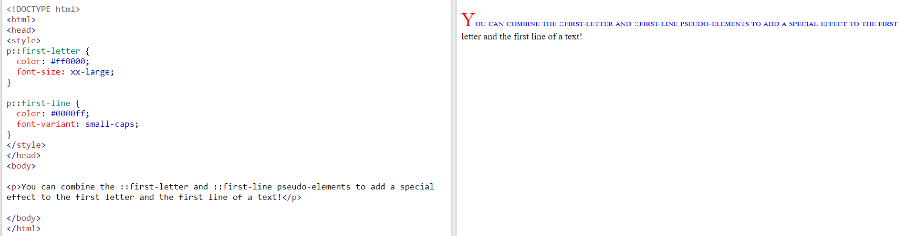

## ::before Pseudo-element

The ::before pseudo-element can be used to insert some content before the content of an element.

The following example inserts an image before the content of each <h1> element:

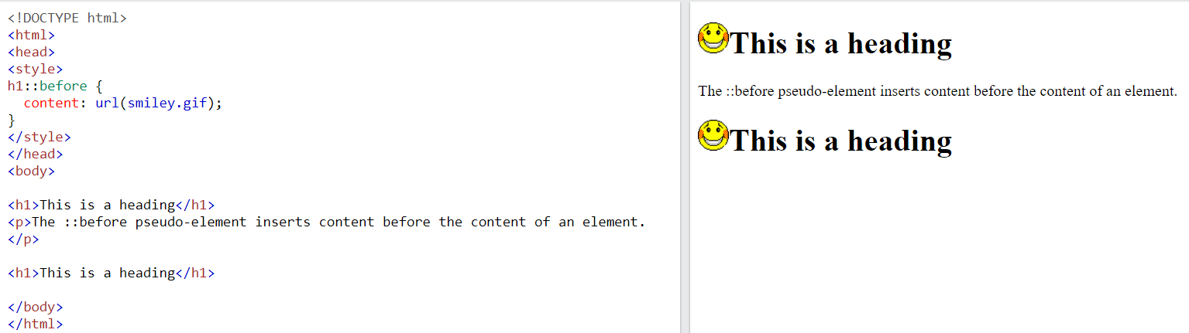

## ::after Pseudo-element

The ::after pseudo-element can be used to insert some content after the content of an element.

The following example inserts an image after the content of each <h1> element:

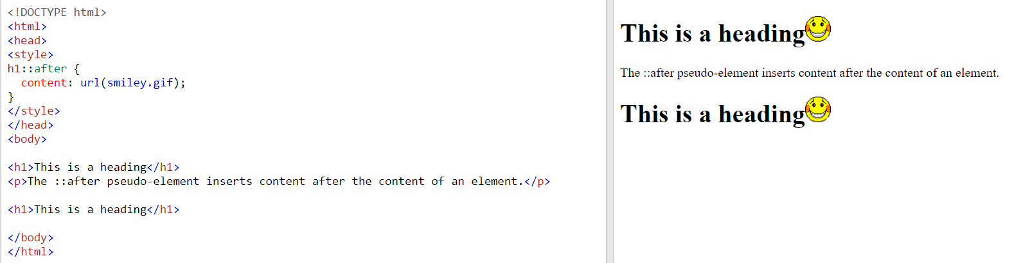

## ::marker Pseudo-element

The ::marker pseudo-element selects the markers of list items.

The following example styles the markers of list items:

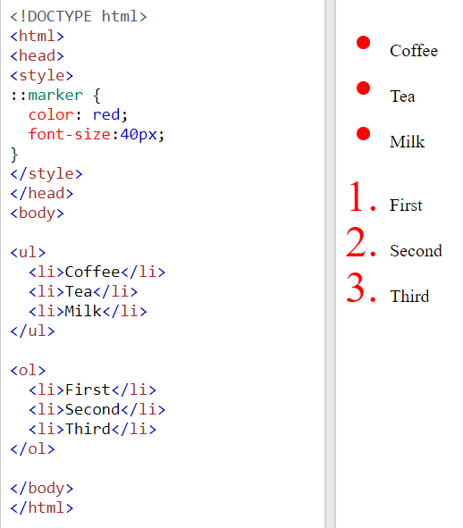

## ::selection Pseudo-element

The ::selection pseudo-element matches the portion of an element that is selected by a user.

The following CSS properties can be applied to ::selection: color, background, cursor, and outline.

The following example makes the selected text red on a yellow background:

::selection {  
  color: red;  
  background: yellow;  
}

# All CSS Pseudo Elements

|  |  |  |
| --- | --- | --- |
| **Selector** | **Example** | **Example description** |
| [::after](https://www.w3schools.com/cssref/sel_after.asp) | p::after | Insert something after the content of each <p> element |
| [::before](https://www.w3schools.com/cssref/sel_before.asp) | p::before | Insert something before the content of each <p> element |
| [::first-letter](https://www.w3schools.com/cssref/sel_firstletter.asp) | p::first-letter | Selects the first letter of each <p> element |
| [::first-line](https://www.w3schools.com/cssref/sel_firstline.asp) | p::first-line | Selects the first line of each <p> element |
| [::marker](https://www.w3schools.com/cssref/sel_marker.asp) | ::marker | Selects the markers of list items |
| [::selection](https://www.w3schools.com/cssref/sel_selection.asp) | p::selection | Selects the portion of an element that is selected by a user |

|  |  |  |
| --- | --- | --- |
| **Selector** | **Example** | **Example description** |
| [[*attribute*]](https://www.w3schools.com/cssref/sel_attribute.asp) | [target] | Selects all elements with a target attribute |
| [[*attribute*=*value*]](https://www.w3schools.com/cssref/sel_attribute_value.asp) | [target="_blank"] | Selects all elements with target="_blank" |
| [[*attribute*~=*value*]](https://www.w3schools.com/cssref/sel_attribute_value_contains.asp) | [title~="flower"] | Selects all elements with a title attribute containing the word "flower" |
| [[*attribute*|=*value*]](https://www.w3schools.com/cssref/sel_attribute_value_lang.asp) | [lang|="en"] | Selects all elements with a lang attribute value starting with "en" |
| [[*attribute*^=*value*]](https://www.w3schools.com/cssref/sel_attr_begin.asp) | a[href^="https"] | Selects every <a> element whose href attribute value begins with "https" |
| [[*attribute*$=*value*]](https://www.w3schools.com/cssref/sel_attr_end.asp) | a[href$=".pdf"] | Selects every <a> element whose href attribute value ends with ".pdf" |
| [[*attribute*\*=*value*]](https://www.w3schools.com/cssref/sel_attr_contain.asp) | a[href*="w3schools"] | Selects every <a> element whose href attribute value contains the substring "w3schools" |

# Attribute Selector

It is possible to style HTML elements that have specific attributes or attribute values.

## [attribute] Selector

The [attribute] selector is used to select elements with a specified attribute.

The following example selects all <a> elements with a target attribute:

a[target] {  
  background-color: yellow;  
}

## [attribute="value"] Selector

The [attribute="value"] selector is used to select elements with a specified attribute and value.

The following example selects all <a> elements with a target="_blank" attribute:

a[target="_blank"] {  
  background-color: yellow;  
}

## [attribute~="value"] Selector

The [attribute~="value"] selector is used to select elements with an attribute value containing a specified word.

The following example selects all elements with a title attribute that contains a space-separated list of words, one of which is "flower":

[title~="flower"] {  
  border: 5px solid yellow;  
}

The example above will match elements with title="flower", title="summer flower", and title="flower new", but not title="my-flower" or title="flowers".

## [attribute|="value"] Selector

The [attribute|="value"] selector is used to select elements with the specified attribute, whose value can be exactly the specified value, or the specified value followed by a hyphen (-).

**Note:** The value has to be a whole word, either alone, like class="top", or followed by a hyphen( - ), like class="top-text".

[class|="top"] {  
  background: yellow;  
}

## [attribute^="value"] Selector

The [attribute^="value"] selector is used to select elements with the specified attribute, whose value starts with the specified value.

The following example selects all elements with a class attribute value that starts with "top":

**Note:** The value does not have to be a whole word!

[class^="top"] {  
  background: yellow;  
}

## [attribute$="value"] Selector

The [attribute$="value"] selector is used to select elements whose attribute value ends with a specified value.

The following example selects all elements with a class attribute value that ends with "test":

**Note:** The value does not have to be a whole word!

[class$="test"] {  
  background: yellow;  
}

## [attribute*="value"] Selector

The [attribute*="value"] selector is used to select elements whose attribute value contains a specified value.

The following example selects all elements with a class attribute value that contains "te":

**Note:** The value does not have to be a whole word!

[class*="te"] {  
  background: yellow;  
}

## Styling Forms

The attribute selectors can be useful for styling forms without class or ID:

input[type="text"] {  
  width: 150px;  
  display: block;  
  margin-bottom: 10px;  
  background-color: yellow;  
}  
  
input[type="button"] {  
  width: 120px;  
  margin-left: 35px;  
  display: block;  
}

# Math Functions

The CSS math functions allow mathematical expressions to be used as property values. Here, we will explain the calc(), max() and min() functions.

|  |  |
| --- | --- |
| **Function** | **Description** |
| [calc()](https://www.w3schools.com/cssref/func_calc.asp) | Allows you to perform calculations to determine CSS property values |
| [max()](https://www.w3schools.com/cssref/func_max.asp) | Uses the largest value, from a comma-separated list of values, as the property value |
| [min()](https://www.w3schools.com/cssref/func_min.asp) | Uses the smallest value, from a comma-separated list of values, as the property value |

## calc() Function

The calc() function performs a calculation to be used as the property value.

calc(expression)

|  |  |
| --- | --- |
| **Value** | **Description** |
| *expression* | Required. A mathematical expression. The result will be used as the value. The following operators can be used: + - * / |

Let us look at an example:

Use calc() to calculate the width of a <div> element:

#div1 {  
  position: absolute;  
  left: 50px;  
  width: calc(100% - 100px);  
  border: 1px solid black;  
  background-color: yellow;  padding: 5px;  
}

## max() Function

The max() function uses the largest value, from a comma-separated list of values, as the property value.

max(value1, value2, ...)

|  |  |
| --- | --- |
| **Value** | **Description** |
| value1, value2, ... | Required. A list of comma-separated values - where the largest value is chosen |

Let us look at an example:

Use max() to set the width of #div1 to whichever value is largest, 50% or 300px:

#div1 {  
  background-color: yellow;  
  height: 100px;  
  width: max(50%, 300px);  
}

## min() Function

The min() function uses the smallest value, from a comma-separated list of values, as the property value.

min(value1, value2, ...)

|  |  |
| --- | --- |
| **Value** | **Description** |
| value1, value2, ... | Required. A list of comma-separated values - where the smallest value is chosen |

Let us look at an example:

Use min() to set the width of #div1 to whichever value is smallest, 50% or 300px:

#div1 {  
  background-color: yellow;  
  height: 100px;  
  width: min(50%, 300px);  
}

# !important

The !important rule in CSS is used to add more importance to a property/value than normal.

In fact, if you use the !important rule, it will override ALL previous styling rules for that specific property on that element!

Let us look at an example

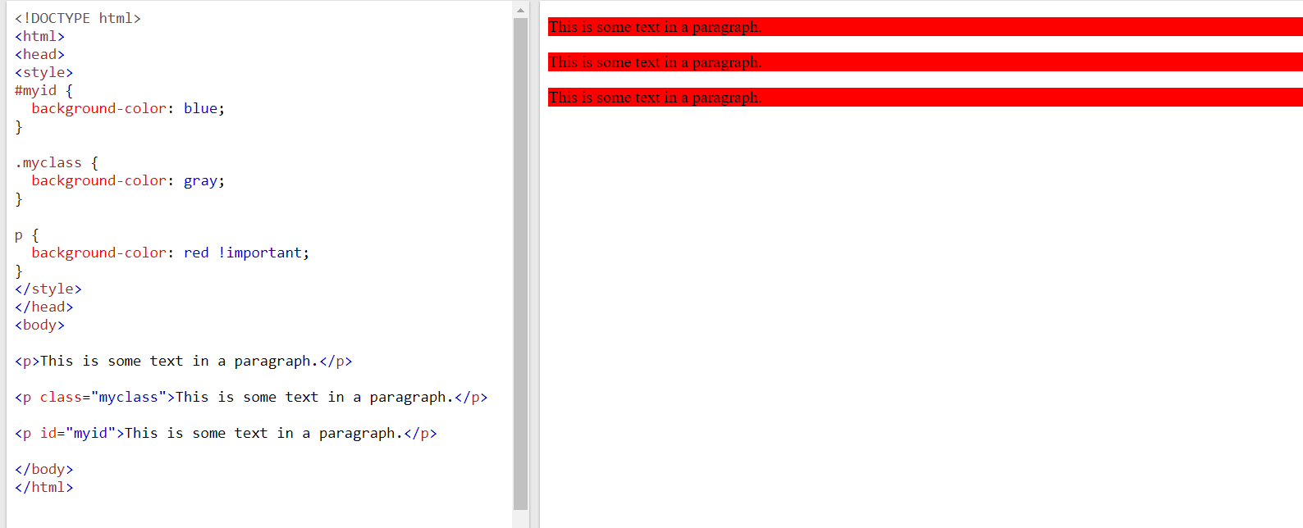

**Example Explained**

In the example above. all three paragraphs will get a red background color, even though the ID selector and the class selector have a higher specificity. The !important rule overrides the background-color property in both cases.

**Important About !important**

The only way to override an !important rule is to include another !important rule on a declaration with the same (or higher) specificity in the source code - and here the problem starts! This makes the CSS code confusing and the debugging will be hard, especially if you have a large style sheet!

Here we have created a simple example. It is not very clear, when you look at the CSS source code, which color is considered most important:

#myid {  
  background-color: blue **!important**;  
}  
  
.myclass {background-color: gray **!important**;}  
  
p {  background-color: red **!important**;}

**Tip:** It is good to know about the !important rule. You might see it in some CSS source code. However, do not use it unless you absolutely have to.

# Specificity

If there are two or more CSS rules that point to the same element, the selector with the highest specificity value will "win", and its style declaration will be applied to that HTML element.

Think of specificity as a score/rank that determines which style declaration is ultimately applied to an element.

Look at the following examples:

In this example, we have used the "p" element as selector, and specified a red color for this element. The text will be red:

<html>  
<head>  
  <style>  
    p {color: red;}  
  </style>  
</head>  
<body>  
  
<p>Hello World!</p>  
  
</body>  
</html>

Now, look at example 2:

In this example, we have added a class selector (named "test"), and specified a green color for this class. The text will now be green (even though we have specified a red color for the element selector "p"). This is because the class selector is given higher priority:

<html> <head>  <style>  
    .test {color: green;}  
    p {color: red;}  
  </style>  
</head> <body>  
<p class="test">Hello World!</p>  
</body>  
</html>

Now, look at example 3:

In this example, we have added the id selector (named "demo"). The text will now be blue, because the id selector is given higher priority:

<html>  
<head>  
  <style>  
    #demo {color: blue;}  
    .test {color: green;}  
    p {color: red;}  
  </style>  
</head>  
<body>  
  
<p id="demo" class="test">Hello World!</p>  
  
</body>  
</html>

Now, look at example 4:

In this example, we have added an inline style for the "p" element. The text will now be pink, because the inline style is given the highest priority:

<html>  
<head>  
  <style>  
    #demo {color: blue;}  
    .test {color: green;}  
    p {color: red;}  
  </style>  
</head>  
<body>  
  
<p id="demo" class="test" style="color: pink;">Hello World!</p>  
  
</body>  
</html>

## Specificity Hierarchy

Every CSS selector has its place in the specificity hierarchy.

There are four categories which define the specificity level of a selector:

1. **Inline styles** - Example: <h1 style="color: pink;">
2. **IDs** - Example: #navbar
3. **Classes, pseudo-classes, attribute selectors** - Example: .test, :hover, [href]
4. **Elements and pseudo-elements** - Example: h1, ::before

## How to Calculate Specificity?

Memorize how to calculate specificity!

Start at 0, add 100 for each ID value, add 10 for each class value (or pseudo-class or attribute selector), add 1 for each element selector or pseudo-element.

**Note:** Inline style gets a specificity value of 1000, and is always given the highest priority!

The table below shows some examples on how to calculate specificity values:

|  |  |  |
| --- | --- | --- |
| **Selector** | **Specificity Value** | **Calculation** |
| p | 1 | 1 |
| p.test | 11 | 1 + 10 |
| p#demo | 101 | 1 + 100 |
| <p style="color: pink;"> | 1000 | 1000 |
| #demo | 100 | 100 |
| .test | 10 | 10 |
| p.test1.test2 | 21 | 1 + 10 + 10 |
| #navbar p#demo | 201 | 100 + 1 + 100 |
| * | 0 | 0 (the universal selector is ignored) |

**The selector with the highest specificity value will win and take effect!**

Consider these three code fragments:

A: h1  
B: h1#content  
C: <h1 id="content" style="color: pink;">Heading</h1>

The specificity of A is 1 (one element selector)  
The specificity of B is 101 (one ID reference + one element selector)  
The specificity of C is 1000 (inline styling)

Since the third rule (C) has the highest specificity value (1000), this style declaration will be applied.

**More Specificity Rules Examples**

**Equal specificity: the latest rule wins**- If the same rule is written twice into the external style sheet, then the latest rule wins:

h1 {background-color: yellow;}  
h1 {background-color: red;}

**The universal selector (*) and inherited values have a specificity of 0** - The universal selector (*) and inherited values are ignored!

# CSS Units

CSS has several different units for expressing a length.

Many CSS properties take "length" values, such as width, margin, padding, font-size, etc.

**Length** is a number followed by a length unit, such as 10px, 2em, etc.

Set different length values, using px (pixels):

h1 {  
  font-size: 60px;  
}  
  
p {  
  font-size: 25px;  
  line-height: 50px;  
}

**Note:** A whitespace cannot appear between the number and the unit. However, if the value is 0, the unit can be omitted.

For some CSS properties, negative lengths are allowed.

There are two types of length units: **absolute**and **relative**.

## Absolute Lengths

The absolute length units are fixed and a length expressed in any of these will appear as exactly that size.

Absolute length units are not recommended for use on screen, because screen sizes vary so much. However, they can be used if the output medium is known, such as for print layout.

|  |  |
| --- | --- |
| **Unit** | **Description** |
| cm | centimeters[Try it](https://www.w3schools.com/css/tryit.asp?filename=trycss_unit_cm) |
| mm | millimeters[Try it](https://www.w3schools.com/css/tryit.asp?filename=trycss_unit_mm) |
| in | inches (1in = 96px = 2.54cm)[Try it](https://www.w3schools.com/css/tryit.asp?filename=trycss_unit_in) |
| px * | pixels (1px = 1/96th of 1in)[Try it](https://www.w3schools.com/css/tryit.asp?filename=trycss_unit_px) |
| pt | points (1pt = 1/72 of 1in)[Try it](https://www.w3schools.com/css/tryit.asp?filename=trycss_unit_pt) |
| pc | picas (1pc = 12 pt)[Try it](https://www.w3schools.com/css/tryit.asp?filename=trycss_unit_pc) |

* Pixels (px) are relative to the viewing device. For low-dpi devices, 1px is one device pixel (dot) of the display. For printers and high resolution screens 1px implies multiple device pixels.

## Relative Lengths

Relative length units specify a length relative to another length property. Relative length units scale better between different rendering mediums.

|  |  |  |
| --- | --- | --- |
| **Unit** | **Description** |  |
| em | Relative to the font-size of the element (2em means 2 times the size of the current font) | [Try it](https://www.w3schools.com/css/tryit.asp?filename=trycss_unit_em) |
| ex | Relative to the x-height of the current font (rarely used) | [Try it](https://www.w3schools.com/css/tryit.asp?filename=trycss_unit_ex) |
| ch | Relative to width of the "0" (zero) | [Try it](https://www.w3schools.com/css/tryit.asp?filename=trycss_unit_ch) |
| rem | Relative to font-size of the root element | [Try it](https://www.w3schools.com/css/tryit.asp?filename=trycss_unit_rem) |
| vw | Relative to 1% of the width of the viewport* | [Try it](https://www.w3schools.com/css/tryit.asp?filename=trycss_unit_vw) |
| vh | Relative to 1% of the height of the viewport* | [Try it](https://www.w3schools.com/css/tryit.asp?filename=trycss_unit_vh) |
| vmin | Relative to 1% of viewport's* smaller dimension | [Try it](https://www.w3schools.com/css/tryit.asp?filename=trycss_unit_vmin) |
| vmax | Relative to 1% of viewport's* larger dimension | [Try it](https://www.w3schools.com/css/tryit.asp?filename=trycss_unit_vmax) |
| % | Relative to the parent element | [Try it](https://www.w3schools.com/css/tryit.asp?filename=trycss_unit_percentage) |

**Tip:** The em and rem units are practical in creating perfectly scalable layout!  
* Viewport = the browser window size. If the viewport is 50cm wide, 1vw = 0.5cm.

# Opacity / Transparency

The opacity property specifies the opacity/transparency of an element.

See more . W3school

# Flexbox

Before the Flexbox Layout module, there were four layout modes:

* Block, for sections in a webpage
* Inline, for text
* Table, for two-dimensional table data
* Positioned, for explicit position of an element

The Flexible Box Layout Module, makes it easier to design flexible responsive layout structure without using float or positioning.

A flex container with three flex items:

<div class="flex-container">  
  <div>1</div>  
  <div>2</div>  
  <div>3</div>  
</div>

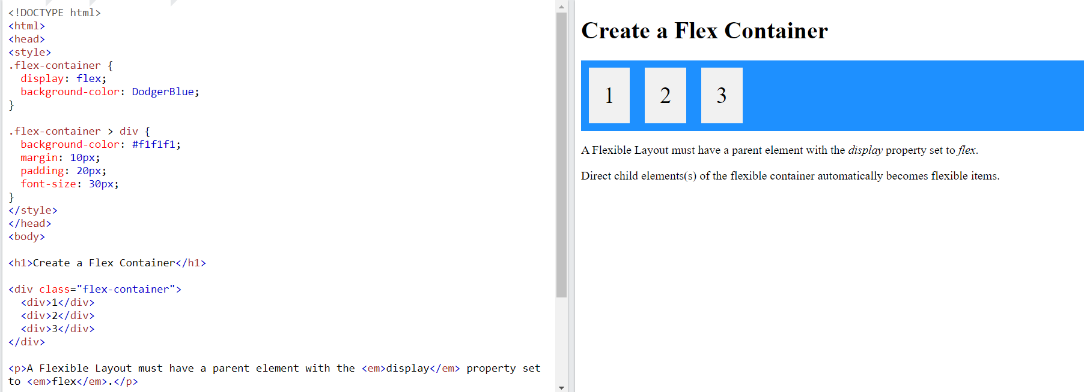

You will learn more about flex containers and flex items in the next chapters.

## Flexbox Container Properties

The following table lists all the CSS Flexbox Container properties:

|  |  |
| --- | --- |
| **Property** | **Description** |
| [align-content](https://www.w3schools.com/cssref/css3_pr_align-content.asp) | Modifies the behavior of the flex-wrap property. It is similar to align-items, but instead of aligning flex items, it aligns flex lines |
| [align-items](https://www.w3schools.com/cssref/css3_pr_align-items.asp) | Vertically aligns the flex items when the items do not use all available space on the cross-axis |
| [display](https://www.w3schools.com/cssref/pr_class_display.asp) | Specifies the type of box used for an HTML element |
| [flex-direction](https://www.w3schools.com/cssref/css3_pr_flex-direction.asp) | Specifies the direction of the flexible items inside a flex container |
| [flex-flow](https://www.w3schools.com/cssref/css3_pr_flex-flow.asp) | A shorthand property for flex-direction and flex-wrap |
| [flex-wrap](https://www.w3schools.com/cssref/css3_pr_flex-wrap.asp) | Specifies whether the flex items should wrap or not, if there is not enough room for them on one flex line |
| [justify-content](https://www.w3schools.com/cssref/css3_pr_justify-content.asp) | Horizontally aligns the flex items when the items do not use all available space on the main-axis |

### [align-content](https://www.w3schools.com/cssref/css3_pr_align-content.asp)

The align-content property specifies how flex lines are distributed along the cross axis in a flexbox container.

In flexbox layout, the main axis is in the [flex-direction](https://www.w3schools.com/cssref/css3_pr_flex-direction.php) (default is 'row', horizontal), and the cross axis is perpendicular to the main axis (default is 'column', vertical).

**CSS Syntax**

align-content: stretch|center|flex-start|flex-end|space-between|space-around|space-evenly|initial|inherit;

|  |  |  |
| --- | --- | --- |
| **Value** | **Description** | **Demo** |
| stretch | Default value. Lines stretch to take up the remaining space | [Demo ❯](https://www.w3schools.com/cssref/playdemo.php?filename=playcss_align-content&preval=stretch) |
| center | Lines are packed toward the center of the flex container | [Demo ❯](https://www.w3schools.com/cssref/playdemo.php?filename=playcss_align-content&preval=center) |
| flex-start | Lines are packed toward the start of the flex container | [Demo ❯](https://www.w3schools.com/cssref/playdemo.php?filename=playcss_align-content&preval=flex-start) |
| flex-end | Lines are packed toward the end of the flex container | [Demo ❯](https://www.w3schools.com/cssref/playdemo.php?filename=playcss_align-content&preval=flex-end) |
| space-between | Lines are evenly distributed in the flex container | [Demo ❯](https://www.w3schools.com/cssref/playdemo.php?filename=playcss_align-content&preval=space-between) |
| space-around | Lines are evenly distributed in the flex container, with half-size spaces on either end | [Demo ❯](https://www.w3schools.com/cssref/playdemo.php?filename=playcss_align-content&preval=space-around) |
| space-evenly | Lines are evenly distributed in the flex container, with equal space around them | [Demo ❯](https://www.w3schools.com/cssref/playdemo.php?filename=playcss_align-content&preval=space-evenly) |
| initial | Sets this property to its default value. [Read about initial](https://www.w3schools.com/cssref/css_initial.php) |  |
| inherit | Inherits this property from its parent element. [Read about inherit](https://www.w3schools.com/cssref/css_inherit.php) |  |

### display

CSS Syntax

display: *value*;

Property Values

|  |  |  |
| --- | --- | --- |
| **Value** | **Description** | **Play it** |
| inline | Displays an element as an inline element (like <span>). Any height and width properties will have no effect | [Demo ❯](https://www.w3schools.com/cssref/playdemo.php?filename=playcss_display&preval=inline) |
| block | Displays an element as a block element (like <p>). It starts on a new line, and takes up the whole width | [Demo ❯](https://www.w3schools.com/cssref/playdemo.php?filename=playcss_display&preval=block) |
| contents | Makes the container disappear, making the child elements children of the element the next level up in the DOM |  |
| flex | Displays an element as a block-level flex container |  |
| grid | Displays an element as a block-level grid container |  |
| inline-block | Displays an element as an inline-level block container. The element itself is formatted as an inline element, but you can apply height and width values |  |
| inline-flex | Displays an element as an inline-level flex container |  |
| inline-grid | Displays an element as an inline-level grid container |  |
| inline-table | The element is displayed as an inline-level table |  |
| list-item | Let the element behave like a <li> element | [Demo ❯](https://www.w3schools.com/cssref/playdemo.php?filename=playcss_display&preval=list-item) |
| run-in | Displays an element as either block or inline, depending on context |  |
| table | Let the element behave like a <table> element |  |
| table-caption | Let the element behave like a <caption> element |  |
| table-column-group | Let the element behave like a <colgroup> element |  |
| table-header-group | Let the element behave like a <thead> element |  |
| table-footer-group | Let the element behave like a <tfoot> element |  |
| table-row-group | Let the element behave like a <tbody> element |  |
| table-cell | Let the element behave like a <td> element |  |
| table-column | Let the element behave like a <col> element |  |
| table-row | Let the element behave like a <tr> element |  |
| none | The element is completely removed |  |
| initial | Sets this property to its default value. [Read about initial](https://www.w3schools.com/cssref/css_initial.php) |  |
| inherit | Inherits this property from its parent element. [Read about inherit](https://www.w3schools.com/cssref/css_inherit.php) |  |

### flex-direction

flex-direction: row|row-reverse|column|column-reverse|initial|inherit;

Property Values

|  |  |  |
| --- | --- | --- |
| **Value** | **Description** | **Play it** |
| row | Default value. The flexible items are displayed horizontally, as a row | [Demo ❯](https://www.w3schools.com/cssref/playdemo.php?filename=playcss_flex-direction&preval=row) |
| row-reverse | Same as row, but in reverse order | [Demo ❯](https://www.w3schools.com/cssref/playdemo.php?filename=playcss_flex-direction&preval=row-reverse) |
| column | The flexible items are displayed vertically, as a column | [Demo ❯](https://www.w3schools.com/cssref/playdemo.php?filename=playcss_flex-direction&preval=column) |
| column-reverse | Same as column, but in reverse order | [Demo ❯](https://www.w3schools.com/cssref/playdemo.php?filename=playcss_flex-direction&preval=column-reverse) |
| initial | Sets this property to its default value. [Read about initial](https://www.w3schools.com/cssref/css_initial.php) |  |
| inherit | Inherits this property from its parent element. [Read about inherit](https://www.w3schools.com/cssref/css_inherit.php) |  |

### flex-wrap

flex-wrap: nowrap|wrap|wrap-reverse|initial|inherit;

Property Values

|  |  |  |
| --- | --- | --- |
| **Value** | **Description** | **Play it** |
| nowrap | Default value. Specifies that the flexible items will not wrap | [Demo ❯](https://www.w3schools.com/cssref/playdemo.php?filename=playcss_flex-wrap&preval=nowrap) |
| wrap | Specifies that the flexible items will wrap if necessary | [Demo ❯](https://www.w3schools.com/cssref/playdemo.php?filename=playcss_flex-wrap&preval=wrap) |
| wrap-reverse | Specifies that the flexible items will wrap, if necessary, in reverse order | [Demo ❯](https://www.w3schools.com/cssref/playdemo.php?filename=playcss_flex-wrap&preval=wrap-reverse) |
| initial | Sets this property to its default value. [Read about initial](https://www.w3schools.com/cssref/css_initial.php) |  |
| inherit | Inherits this property from its parent element. [Read about inherit](https://www.w3schools.com/cssref/css_inherit.php) |  |

### justify-content

justify-content: flex-start|flex-end|center|space-between|space-around|space-evenly|initial|inherit;

Property Values

|  |  |  |
| --- | --- | --- |
| **Value** | **Description** | **Play it** |
| flex-start | Default value. Items are positioned at the beginning of the container | [Demo ❯](https://www.w3schools.com/cssref/playdemo.php?filename=playcss_justify-content&preval=flex-start) |
| flex-end | Items are positioned at the end of the container | [Demo ❯](https://www.w3schools.com/cssref/playdemo.php?filename=playcss_justify-content&preval=flex-end) |
| center | Items are positioned in the center of the container | [Demo ❯](https://www.w3schools.com/cssref/playdemo.php?filename=playcss_justify-content&preval=center) |
| space-between | Items will have space between them | [Demo ❯](https://www.w3schools.com/cssref/playdemo.php?filename=playcss_justify-content&preval=space-between) |
| space-around | Items will have space before, between, and after them | [Demo ❯](https://www.w3schools.com/cssref/playdemo.php?filename=playcss_justify-content&preval=space-around) |
| space-evenly | Items will have equal space around them | [Demo ❯](https://www.w3schools.com/cssref/playdemo.php?filename=playcss_justify-content&preval=space-evenly) |
| initial | Sets this property to its default value. [Read about initial](https://www.w3schools.com/cssref/css_initial.php) |  |
| inherit | Inherits this property from its parent element. [Read about inherit](https://www.w3schools.com/cssref/css_inherit.php) |  |

# Transitions

CSS transitions allows you to change property values smoothly, over a given duration.

* transition
* transition-delay
* transition-duration
* transition-property
* transition-timing-function

## How to Use CSS Transitions?

To create a transition effect, you must specify two things:

* the CSS property you want to add an effect to
* the duration of the effect

**Note:** If the duration part is not specified, the transition will have no effect, because the default value is 0.

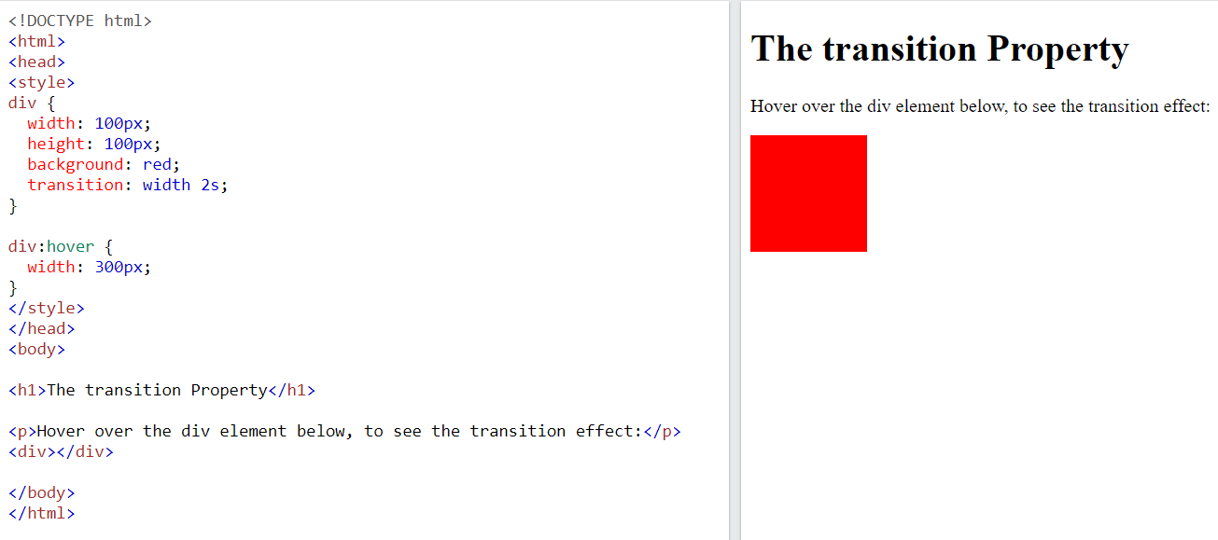

Change Several Property Values

The following example adds a transition effect for both the width and height property, with a duration of 2 seconds for the width and 4 seconds for the height:

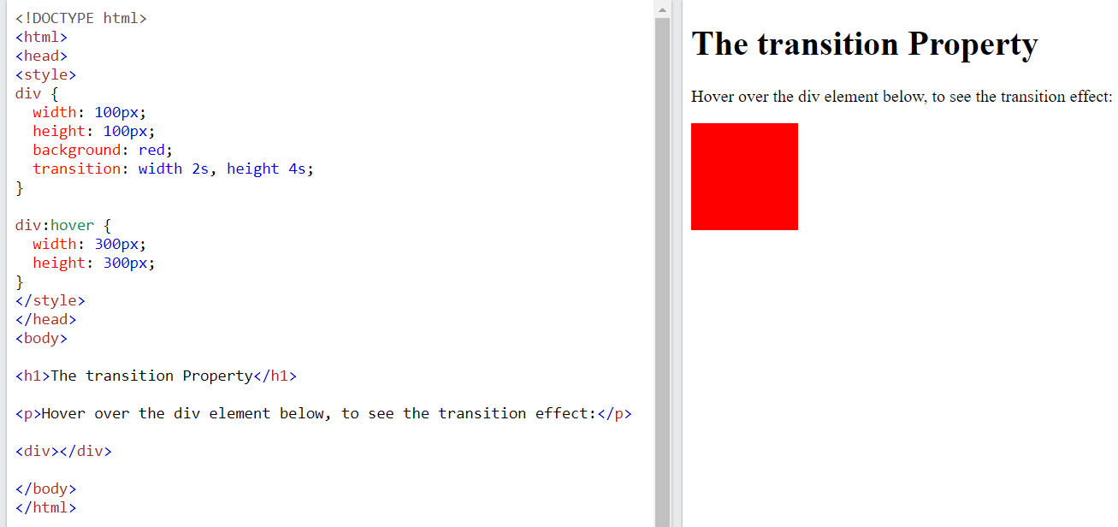

**Specify the Speed Curve of the Transition**

The transition-timing-function property specifies the speed curve of the transition effect.

The transition-timing-function property can have the following values:

* ease - specifies a transition effect with a slow start, then fast, then end slowly (this is default)
* linear - specifies a transition effect with the same speed from start to end
* ease-in - specifies a transition effect with a slow start
* ease-out - specifies a transition effect with a slow end
* ease-in-out - specifies a transition effect with a slow start and end
* cubic-bezier(n,n,n,n) - lets you define your own values in a cubic-bezier function

The following example shows some of the different speed curves that can be used:

#div1 {transition-timing-function: linear;}  
#div2 {transition-timing-function: ease;}  
#div3 {transition-timing-function: ease-in;}  
#div4 {transition-timing-function: ease-out;}  
#div5 {transition-timing-function: ease-in-out;}

**Delay the Transition Effect**

The transition-delay property specifies a delay (in seconds) for the transition effect.

The following example has a 1 second delay before starting:

div {  
  transition-delay: 1s;  
}

**Transition + Transformation**

The following example adds a transition effect to the transformation:

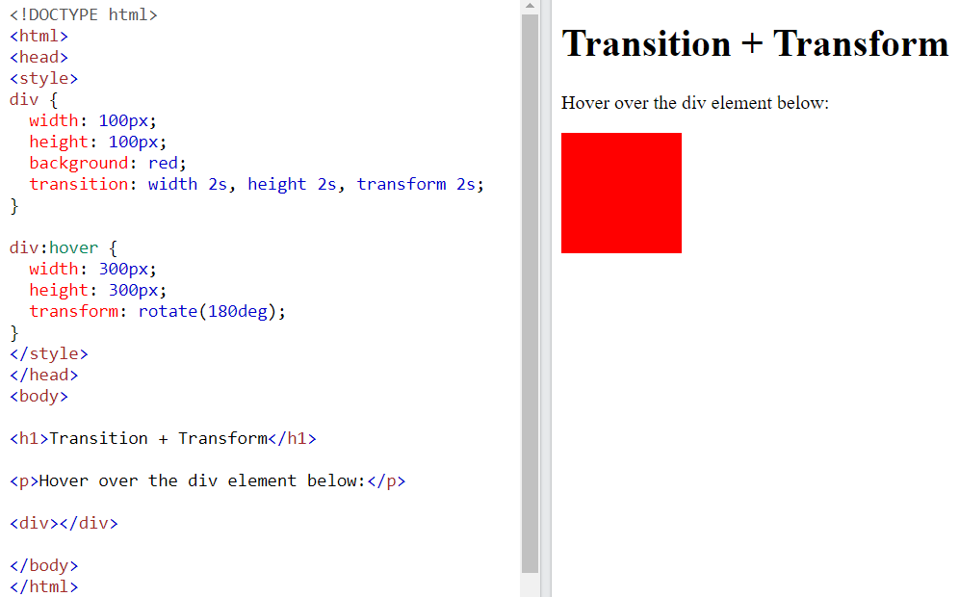

**CSS Transition Properties**

The following table lists all the CSS transition properties:

|  |  |
| --- | --- |
| **Property** | **Description** |
| [transition](https://www.w3schools.com/cssref/css3_pr_transition.asp) | A shorthand property for setting the four transition properties into a single property |
| [transition-delay](https://www.w3schools.com/cssref/css3_pr_transition-delay.asp) | Specifies a delay (in seconds) for the transition effect |
| [transition-duration](https://www.w3schools.com/cssref/css3_pr_transition-duration.asp) | Specifies how many seconds or milliseconds a transition effect takes to complete |
| [transition-property](https://www.w3schools.com/cssref/css3_pr_transition-property.asp) | Specifies the name of the CSS property the transition effect is for |
| [transition-timing-function](https://www.w3schools.com/cssref/css3_pr_transition-timing-function.asp) | Specifies the speed curve of the transition effect |

# CSS gradients

CSS gradients let you display smooth transitions between two or more specified colors.

CSS defines three types of gradients:

* **Linear Gradients (goes down/up/left/right/diagonally)**
* **Radial Gradients (defined by their center)**
* **Conic Gradients (rotated around a center point)**

## Linear Gradients

To create a linear gradient you must define at least two color stops. Color stops are the colors you want to render smooth transitions among. You can also set a starting point and a direction (or an angle) along with the gradient effect.

Syntax

background-image: linear-gradient(direction, color-stop1, color-stop2, ...);

## Radial Gradients

A radial gradient is defined by its center.

To create a radial gradient you must also define at least two color stops.

Syntax

background-image: radial-gradient(shape size at position, start-color, ..., last-color);

By default, shape is ellipse, size is farthest-corner, and position is center.

## Conic Gradients

A conic gradient is a gradient with color transitions rotated around a center point.

To create a conic gradient you must define at least two colors.

Syntax

background-image: conic-gradient([from angle] [at position,] color [degree], color [degree], ...);

By default, angle is 0deg and position is center.

If no degree is specified, the colors will be spread equally around the center point.

# CSS 2D Transforms

CSS transforms allow you to move, rotate, scale, and skew elements.

Mouse over the element below to see a 2D transformation:

The following table lists all the 2D transform properties:

|  |  |
| --- | --- |
| **Property** | **Description** |
| [transform](https://www.w3schools.com/cssref/css3_pr_transform.asp) | Applies a 2D or 3D transformation to an element |
| [transform-origin](https://www.w3schools.com/cssref/css3_pr_transform-origin.asp) | Allows you to change the position on transformed elements |

## CSS 2D Transform Methods

|  |  |
| --- | --- |
| **Function** | **Description** |
| matrix(*n,n,n,n,n,n*) | Defines a 2D transformation, using a matrix of six values |
| translate(*x,y*) | Defines a 2D translation, moving the element along the X- and the Y-axis |
| translateX(*n*) | Defines a 2D translation, moving the element along the X-axis |
| translateY(*n*) | Defines a 2D translation, moving the element along the Y-axis |
| scale(*x,y*) | Defines a 2D scale transformation, changing the elements width and height |
| scaleX(*n*) | Defines a 2D scale transformation, changing the element's width |
| scaleY(*n*) | Defines a 2D scale transformation, changing the element's height |
| rotate(*angle*) | Defines a 2D rotation, the angle is specified in the parameter |
| skew(*x-angle,y-angle*) | Defines a 2D skew transformation along the X- and the Y-axis |
| skewX(*angle*) | Defines a 2D skew transformation along the X-axis |
| skewY(*angle*) | Defines a 2D skew transformation along the Y-axis |

div {  
  transform: translate(50px, 100px);  
}

div {  
  transform: rotate(20deg);  
}

# CSS 3D Transforms

CSS also supports 3D transformations.

With the CSS transform property you can use the following 3D transformation methods:

* rotateX()
* rotateY()
* rotateZ()

#myDiv {  
  transform: rotateX(150deg);  
}

#myDiv {  
  transform: rotateY(150deg);  
}

#myDiv {  
  transform: rotateZ(90deg);  
}

# User Interface

In this chapter you will learn about the following CSS user interface properties:

* resize
* outline-offset

## Resizing

The resize property specifies if (and how) an element should be resizable by the user.

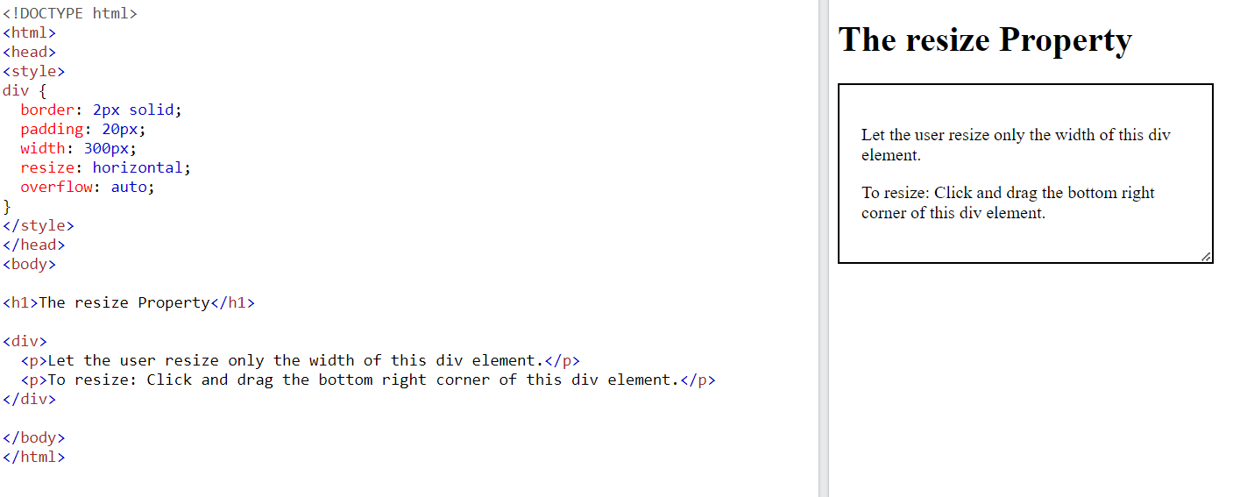

The following example lets the user resize only the width of a <div> element:

div {  
  resize: horizontal;  
  overflow: auto;  
}

The following example lets the user resize only the height of a <div> element:

div {  
  resize: vertical;  
  overflow: auto;  
}

The following example lets the user resize both the height and width of a <div> element:

div {  
  resize: both;  
  overflow: auto;  
}

In many browsers, <textarea> is resizable by default. Here, we have used the resize property to disable the resizability:

textarea {  
  resize: none;  
}

## Outline Offset

The outline-offset property adds space between an outline and the edge or border of an element.

This div has an outline 15px outside the border edge.

**Note:** Outline differs from borders! Unlike border, the outline is drawn outside the element's border, and may overlap other content. Also, the outline is NOT a part of the element's dimensions; the element's total width and height is not affected by the width of the outline.

The following example uses the outline-offset property to add space between the border and the outline:

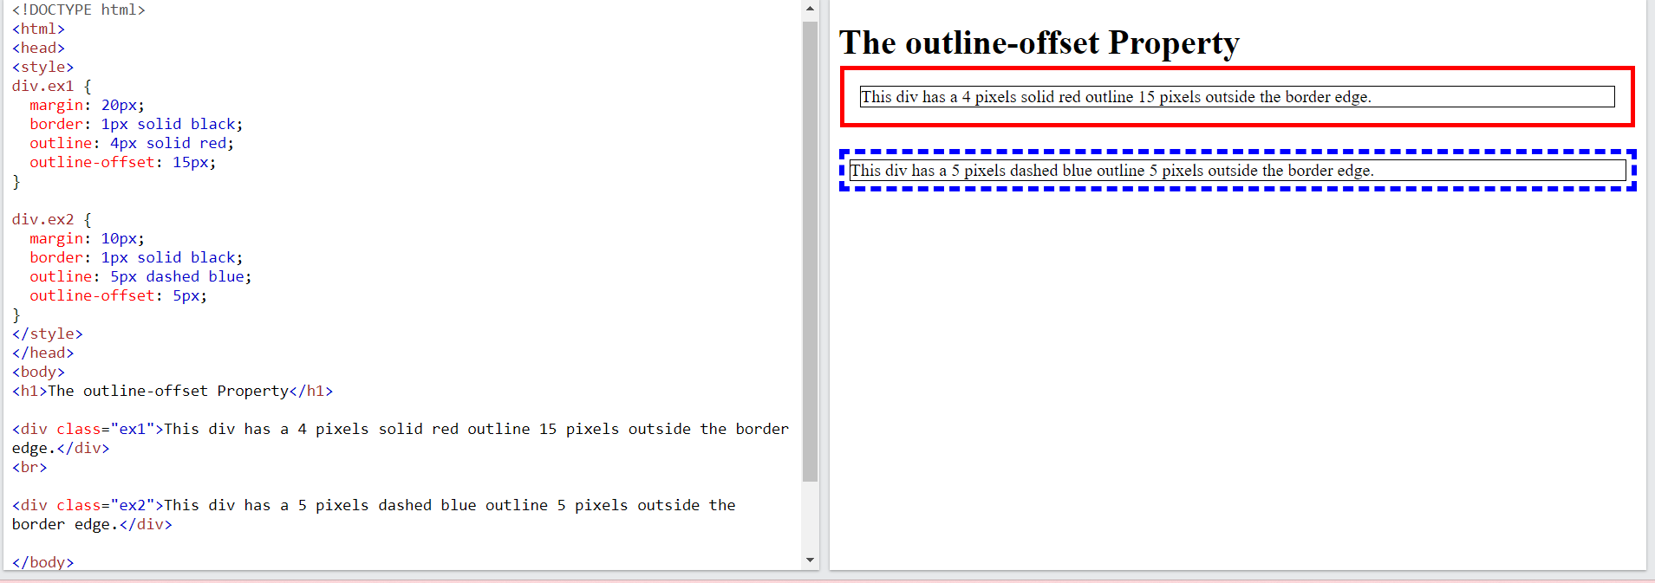

# Variables

The var() function is used to insert the value of a CSS variable.

CSS variables have access to the DOM, which means that you can create variables with local or global scope, change the variables with JavaScript, and change the variables based on media queries.

A good way to use CSS variables is when it comes to the colors of your design. Instead of copy and paste the same colors over and over again, you can place them in variables.

**Syntax of the var() Function**

The var() function is used to insert the value of a CSS variable.

The syntax of the var() function is as follows:

var(--name, value)

|  |  |
| --- | --- |
| **Value** | **Description** |
| name | Required. The variable name (must start with two dashes) |
| value | Optional. The fallback value (used if the variable is not found) |

**Note:** The variable name must begin with two dashes (--) and it is case sensitive!

## How var() Works

First of all: CSS variables can have a global or local scope.

Global variables can be accessed/used through the entire document, while local variables can be used only inside the selector where it is declared.

To create a variable with global scope, declare it inside the :root selector. The [:root](https://www.w3schools.com/cssref/sel_root.asp) selector matches the document's root element.

To create a variable with local scope, declare it inside the selector that is going to use it.

The following example is equal to the example above, but here we use the var() function.

First, we declare two global variables (--blue and --white). Then, we use the var() function to insert the value of the variables later in the style sheet:

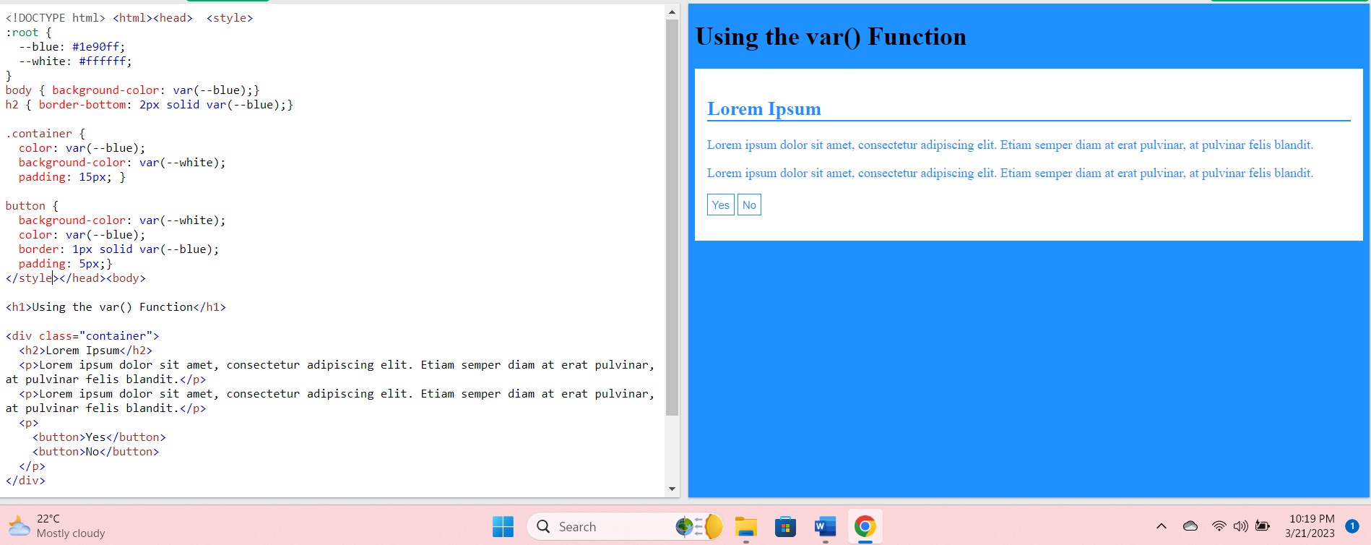

Advantages of using var() are:

* makes the code easier to read (more understandable)
* makes it much easier to change the color values

## Override Global Variable With Local Variable

From the previous page we have learned that global variables can be accessed/used through the entire document, while local variables can be used only inside the selector where it is declared.

Look at the example from the previous page:

:root {  
  --blue: #1e90ff;  
  --white: #ffffff;  
}  
  
body {  
  background-color: var(--blue);  
}  
  
h2 {  
  border-bottom: 2px solid var(--blue);  
}  
  
.container {  
  color: var(--blue);  
  background-color: var(--white);  
  padding: 15px;  
}  
  
button {  
  background-color: var(--white);  
  color: var(--blue);  
  border: 1px solid var(--blue);  
  padding: 5px;  
}

Sometimes we want the variables to change only in a specific section of the page.

Assume we want a different color of blue for button elements. Then, we can re-declare the --blue variable inside the button selector. When we use var(--blue) inside this selector, it will use the local --blue variable value declared here.

We see that the local --blue variable will override the global --blue variable for the button elements:

:root {  
  --blue: #1e90ff;  
  --white: #ffffff;  
}  
  
body {  
  background-color: var(--blue);  
}  
  
h2 {  
  border-bottom: 2px solid var(--blue);  
}  
  
.container {  
  color: var(--blue);  
  background-color: var(--white);  
  padding: 15px;  
}  
  
button {  
  --blue: #0000ff; /* local variable will override global */  
  background-color: var(--white);  
  color: var(--blue);  
  border: 1px solid var(--blue);  
  padding: 5px;

## Add a New Local Variable

If a variable is to be used at only one single place, we could also have declared a new local variable, like this:

:root {  
  --blue: #1e90ff;  
  --white: #ffffff;  
}  
  
body {  
  background-color: var(--blue);  
}  
  
h2 {  
  border-bottom: 2px solid var(--blue);  
}  
  
.container {  
  color: var(--blue);  
  background-color: var(--white);  
  padding: 15px;  
}  
  
button {  
  --button-blue: #0000ff; /* new local variable */  
  background-color: var(--white);  
  color: var(--button-blue);  
  border: 1px solid var(--button-blue);  
  padding: 5px;  
}

# Box Sizing

The CSS box-sizing property allows us to include the padding and border in an element's total width and height.

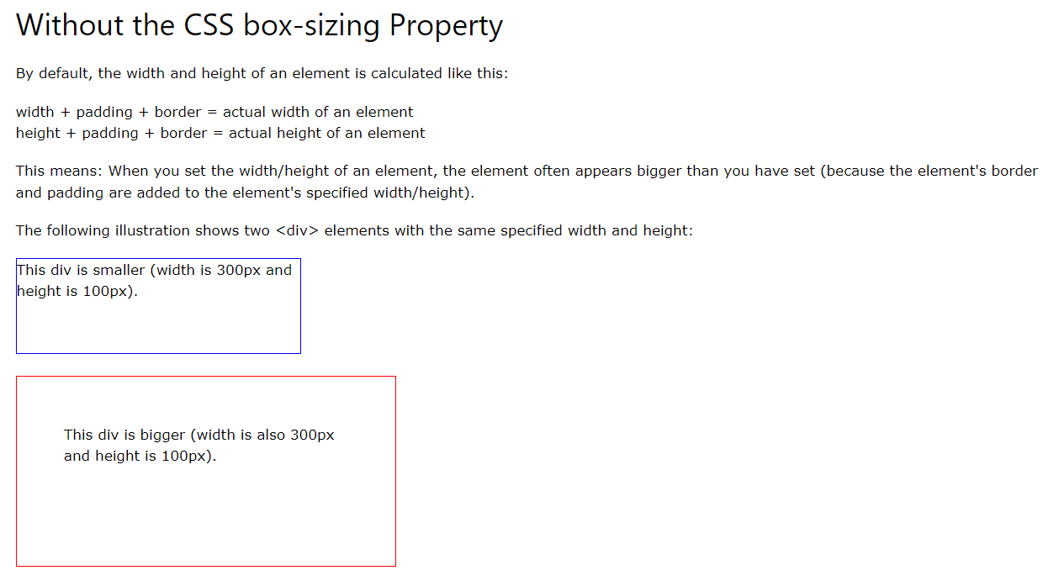

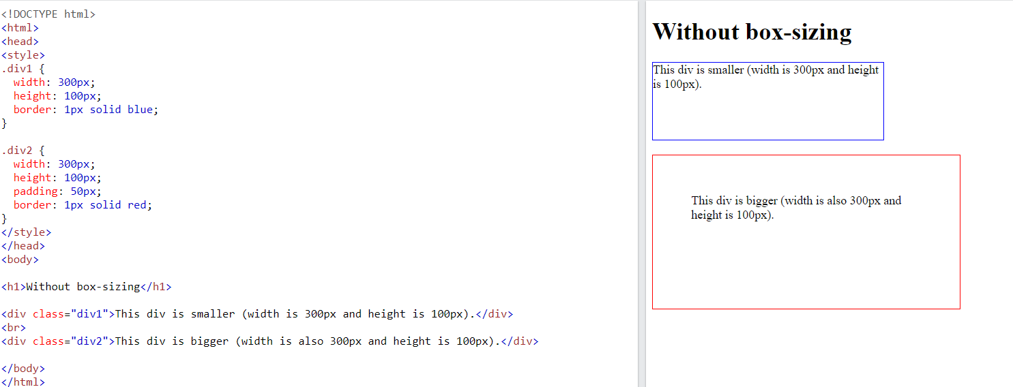

The box-sizing property solves this problem

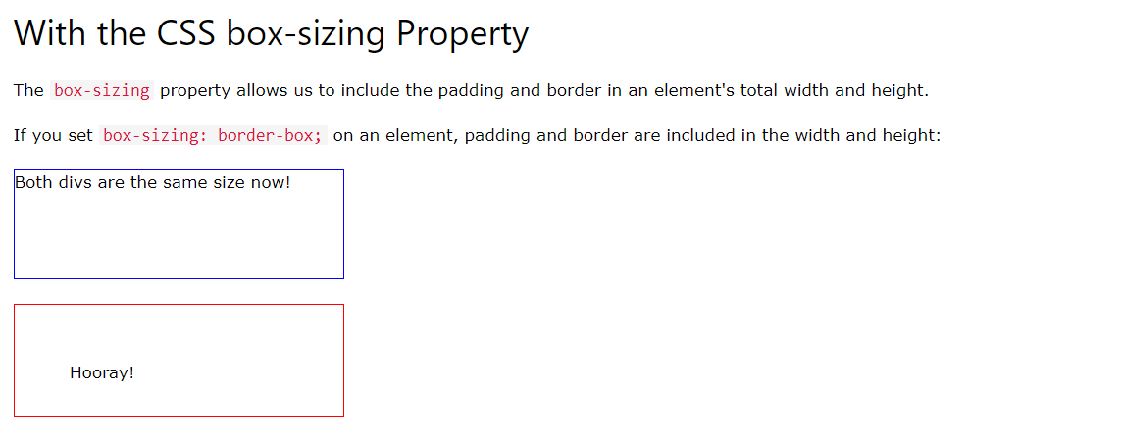

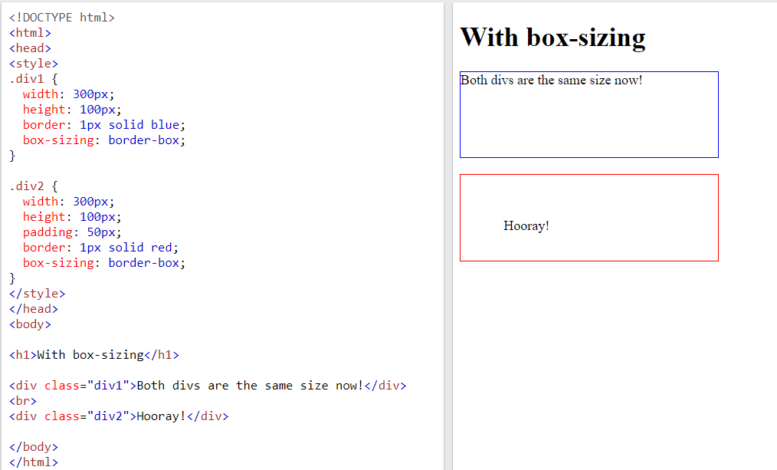

# Media Queries

The @media rule, introduced in CSS2, made it possible to define different style rules for different media types.

Examples: You could have one set of style rules for computer screens, one for printers, one for handheld devices, one for television-type devices, and so on.

Unfortunately these media types never got a lot of support by devices, other than the print media type.

**CSS3 Introduced Media Queries**

Media queries in CSS3 extended the CSS2 media types idea: Instead of looking for a type of device, they look at the capability of the device.

Media queries can be used to check many things, such as:

* width and height of the viewport
* width and height of the device
* orientation (is the tablet/phone in landscape or portrait mode?)
* resolution

Using media queries are a popular technique for delivering a tailored style sheet to desktops, laptops, tablets, and mobile phones (such as iPhone and Android phones).

Media Query Syntax

A media query consists of a media type and can contain one or more expressions, which resolve to either true or false.

@media not|only *mediatype*and(*expressions*) { *CSS-Code;*}

The result of the query is true if the specified media type matches the type of device the document is being displayed on and all expressions in the media query are true. When a media query is true, the corresponding style sheet or style rules are applied, following the normal cascading rules.

Unless you use the not or only operators, the media type is optional and the all type will be implied.

You can also have different stylesheets for different media:

<link rel="stylesheet" media="mediatype and|not|only (expressions)" href="print.css">

CSS3 Media Types

|  |  |
| --- | --- |
| **Value** | **Description** |
| all | Used for all media type devices |
| print | Used for printers |
| screen | Used for computer screens, tablets, smart-phones etc. |
| speech | Used for screenreaders that "reads" the page out loud |

## Media Queries Simple Examples

One way to use media queries is to have an alternate CSS section right inside your style sheet.

The following example changes the background-color to lightgreen if the viewport is 480 pixels wide or wider (if the viewport is less than 480 pixels, the background-color will be pink):

# Grid Layout

The CSS Grid Layout Module offers a grid-based layout system, with rows and columns, making it easier to design web pages without having to use floats and positioning.

## Grid Elements

A grid layout consists of a parent element, with one or more child elements.

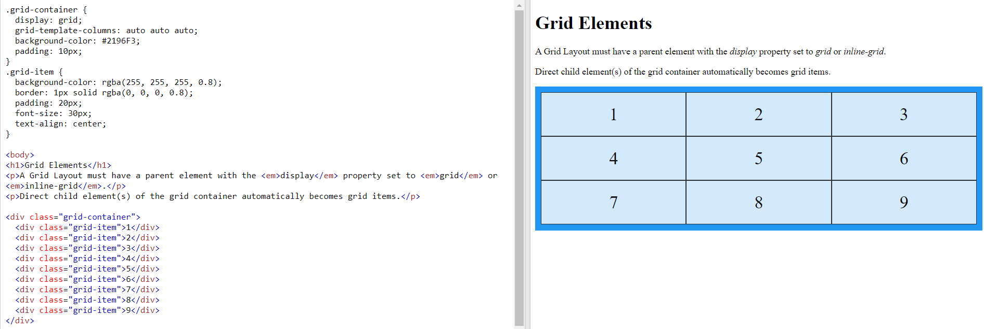

## Display Property

An HTML element becomes a grid container when its display property is set to grid or inline-grid.

Display -grid

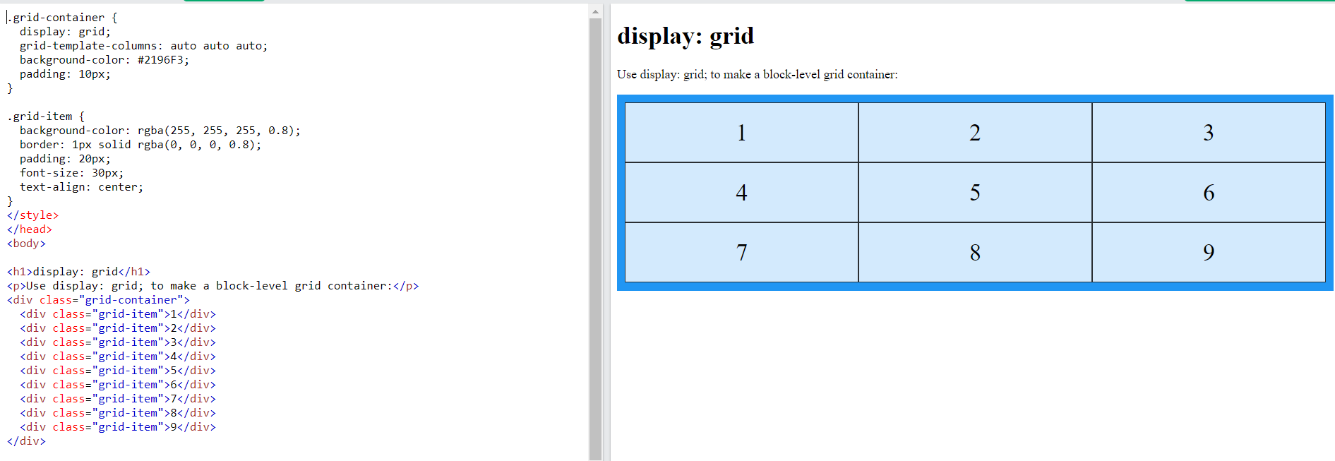

Display-inline-grid

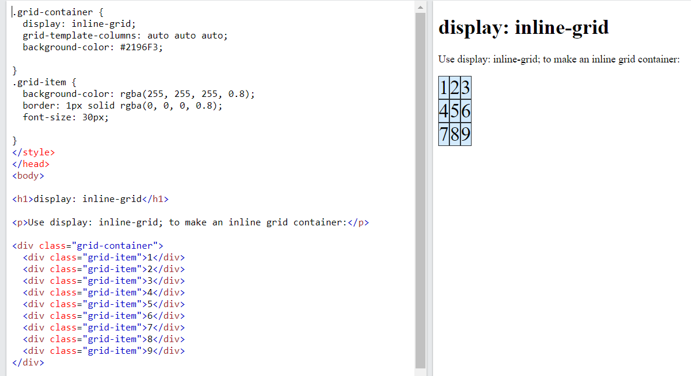

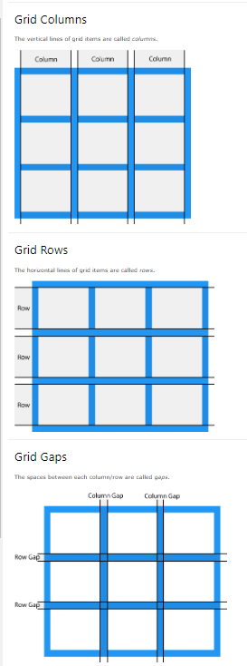

## gap

You can adjust the gap size by using one of the following properties:

* column-gap
* row-gap
* gap

The column-gap property sets the gap between the columns:

.grid-container {  
  display: grid;  
**column-gap: 50px;**  
}

The row-gap property sets the gap between the rows:

.grid-container {  
  display: grid;  
**row-gap: 50px;**}

The gap property is a shorthand property for the row-gap and the column-gap properties:

.grid-container {  
  display: grid;  
**gap: 50px 100px;**}

The gap property can also be used to set both the row gap and the column gap in one value:

.grid-container {  
  display: grid;  
**gap: 50px;**}

## Grid lines

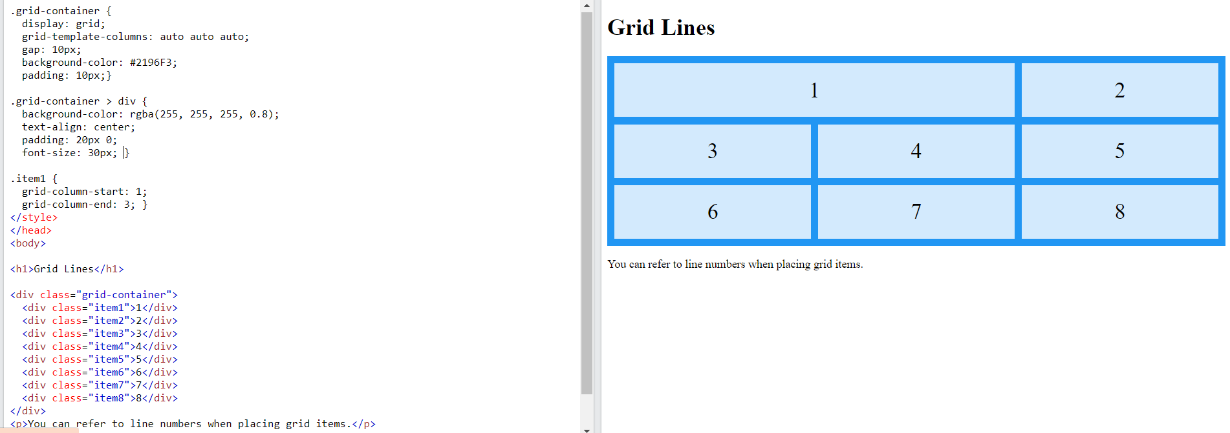

### grid-column-start , grid-column-end

Place a grid item at column line 1, and let it end on column line 3:

.item1 {  
grid-column-start: 1;  
  grid-column-end: 3;  
}

### grid-row-start ,grid-row-end

Place a grid item at row line 1, and let it end on row line 3:

.item1 {  
grid-row-start: 1;  
  grid-row-end: 3;  
}

# All CSS Grid Properties

|  |  |
| --- | --- |
| **Property** | **Description** |
| [column-gap](https://www.w3schools.com/cssref/css3_pr_column-gap.asp) | Specifies the gap between the columns |
| [gap](https://www.w3schools.com/cssref/css3_pr_gap.asp) | A shorthand property for the row-gap and the column-gap properties |
| [grid](https://www.w3schools.com/cssref/pr_grid.asp) | A shorthand property for the grid-template-rows, grid-template-columns, grid-template-areas, grid-auto-rows, grid-auto-columns, and the grid-auto-flow properties |
| [grid-area](https://www.w3schools.com/cssref/pr_grid-area.asp) | Either specifies a name for the grid item, or this property is a shorthand property for the grid-row-start, grid-column-start, grid-row-end, and grid-column-end properties |
| [grid-auto-columns](https://www.w3schools.com/cssref/pr_grid-auto-columns.asp) | Specifies a default column size |
| [grid-auto-flow](https://www.w3schools.com/cssref/pr_grid-auto-flow.asp) | Specifies how auto-placed items are inserted in the grid |
| [grid-auto-rows](https://www.w3schools.com/cssref/pr_grid-auto-rows.asp) | Specifies a default row size |
| [grid-column](https://www.w3schools.com/cssref/pr_grid-column.asp) | A shorthand property for the grid-column-start and the grid-column-end properties |
| [grid-column-end](https://www.w3schools.com/cssref/pr_grid-column-end.asp) | Specifies where to end the grid item |
| [grid-column-gap](https://www.w3schools.com/cssref/pr_grid-column-gap.asp) | Specifies the size of the gap between columns |
| [grid-column-start](https://www.w3schools.com/cssref/pr_grid-column-start.asp) | Specifies where to start the grid item |
| [grid-gap](https://www.w3schools.com/cssref/pr_grid-gap.asp) | A shorthand property for the grid-row-gap and grid-column-gap properties |
| [grid-row](https://www.w3schools.com/cssref/pr_grid-row.asp) | A shorthand property for the grid-row-start and the grid-row-end properties |
| [grid-row-end](https://www.w3schools.com/cssref/pr_grid-row-end.asp) | Specifies where to end the grid item |
| [grid-row-gap](https://www.w3schools.com/cssref/pr_grid-row-gap.asp) | Specifies the size of the gap between rows |
| [grid-row-start](https://www.w3schools.com/cssref/pr_grid-row-start.asp) | Specifies where to start the grid item |
| [grid-template](https://www.w3schools.com/cssref/pr_grid-template.asp) | A shorthand property for the grid-template-rows, grid-template-columns and grid-areas properties |
| [grid-template-areas](https://www.w3schools.com/cssref/pr_grid-template-areas.asp) | Specifies how to display columns and rows, using named grid items |
| [grid-template-columns](https://www.w3schools.com/cssref/pr_grid-template-columns.asp) | Specifies the size of the columns, and how many columns in a grid layout |
| [grid-template-rows](https://www.w3schools.com/cssref/pr_grid-template-rows.asp) | Specifies the size of the rows in a grid layout |
| [row-gap](https://www.w3schools.com/cssref/css3_pr_row-gap.asp) | Specifies the gap between the grid rows |

# Grid Container

## The grid-template-columns Property

The grid-template-columns property defines the number of columns in your grid layout, and it can define the width of each column.

The value is a space-separated-list, where each value defines the width of the respective column.

If you want your grid layout to contain 4 columns, specify the width of the 4 columns, or "auto" if all columns should have the same width.

Make a grid with 4 columns:

.grid-container {  
  display: grid;  
  grid-template-columns: auto auto auto auto;  
}

**Note:** If you have more than 4 items in a 4 columns grid, the grid will automatically add a new row to put the items in.

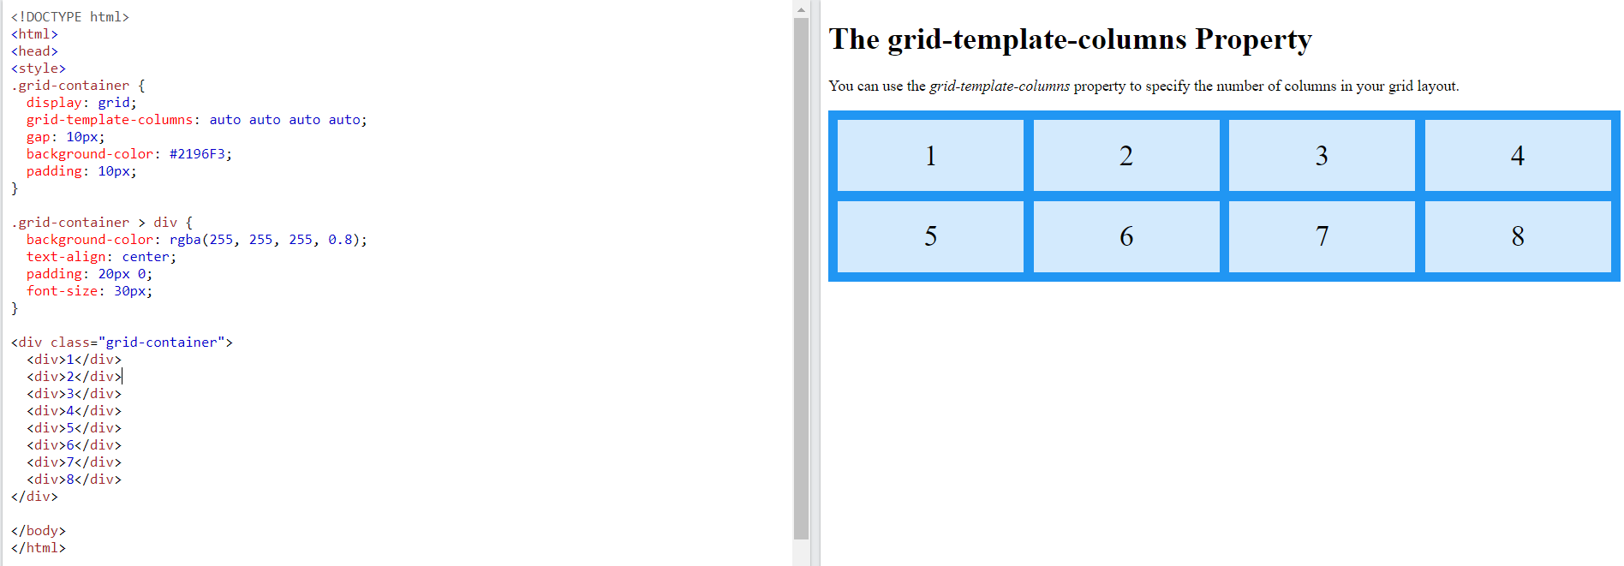

The grid-template-columns property can also be used to specify the size (width) of the columns.

Set a size for the 4 columns:

.grid-container {  
  display: grid;  
  grid-template-columns: 80px 200px auto 40px;  
}

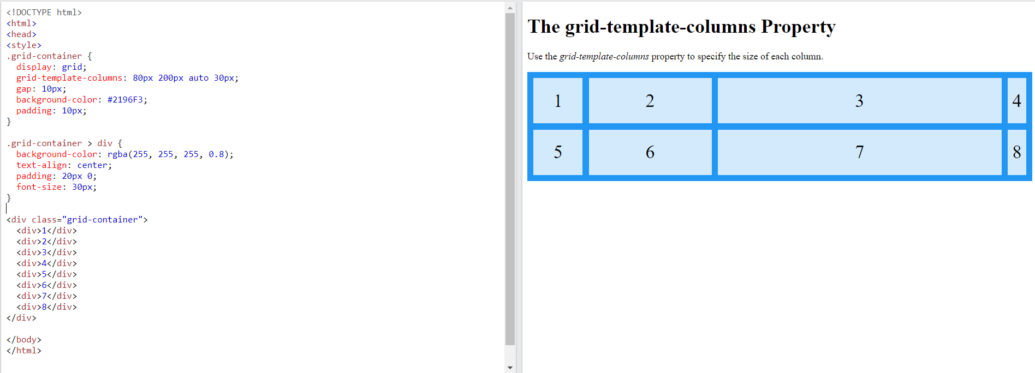

## The grid-template-rows Property

The grid-template-rows property defines the height of each row.

The value is a space-separated-list, where each value defines the height of the respective row:

.grid-container {  
  display: grid;  
  grid-template-rows: 80px 200px;  
}

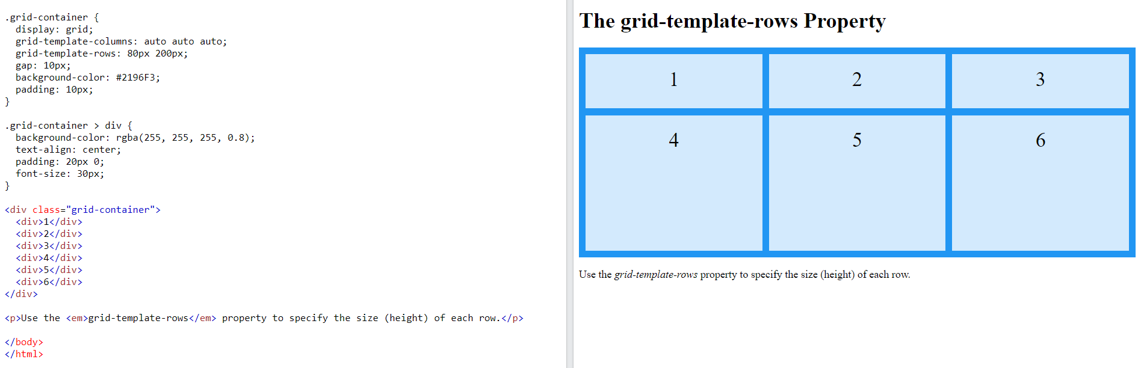

# Grid item

## Child Elements (Items)

A grid container contains grid items.

By default, a container has one grid item for each column, in each row, but you can style the grid items so that they will span multiple columns and/or rows.

## The grid-column Property:

The grid-column property defines on which column(s) to place an item.

You define where the item will start, and where the item will end.

**Note:** The grid-column property is a shorthand property for the grid-column-start and the grid-column-end properties.

To place an item, you can refer to line numbers, or use the keyword "span" to define how many columns the item will span.

Make "item1" start on column 1 and end before column 5:

.item1 {  
  grid-column: 1 / 5;  
}

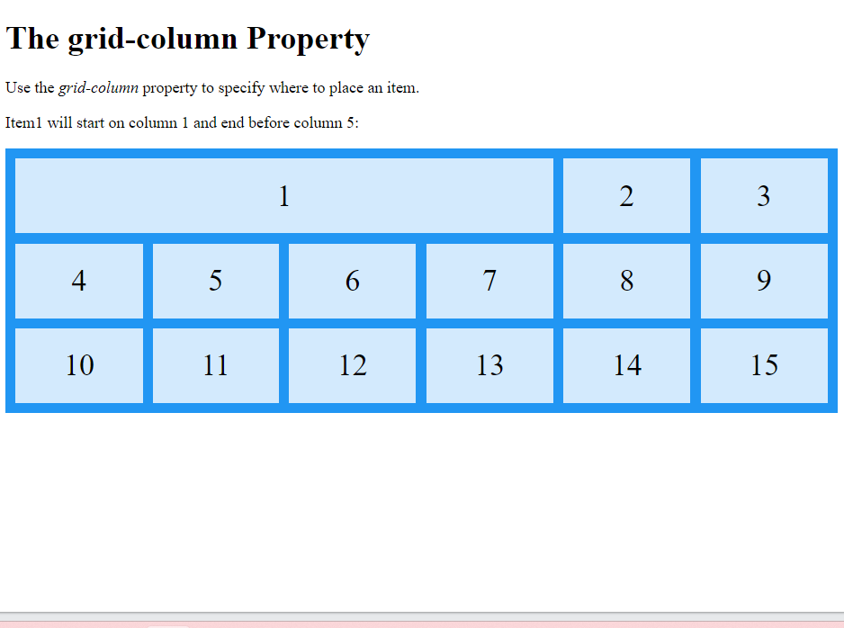

Make "item1" start on column 1 and span 3 columns:

.item1 {  
  grid-column: 1 / span 3;  
}

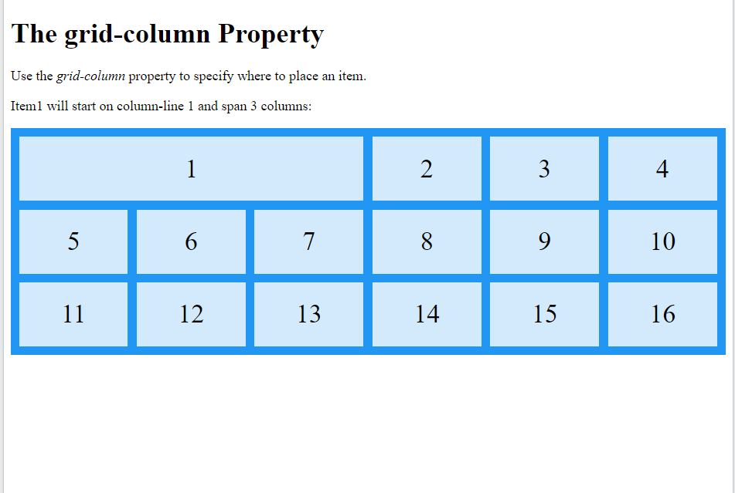

Make "item2" start on column 2 and span 3 columns:

.item2 {  
  grid-column: 2 / span 3;  
}

## The grid-row Property:

The grid-row property defines on which row to place an item.

You define where the item will start,

**Note:** The grid-row property is a shorthand property for the grid-row-start and the grid-row-end properties.

To place an item, you can refer to line numbers, or use the keyword "span" to define how many rows the item will span:

Make "item1" start on row-line 1 and end on row-line 4:

.item1 {  
  grid-row: 1 / 4;  
}

Make "item1" start on row 1 and span 2 rows:

.item1 {  
  grid-row: 1 / span 2;  
}

## The grid-area Property

The grid-area property can be used as a shorthand property for the grid-row-start, grid-column-start, grid-row-end and the grid-column-end properties.

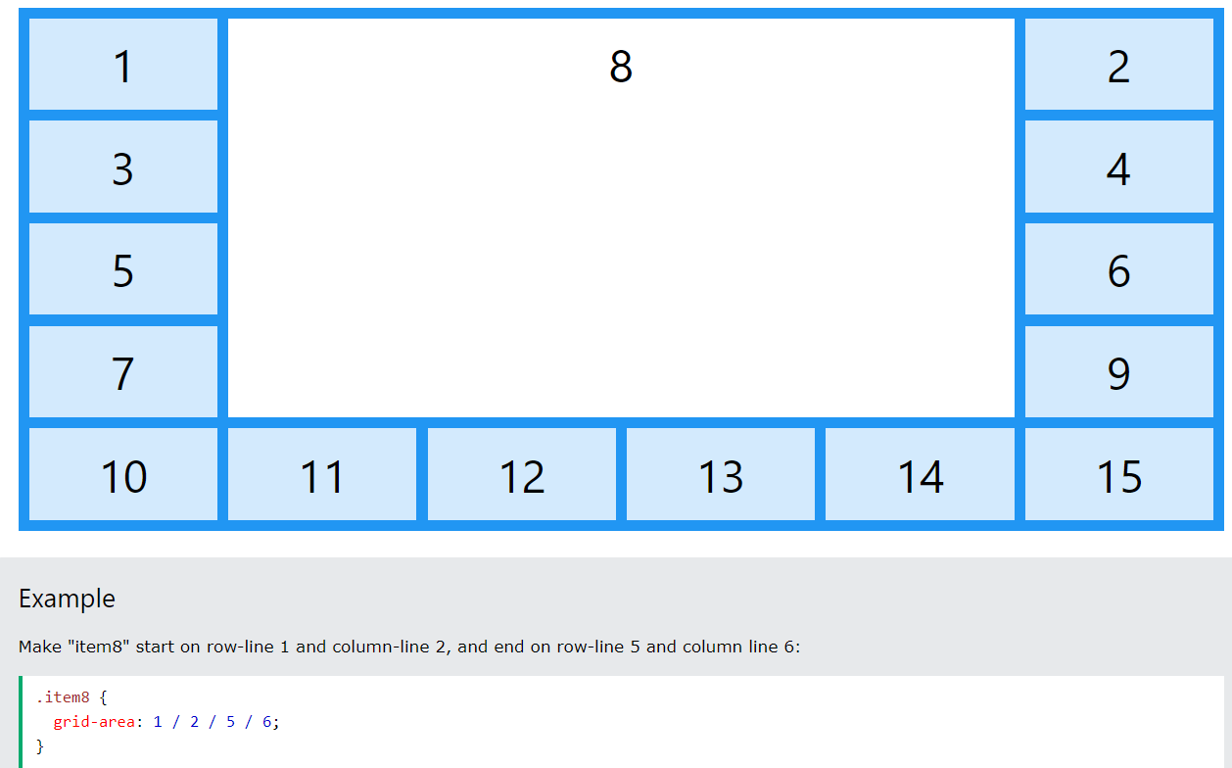

# Naming Grid Items

The grid-area property can also be used to assign names to grid items.

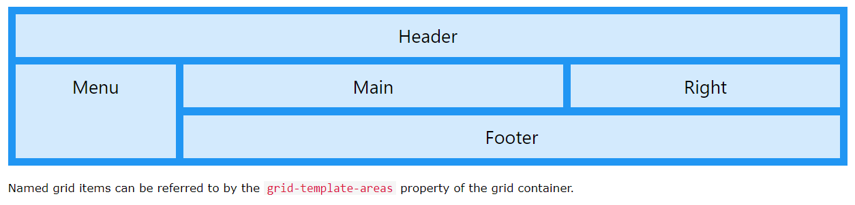

Item1 gets the name "myArea" and spans all five columns in a five columns grid layout:

.item1 {  
  grid-area: myArea;  
}  
.grid-container {  
  grid-template-areas: 'myArea myArea myArea myArea myArea';  
}

Each row is defined by apostrophes (' ')

The columns in each row is defined inside the apostrophes, separated by a space.

**Note:** A period sign represents a grid item with no name.

